**অন্ধের লাঠি**

**Submitted By  
 Group - 04**

**Group Members:**

201814142 – Mudassir Salman Asim  
202014037 – Mohiuddin Bilwal  
202014051 – Sheikh Md. Saifur Rahman  
  
**Submission Date:** 19/07/2022  
**Course:** CSE – 306 (Microprocessor and Microcontroller Sessional)

**Abstract:**The sufferings of the blind people know now bounds. They’ve to sacrifice a lot of things from their life for the loss of their eyesight. Some restrictions come to their life which give them a tough challenge to settle the surrounding of them. They normally move or travel with the help of a stick or the memories they keep in their memory in their long-term exploration. The main objective of this work is to design an affordable, low cost, efficient and user-friendly system to create smooth navigation and driving device for the visually impaired people. It’s a report based on a glass which is implemented specially for those people who suffer most of the time due to loss of their eyesight. The device contains some ultrasonic sonar sensors, buzzer alarm, vibration motor, two 3.7V lithium-ion batteries and most importantly an Arduino Nano. The in-built sensor will make sure if any obstacle comes into the range up to 1m, the user can feel it. Besides, this project will help to move freely, safe and sound.

**Keywords:**Arduino, Ultrasonic Sensor, Buzzer, Lithium-Ion Batteries, Vibration Motor

**Introduction:**

Visually impaired people often find it very difficult to interact with their surroundings, physical movement is a tough challenge for them. They can rarely feel their environment. Often, they can not distinguish the obstacles which appear in front of them, they need to have the support of some medium or the people who’re closest to them. They’re mainly depended on their families for the physical movement of theirs as well as financial support and mobility. So, it can be said that, they’ve to suffer in a long run. Blind stick is an option for the visually impaired people by which they can rely to walk or move. But there’re some limitations to detect the obstacles by the blind stick. It can not get them alerted when some big obstacle take place around them. From an idea like that, we’ve designed a blind glass which can be a shield for them. Blind people use a black sunglass to obstruct bright light to avoid the pain. We tried to implement a design on that glass which can do multiple tasks like – it’ll help them to avoid pain from bright light, help them to walk with audio and vibrator which results in avoiding the blind stick also, even help them to detect the obstacles towards them also. Blind glass is specially designed to detect obstacles and help the blind to navigate care free. The audio messages will keep the user alert and considerably reduce the accidents. Sonar sensors, Arduino, Vibrators, Buzzers etc. are used here to do these tasks and keep the users in a relaxation mood. The proposed system detects the obstacles which are present in outdoor and indoor with the help of the sonar sensors and create a sound with the buzzer. We’ve designed the glass with three sonar sensors to detect the obstacles of the front side by left and right sensor and to detect small obstacles by front sensor. It may not work for a greater distance but it’ll ensure the user to keep them safe to a certain distance around them.

**Components:**

|  |  |  |
| --- | --- | --- |
| **Name** | **Model** | **Price** |
| Arduino | Nano | 650*2 |
| Jumper Wires | - | 100 |
| Buzzer Alarm | - | 30*3 |
| Bread Board | - | 100 |
| Battery | Li-Ion 3.7V | 90*2 |
| Vibration Motor | Coin Type | 60*6 |
| Battery Holder | - | 60+80 |
| Battery Charger |  | 400 |
| Soldering Iron | - | Lab |
| Sunglass | - | 150 |
| Sonar Sensor | HC-HR04 | 110*3 |
|  |  | = 3,150 Taka |

**Methadology:**

Basically, the idea of designing a blind glass is generated to provide such a module for visually impaired people by which they can be alerted if any obstacle occurs around them. The sonar sensor on the left of the sunglass will measure the distance of the obstacle of left side in front by transmitting ultrasonic sound waves and will convert the sound into an electrical signal. This electrical signal will create a buzzer alarm and the vibration motor will be active to alert the user about the incidence of his front side. Same system goes for right side sonar for right side in front. But we’ve designed the forward sonar sensor on a little so that it can cover the small obstacles below of the front position. Sonar sensors can cover up to maximum of 1 m distance. These sensors will be directed by an Arduino nano which is nicely settled with our design. The Arduino will send a short pulse to trigger the detection and listens for a pulse on the pin where the sensor is connected. Arduino will be run with two 3.7 V Li-ion batteries. A battery holder nicely balances those two batteries. We’ve tried to cover 180-degree angle area around the user which can ensure the blind person to navigate care free. The connection of the components was implemented correctly and the process worked perfectly for us. To visualize the project with a clear image, a flow chart is given below-

Fig: Working Flow of Blind Glass

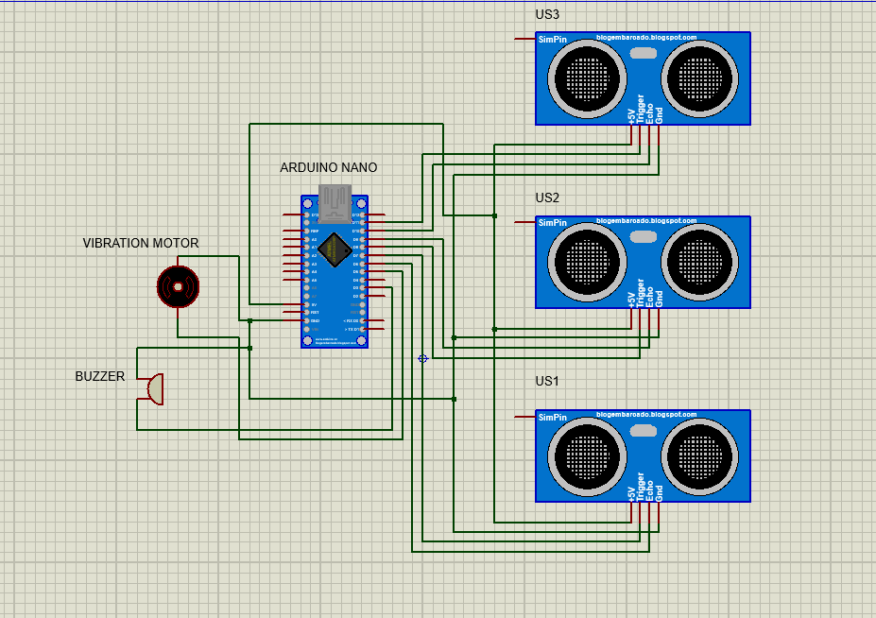

Fig: Circuit Diagram

From the circuit diagram, we can see that, all the Vcc(5 V) pins of sonar sensors are connected with Arduino’s Vcc pin. The trigger pins are connected with Arduino’s D7, D9 and D11 pins. The echo pins are connected with Arduino’s D6, D8 and D10 pins. The GND pins are connected with Arduino GND. One pin each from buzzer and vibration motor is sorted with sonar GND pins to connect them with Arduino GND. The other pins of buzzer and vibration motor are in D3 and D5 pins respectively. Arduino is driven with two 3.7 volts lithium battery here.

**Outcome:**In this protocol, an obstacle within the range in between 1 m can be easily measured. When any obstacle found within the range, then the sonar sensor will detect the issue and the voice of the buzzer notify blind person about the obstacle. Besides, the vibration will make the person understand in which side the obstacle is coming. The accuracy of this device is quite moderate and the performance is quite appreciable.

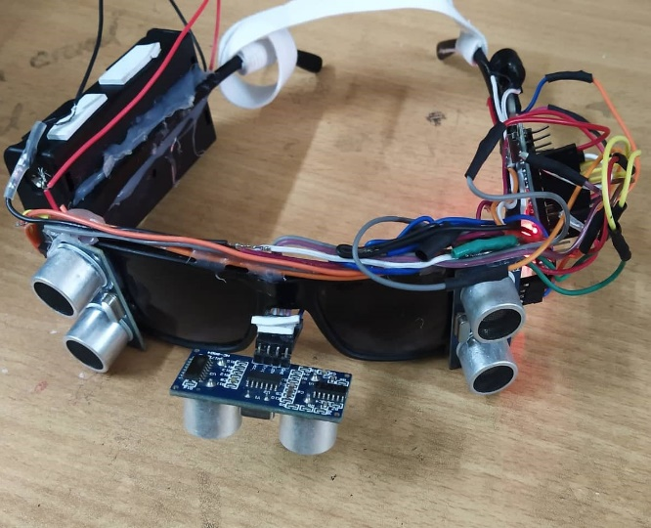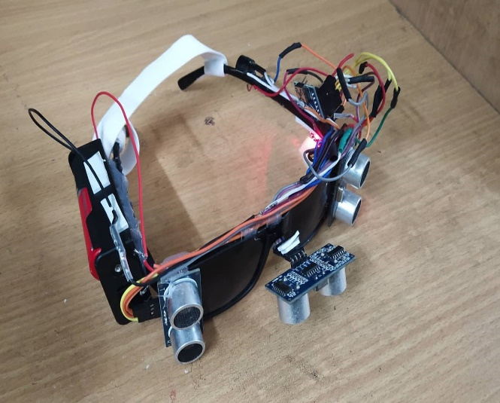

Fig: Project View

**Contribution:**Contribution of each member is shown below:

|  |  |
| --- | --- |
| **Student Id** | **Contribution** |
| 201814142 | * Component Collection * Circuit Connection |
| 202014037 | * Component Collection * Circuit Connection * Report Writing * Design Management |
| 202014051 | * Component Collection * Circuit Connection * Arduino Programming * Design Management |

**Conclusion:**From the above project, it can be said that, to design a user-friendly hardware system for visually impaired people was a successful one. Though it is costly for the poor ones, but if the research is continued for this project in future, the cost can be reduced for sure. The range for obstacle detection can also be increased. It’s a light device which easy to put on. Before using the batteries for power supply, the whole system was executed by Arduino code through the laptop with the help of Arduino IDE. The simulated data of the IDE helped us all in our project.