CSE 201 Project High Level Design Document

## Team Member Names

Michaela Ballard, Logan Brown, Ling Xiang, ChenLing Zhang

## Team Project Title

Campus Market

### Project Description

The Campus Market is a web application to make moving in and out of campus and near campus housing easier. The software is designed for universities. Students can buy or sell their used items in their own communities. Since all transactions occur among people who are nearby each other, they can drop off or pick up items easily and avoid shipping costs.

## Overall Design Description

<Describe the overall design – mention if this is Object Oriented Design or Functional/Procedural design, what components it has (UI, Backend, Front end, Database in backend etc) – use UML diagrams if you want or simple block diagrams>

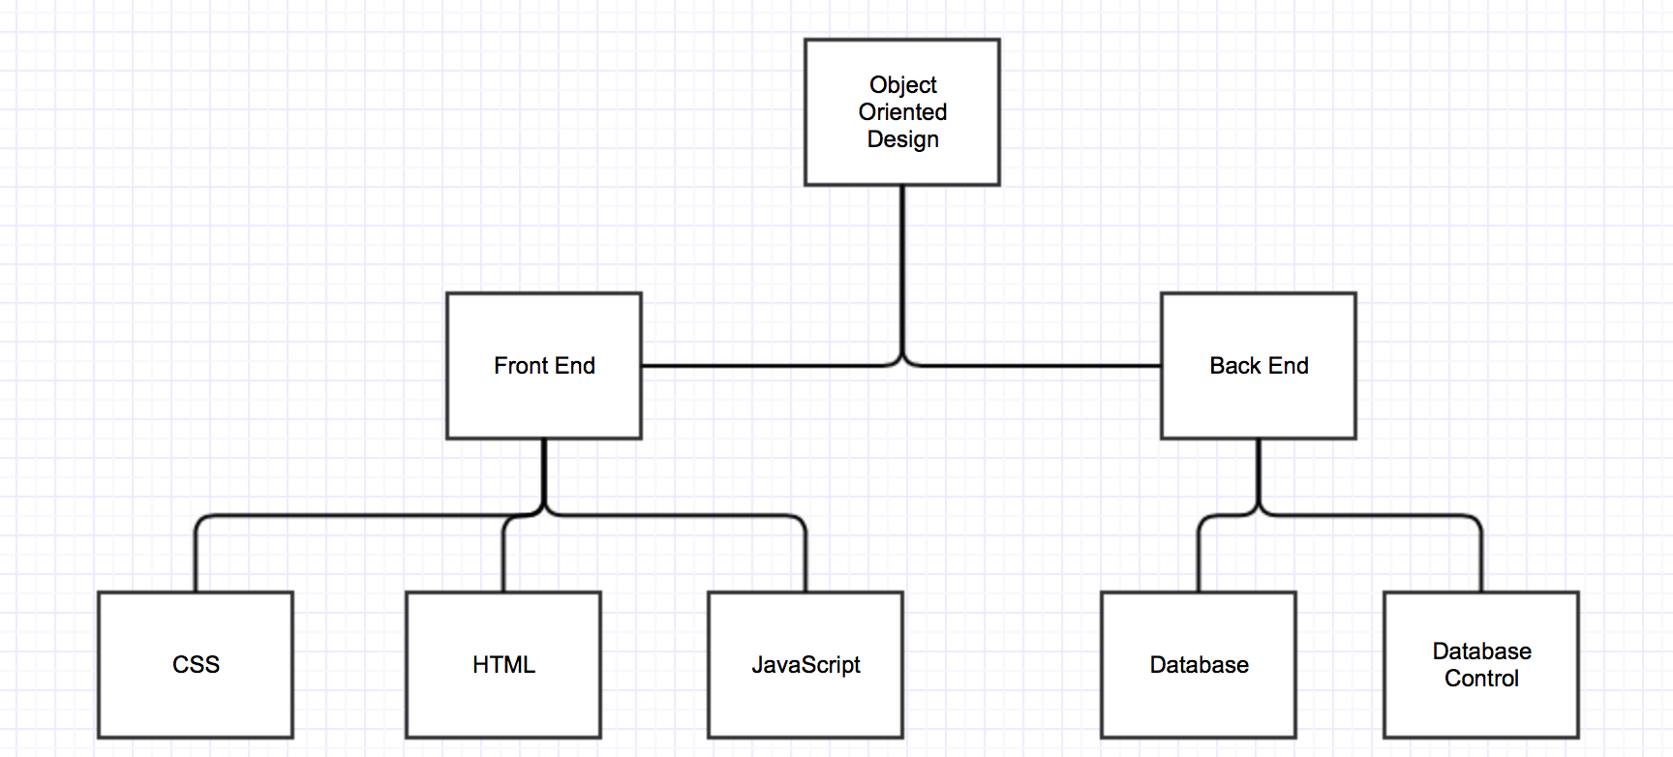

## UML Diagram 1

<Include a short text description of what the UML diagram is showing and then cut and paste your UML diagram here. Use a minimum of 1 class diagram, 2 Use Cases and 2 Sequence diagrams. You are not required to do the OPT and ALT cases in the Sequence diagrams.>

Talk about classes and what will be stored for each of them as well as a use case diagram.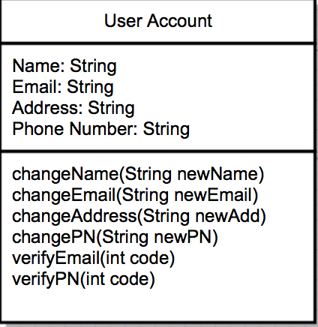

A very simple User Account class. Each user has it’s name, email, address and phone number. Users are able to change names, emails, addresses, phone number of their accounts. Also they need to verify their emails and phone numbers.

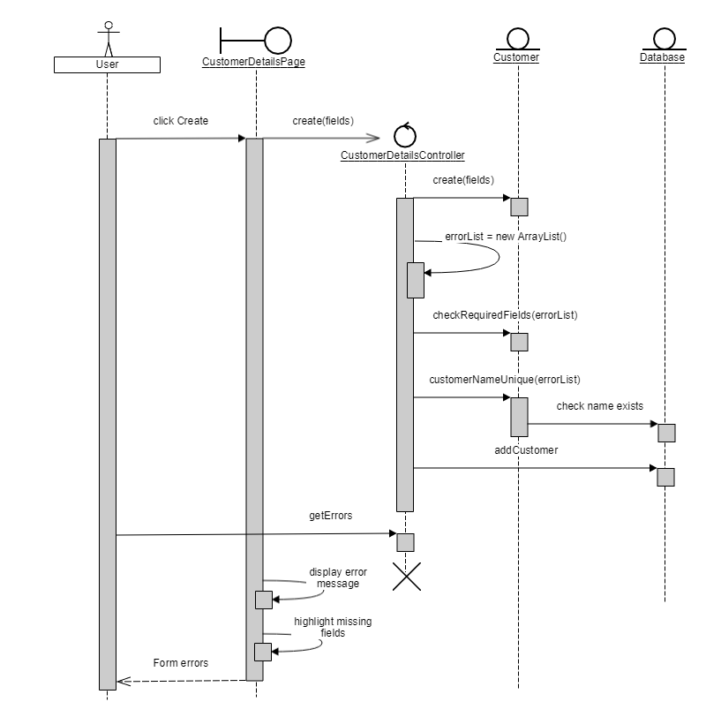The seller sequence diagram displays the users interaction with the software if they intend to create an account.

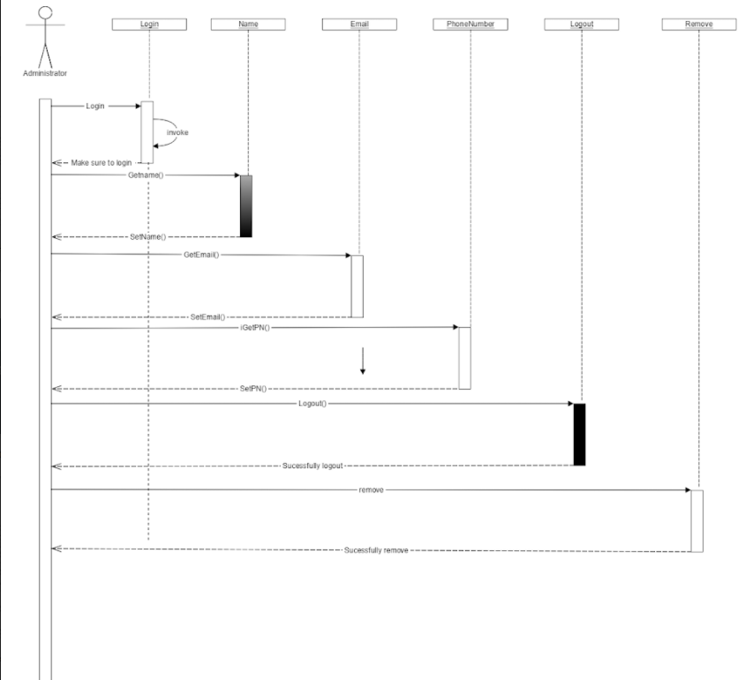

This sequence diagram displays the interaction an administrative user has with the software.