http://sce.uhcl.edu/helm/rationalunifiedprocess/applet/images/artfc_w.gif [Artifacts](http://sce.uhcl.edu/helm/rationalunifiedprocess/process/artifact/ovu_arts.htm) > http://sce.uhcl.edu/helm/rationalunifiedprocess/applet/images/artfc_y.gif [Requirements Artifact Set](http://sce.uhcl.edu/helm/rationalunifiedprocess/process/artifact/ars_req.htm) > http://sce.uhcl.edu/helm/rationalunifiedprocess/applet/images/additional.gif [{More Requirements Artifacts}](http://sce.uhcl.edu/helm/rationalunifiedprocess/process/artifact/arp_req_add.htm) > http://sce.uhcl.edu/helm/rationalunifiedprocess/applet/images/ar_srs.gif [Software Requirements Specification](http://sce.uhcl.edu/helm/rationalunifiedprocess/process/artifact/ar_srs.htm) > http://sce.uhcl.edu/helm/rationalunifiedprocess/applet/images/ie.gif SRS w/ Use-Cases

**Campus Market**

**Software Requirements Specification**

**For Campus Market Web Application**

**Version <1.0>**

*[Note: The following template is provided for use with the Rational Unified Process. Text enclosed in square brackets and displayed in blue italics (style=InfoBlue) is included to provide guidance to the author and should be deleted before publishing the document. A paragraph entered following this style will automatically be set to normal (style=Body Text).]*

**Revision History**

|  |  |  |  |
| --- | --- | --- | --- |
| **Date** | **Version** | **Description** | **Author** |
| <dd/mmm/yy> | <x.x> | <details> | <name> |
| 25/03/18 | <0.1> | Filled in details for each section of document | Logan Brown |
|  |  |  |  |
|  |  |  |  |

**Table of Contents**

[1.          Introduction](http://sce.uhcl.edu/helm/rationalunifiedprocess/webtmpl/templates/req/rup_srsuc.htm#1.%20%20%20%20%20%20%20%20%20%20%20%20%20%20%20%20%20%20Introduction)

[1.1      Purpose](http://sce.uhcl.edu/helm/rationalunifiedprocess/webtmpl/templates/req/rup_srsuc.htm#1.1%20%20%20%20%20%20%20%20%20%20%20%20%20%20%20Purpose)

[1.2      Scope](http://sce.uhcl.edu/helm/rationalunifiedprocess/webtmpl/templates/req/rup_srsuc.htm#1.2%20%20%20%20%20%20%20%20%20%20%20%20%20%20%20Scope)

[1.3      Definitions, Acronyms and Abbreviations](http://sce.uhcl.edu/helm/rationalunifiedprocess/webtmpl/templates/req/rup_srsuc.htm#1.3%20%20%20%20%20%20%20%20%20%20%20%20%20%20%20Definitions,%20Acronyms%20and%20Abbreviations)

[1.4      References](http://sce.uhcl.edu/helm/rationalunifiedprocess/webtmpl/templates/req/rup_srsuc.htm#1.4%20%20%20%20%20%20%20%20%20%20%20%20%20%20%20References)

[1.5      Overview](http://sce.uhcl.edu/helm/rationalunifiedprocess/webtmpl/templates/req/rup_srsuc.htm#1.5%20%20%20%20%20%20%20%20%20%20%20%20%20%20%20Overview)

[2.          Overall Description](http://sce.uhcl.edu/helm/rationalunifiedprocess/webtmpl/templates/req/rup_srsuc.htm#2.%20%20%20%20%20%20%20%20%20%20%20%20%20%20%20%20%20%20Overall%20Description)

[2.1      Use-Case Model Survey](http://sce.uhcl.edu/helm/rationalunifiedprocess/webtmpl/templates/req/rup_srsuc.htm#2.1%20%20%20%20%20%20%20%20%20%20%20%20%20%20%20Use-Case%20Model%20Survey)

[2.2      Assumptions and Dependencies](http://sce.uhcl.edu/helm/rationalunifiedprocess/webtmpl/templates/req/rup_srsuc.htm#2.2%20%20%20%20%20%20%20%20%20%20%20%20%20%20%20Assumptions%20and%20Dependencies)

[3.          Specific Requirements](http://sce.uhcl.edu/helm/rationalunifiedprocess/webtmpl/templates/req/rup_srsuc.htm#3.%20%20%20%20%20%20%20%20%20%20%20%20%20%20%20%20%20%20Specific%20Requirements)

[3.1      Use-Case Reports](http://sce.uhcl.edu/helm/rationalunifiedprocess/webtmpl/templates/req/rup_srsuc.htm#3.1%20%20%20%20%20%20%20%20%20%20%20%20%20%20%20Use-Case%20Reports)

[3.2      Supplementary Requirements](http://sce.uhcl.edu/helm/rationalunifiedprocess/webtmpl/templates/req/rup_srsuc.htm#3.2%20%20%20%20%20%20%20%20%20%20%20%20%20%20%20Supplementary%20Requirements)

[4.          Supporting Information](http://sce.uhcl.edu/helm/rationalunifiedprocess/webtmpl/templates/req/rup_srsuc.htm#4.%20%20%20%20%20%20%20%20%20%20%20%20%20%20%20%20%20%20Supporting%20Information)

**Software Requirements Specification**

**1.**                  **Introduction**

*[The introduction of the****Software Requirements Specification (SRS)****should provide an overview of the entire document. It should include the purpose, scope, definitions, acronyms, abbreviations, references, and overview of the****Software Requirements Specification****.]*

*[Note: The****Software Requirements Specification****captures the complete software requirements for the system, or a portion of the system.  Following is a typical****Software Requirements Specification****outline for a project****using use-case modeling****. This artifact consists of a package containing use cases of the use-case model and applicable Supplementary Specifications and other supporting information.  For a template of an****Software Requirements Specification******not****using use-case modeling, which captures all requirements in a single document, with applicable sections inserted from the Supplementary Specifications (which would no longer be needed), see rup_srs.dot.]*

*[Many different arrangements of a****Software Requirements Specification****are possible.  Refer to [IEEE830-1998] for further elaboration of these explanations, as well as other options for a****Software Requirements Specification****organization.]*

**1.1**               **Purpose**

*[Specify the purpose of this****Software Requirements Specification****. The****Software Requirements Specification****should fully describe the external behavior of the application or subsystem identified. It also describes nonfunctional requirements, design constraints and other factors necessary to provide a complete and comprehensive description of the requirements for the software.]*

The purpose of this software requirements specification is to describe the Campus Market Web Application.

**1.2**               **Scope**

*[A brief description of the software application that the****Software Requirements Specification****applies to; the feature or other subsystem grouping; what Use-case model(s) it is associated with; and anything else that is affected or influenced by this document.]*

This software requirements specification applies solely to the Campus Market software.

**1.3**               **Definitions, Acronyms and Abbreviations**

*[This subsection should provide the definitions of all terms, acronyms, and abbreviations required to properly interpret the****Software Requirements Specification****.  This information may be provided by reference to the project Glossary.]*

HTML: Hyper Text Markup Language is the standard markup language for creating web pages and web applications

CSS: Cascading Style Sheet is a style sheet language used for describing the presentation of a document written in a markup language

JavaScript: JavaScript is a high-level, interpreted programming language. It is a language which is also characterized as dynamic, weakly typed, prototype-based and multi-paradigm

**1.4**               **References**

*[This subsection should provide a complete list of all documents referenced elsewhere in the****Software Requirements Specification****.  Each document should be identified by title, report number (if applicable), date, and publishing organization.  Specify the sources from which the references can be obtained. This information may be provided by reference to an appendix or to another document.]*

No Sources Yet

**1.5**               **Overview**

*[This subsection should describe what the rest of the****Software Requirements Specification****contains and explain how the document is organized.]*

The Software Requirements Specification contains a description of the software and software requirements as well as the individual requirements. This document is organized into two sections. One describing the overall software requirements, and one describing the specifics.

**2.**                  **Overall Description**

*[This section of the****Software Requirements Specification****should describe the general factors that affect the product and its requirements.  This section does not state specific requirements.  Instead, it provides a background for those requirements, which are defined in detail in****Section 3****, and makes them easier to understand. Include such items as product perspective, product functions, user characteristics, constraints, assumptions and dependencies, and requirements subsets.]*

**2.1**               **Use-Case Model Survey**

*[If using use-case modeling, this section contains an overview of the use-case model or the subset of the use-case model that is applicable for this subsystem or feature.  This includes a list of names and brief descriptions of all use cases and actors, along with applicable diagrams and relationships.  Refer to the****Use-Case-Model Survey Report****, which may be used as an enclosure at this point.]*

**Users include:**

Sellers: Post and monitor items they wish to sell. They must include necessary information for the transaction and pick up to be possible.

Buyers: Browse, search, and purchase items from sellers to be picked up at a convenient time.

Administrators: Monitor transactions and remove inappropriate material.

**2.2**               **Assumptions and Dependencies**

*[This section describes any key technical feasibility, subsystem or component availability, or other project related assumptions on which the viability of the software described by this****Software Requirements Specification****may be based.]*

The software does depends on a front end component utilizing javascript, html, and css or some other web compatible language and a back end utilizing databases and software controlling input, output, and changes to the database.

**3.**                  **Specific Requirements**

*[This section of the****Software Requirements Specification****should contain all the software requirements to a level of detail sufficient to enable designers to design a system to satisfy those requirements and testers to test that the system satisfies those requirements.   When using use-case modeling, these requirements are captured in the use cases and the applicable supplementary specifications.  If use-case modeling is not used, the outline for supplementary specifications may be inserted directly into this section.]*

**3.1**               **Use-Case Reports**

*[In use-case modeling, the use cases often define the majority of the functional requirements of the system, along with some non-functional requirements.  For each use case in the above use-case model, or subset thereof, refer to, or enclose, the use-case report in this section.  Make sure that each requirement is clearly labeled.]*

Sellers must be able to post items for sale on the website. Sellers must be able to monitor their pending sales. Sellers must be able to provide convenient times that their item can be picked up or delivered. Sellers must be able to receive payments for their items sold.

Accounts: Accounts can be created to hold seller information. Includes Seller Name, Email, Address, and Phone Number as well as store the information on all the seller’s items pending.

Add Listing: Sellers have the ability to add a listing for an item they wish to sell. This requires a photo, price, and date available for pickup.

Sellers can lock an item so it can only be seen but not yet purchased.

Buyers must be able to browse items posted. Buyers must be able to see a list of times items that are available for pick up or delivery. Buyers must be able to pay the seller prior to receiving the item.

Display Listings: All of the listing are displayed providing important information about the sale such as item name, photo, price, and dates available for pickup.

Search Listings: Buyers can search listings for specific items in order to speed up their search.

Sort and Filter Listings: Buyers can filter and sort listings and search results based on price, date posted, or dates availble.

Administrators must be able to browse sales posts. Administrators must have ability to remove inappropriate posts.

**3.2**               **Supplementary Requirements**

*[Supplementary Specifications capture requirements that are not included in the use cases.  The specific requirements from the Supplementary Specifications, which are applicable to this subsystem or feature, should be included here and refined to the necessary level of detail to describe this subsystem or feature.  These may be captured directly in this document or referred to as separate Supplementary Specifications, which may be used as an enclosure at this point. Make sure that each requirement is clearly labeled.]*

Sellers will have accounts that can be rated to help buyers judge whether or not a seller is trustworthy.

Buyers will be able to rate a seller based on quality of product sold.

**4.**                  **Supporting Information**

*[The supporting information makes the****Software Requirements Specification****easier to use.  It includes:*

*•           Table of Contents*

*•         Index*

*•         Appendices*

*These may include use-case storyboards or user-interface prototypes. When appendices are included, the****Software Requirements Specification****should explicitly state whether or not the appendices are to be considered part of the requirements.]*

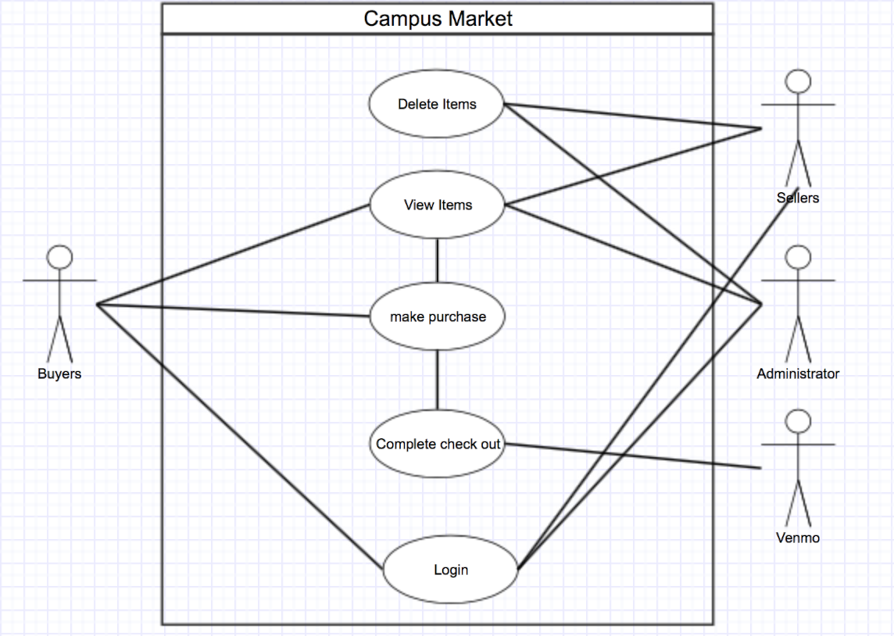

GUIDELINES FOR REQUIREMENTS

|  |  |  |
| --- | --- | --- |
| Checkpoints:  Software Requirements Specification  * The following basic issues should be addressed:   + *Functionality*: What is the software supposed to do?   + *External interfaces*: How does the software interact with people, the system's hardware, other hardware, and other software?   + *Performance*: What is the speed, availability, response time, recovery time of various software functions, etc.?   + *Attributes*: What are the portability, correctness, maintainability, security, etc. considerations?   + *Design constraints imposed on an implementation*: Are there any required standards in effect, implementation language, policies for database integrity, resource limits, operating environments, etc.? * Are any requirements specified that are outside the bounds of the SRS? This means the SRS   + Should correctly define all of the software requirements,   + Should not describe any design or implementation details,   + Should not impose additional constraints on the software. * Does the SRS properly limit the range of valid designs without specifying any particular design? * Does the SRS exhibit the following characteristics?   + *Correct*: Is every requirement stated in the SRS one that the software should meet?   + *Unambiguous*     - Does each requirement have one, and only one, interpretation?     - Has the customer's language been used?     - Have diagrams been used to augment the natural language descriptions?   + *Complete*     - Does the SRS include all significant requirements, whether related to functionality, performance design constraints, attributes, or external interfaces?     - Have the expected ranges of input values in all possible scenarios been identified and addressed?     - Have responses been included to both valid and invalid input values?     - Do all figures, tables and diagrams include full labels and references and definitions of all terms and units of measure?     - Have all TBDs been resolved or addressed?   + *Consistent*     - Does this SRS agree with the Vision document, the use-case model and the Supplementary Specifications?     - Does it agree with any other higher level specifications?     - Is it internally consistent, with no subset of individual requirements described in it in conflict?   + *Ability to Rank Requirements*     - Has each requirement been tagged with an identifier to indicate either the importance or stability of that particular requirement?     - Have other significant attributes for properly determining priority been identified?   + *Verifiable*     - Is every requirement stated in the SRS verifiable?     - Does there exist some finite cost-effective process with which a person or machine can check that the software product meets the requirement?   + *Modifiable*     - Are the structure and style of the SRS such that any changes to the requirements can be made easily, completely, and consistently while retaining the structure and style?     - Has redundancy been identified, minimized and cross-referenced?   + *Traceable*     - Does each requirement have a clear identifier?     - Is the origin of each requirement clear?     - Is backward traceability maintained by explicitly referencing earlier artifacts?     - Is a reasonable amount of forward traceability maintained to artifacts spawned by the SRS?   Reference: [[IEEE93](http://sce.uhcl.edu/helm/rationalunifiedprocess/process/referenc.htm#IEEE93)]  [Copyright  © 1987 - 2001 Rational Software Corporation](http://sce.uhcl.edu/helm/rationalunifiedprocess/copyrite/copyrite.htm) |  | Display Rational Unified Process using frames |

|  |
| --- |
| Rational Unified Process   http://sce.uhcl.edu/helm/rationalunifiedprocess/_borders/rupversion.gif |