ConvertX
A Graph-Routed, Multi-Format File Conversion CLI
VITyarthi -- Build Your Own Project (BYOP)
Final Project Report
Course: Programming in Java (CSE2006)
Submitted by
Simrandeep
Registration No.: 25BAI11132
B.Tech -- Artificial Intelligence & Machine Learning
VIT Bhopal University
September 2026
GitHub Repository: [insert repository link here]

Table of Contents
(Right-click below and choose "Update Field" -- or press F9 -- to populate this table in Word.)

1. Introduction
ConvertX is a Java 17 command-line file conversion system built as the VITyarthi Build Your Own Project (BYOP) submission for Programming in Java. Rather than hard-coding a fixed list of supported format pairs, ConvertX models every available converter as a directed edge in a conversion graph, and automatically discovers a route between formats -- including multi-step routes through an intermediate format -- using classical graph-search algorithms (BFS and Dijkstra).
Around this routing core, the project implements batch conversion, persistent conversion history, user-editable configuration, PDF merge/split utilities, and safe ZIP extraction, so the submission demonstrates not only algorithmic understanding but also modular object-oriented design, concurrency, file I/O, exception handling, and automated testing.
The application is entirely command-line driven: it exposes both a guided interactive menu and direct one-line CLI commands, and requires no GUI framework or GUI-based setup, in line with the project executability requirement of the submission portal.

2. Problem Statement
People regularly need to convert files between formats -- a report from DOCX to PDF, a dataset from CSV to JSON, an image from PNG to JPG -- but no single common tool converts every pair of formats directly. When a direct converter for a given pair does not exist, the usual workaround is to chain several separate tools by hand, which is slow, error-prone, and hard to repeat consistently, especially across a batch of files.
ConvertX addresses this by treating conversion as a graph-search problem: each registered converter is an edge between two formats, and the system searches the graph to find a route -- direct or multi-step -- instead of requiring the user to know or manage intermediate conversions themselves.

3. Functional Requirements
ConvertX is organized into three major functional modules, each with a clear input/output structure and workflow:
Module | Input | Processing | Output
1. Conversion routing & execution | Source file path, desired output file path (menu, CLI args, or direct command) | Detect formats from file names -> search conversion graph (BFS or Dijkstra) -> execute converter(s) in sequence via temporary intermediate files -> report per-stage progress | Converted output file, selected route, success/failure status
2. Batch & utility operations | Directory of files (batch), multiple PDFs (merge), one PDF (split), or a ZIP archive | Iterate matching files using a thread pool (batch); concatenate or split PDF pages (PdfTools); validate and normalize archive entry paths (ArchiveConverter) | Converted files in a destination folder, merged/split PDFs, extracted archive contents
3. History & configuration | Completed conversion results; user configuration file | Append each result (source, target, route, duration, status) to persistent history; load configuration (overwrite policy, temp directory, keep-intermediates flag) | Viewable/clearable history log; active configuration displayed to the user

Each module also satisfies the workflow requirement of a logical user interaction sequence: the user supplies input, ConvertX resolves and executes the required processing steps automatically, and the user receives a clear, terminal-printed result, with no hidden or undocumented steps.

4. Non-Functional Requirements
Requirement | How ConvertX addresses it
Performance | Batch conversion uses a thread pool (BatchConverter) to process multiple files concurrently; Dijkstra routing selects the lowest-cost route rather than always the longest/most expensive one.
Security | ZIP extraction (ArchiveConverter) normalizes every output path and rejects entries that resolve outside the destination directory, preventing Zip Slip / path-traversal attacks.
Usability | A guided interactive menu is provided for exploratory use, alongside direct CLI commands for scripted/repeated use; error messages are printed as plain 'ERROR: <reason>' text rather than raw stack traces.
Reliability | Conversion outcomes (including failures) are recorded to persistent history with a message, so past runs can be audited; an overwrite-protection configuration flag guards against silently overwriting existing files.
Maintainability | Conversion logic is decomposed behind a single Converter interface, so new format support is added by implementing one interface and registering it, rather than modifying routing or engine code.
Scalability | The conversion graph and registry are format-agnostic; adding new formats or converters extends the graph without changing the BFS/Dijkstra routing implementation.
Error handling strategy | Conversion failures raise a dedicated ConversionException, are caught at the CLI boundary, printed as a clear error, and still logged to history with the failure message rather than crashing the application.
Resource efficiency | Multi-step conversions use temporary intermediate files that are deleted after use unless the user explicitly configures keepIntermediates=true.

5. System Architecture
ConvertX follows a layered design. The CLI layer (Main) parses user input, either interactive menu choices or direct command-line arguments, and delegates to the core engine. ConvertXEngine coordinates the ConversionRegistry (the conversion graph and its BFS/Dijkstra routing), the ConfigManager, and the HistoryManager. Once a route is selected, the engine invokes the relevant Converter implementations in sequence, writing to temporary files between stages where needed, before producing the final output. Supporting utilities (BatchConverter, PdfTools) sit alongside the engine and reuse it rather than duplicating conversion logic.
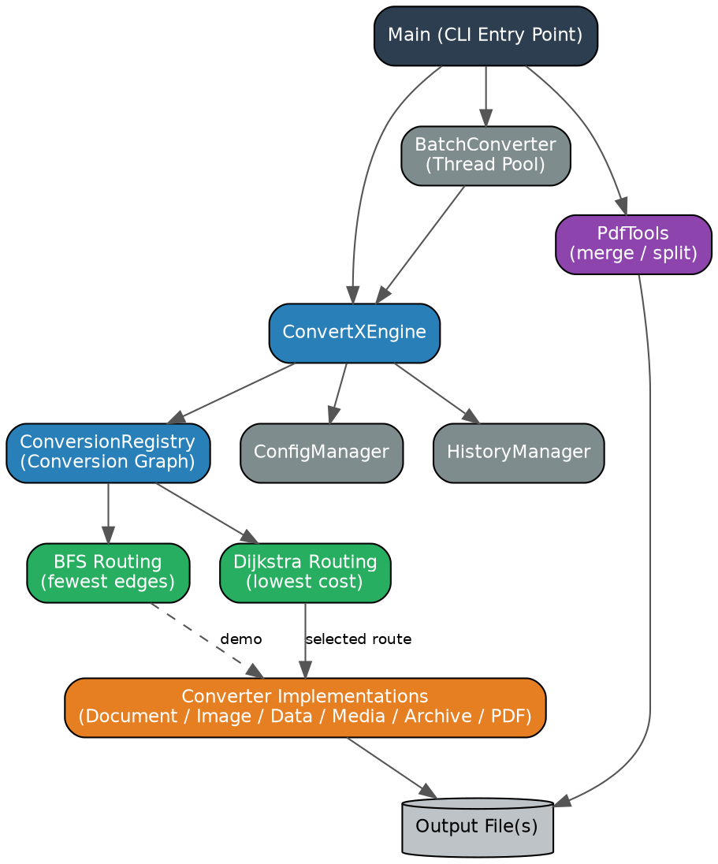
Figure 5.1 -- System architecture: CLI, engine, routing, converters, and supporting utilities.
Security note: ZIP extraction validates and normalizes every extracted path before writing to disk, rejecting any entry that would escape the selected destination directory.

6. Design Diagrams

6.1 Use Case Diagram
The single actor (User) can perform ten distinct operations through the CLI. Convert a single file and Batch convert both include the underlying path-finding use case, since both rely on the conversion graph to resolve a route before executing converters.
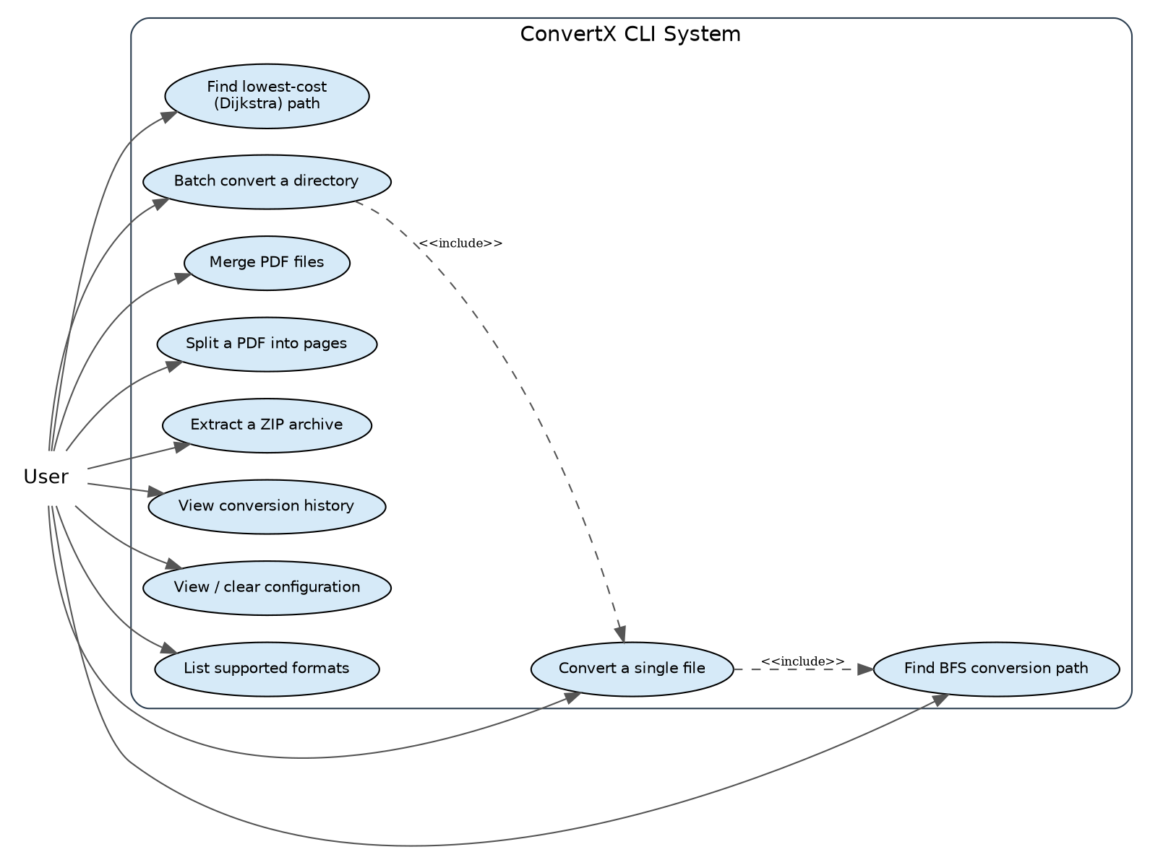
Figure 6.1 -- Use case diagram for the ConvertX CLI.

6.2 Process Flow / Workflow Diagram
The workflow below traces a single conversion end-to-end: from user input, through format detection and route search, to execution, history recording, and final output, with an explicit error branch when no route exists between the requested formats.
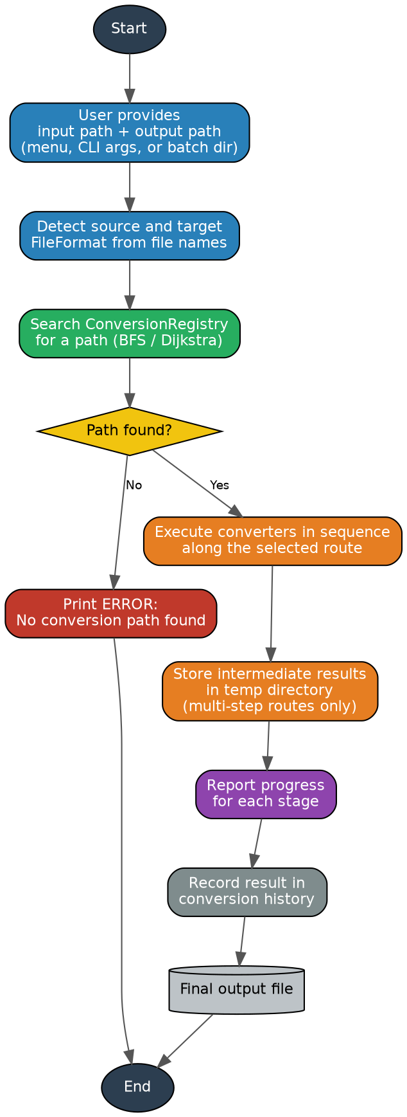
Figure 6.2 -- Process flow for a single file conversion.

6.3 Sequence Diagram
The sequence diagram illustrates the runtime message flow for a conversion request: the CLI asks the engine for the best route, the engine queries the registry (Dijkstra), then drives each Converter in the route in a loop, and finally records the outcome in history before reporting back to the user.
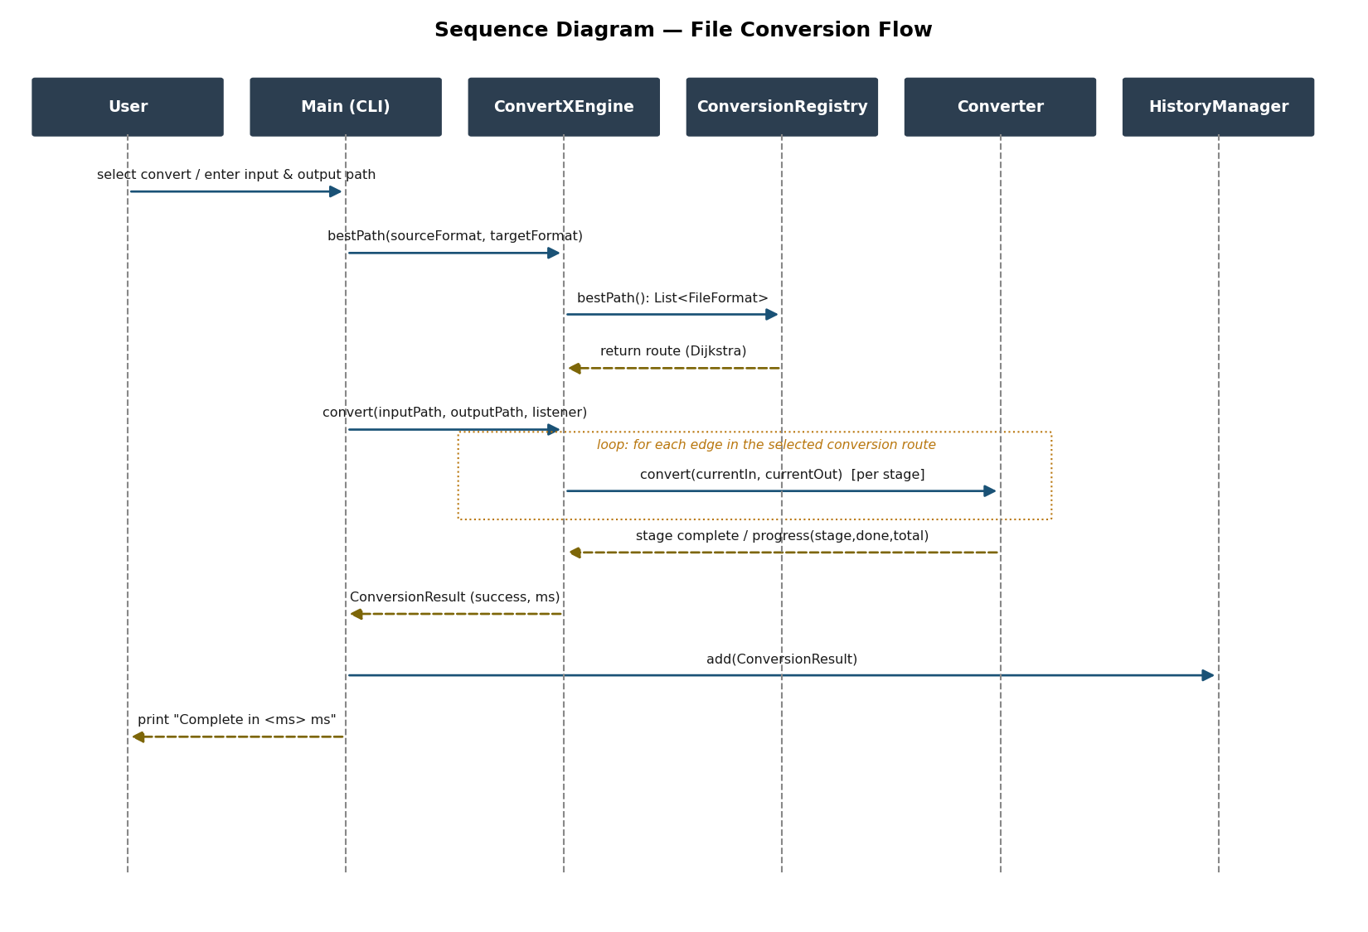
Figure 6.3 -- Sequence diagram for the convert operation.

6.4 Class / Component Diagram
All format-specific converters implement a single Converter interface (convert(), cost()), which lets ConversionRegistry and ConvertXEngine work with any converter uniformly. Main composes the engine with the supporting utility classes; the engine in turn depends on the registry, configuration, and history components.
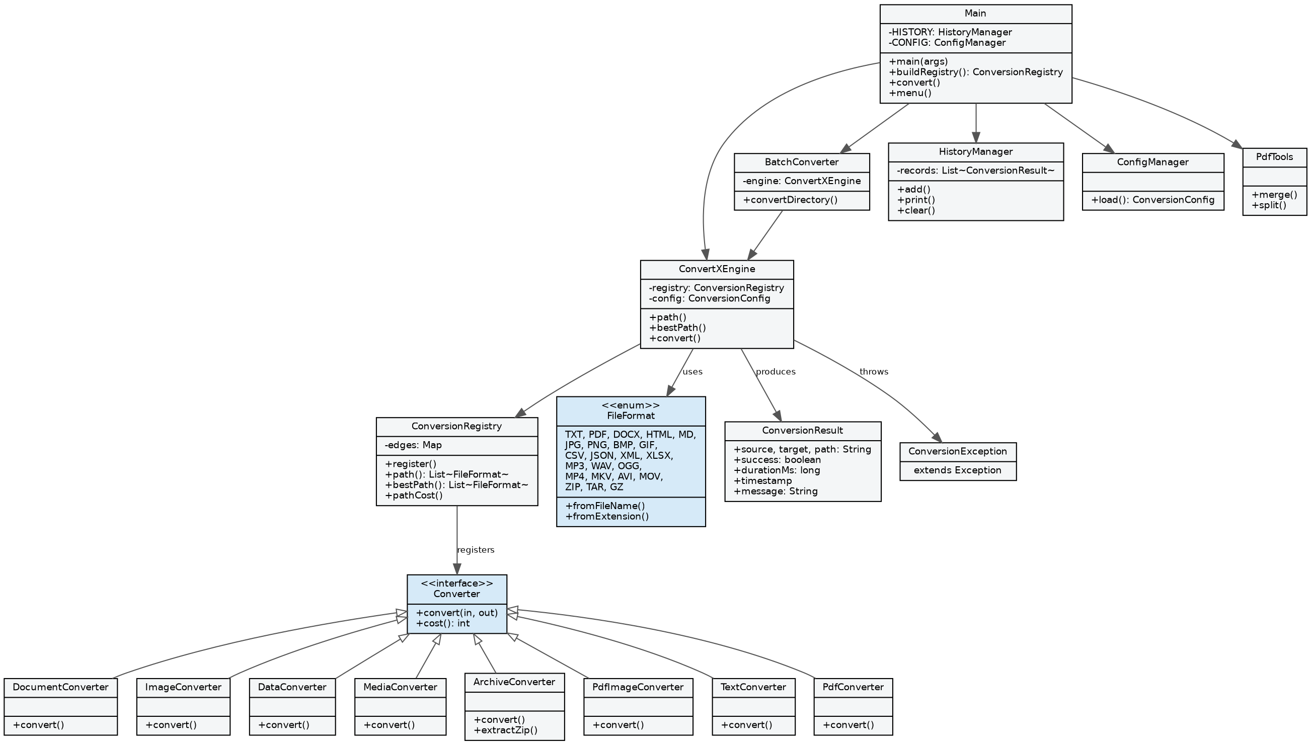
Figure 6.4 -- Class diagram: core engine, Converter interface and implementations, and supporting classes.

6.5 Database / Storage Design
ConvertX does not use a relational database, so no ER diagram applies. Persistent state is limited to two local files managed by HistoryManager and ConfigManager: a conversion history log (one record per attempted conversion: source, target, route, duration, success flag, message, timestamp) and a configuration file (overwrite policy, temporary directory, keep-intermediates flag). Both are plain, human-readable local files rather than a managed database schema.

7. Design Decisions & Rationale
- Why both BFS and Dijkstra? BFS finds the route with the fewest conversion steps in an unweighted view of the graph, which is a clear, direct demonstration of the core graph-search requirement. Not all conversions have equal computational or quality cost, however, so Dijkstra is used for the route that is actually executed, selecting a lower-cost route even if it contains more edges. BFS remains available as an explicit, separate command so both algorithms are independently inspectable.
- Why a single Converter interface? Every format pair, however different internally (text, binary, media), is exposed to the routing layer only as convert(in, out) and cost(). This keeps ConversionRegistry and ConvertXEngine completely decoupled from format-specific logic, so new converters can be added by implementing one interface and registering an edge, without touching routing code.
- Why temporary intermediate files? A multi-step route needs the output of one converter to become the input of the next converter. Temporary files let each Converter implementation stay simple (one input file, one output file) instead of every converter needing to understand streaming or chaining.
- Why separate PDF/archive commands instead of graph edges? Operations such as merging several PDFs into one, or extracting an archive, are not ordinary one-format-to-one-format conversions -- they take a variable number of inputs or produce many outputs. Modeling them as dedicated CLI operations (PdfTools, ArchiveConverter.extractZip) keeps the conversion graph's edges semantically consistent (exactly one input format to exactly one output format).
- Why bundle Unicode fonts for PDF output? PDF's built-in Standard 14 fonts only cover basic Latin text; using them for arbitrary DOCX/TXT content silently replaces unsupported characters with '?'. Bundling Noto Sans font families (Latin, Devanagari, Gurmukhi, Arabic, CJK) and selecting a font per Unicode script in PdfTextWriter preserves the original text instead of corrupting it.
- Why Maven Shade for packaging? Shading bundles all third-party dependencies (PDFBox, POI, Jackson, Commons Compress, Log4j) into a single runnable JAR, so the project satisfies the command-line executability requirement with one java -jar invocation and no manual classpath assembly.

8. Implementation Details
The codebase is organized under com.convertx into five packages: cli (entry point and command dispatch), core (conversion graph, routing, engine, history, configuration, PDF utilities, batch conversion), converters (one class per format family), model (FileFormat enum and ConversionResult), and exceptions (ConversionException). In total the main source tree spans roughly 730 lines across 23 Java files, plus five JUnit 5 test classes.
The routing algorithms sit at the heart of the engine. ConversionRegistry stores the graph as an EnumMap<FileFormat, List<FileFormat>> of registered edges. findBfsPath performs a standard breadth-first search, tracking visited formats and a predecessor map to reconstruct the shortest-edge route. findBestPath implements Dijkstra's algorithm over the same graph, using a PriorityQueue ordered by running distance and each converter's cost() (minimum 1) as edge weight:
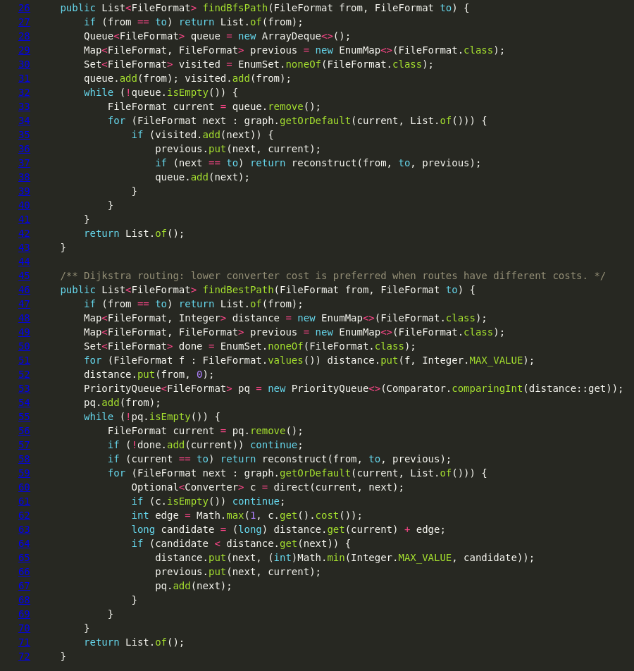
Figure 8.1 -- ConversionRegistry.java: BFS (findBfsPath) and Dijkstra (findBestPath) routing implementations.
ConvertXEngine wraps the registry with the actual conversion execution: it resolves the best path, then walks each consecutive pair of formats in the route, invoking the registered Converter and writing to a temporary file for every intermediate stage while reporting progress through a ProgressListener callback. BatchConverter reuses this engine inside a fixed thread pool, submitting one conversion task per matching file in a directory. HistoryManager and ConfigManager persist their state to simple local files so history and settings survive across runs. PdfTools implements PDF merge and page-splitting directly against PDFBox's PDDocument API, and PdfTextWriter (the largest single class at 264 lines) implements Unicode-aware text layout for TXT/DOCX-to-PDF conversion, selecting a bundled font per Unicode script and embedding it into the output PDF.

9. Screenshots / Results
The following terminal captures demonstrate ConvertX running from the command line, covering routing, batch conversion, PDF utilities, configuration, and Unicode-safe output. Additional screenshots are included in the Screenshots/ folder of the submission.
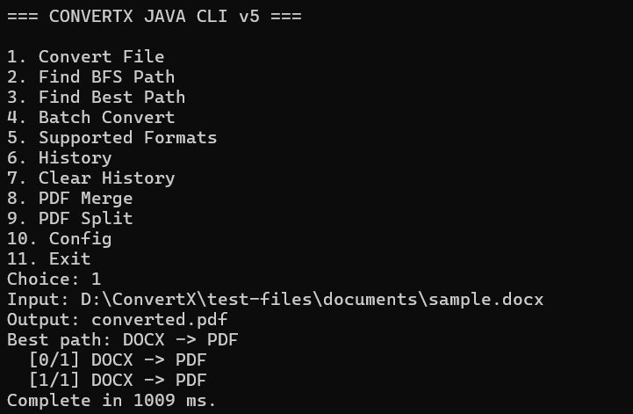
Figure 9.1 -- Interactive menu and a direct DOCX -> PDF conversion.
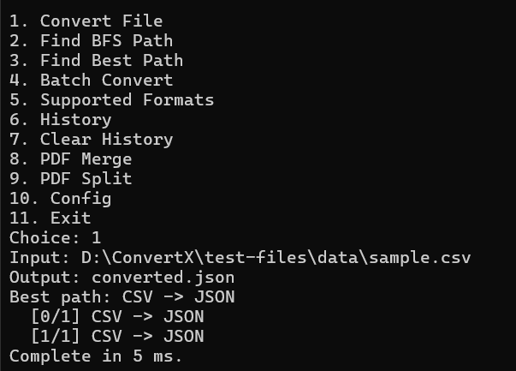
Figure 9.2 -- CSV -> JSON data conversion.
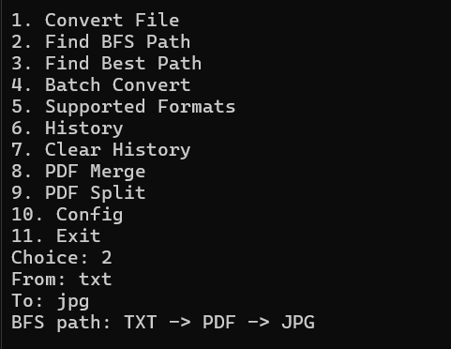
Figure 9.3 -- BFS path search showing the automatic multi-step route TXT -> PDF -> JPG.
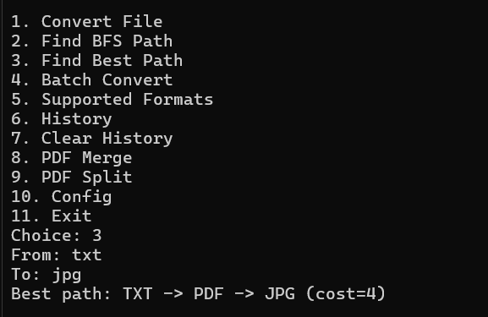
Figure 9.4 -- Dijkstra best-path search reporting the route and its total cost.
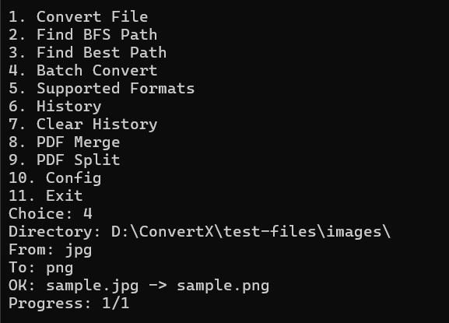
Figure 9.5 -- Batch conversion of an image directory.
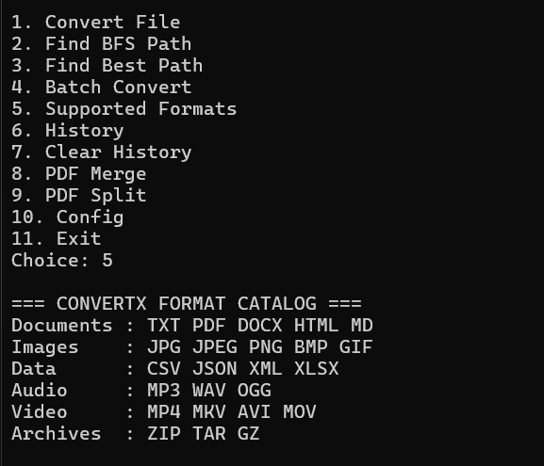
Figure 9.6 -- Supported-formats catalog grouped by category.
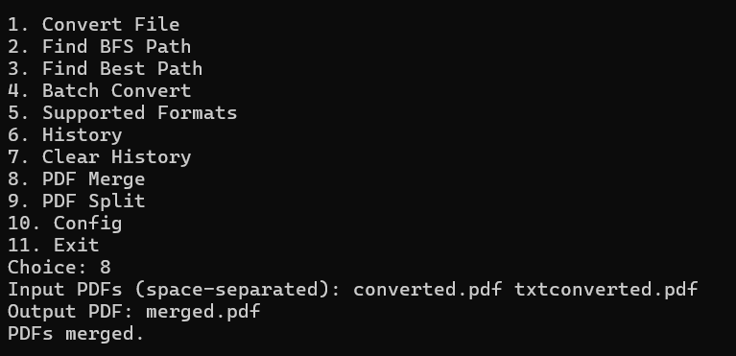
Figure 9.7 -- PDF merge utility combining multiple PDFs into one.
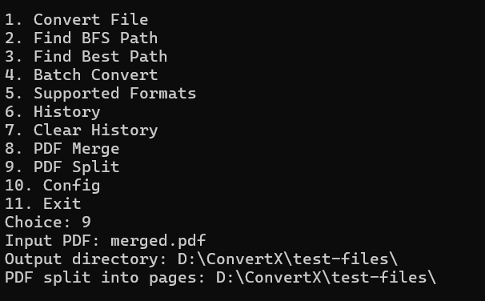
Figure 9.8 -- PDF split utility producing one file per page.
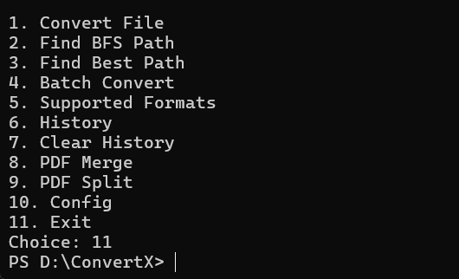
Figure 9.9 -- Active configuration display.
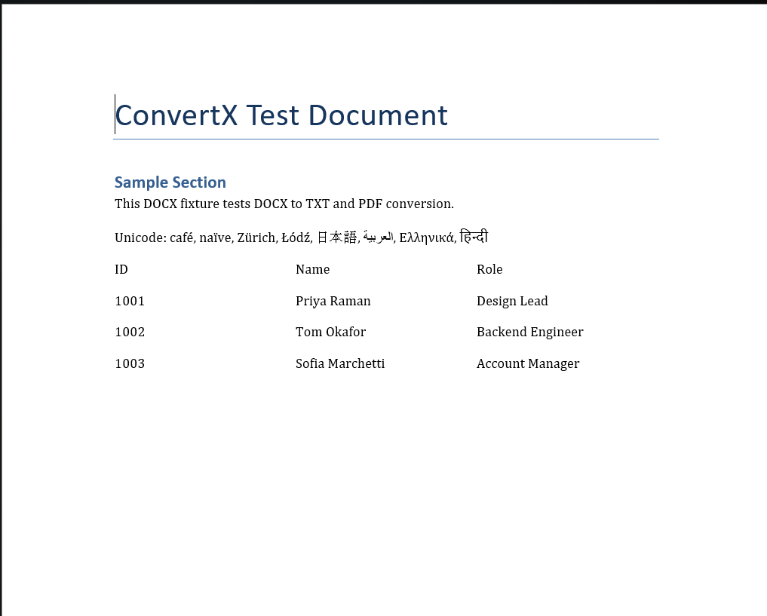
Figure 9.10 -- Generated PDF preserving Unicode text (accented Latin, CJK, Arabic, Devanagari) after DOCX -> PDF conversion.

10. Testing Approach

10.1 Automated tests (JUnit 5)
Automated tests run via mvn clean test and focus on the parts of the system that are easiest to silently break: routing correctness and Unicode PDF generation.
Test class | What it verifies
ConversionRegistryTest | Graph registration and BFS path-finding return the expected route.
WeightedPathTest | Dijkstra selects the lower-cost route when multiple routes exist with different converter costs.
DocumentUnicodeConversionTest | End-to-end DOCX -> PDF conversion containing accented Latin, Japanese, Arabic and Devanagari text produces a valid, readable PDF.
PdfFontResourceTest | Bundled Noto font resources load correctly for PDF embedding.
CjkFontCompatibilityTest | The CJK OpenType/CFF font is compatible with PDFBox 3.x's embedding path (no TrueType-style subsetting, per PDFBox 3.x constraints).

10.2 Manual verification checklist
Beyond automated tests, a scripted manual checklist (FINAL_TEST_PLAN.md / SUBMISSION_CHECKLIST.md) is run against the sample files under test-files/ before every submission:
- Build: mvn clean test, mvn clean package, then java -jar target/convertx-1.0.0.jar opens the main menu without errors.
- Document, data and image conversions (DOCX->PDF, DOCX->TXT, TXT->PDF/HTML, PDF->TXT, CSV/JSON/XML/XLSX, PNG/JPG/BMP/GIF) each produce the expected output file.
- BFS and best-path searches (e.g. DOCX -> JPG) report the expected automatic route through PDF.
- Unicode regression: DOCX -> PDF preserves accented Latin, Cyrillic, Devanagari, Gurmukhi and CJK text with no '?' substitutions.
- PDF merge, PDF split, and ZIP extraction (including a path-traversal entry, which must be rejected) behave correctly.
- Batch conversion processes every matching file in a directory; history persists across an application restart.
- Media conversion (WAV -> MP3) works with FFmpeg installed, and fails with a clear ERROR: message (not a stack trace) when it is not.

11. Challenges Faced
- Unicode text in generated PDFs: Early PDF output using PDFBox's Standard 14 fonts silently replaced non-Latin characters with '?'. This was resolved by bundling Noto Sans font families and writing a font-selection-by-Unicode-script layer (PdfTextWriter) that embeds the correct font for each run of text.
- PDFBox 3.x API differences: PDFBox 3.x changed how documents are loaded (Loader.loadPDF(...) rather than the older static PDDocument.load(...)) and how OpenType/CFF fonts can be embedded -- PDFBox 3.x does not support TrueType-style subsetting for the bundled CJK OpenType/CFF font, so that font is embedded without subsetting while the other fonts are embedded as subsets.
- Safe ZIP extraction: A naive ZIP extractor is vulnerable to a Zip Slip / path-traversal attack, where a crafted entry name (e.g. containing ../) writes outside the intended destination directory. ArchiveConverter normalizes every extracted entry path and rejects any entry that resolves outside the destination directory.
- Designing one interface for very different formats: Text documents, binary images, tabular data, media, and archives all convert very differently internally. Keeping the Converter interface down to convert(in, out) and cost(), with all format-specific complexity hidden inside each implementation, took iteration to get right so the routing layer never needed to know about format-specific details.
- Reliable console output on Windows terminals: Some Windows terminal configurations do not render extended Unicode box-drawing or symbol characters reliably in the CLI itself, so console output was kept to plain ASCII while Unicode support was reserved for actual file content (e.g. generated PDFs).

12. Learnings & Key Takeaways
- Applying textbook graph algorithms (BFS, Dijkstra) to a practical problem clarified the real trade-off between them: fewest steps versus lowest total cost are genuinely different objectives, not interchangeable choices.
- A small, strict interface (Converter) is a powerful way to keep a system extensible -- new format support never required touching the routing or engine code.
- Working with several real third-party libraries (PDFBox, Apache POI, Jackson, Commons Compress) in one project surfaced real-world integration issues, like major-version API changes, that do not show up in isolated tutorial examples.
- Automated regression tests (particularly the Unicode PDF test) were directly responsible for catching a real defect early, reinforcing the value of testing beyond 'does it compile'.
- Security cannot be an afterthought even in a small CLI tool -- the ZIP path-traversal protection was only added after specifically considering how a malicious archive could be constructed.
- Concurrency (the batch-conversion thread pool) and persistence (history/configuration files) both needed to be designed around the same core engine rather than as parallel, duplicated code paths.

13. Future Enhancements
- Full ImageIO-backed WEBP and TIFF conversion (currently reserved as format identifiers only).
- RFC 4180-compliant CSV parsing to correctly handle quoting/escaping in non-classroom datasets.
- A richer PDF rendering/layout engine, beyond the current lightweight, educational implementation.
- A pluggable converter architecture (e.g. loading converters from external JARs) so new formats can be added without recompiling ConvertX.
- Conversion quality scoring, so the routing layer can weigh fidelity loss alongside computational cost.
- An optional thin GUI or web front-end layered on top of the existing engine, while keeping the current CLI as the primary, scriptable interface.

14. References
- Oracle, "The Java Tutorials" and Java 17 API documentation -- docs.oracle.com/en/java/
- Apache PDFBox documentation -- pdfbox.apache.org
- Apache POI documentation -- poi.apache.org
- FasterXML Jackson (jackson-databind, jackson-dataformat-xml) documentation -- github.com/FasterXML/jackson
- Apache Commons Compress documentation -- commons.apache.org/proper/commons-compress
- JUnit 5 (Jupiter) User Guide -- junit.org/junit5
- FFmpeg Documentation -- ffmpeg.org/documentation.html
- Cormen, Leiserson, Rivest, Stein, Introduction to Algorithms -- reference for BFS and Dijkstra's algorithm.
- VITyarthi -- "Build Your Own Project" General Project Instructions & Submission Guidelines.

