***<https://killercoda.com/pawelpiwosz/course/linuxFundamentals>***

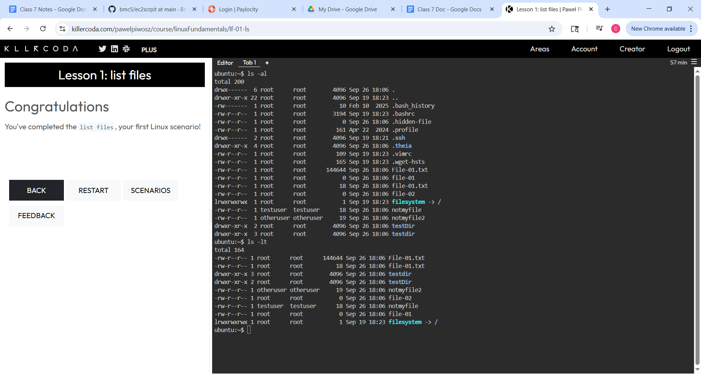

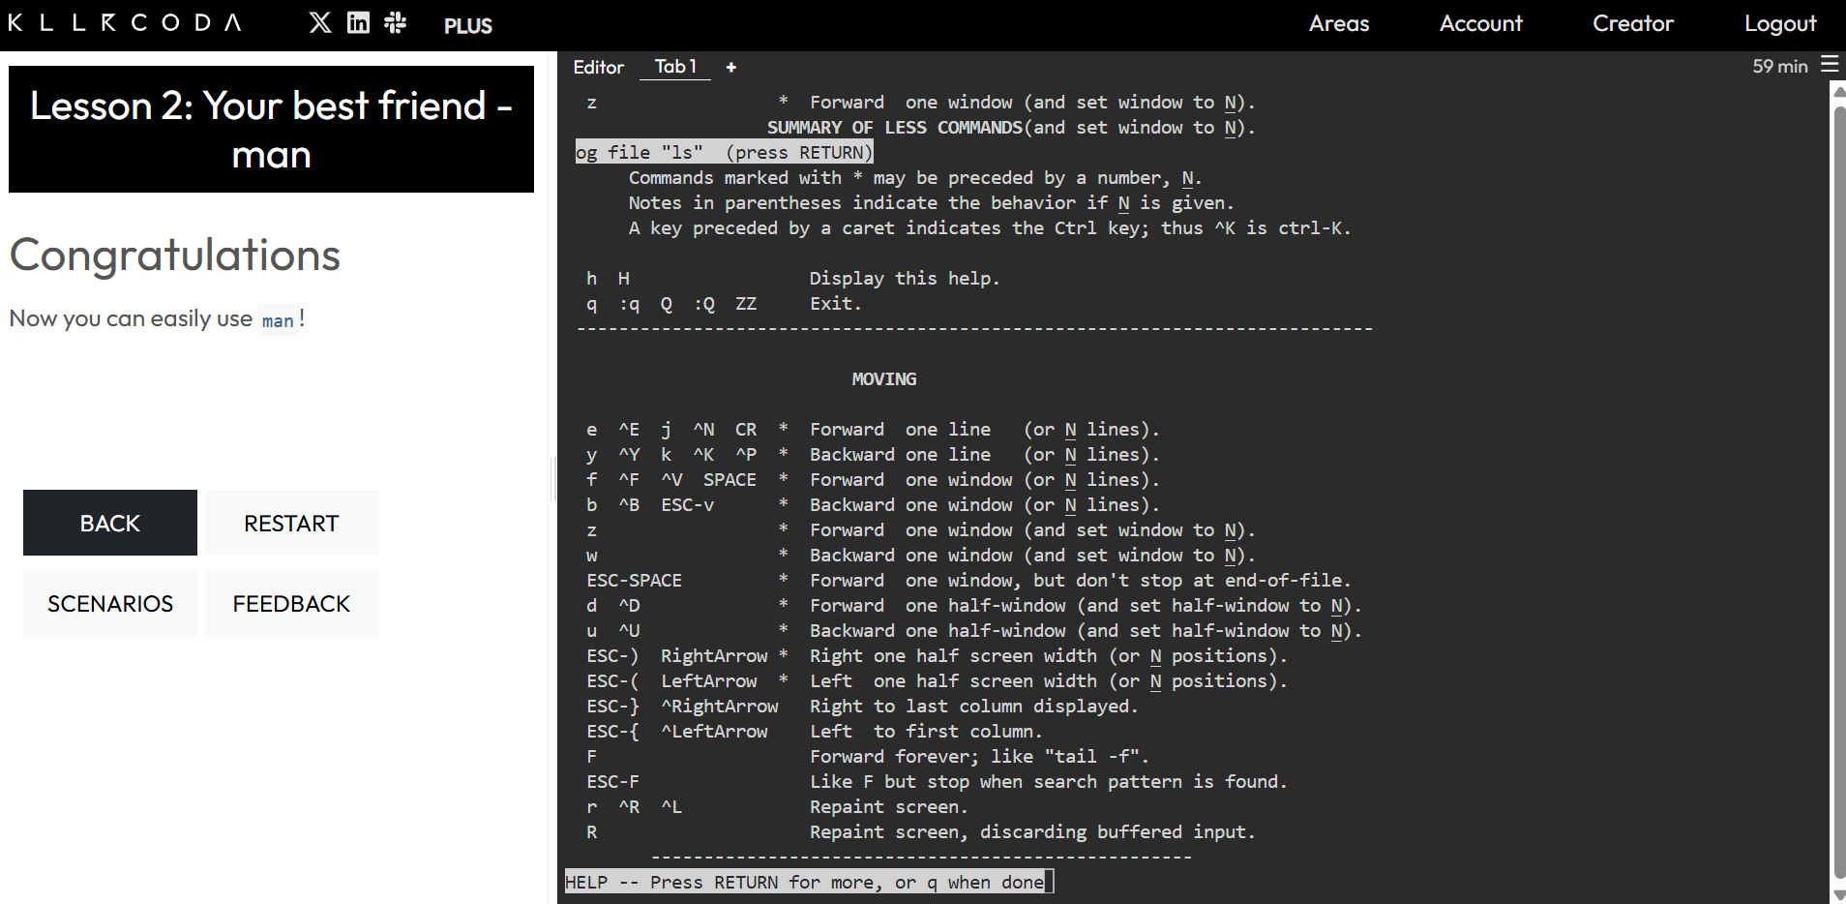

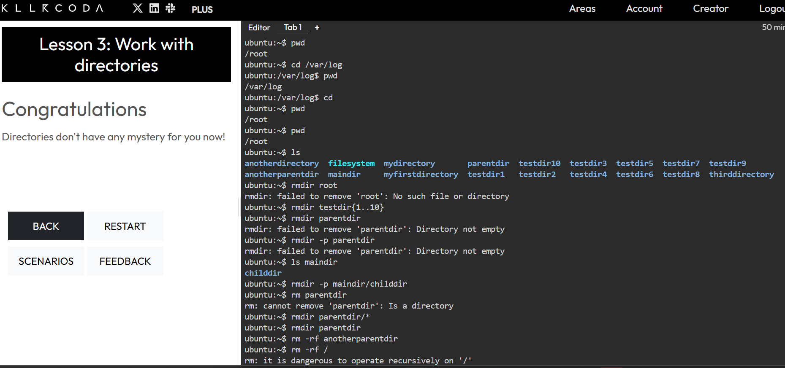

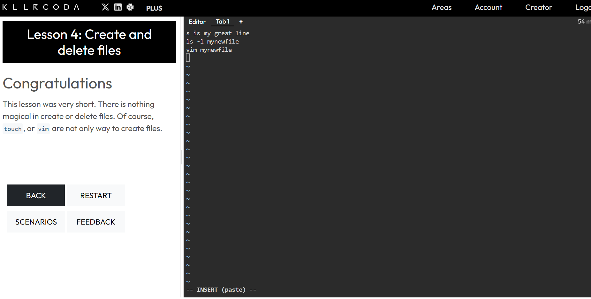

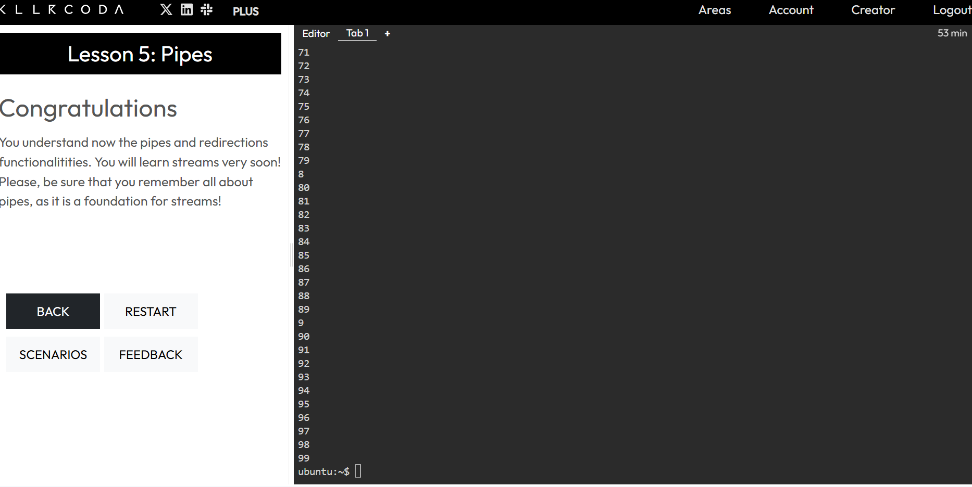

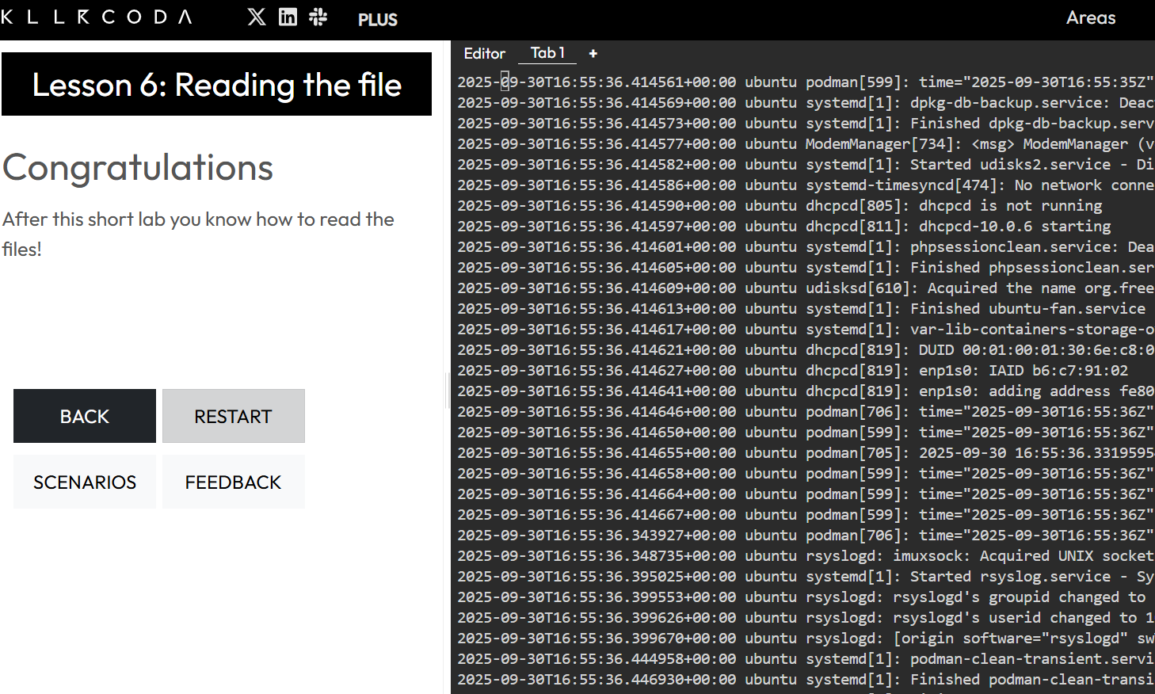

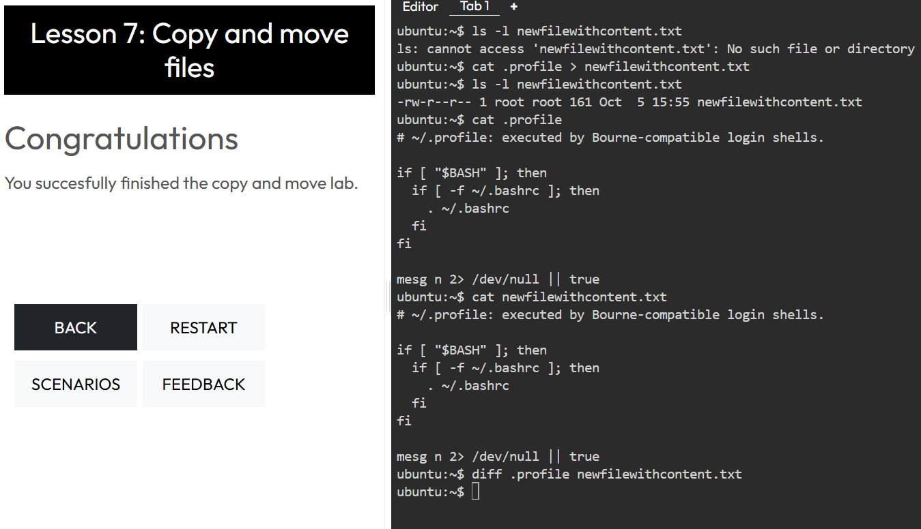

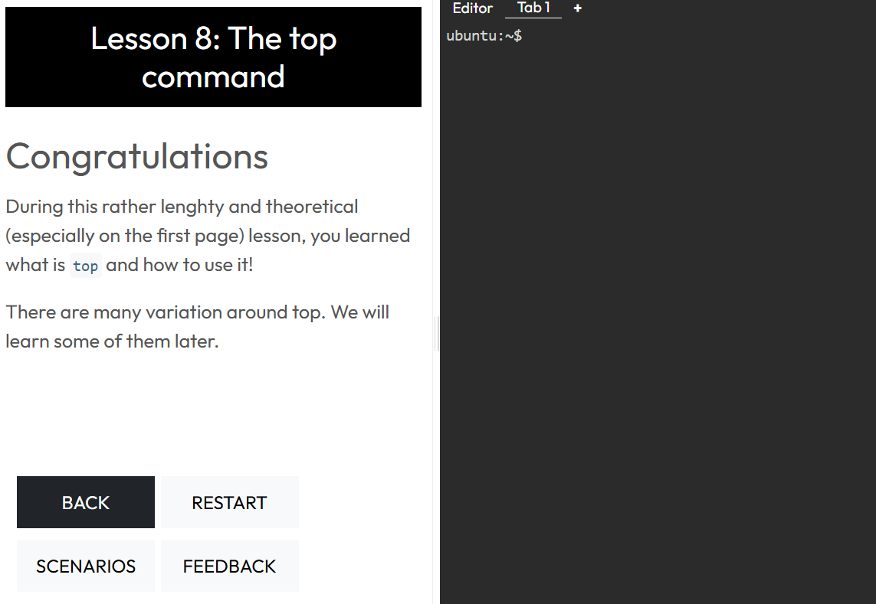

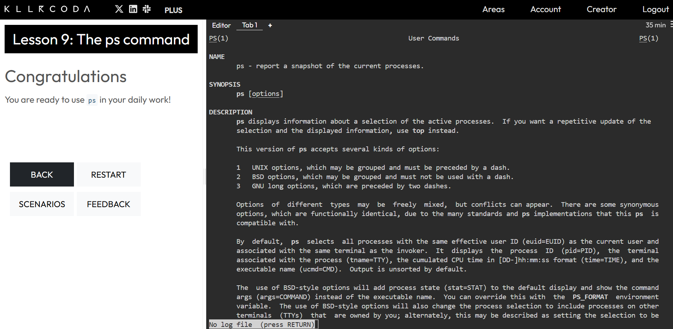

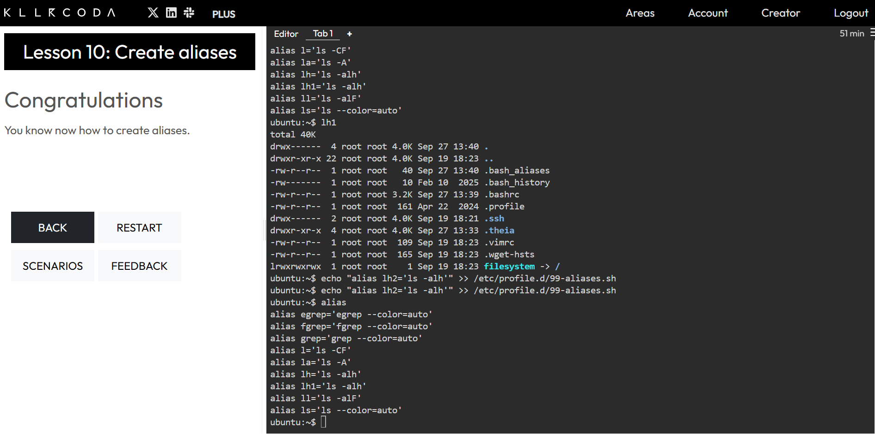

***https://git-scm.com/book/en/v2/Git-Branching-Basic-Branching-and-Merging***

***NEW***

***[8:10 PM]***

***https://docs.github.com/en/pull-requests/collaborating-with-pull-requests/proposing-changes-to-your-work-with-pull-requests/creating-a-pull-request***

***GitHub Docs***

***Creating a pull request - GitHub Docs***

***Create a pull request to propose and collaborate on changes to a repository. These changes are proposed in a branch, which ensures that the default branch only contains finished and approved work.***

***NEW***

***[8:11 PM]***

***https://www.atlassian.com/git/tutorials/making-a-pull-request***

***Atlassian***

***What Is a Pull Request? | Atlassian Git Tutorial***

***Open source development is more than just writing code. It also involves collaboration with other developers. Learn about how pull requests work in Git!***