Breast Cancer Classification Model Analysis

Eric S. Brown
Purdue Global University
IN400M5: Artificial Intelligence and Machine Learning Case Studies
Instructor Sonali Sen Baidya
12/9/2025

Breast Cancer Classification Model Analysis
The main objective of this case study was to build a classification model using the Breast Cancer Wisconsin (Diagnostic) dataset to predict whether a tumor is malignant or benign. A Random Forest classifier was utilized in Python using the scikit0learn library. After training and testing the model, it performed the expected outcome successfully by generating a classification report and a confusion matrix.

Model Validity
The model achieved an accuracy of 97.08% which suggests a high level of predictive confidence. The confusion matrix displayed on Figure 1 shows:
- True Positives (Malignant correctly predicted): 59
- False Negatives (Malignant predicted as Benign): 4
- False Positives (Benign predicted as Malignant): 1
- True Negatives (Benign correctly predicted): 107
Figure 1
Confusion Matrix
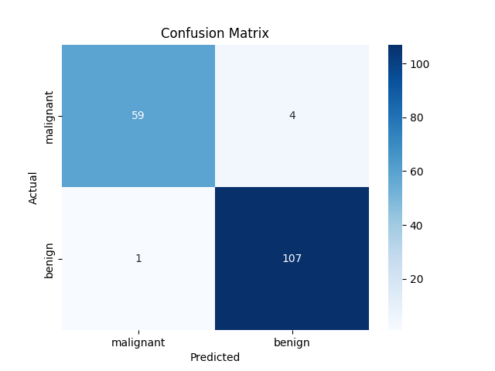
Note. By Eric S. Brown, 2025, using PyCharm 2025.2.
These results suggest that the model is highly effective at identifying benign cases, with a recall of 0.99 for the benign class. The precision and F1-scores for both classes are also strong which indicates that the model effectively balances sensitivity and specificity. The low number of misclassifications reinforces the reliability of the model for medical diagnosis use.

Potential Improvements
- Hyperparameter Tuning:
Adjusing “max_depth” and “min_samples_split” could optimize the model by reducing the small number of false negatives and improve generalization (Probst et al., 2019).
- Cross-Validation:
Using k-fold-cross-validation would provide a more robust estimate of model performance (Kohavi, 1995).
- Feature Selection or Dimensionality Reduction:
Principal Component Analysis (PCA) or Recursive Feature Elimination (RFE) could help identify the most influential features and remove noise in the data (Guyon & Elisseeff, 2003).
- Alternative Algorithms:
Using Gradient Boosting or AdaBoost could provide better performance for edge cases where Random Forest might slack (Natekin & Knoll, 2013).
Ultimately, the Random Forest model shows strong predictive capability for breast cancer classification. With implementing tuning and more experimentation, its performance could be enhanced to support more accurate and reliable healthcare diagnosis cases.

References
Guyon, I., & Elisseeff, A. (2003). An introduction to variable and feature selection. Journal of Machine Learning Research, 3, 1157–1182.
Kohavi, R. (1995). A study of cross-validation and bootstrap for accuracy estimation and model selection. Proceedings of the 14th International Joint Conference on Artificial Intelligence, 2, 1137–1143.
Natekin, A., & Knoll, A. (2013). Gradient boosting machines, a tutorial. Frontiers in Neurorobotics, 7, 21. https://doi.org/10.3389/fnbot.2013.00021
Probst, P., Wright, M. N., & Boulesteix, A. L. (2019). Hyperparameters and tuning strategies for random forest. Wiley Interdisciplinary Reviews: Data Mining and Knowledge Discovery, 9(3), e1301. https://doi.org/10.1002/widm.1301

