

Name: **SHELDON NYAKITI**

Registration No: **ENG-219-029/2019**

Institution: **MULTIMEDIA UNIVERSITY OF KENYA**

Program: **INDUSTRIAL ATTACHMENT**

Organization: **KENYA POWER AND LIGHTING COMPANY (KPLC)**



Period**:** **20TH MAY 2024 – 31ST JULY 2024**

**TABLE OF CONTENTS**

**DECLARATION** 2

**ACKNOWLEDGEMENT** 3

**1.0 EXECUTIVE SUMMARY** 4

**2.0 INTRODUCTION** 5

**2.1 Area of Training** 5

**2.2 Structure and History of KPLC** 5

**2.3 Responsibilities of KPLC** 6

**2.4 Self Concept of KPLC** 6

**2.5 Special Regulations Concerning Attachés at KPLC** 7

**2.6 Organization Chart of KPLC** 8

**3.0 DESCRIPTION OF THE ATTACHMENT** 9

**3.1 Weekly Timetable** 9

**3.2 Description of the Work Station** 9

**4.0 IMPACT OF THE INTERNSHIP** 12

**4.1 Work Environment** 12

**4.2 Knowledge and Skills Gained During the Attachment** 12

**4.3 Responsibilities Undertaken During the Attachment** 22

**4.4 Influence of the Attachment to My Future Career Plans** 22

**4.5 Relationship Between Classroom Knowledge and Knowledge Gained During the Attachment** 23

**5.0 CONCLUSION** 24

**REFERENCES** 25

# **DECLARATION**

I hereby declare that the report presented below is my work and a record of the knowledge and experience I acquired during my attachment period at Kenya Power and Lighting Company.

# **ACKNOWLEDGEMENT**

First, I thank the Almighty God for guiding and protecting us throughout the attachment period ever since it began in May until it ended in July. Secondly, I would like to acknowledge my supervisors at KPLC, Mr. Silas Bett and Mr. Stephen Onditi, for the time they spent in our training, and for in ensuring that we understood the concepts they taught us during the attachment period. My gratitude also goes to my fellow attachés and interns whom we were present with in the ICT/Telecoms department for their accommodativeness and their willingness to support their colleagues in case of any challenges/difficulties anyone faced during the attachment period.

# **1.0 EXECUTIVE SUMMARY**

Kenya Power and Lighting Company (commonly referred to as Kenya Power, or KPLC) is a national electric utility company that transmits, distributes and retails electric power to customers throughout Kenya.

During the attachment period, the main tasks that attachés were assigned included: installation and configuration of required computer software e.g., operating systems, Microsoft office applications and other programs used in the company; troubleshooting, repair, and replacement of various components of a computer/laptops i.e., CPU, motherboard, monitor, adapters, and chargers; repair and replacement damaged/old sockets and extensions; resolving network and internet connectivity issues; fixing and maintaining LAN switches, ethernet cables, and routers; configuring routers and printers to the company’s network domain; and assisting clients in accessing and using printers set up within the company.

In accordance to my career objective and my future aspiration of becoming a telecommunications engineer, I was compelled to select and apply for my attachment program at KPLC because of its rapidly growing internet and connectivity services through fibre optics. The attachment application was done online through the KPLC’s website, and the selected applicants were issued various forms which they were required to fill and submit to the stations they had selected. The terms and conditions agreed upon between the attaché and the company included only provision of field knowledge and experience to the attaché during the attachment period. No payments or contracts was offered by the company to the attaché. In addition, the working time agreed upon was 8 hrs a day; from 8.00 am to 5.00 pm. The tasks that attachés carried out within the company were only those specified by the respective supervisor. No jobs were allowed to be done without authorization from the respective supervisor or any staff member employed by the company.

# **2.0 INTRODUCTION**

## **2.1 Area of Training**

The attachment was centred in the company’s headquarters of the Central Rift region, known as Electricity House, which is located in Kenyatta Avenue, Nakuru. Although much of the tasks were done within and around the Electricity House, attachés were also able to work in other minor branches of KPLC Central Rift branch, offices and areas which included Nakuru depot, Lanet offices, Gilgil offices, and Narok offices.

## **2.2 Structure and History of KPLC**

Kenya Power and Lighting Company (or Kenya Power) is one of the largest companies in Kenya which has set up its branches in nearly all major cities and towns in Kenya. Kenya Power was founded on 6th January 1922 by two founders, namely, Harrali Esmaijee Jeevanjee and Clement Hertzel. The two founder members merged two electric utility companies i.e., Mombasa Electric Power and Lighting Company and Nairobi Power and Lighting Syndicate, to form one national electric utility company which is today commonly referred to as Kenya Power. By far, KPLC is the only major electric utility company in Kenya from which nearly all companies and most of the country’s population draws their power from.

The central office of Kenya Power is located in Parklands, Nairobi, Kenya; and its main address and official website is as listed below.

*Central Office – P.O. Box 30099-00100, Nairobi, Kenya;*

*Telephone – +254-02-3201000;*

*Telegram – ‘ELECTRIC’*

*Website –* [*www.kplc.co.ke*](http://www.kplc.co.ke)*;*

*Building – Stima Plaza, Kolobot Road.*

Other branches of KPLC within the country include: Central Rift, Coast, Nairobi North, Nairobi South, Nairobi West, North Eastern and North Rift regions. The various departments and sections found in KPLC include:

* CEO’s office,
* Pension and Administration,
* Finance,
* Human Resource and Administration,
* Investments,
* Procurement,
* ICT/Telecoms.

At the end of KPLC’s financial year of June 2022, 9,655 staff members were found employed by Kenya Power in the entire country, and in 2023 the number grew by 3% from the previous year’s number to 10,018. Although statistics for the number of KPLC’s staff members in 2024 is not yet released, it is approximated that many staff members have been employed by the company by a higher percentage compared to the year 2023 due to the company’s advancements in the field of telecommunications.

## **2.3 Responsibilities of KPLC**

The major activities carried out by Kenya Power involves transmission, distribution, and retail of electricity to customers within the country. It plays a crucial role in ensuring that electricity is efficiently distributed to consumers across Kenya, from urban areas to rural communities. Also, KPLC manages a vast network of power lines, transformers, and substations to deliver electricity to homes, businesses, and industries.

Other responsibilities include:

1. Customer Service – KPLC handles billing, metering, and customer inquiries related to electricity supply. It also manages connections, disconnections, and reconnections of electricity services.
2. Maintenance and Expansion – KPLC is also responsible for the maintenance of its infrastructure and the expansion of the electricity grid to reach more areas and accommodate the growing demand.
3. Internet Connections – Recently, KPLC has delved into telecommunication industry to provide internet connections to various customers including Safaricom Limited, through optical fibre networks.

## **2.4 Self Concept of KPLC**

Although Kenya Power has served the country considerably well ever since its establishment, it has somewhat monopolized retail of electricity to itself as the only retailer of electricity in Kenya. By this means, it may have an effect of limiting future power engineers from building their own power utilities within the country.

## **2.5 Special Regulations Concerning Attachés at KPLC**

Kenya Power had a Business Conduct Policy which provided the following guidelines to all persons on attachment in all capacities to serve as a basis which guided them to ensure ethical conduct in their relationships with their colleagues and customers with whom they interacted on daily basis. The management expected all persons on attachment/internship to abide by the set standards listed below and as they might have been changed from time to time.

1. Attachés were to perform their duties with honesty, integrity and to the best of their abilities. They were not allowed themselves to be unduly influenced by anything or anybody. They were to communicate openly and honestly, and demonstrate a sense of purpose and a commitment to achieving the optimum outcome, to the interest of the company even under adverse or tempting conditions.
2. At all times, persons on attachment/internship were to treat people with fairness, courtesy and sensitivity with respect to their rights and dignity. They were expected to have respect for diversity.
3. Attachés were to accept accountability for their actions and decisions, and also appreciate positive criticism.
4. Attachés were to behave in a way which is above reproach and which did not put them in a compromising situation.
5. Attachés were expected to comply with all the rules, procedures and regulations that applied to the company, its systems and the way it conducted its business. They were expected to uphold the positive image of the company at all times.
6. Attachés were expected to use information obtained from the company only for the purpose for which it was intended and within their Delegation of Authority.
7. Attachés were to treat the assets and property of Kenya Power, its employees, its customers and its suppliers with the same respect as if they were their personal property. They were not to waste the Company's resources, including time. They were also expected to develop a positive and constructive attitude at all times.
8. Attachés were expected to share and declare any information they may have about a personal or corporate conflict of interests to avoid a compromising situation.
9. Attachés were expected to refuse any gift that could have been regarded as an attempt to exert undue influence on them.

## **2.6 Organization Chart of KPLC**

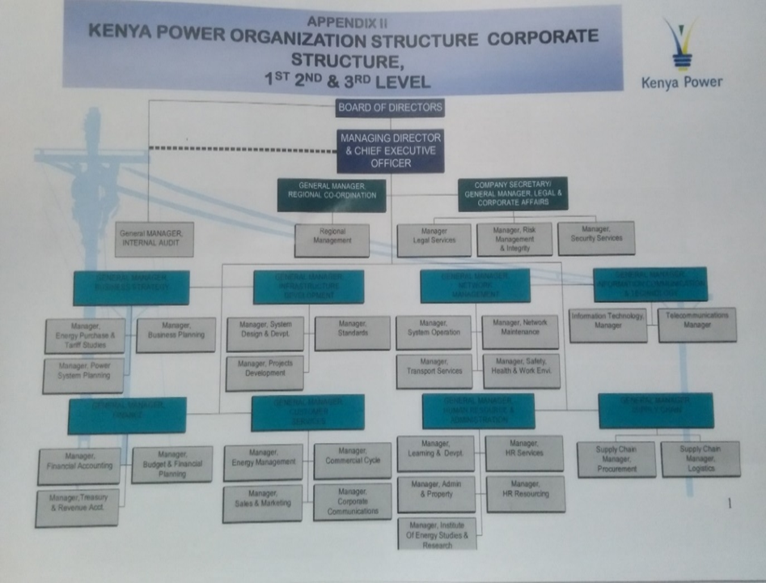

*Fig. 1: Organization Chart of KPLC*

# **3.0 DESCRIPTION OF THE ATTACHMENT**

## **3.1 Weekly Timetable**

*The weekly timetable, the corresponding daily record of tasks carried out within the company, the department(s) where each week was spent, the name and signature of the supervisor that was in charge, and the official stamp of KPLC are all included in the external attachment logbook which was issued by the institution.*

## **3.2 Description of the Work Station**

The ICT/Telecoms department was subdivided into 5 main offices which is as shown in the figure below.

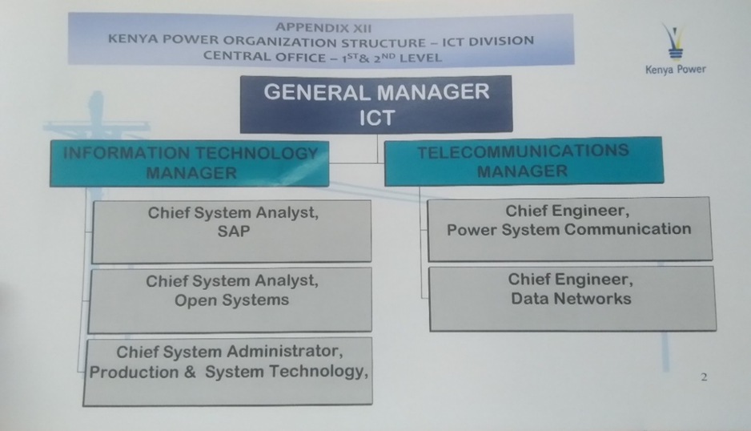

*Fig. 2: Structure of the ICT/Telecoms Department*

In addition, the department consisted of other 6 sub-offices in which other staff members who were or should be in them were to work under the supervision of the ICT or Telecommunications department.

All attachés and interns within the department were introduced and mentored on the code of ethics as well as the attracted penalties for failure of compliance with the rules and terms and conditions of the attachment by the Human Resource Manager, the supervisors of ICT/Telecoms and the other staff members present in the ICT/Telecoms department.

Although the work station was mostly based within the building (the Electricity House), attachés were also be delegated tasks outside the offices whenever they were selected for fieldwork by the respective supervisor. The delegated tasks were carried out delightfully and attachés enjoyed working together as well as the company of the supervisors even though the tasks required much effort and carefulness from them. The presentations of their work done by attachés were also well ordered despite their minor deficiencies in language and expression. Different clients appreciated and rewarded their diligence, respect, and time consciousness, and also encouraged them to move on with the same attitude in whatsoever task they will be called upon in future to do.

A typical working day during the attachment period is as shown in the table below.

|  |  |  |
| --- | --- | --- |
| No. | Time | Tasks Involved |
| 1. | 7.45 – 8.00 am | Arrival and opening prayer. |
| 2. | 8.00 – 10.00 am | Attachés arranging themselves in their various groups/teams and perform a given task or do the assigned project as they wait for tasks to be assigned to them. |
| 3. | 10.00 – 10.30 am | Tea break. |
| 4. | 10.30 – 12.45 pm | Participating in various tasks. |
| 5. | 12.45 – 1.45 pm | Lunch break. |
| 6. | 1.45 – 4.30 pm | Continuing with the assigned tasks. |
| 7. | 4.30 – 4.45 pm | Winding up the assigned tasks and presenting them, holding meetings and discussions, and planning for the next day. |
| 8. | 4.45 – 5.00 pm | Closing prayer and departure from the building. |

Furthermore, during the attachment period attachés were usually mentored by their respective supervisors on Friday evening as from 4.00 – 4.30 pm. The major issues of concern during this program were adherence to the code of conduct while within the company’s premises and the penalties that would cost them should they fail to do so, drug abuse during the weekend, taking care of themselves during the weekend, and maintaining good morals wherever they were.

# **4.0 IMPACT OF THE INTERNSHIP**

## **4.1 Work Environment**

During the attachment, attachés were able to find conducive environment for learning, and application of the knowledge acquired in school. The supervisors were open, friendly, encouraging. Also, the department was very resourceful in providing to the attachés the necessary tools and resources that enabled them to apply the knowledge they learnt at school. For instance, one could easily cut and clip an Ethernet cable since the Ethernet cables and clippers was readily available, and the supervisors allowed free access to them.

Also, the supervisors of ICT/Telecoms department trained students to handle and solve various computer, networking, and internet problems so that whenever problems requiring fixing or maintenance arose, the attachés were often sent to handle and fix such problems, and this aided them to gain more experience in the field of ICT and Telecommunications. In addition, the supervisors were very accommodative i.e., they ensured that all students understood the lessons they taught during fieldwork and training, they frequently checked the tasks attachés did and evaluated them, and also mentored the students on various matters including social lifestyle, personal grooming, and other things that will give add credit to attachés besides their work they did and the experience they gained.

## **4.2 Knowledge and Skills Gained During the Attachment**

1. **Printers and Printing**

* For one to be able to use the printing machine, it was first configured with the PCs and laptops. Configuration was done using the IP addresses the printers used e.g. 192.168.30.41.  
  After configuration, the printer was set as default printer to the client’s computer.
* For one to access the printer, he/she was required to enter a unique identification pin, which was generated for him during configuration.
* Normally, failures like congestion and toner replacement were common to the printers used.

1. **System Installations**

This included installation of common programs/software used by the company such as:

1. DCS
2. SAP
3. InCMS
4. FDB

All these programs assisted staffs within the company to perform their daily duties and were installed from the company’s regional or main headquarters’ server.

1. **LAN Support**

Local Area Network Support involved reporting the work done to the respective clients attachés were sent to in the company’s help support desk. The client’s details recorded; the client’s staff number, the department he/she belonged to, and the service offered to him/her. All these recordings were done in a software within a computer.

1. **Field Work**

**Operation and Working of an OTDR (Optical Time Domain Reflectometer)**

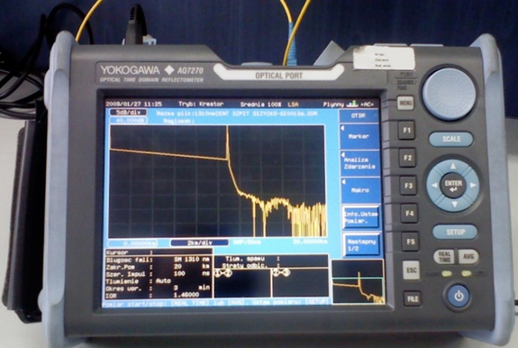

*Fig. 3: An Optical Time Domain Reflectometer (OTDR)*

* This an electronic device that was used to categorize an optical fiber.
* It uses a radar like set of signals. It sends out a pulse of light and ‘listens’ for echoes from the fiber. During pulse transmission, some of the light transmitted through the cable will scatter while some will be reflected back to the OTDR.
* The reflected reflections are then measured to gather useful information about the fibre cable. The gathered information includes:

1. Losses,
2. Distance connectors or Faults.
3. Fiber Cuts.

* The parameters of OTDR includes:

1. Attenuation,
2. Reflection.
3. Distance.

* The above parameters of OTDR are then used to plot a graph and monitor the behavior of energy of light waves at different wavelengths.
* Procedure for testing a fiber cut.

1. Plug the F.C end of a fiber to the port source.
2. The L.C end is plugged into the OTDR.
3. The OTDR is then started or run.
4. **Optical Distribution Frame**

An optical distribution frame (ODF) is a frame used to provide cable interconnections between communication facilities, which can integrate fiber splicing, fiber termination, fiber optic adapters & connectors and cable connections together in a single unit. It can also work as a protective device to protect fiber optic connections from damage.

1. **Media converters**

Media converters are devices that allows two dissimilar media types to connect and communicate with each other.**it** can be viewed as media conversion unit that exchange short distance twisted pair electrical signal with a long-distance optical signal and vice versa.Types of media converters learnt about included:

1. Fiber to coper converter,
2. Fiber converters,
3. PoE media converter,
4. Gigabite converters,
5. Media converter chassis
6. TDM converters
7. **Uninterruptible Power Supply (UPS)**

This is a system that provide back-up power, protecting equipment from damage in the event of grid power failure.

1. *Principle of operation*

It converts ac input (utility power) to dc and then converts back the dc to a stable ac using the inverter while constantly charging the batteries. The ac current from the grid is converted to dc current via the auto-transformers voltage reduction, full-wave rectification and filtering and is provided by the inverter.

1. **Change Over Switch**

It is a switch that automatically detects any drop-in voltage and immediately sends a signal to the generator to start. When services are restored to the main grid, the switch automatically switches off and shuts down the generator.

1. **Patch Panel**

A patch panel in a Local Area Network (LAN) that consists of a mounted hardware assembly that contains ports which are used to connect and manage incoming and outgoing LAN cables. A patch panel provides a way to keep large numbers of cables organized, enabling flexible connectivity into network hardware located in a data center or an access or wiring closet.

The patch panel hardware assembly contains blank ports on one side and a termination point on the other. Cables running throughout a building can be terminated, labeled and then patched into network or audiovisual (AV) hardware. Patch panels are also called patch bays, patch fields or jack fields. Besides being used in enterprise LANs, patch panels are also used in the legacy voice, radio and television fields.

*Principle of Operation*

* Patch panel ports are configured to accommodate twisted-pair copper, fiber optic or coaxial cables in a data center or wiring closet. In an enterprise network, a patch panel serves as a sort of static switchboard, using cables to interconnect network computers within a LAN and to outside lines, including the internet or other wide area networks (WAN). For twisted-pair ethernet connections, the patch panels use RJ-45 interconnects.
* In facilities that require cable or satellite television hookups with centralized control, coax patch panels are used to centrally feed television sets throughout large portions of a building. For legacy voice communications, such as analog fax machines, two- or four-wire patch panels using RJ-11 interconnects are typically used.
* A patch panel uses a patch cord, a sort of jumper cable, to create each interconnection between the terminated patch panel and the network device, such as an Ethernet switch, router or firewall. The patch panel makes it easy to rearrange circuits and devices by moving the patch cables between network devices. Enterprises and other organizations often place patch panels in wiring closets, which are small rooms where networking and other electrical connections are made.
* Patch panels are usually mounted into network racks, either above or below network switches. They typically use 1U to 2U of rack space; 1U is equivalent to 1.75 inches of vertical space on the rack. Patch cords connect the patch panel ports to ports in the network switch, voice private branch exchange or digital AV mixers, which creates permanent port connections to the switch that will not be interrupted during moves, adds and changes (MACs).

1. **Cables Termination of Cat 6 Cables**
2. *Tools used.*
3. Wire Strippers,
4. Wire Cutters (Side Cutters will work),
5. RJ-45 Crimping Tool,
6. 2 RJ-45 Modular Data Plug (Ends),
7. Bulk CAT 6 Network Cable.
8. *Procedure includes:*
9. *Step 1:* Separate the twisted pairs of cables from the bundle. When the entire cable is seen from one end, no twisted pairs should be seen crossing over each other.
10. *Step 2*: Separate the wires of the twisted pairs. Also, when the wires are separated, they should not be seen crossing over each other.
11. *Step 3*: Assemble the wires in a straight line and place them closely packed to each other for the data plug. There are two commonly used ways of organizing the wires for the data plug. However, regardless of the way one might choose, both ends of the cable MUST use the same configuration/pattern/sequence of colours otherwise the cable will not work. A typical configuration that attachés used during cable fixing and repair within is as shown below.

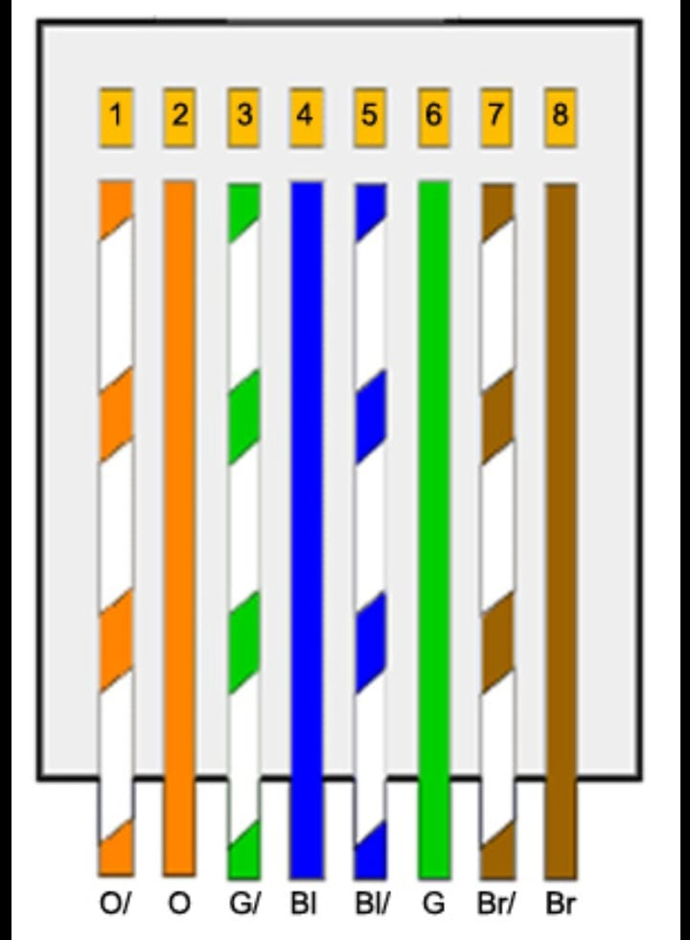

*Fig. 4: A Typical Cat 6 Cable Arrangement for the data plug*

1. *Step 4*: Firmly grasp all the wires near the sheath, slide your fingers up, and level all the wires into a flat line while ensuring that the arrangement remains as shown in figure 4 above. When looking at the wire colours from left to right, the wires should be in the same configuration as described in figure 4.
2. *Step 5*: Ensure all wires are straight, and that none is bent/appears bent. Using the wire cutters, trim the tips of the wires in a straight line so that all of the wires are on the same level. Make sure the cut is perpendicular to the ends of the wires.
3. *Step 6*: Insert all the 8 wires carefully into the RJ-45 while ensuring the colour sequence is maintained until all of them reach the end of the lines within the RJ-45.
4. *Step 7*: Insert the RJ-45 containing the cable into the RJ-45 crimping tool and crimp.
5. *Step 8*: Follow the same procedure for the other end of the ethernet cable and test whether it transfers data from the ethernet outlets to a computer.
6. **Fibre Splicing and Fusion**
7. Tools used includes:
8. Cleaver,
9. Fiber Fusion Machine,
10. Wire stripper.

Fusion splicing is a process of aligning the fibers from the fiber optic cables and then connecting them together. This is a welding process for fiber optic strands. During fusion, the fiber strands are aligned using a fusion splicer that pulls the fiber cores along their central axis. As the fiber strands from both the cables are pulled and aligned centric to the same axis, the core of both the fiber cables match, which enables signal transmission in a straight line. This process is performed in order to allow the optical signal transmission without splitting the connecting end and to reduce attenuation or insertion losses. The fusion splicing method is known for offering fiber optic transmission at insertion loss less than 0.1dB. Being a highly effective method of fiber optic cable termination, it demands professional and experienced operators and a fusion splicer apparatus.

1. *Fiber Preparation*:

* Fiber preparation is the primary activity of fusion splicing. It involves the following steps.

1. Stripping off the fiber jacket up to a considerable length. Often, the cable ripcord is used to remove and peel off the jacket material. This is done to expose the loose tube or buffer tube of the fiber cable.
2. The buffer tube material is further ripped off up to a distance shorter than the fiber jacket rip off.
3. Clean the bare fiber and remove the cable gel/adhesive.
4. Expose the clean bare fiber and cleave it at both ends.
5. Fix both the cleaved ends of the fibers in the claws of the splicing apparatus.
6. *Splicer Alignment Programming*

The fusion splicing apparatus is an equipment which performs the fiber splicing procedure automatically. Since the splicing process is automatic, it is the operator’s job to set a specific splicing program that will give the desired splicing results. The following are the steps performed by the splicing apparatus after the program is set.

1. The operator has to first prepare the fiber as described in part (ii) above, from step 1 to 4.
2. Once the fiber is inserted in the apparatus, the fiber ends to be fused are first examined before fusion. If badly cleaved fiber ends are detected, they will be automatically rejected by the apparatus’ program.
3. Then, the pre-fusion cycle is initiated; which involves re-cleaning the fiber ends to remove dust/dirt which may affect the quality of the splice, and thus lead to signal losses.
4. During the same pre-fusion cycle, the fiber ends are slightly heated after the cleaning process.
5. After pre-fusion cycle, the splicing cycle is then initiated by the apparatus. Here, the apparatus uses a core alignment method to align the fibers. Once the fiber cores are aligned, an automated electric arc cycle is triggered that generates heat and welds the two ends of fibers together, thus joining them into one fiber.



*Fig. 5: Fiber Splicing Machine*

1. *Splice Inspection*

The fusion splicing process terminates when the splicing apparatus fuses the fiber ends. However, the apparatus is also programmed for an inspection program that evaluates the fusion joint. During testing, an optical ray (usually from a Laser or an LED) is transmitted via fused fibers to test the losses at the fused joint. If the losses are found to be below the maximum losses, the fibers are taken out and preferred for use. However, if the losses are higher than the maximum losses, the apparatus is re-programmed for re-splicing. Once the fiber is well spliced, the operator takes out the fibers and visually examines the fusion spot.

1. *Fiber Protection*

Fiber protection is achieved by adding a heat shrinkage tube to the fusion spot to avoid stretching forces and sagging of the fiber glass due to heating.

1. **SCADA and SCADA systems**

A SCADA system is a combination of hardware and software that enables industrial process automation by capturing Operational Technology (OT) and real-time data. SCADA connects the sensors that monitor equipment like motors, pumps, and valves to an on-site or remote server. A SCADA system usually empowers organizations to:

1. Control processes locally or in remote locations.
2. Acquire, analyze and display real-time data.
3. Directly interact with industrial equipment such as sensors, valves, pumps, and motors.
4. Record and archive events for future reference or report creation.

Depending on the configuration of the SCADA control system, the state of industrial processes can be viewed from an operator’s workstation overlooking the industrial plant, a HMI located directly beside machinery, or even from an employee’s house.

*SCADA System Hardware*

* SCADA hardware, such as Remote Terminal Units (RTUs) and Programmable Logic Controllers (PLCs), serve as local collection points for acquiring sensor information. This hardware in a modern SCADA system often triggers actions of the connected pieces of equipment via programmed logics. In a SCADA system, the collected data from the sensors is gathered by a computer commonly known as a ‘gateway’, which pass the data from PLCs to servers or to edge computers.
* Edge computers are often close to the source of the data and can act as a gateway. However, they will first process the data before transferring to the cloud or central physical server. This enables quicker decisions at a local level as well as bandwidth and saves on cost.
* On the other hand, Human Machine Interfaces (HMIs) provide a local touchscreen interface for machine monitoring and control. They can also act as gateways or edge computers.
* Besides, the server acts as the central control for local SCADA system. Local historian server (historical data logging over time) may stay here. Depending on its architecture, the server may also report back to cloud or a larger server on the enterprise network.
* Once sensor data are collected, they can either be acted upon directly through the use of SCADA software, or saved for later review.

*How to implement a SCADA solution?*

* To successfully implement a SCADA solution, the following steps were recommended to be followed. They include:

1. Clearly define and understand what is to be monitored.
2. Determine the type of data collected and start a small proof, i.e., pick one set of data and one location to do a proof of concept.
3. Define a scalable architecture.
4. Add gateways to connect current data collection points.
5. Create new data collection points if needed.
6. Centralize the data to your intended monitoring location.
7. Map the data in your SCADA software of choice.
8. Add visualizations of data and controls.
9. Define automations and rules.

* In addition, SCADA software often takes over to help people interact with their facility, alert their to issues, inform predictive maintenance, and provide control over a handful, or even thousands of pieces of equipment.
* It may seem complicated at first, but the goals are simple. First, the things to be monitored are connected, and then the operator selects the location from which he/she wishes to monitor and control them.

## **4.3 Responsibilities Undertaken During the Attachment**

Some of the responsibilities that attachés were issued during the attachment included:

1. Fixing and replacing worn out, faulty or old extensions, adapters and laptop chargers, and also costing them for the company.
2. Transporting, configuring and maintaining printers i.e., toner replacement, troubleshooting them, and fixing its power issues. Also, attachés were responsible for guiding employees within the company on how to use various printers set up in the company.
3. Fixing ethernet cables, their outlet ports and their trunks, i.e., crimping, and replacing them.
4. Assisting clients with computer software installations/problems, i.e., operating systems, software crash, and software updates.
5. Cleaning LAN switches and routers at different stations from which ethernet cables diverged.
6. Fixing, and restoring faulty computers/computer components, i.e., hard drive, motherboard, keyboard, monitors and CPUs, back to use and assigning them to clients/staffs in need.

## **4.4 Influence of the Attachment to My Future Career Plans**

The attachment has greatly influenced my career objective by the following:

1. It has brought a realistic picture of the units learnt at school and the exact applications of the knowledge expended in class/knowledge read from books.
2. I have been encouraged to continue working towards my goals and achieve them knowing that a future awaits me.
3. It has also enlightened me on the gaps unexploited within the field of telecommunications, which if exploited would make communication easier and generate income to the system designers and builders.
4. It has also enlightened me on the importance of having an extra knowledge in other fields so as to be highly competitive in the advancing technological world.
5. Besides, it has also cultivated in me a better start-off work experience which I can apply outside through self-employment or whenever called to operate/maintain/fix various systems i.e., routers, LAN switches, printers computer software and hardware, and ethernet cables.
6. Also, being in attachment at KPLC has also cultivated in me other core values such as connections, working together with people effectively, the importance of maintaining good relations and personal conduct/deportment.

## **4.5 Relationship Between Classroom Knowledge and Knowledge Gained During the Attachment**

During the attachment, I realized that there existed many similarities between the knowledge learnt in class and the tools/machines/components we encountered. For instance, the optical communication system which we learnt in year 4 was exactly the same as the optical communication system present in the industry i.e., at KPLC. Also, the knowledge acquired about operating systems, computer programming, multiplexing, information theory, channel coding, transmission lines and other calculations done in class were all applicable in the industry.

However, in as much as many similar concepts were noticed, there also existed some advancements which were beyond the scope of our learning at school, and other newly added technologies which are not taught in class. For instance, the advancement in technology made the systems used at KPLC (i.e., the optical receivers and transmitters) appear strange and their mode of operation too difficult for the students to understand, although the fundamental principles they used were learnt in class. In other cases, students found out that that which they had spent time to learn in class were but old and outdated methods which were long replaced by other methods approximately 10-15 ago, and were no longer operational (especially in the field of electronics). In addition, the students also realized that classroom knowledge just served only as a foundation of what they were supposed to meet in their field of study, and that much knowledge and experience would be gained as one continues working in the field.

# **5.0 CONCLUSION**

Throughout the attachment, I was able to gain an overview of the kind of work, duties, or responsibilities awaiting a future aspiring engineer in the field of telecommunications. The attachment opened our eyes to the common faults encountered in the field of telecommunications, especially within our country. The attachment also brought to our view the level of advancement communications reached, and the rate at which it is advancing so as to awaken us to be alert and always catch up with the advancing technology. Furthermore, the attachment has also enlightened us on the importance of exploring other fields of knowledge, working together as a team, being able to work with a wide range of personalities, and not to mention good morals and personal demeanour.

To conclude, in as much as Kenya Power continues to supply and manage much of the power consumed by nearly all Kenyan citizens and most companies, it’s department of telecommunications is rapidly growing into becoming a big internet service provider to many customers around the country through fibre network. Recently, it was noted that even bigger telecommunications companies like Safaricom use KPLC’s communication lines to serve their customers. In addition, the *Kenya Kwanza* government, in its ambitious project to liberalize internet connection to all citizens around the country, has also selected KPLC as the executor of that project through fibre optics.

# **REFERENCES**

Kenya Power and Lighting Company, [www.kplc.co.ke](http://www.kplc.co.ke).

Gupta, M., Grover, S., & Singh, S. (2004, October). A feasibility study for power management in LAN switches. In *Proceedings of the 12th IEEE International Conference on Network Protocols, 2004. ICNP 2004.* (pp. 361-371). IEEE.

Daneels, A., & Salter, W. (1999). What is SCADA?.

Sampson, W. W. (2001). The structural characterisation of fibre networks in papermaking processes—a review. In *Proceedings of the Transactions of 12th Fundamental Resource Symposium, Oxford* (pp. 1205-1288).

Spurgeon, C. E. (2000). *Ethernet: the definitive guide*. " O'Reilly Media, Inc.".

Xiao, L., Demokan, M. S., Jin, W., Wang, Y., & Zhao, C. L. (2007). Fusion splicing photonic crystal fibers and conventional single-mode fibers: microhole collapse effect. *Journal of lightwave technology*, *25*(11), 3563-3574.

Barnoski, M., Rourke, M., Jensen, S. M., & Melville, R. T. (1977). Optical time domain reflectometer. *Applied optics*, *16*(9), 2375-2379.

Du, Y., Chen, J., Zhou, H., Yang, X., Wang, Z., Zhang, J., ... & Zheng, X. (2023). An automated optical inspection (AOI) platform for three-dimensional (3D) defects detection on glass micro-optical components (GMOC). *Optics Communications*, *545*, 129736.

McKenzie, I., Jones, R., Marshall, I. H., & Galea, S. (2000). Optical fibre sensors for health monitoring of bonded repair systems. *Composite structures*, *50*(4), 405-416.