# Create a Sharepoint site

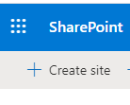

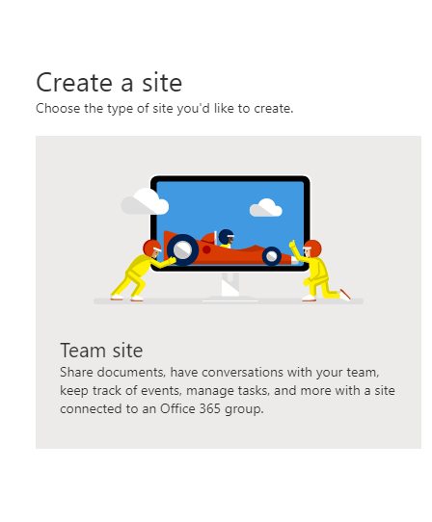

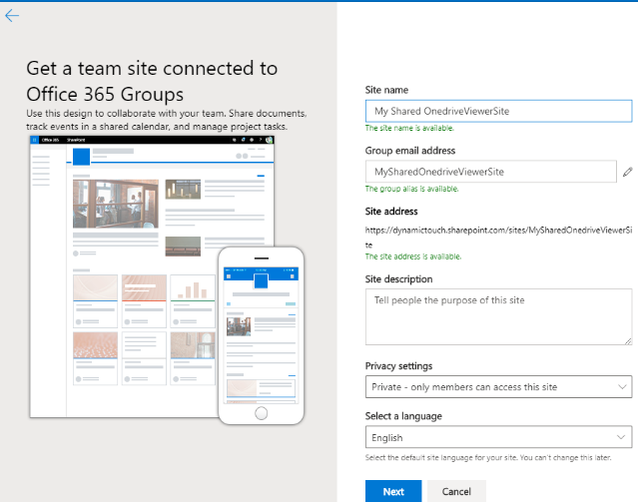

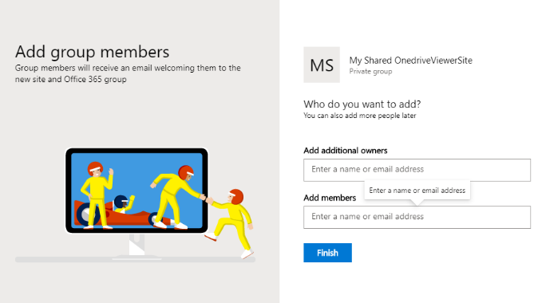

# Get Id of group

One way to do this is by using the graph explorer

Open <https://developer.microsoft.com/en-us/graph/graph-explorer>

Execute: <https://graph.microsoft.com/v1.0/groups/>

Lookup your team and look for your group id

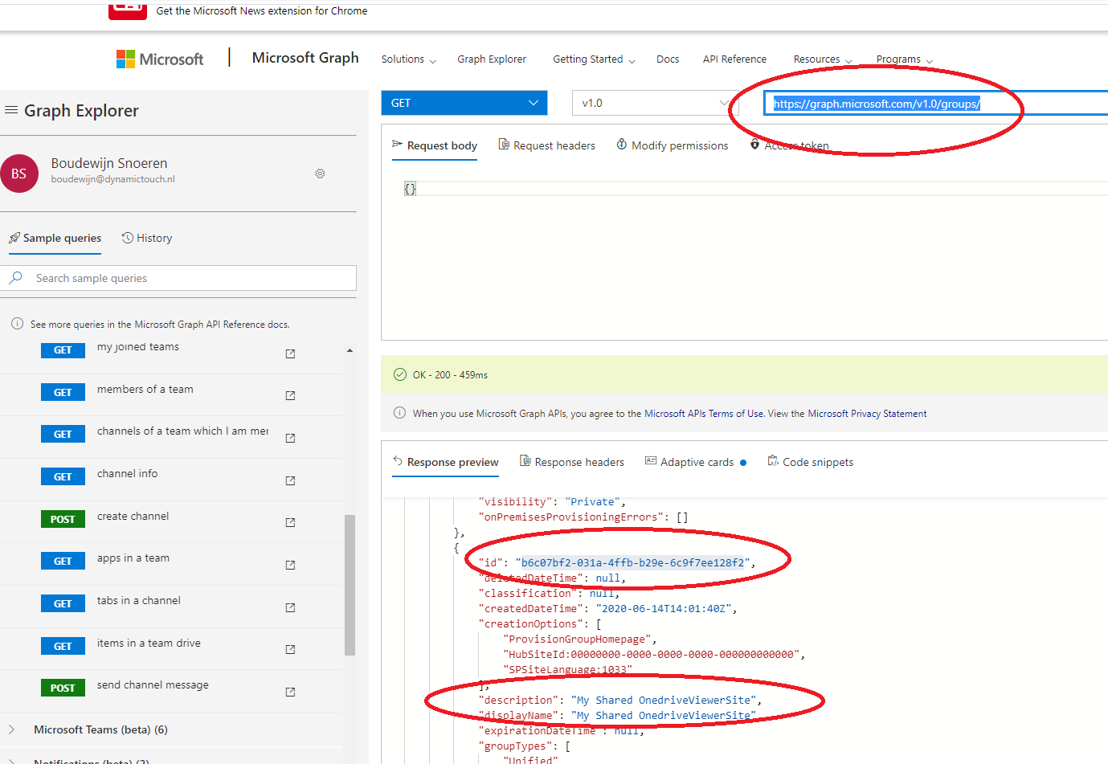

# Register Azure App

Navigate to <https://portal.azure.com/#home>

And register an app

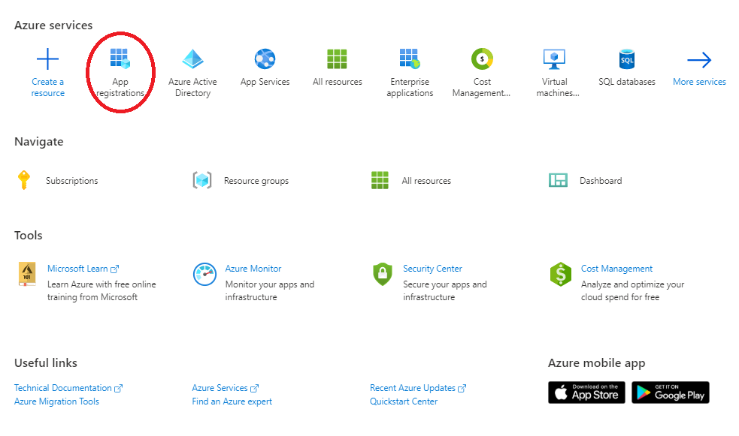

Fill the correct url

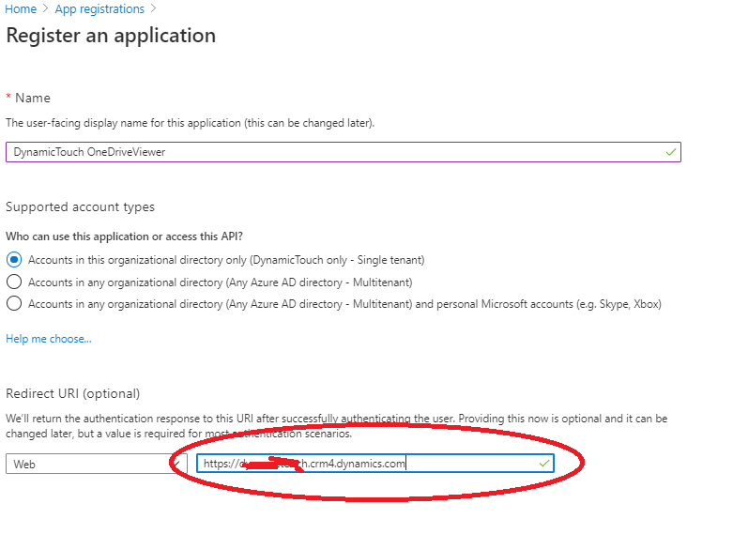

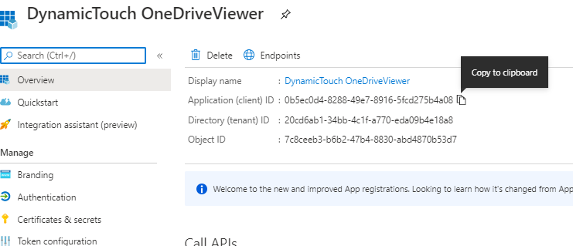

Note the clientId and Directory (tenant) id

Add permission Files.Read.All

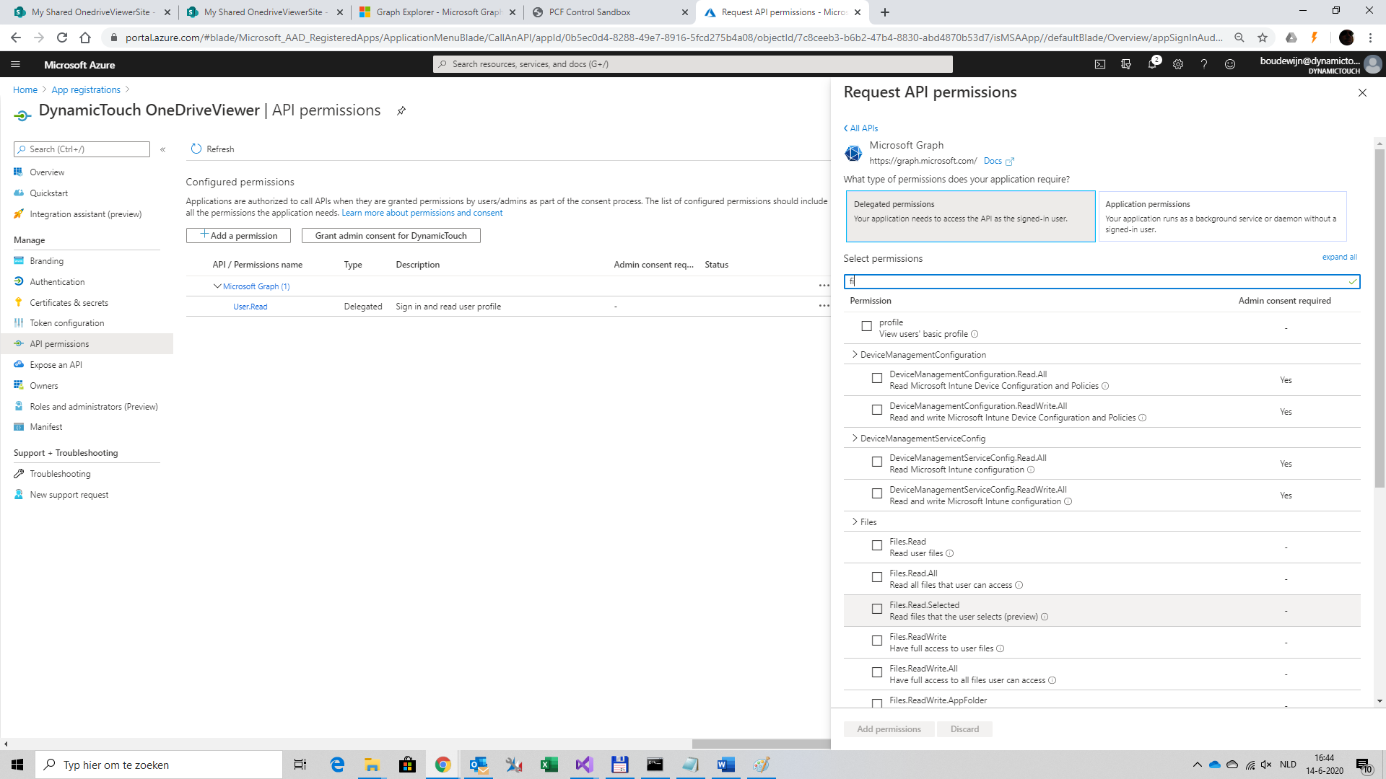

# Import solution

Import the zip file

# Register component

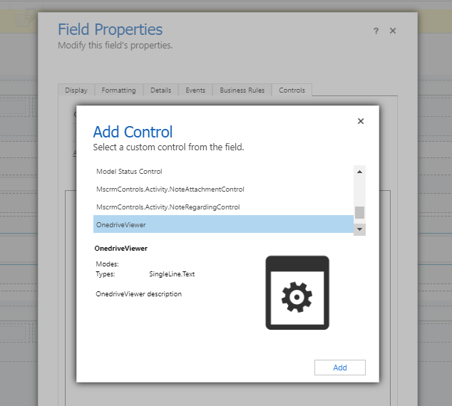

FileId : Bound to text attribute

FrameHeigth: 800px

ClientId: <ClientId>

EnableSelect: 1

Authotiy: [https://login.windows.net/<Tenantid](https://login.windows.net/%3cTenantid)>

RedirectUri: <https://mydynamics.crm4.dynamics.com>

Endpoint: <https://graph.microsoft.com/v1.0/>

Path: groups/<GroupId>