TECHNICAL DESIGN DOCUMENT

|  |  |
| --- | --- |
| **Authors** | *Brock Hemsouvanh and Zadkiel Rodriguez* |
| **Last Updated** | 2/25/2024 @ 19:48 |
| **Version Number** | *1.1.0* |

**Version History**

|  |  |  |  |
| --- | --- | --- | --- |
| **Name** | **Date** | **Reason for Change** | **Version** |
| *Brock & Zadkiel* | *02/26/2024* | *New Document* | *1.0.0* |
| **Brock & Zadkiel** | **03/03/2024** | **Updates on prototypes with NoSQL and JSON structure** | **1.1.0** |
| **Brock & Zadkiel** | **03/10/2024** | **Add queries and Python console app, QA Unit Testing Proofs and References** | **2.0.0** |
|  |  |  |  |
|  |  |  |  |
|  |  |  |  |
|  |  |  |  |
|  |  |  |  |
|  |  |  |  |
|  |  |  |  |

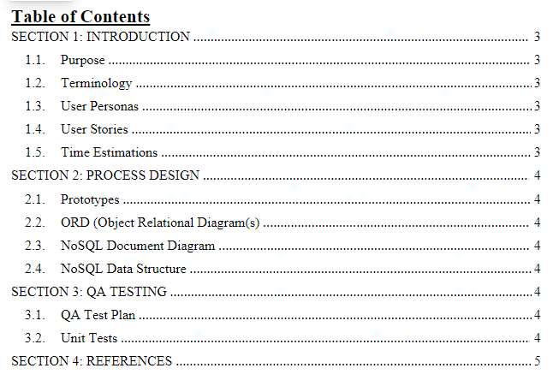

1. **Identify the team captain, team name, mascot, and provide a short bio of each team member.**
   * 1. Team Captain: Brock Hemsouvanh
     2. Team Name: Mighty Lions
        1. We picked the name Mighty Lions because the Lions symbolized courage, wisdom, and creativity. We are both mighty when we both combine our creativity to accomplish our goals. Our mascot is a Lion, we choose it because of how strong and powerful they are. It makes us believe we can achieve everything we put ourselves to.
     3. Mascot
        1. A lion with colorful lines

           Description automatically generated
     4. Team Bio

**Zadkiel Rodriguez**

Hi there, I am Zadkiel, an aspiring full-stack developer with a burning passion for tech. From a young age, I have been captivated by the endless possibilities of the digital world, and now I am on a mission to turn that passion into a career.

What drives me is the opportunity to solve complex problems and create solutions that make a real difference in people's lives. Whether streamlining processes, improving user experiences, or building innovative new features, I constantly seek ways to innovate and elevate my skills.

Nevertheless, it is not just about the code for me. I believe in the power of collaboration and teamwork and am always eager to learn from others and share my knowledge and expertise. I thrive in dynamic environments where I can collaborate with cross-functional teams, exchange ideas, and work together to achieve our goals.

As I continue my journey as a full-stack developer, I am excited to dive deeper into new technologies, hone my skills, and make a meaningful impact in software engineering. With dedication, determination, and a relentless thirst for knowledge, I know the possibilities are endless.

**Brock Hemsouvanh**

*I’m Brock- an aspiring full stack web developer immersed in honing my web development skills in order to breathe life into diverse business visions. With an entrepreneurial spirit and a freelancer's versatility, I am passionate about channeling my growing tech expertise into projects that improve animal welfare.*

*I am also a musician, currently composing my debut solo album, anticipating its launch within the year. My melodies and lyrics are not just tunes; they are echoes of my journey and a reflection on my relationships with people I’ve known.*

*Martial arts discipline shapes my physical routines as my philosophy; it's where I've learned the art of balance and the power of a centered mind. I find solace in the musings of optimistic nihilism, which reminds me that meaning is a canvas we paint with our actions and intentions. I am dedicated to cultivating a positive, empowered mindset, and I am as committed to personal growth as I am to guiding others towards their aspirations and a state of contentment. My life is a juggling of skills: code, chords, and the quest for equilibrium, always striving to uplift, improve, and inspire.*

1. **Identify the goals of the website.**
   1. Facilitating Book Discovery: The website's primary goal is to help users discover new books that align with their interests and preferences. This goal involves providing features such as wishlists, browsing categories of books, and personalized recommendations based on the user's wishlist books.
   2. Building a Vibrant Community: Another goal would be to foster a lively and engaged community of readers and authors. This could involve enabling readers to engage with authors through comments on book posts, fostering discussions and interactions around books, and facilitating connections between like-minded individuals.
   3. Driving Book Sales: Whatabook aims to drive book sales by connecting users with books they are interested in and facilitating the acquisition process of the books they desire.
   4. Supporting Authors and Books: Whatabook seeks to support authors and promote their work by providing a platform for them to showcase their books and engage with readers.
   5. Increase customer engagement: Whatabook will offer an easy-to-use interface that allows customers to navigate the website as easily as possible. This will potentially attract customers back to the website since it will be easy to use.
2. **Identify the core users of the website.**
   1. Book Enthusiast: These individuals are passionate about reading and seek new books to explore across various genres, authors, and topics. They may use Whatabook to discover new titles, read reviews, and engage with other members of the reading community.
   2. Educators and Students: Educators, librarians, and students may also be core users of Whatabook, using the platform to discover books for educational purposes, access resources for research and study, and engage in discussions about literature and academic topics.
   3. Casual Readers: Casual readers enjoy reading for leisure and entertainment, often exploring popular bestsellers, fiction, and non-fiction titles across various genres. They may use Whatabook to find recommendations, read user reviews, and participate in book-related discussions without the pressure of commitment or analysis.
   4. Book Authors Aspirants: Individuals aspiring to work in the book publishing, writing, or literary industries may use Whatabook to network with professionals, seek mentorship or career advice, and stay informed about industry news, events, and job opportunities.
3. **Create at least three (3) detailed personas to represent the core users of the website.**

Persona 1:

Name: Luna

Age: 56

Role: Professional

Story: Luna is a book enthusiast and a writer. She mostly passes her time searching for new ideas for her new books and making sure to engage with her fanbase to see how they like her books.

Tech Requirements: Luna is very proficient with computers.

Goals/Wants: Luna wants the website to have a user-friendly interface where her fanbase can easily research her books and interact with her.

**Story 1**: As Luna, I want to easily upload new books I've written, so that my fanbase can quickly find and read them.  
Story Points: 5

**Story 2:** As Luna, I want to interact with my readers through comments on my book pages, to build a strong community and receive feedback.  
Story Points: 3

**Story 3:** As Luna, I need a dashboard to see which of my books are added to wishlists the most, to understand my audience's preferences better.  
Story Points: 8

**Story 4:** As Luna, I want to categorize my books by genre, so readers can easily discover them based on their interests.  
Story Points: 3

**Story 5:** As Luna, I wish to have a feature where readers can rate my books, to gain visibility on how well my works are received.  
Story Points: 2

Persona 2:

Name: Jake

Age: 23

Role: Student

Story: Jake is a psychology student at a local university. He goes to WhatABook to search for his schoolbooks and personal readings.

Tech Requirements: Jake is not a tech savvy individual, but he hopes that WhatABook will convince him to read more books digitally.

Goals/Wants: Jake wants to have features where he can see recommended books based on his wishlist books.

**Story 1:** As Jake, I want to search for textbooks by title, so I can quickly find the materials I need for my courses.  
Story Points: 2

**Story 2:** As Jake, I need to see a list of recommended books based on my search history and wishlist, to discover new reading material.  
Story Points: 5

**Story 3:** As Jake, I want to filter books by academic genres, to easily find textbooks relevant to my psychology studies.  
Story Points: 3

**Story 4:** As Jake, I wish to have a simple checkout process for buying books, to make my purchase experience hassle-free.  
Story Points: 8

**Story 5:** As Jake, I need a feature to view the most popular books among students, to stay updated with essential readings.  
Story Points: 1

Persona 3:



Name: Stacy

Age: 16

Role: Student

Story: Stacy when she is not in school, she loves to dive into the fantasy of romance comedy books.

Tech Requirements: Stacy is a very tech savvy and environmentally friendly individual.

Goals/Wants: Stacy hopes that the website will be filled with a diversity of books for her to choose from.

**Story 1:** As Stacy, I want to browse books by the romance comedy genre, so I can find new stories to dive into.  
Story Points: 1

**Story 2:** As Stacy, I wish to create a wish list of books I plan to read, so I can keep track of them for future purchases.  
Story Points: 2

**Story 3:** As Stacy, I need to see reviews and ratings on books, to make informed decisions about what to read next.  
Story Points: 3

**Story 4:** As Stacy, I want to share books I love on social media, to discuss them with my friends and encourage them to read along.  
Story Points: 5

**Story 5:** As Stacy, I wish to receive notifications on new releases in my favorite genres, to stay ahead with the latest books.  
Story Points: 8

Story point total: 59

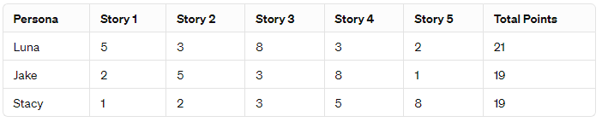

Total Development Time Available: 3 weeks

Sprint Duration: 1 week

Sprints Available: 3 (since 3 weeks / 1 week per sprint = 3 sprints)

**Conclusion:**

To finish the project within the 3-week timeframe, our team would need to achieve a velocity of about 20 story points per sprint over 3 one-week sprints. This is a high velocity that assumes efficient and uninterrupted development efforts, as well as the capability of the team to tackle and complete a significant amount of work in each sprint.

# **SECTION 2: PROCESS DESIGN**

## **2.1.** **Prototypes**

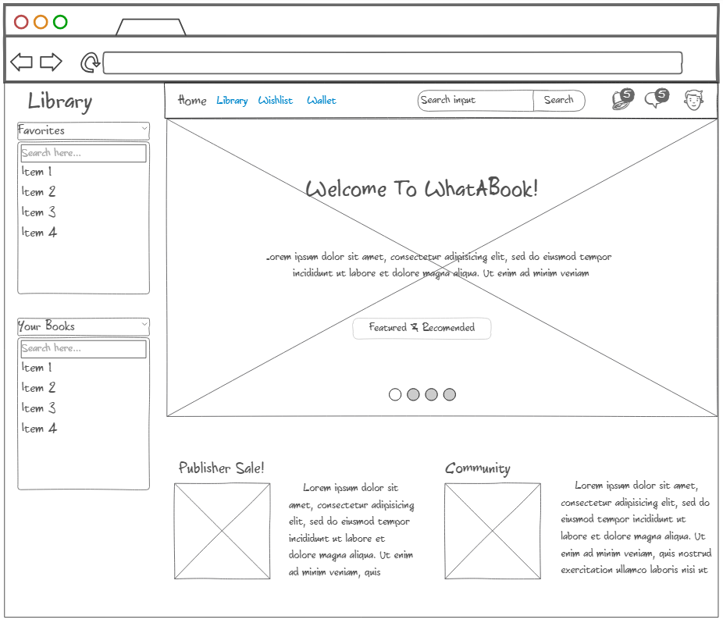

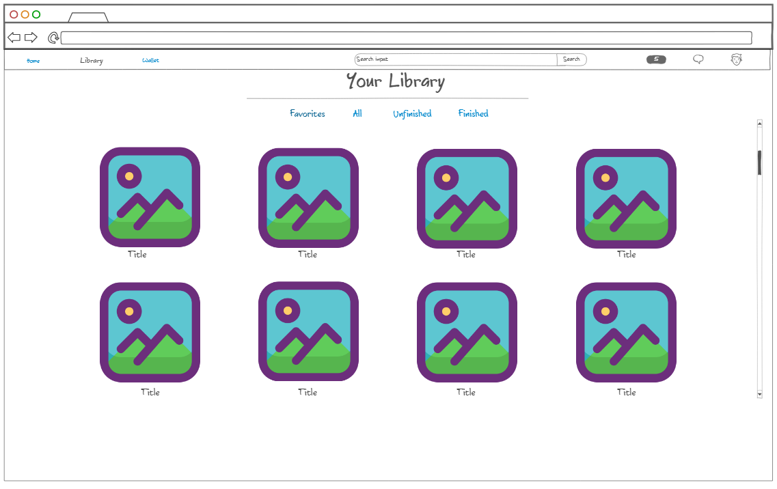

## **2.2.** **ORD (Object Relational Diagram(s)**

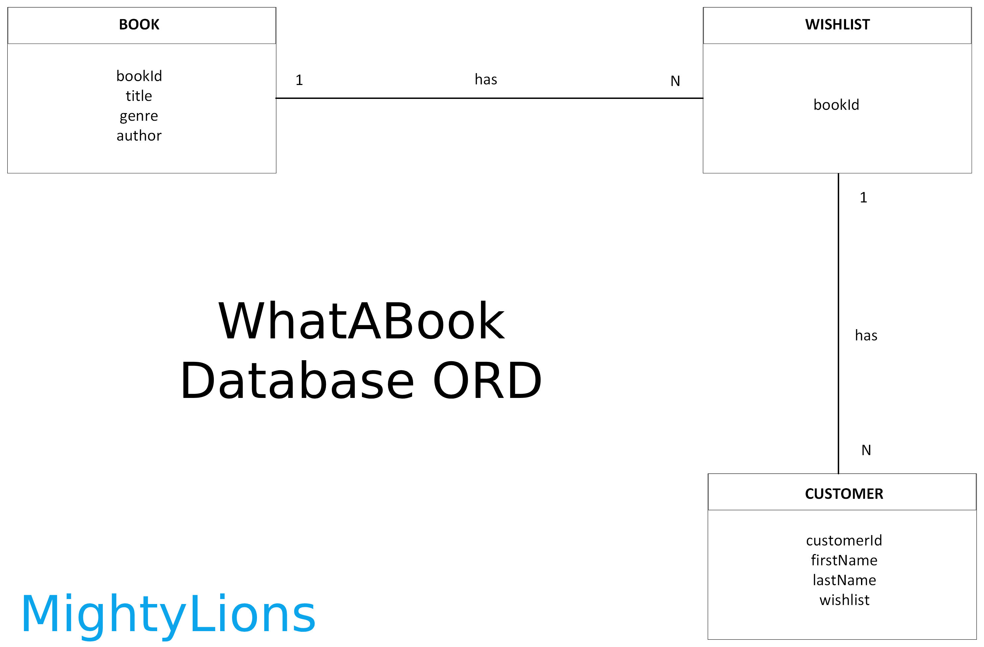

## **2.3.** **NoSQL Document Diagram**

## 

## **2.4.** **NoSQL Data Structure**

// Books data

const book1 = {

"bookId": "37492",

"title": "Harry Potter and the Philosopher's Stone",

"genre": "fantasy",

"author": "J. K. Rowling"

}

const book2 = {

"bookId": "81635",

"title": "Harry Potter and the Prisoner of Azkaban",

"genre": "fantasy",

"author": "J. K. Rowling"

}

const book3 = {

"bookId": "20947",

"title": "The Hunger Games: Catching Fire",

"genre": "drama",

"author": "Suzanne Collins"

}

const book4 = {

"bookId": "45735",

"title": "The Hunger Games: Mockingjay - Part 1",

"genre": "drama",

"author": "Suzanne Collins"

}

// Customer data

const harry = {

"customerId": "c1000",

"firstName": "Harry",

"lastName": "Potter",

"wishlist": [

{

"bookId": "37492",

"title": "Harry Potter and the Philosopher's Stone",

"genre": "fantasy",

"author": "J. K. Rowling"

},

{

"bookId": "81635",

"title": "Harry Potter and the Prisoner of Azkaban",

"genre": "fantasy",

"author": "J. K. Rowling"

}

]

}

const jennifer = {

"customerId": "c1001",

"firstName": "Jennifer",

"lastName": "Lawrence",

"wishlist": [

{

"bookId": "20947",

"title": "The Hunger Games: Catching Fire",

"genre": "drama",

"author": "Suzanne Collins"

},

{

"bookId": "45735",

"title": "The Hunger Games: Mockingjay - Part 1",

"genre": "drama",

"author": "Suzanne Collins"

}

]

}

const john = {

"customerId": "c1002",

"firstName": "John",

"lastName": "Doe",

"wishlist": [

{

"bookId": "81635",

"title": "Harry Potter and the Prisoner of Azkaban",

"genre": "fantasy",

"author": "J. K. Rowling"

},

{

"bookId": "20947",

"title": "The Hunger Games: Catching Fire",

"genre": "drama",

"author": "Suzanne Collins"

},

{

"bookId": "45735",

"title": "The Hunger Games: Mockingjay - Part 1",

"genre": "drama",

"author": "Suzanne Collins"

}

]

}

# **SECTION 3: QA TESTING**

## **3.1.** **QA Test Plan**

*Test each entry operation to ensure it works.*  
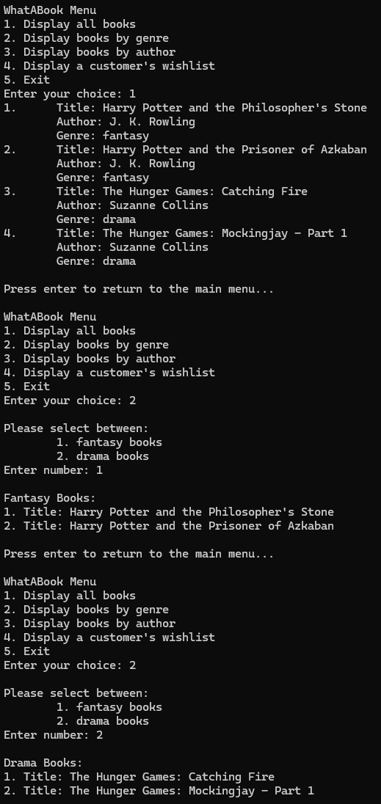

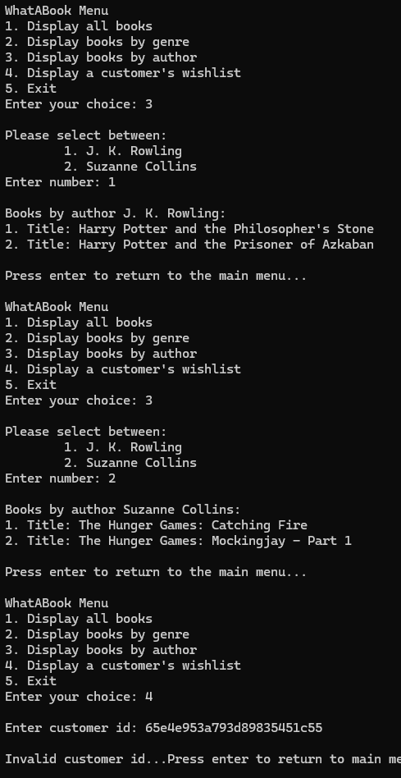

## **3.2.** **Unit Tests**

*Troubleshoot and solve customer ID error.*

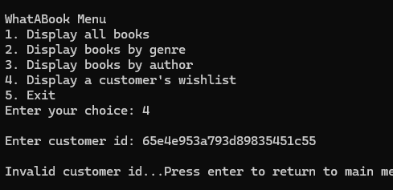

There was no problem. Just needed to use the assigned customer ID, not the database’s auto-generated ID.  
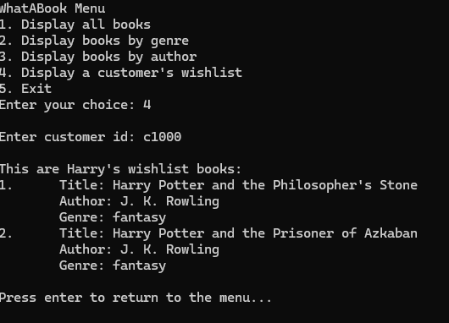

It all works!!

# **SECTION 4: REFERENCES**

Alvarado, Z. R. (2024, March 10). *RodriguezAlvarado-Projections.js.* GitHub.https://github.com/Zadkiel26/web-335/blob/main/week-5/RodriguezAlvarado-Projections.js

Alvarado, Z. R. (2024, March 10). *RodriguezAlvarado-AggregateQueries.js.* GitHub. https://github.com/Zadkiel26/web-335/blob/main/week-6/RodriguezAlvarado-AggregateQueries.js