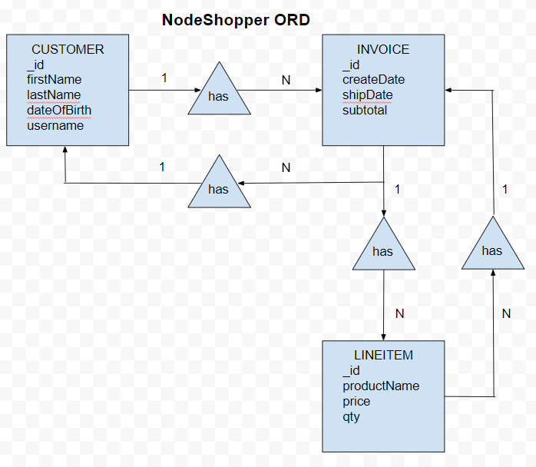

{

"_id": "cust123",

"firstName": "Josh",

"lastName": "Bro",

"dateOfBirth": "1980-01-01",

"username": "joshbro",

"invoices": [

{

"_id": "inv123",

"createDate": "2024-01-18",

"shipDate": "2024-01-20",

"subtotal": 100.00,

"lineItems": [

{

"_id": "item123",

"productName": "Widget",

"price": 25.00,

"qty": 2

},

{

"_id": "item124",

"productName": "Fidget",

"price": 50.00,

"qty": 1

}

]

}

]

}

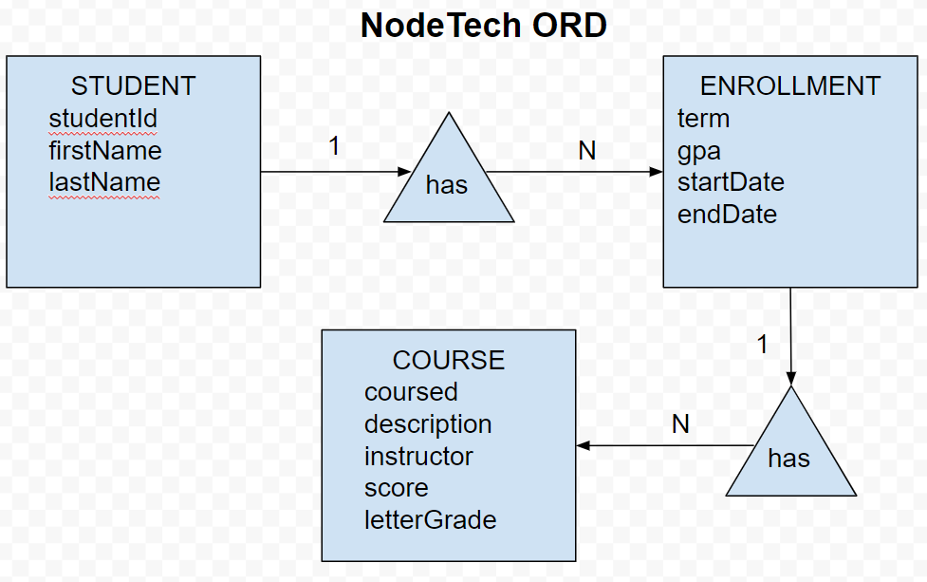

{

"studentId": "0123",

"firstName": "Jorsh",

"lastName": "Farsh",

"enrollments": [

{

"term": "Spring",

"gpa": "4.0",

"startDate": "2034-03-20",

"endDate": "2034-05-18",

"courses": [

{

"coursed": "Webby?",

"description": "New programming language to speak directly to AI agents without the need to speak English.",

"instructor": "Professor Krasso",

"score": "95%",

"letterGrade": "A"

}

]

}

]

}