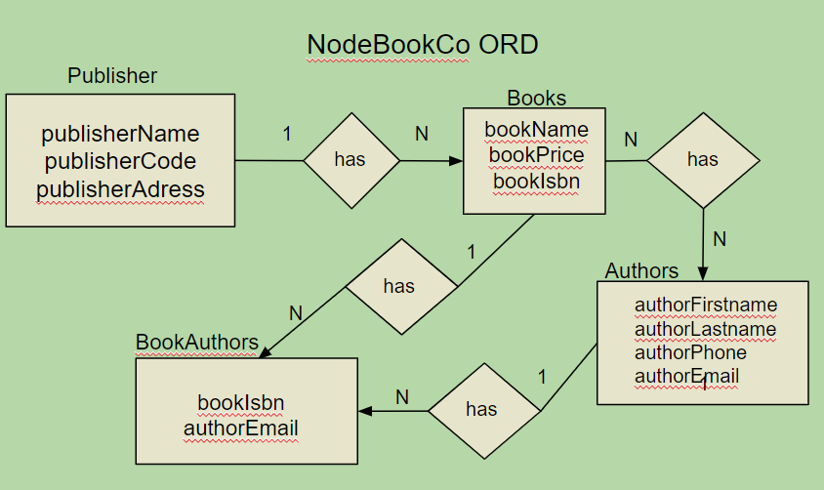

{

"publisher_name": "RoundHouse Publishing",

"publisher_code": "RH001",

"publisher_address": "100 Publishing Lane",

"books": [

{

"book_isbn": "isbn12345",

"book_name": "NodeJS for Beginners",

"book_price": 29.99,

"authors": [

{

"author_first_name": "Robert",

"author_last_name": "Bakker",

"author_phone": "555-456-7890",

"author_email": "robertbakker@email.com"

},

{

"author_first_name": "Lao",

"author_last_name": "Tsu",

"author_phone": "111-765-4321",

"author_email": "laotsu@email.com"

}

]

}

]

}

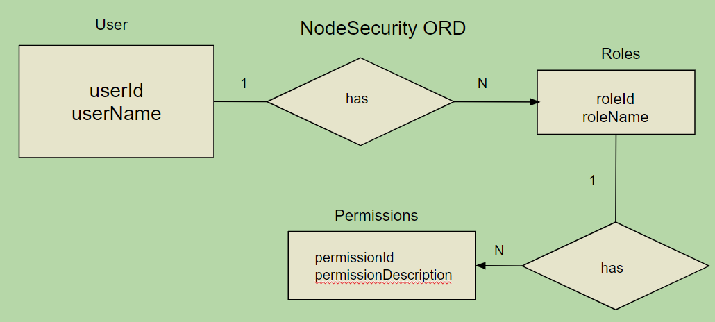

{

"user_id": "hawst123",

"user_name": "StephenHawking",

"roles": [

{

"role_id": "role1",

"role_name": "Administrator",

"permissions": [

{

"permission_id": "perm1",

"permission_description": "Create and edit users"

},

{

"permission_id": "perm2",

"permission_description": "Delete users"

}

]

},

{

"role_id": "role2",

"role_name": "Editor",

"permissions": [

{

"permission_id": "perm3",

"permission_description": "Edit content"

},

{

"permission_id": "perm4",

"permission_description": "Publish content"

}

]

}

]

}