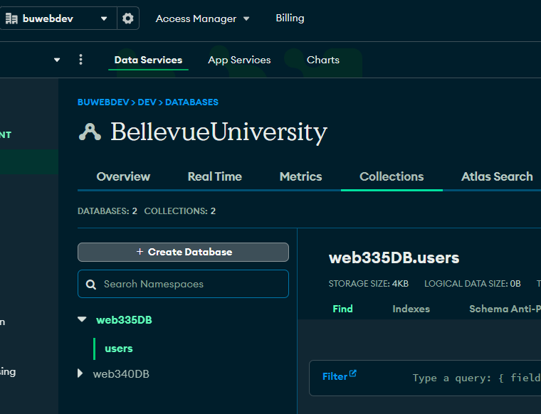

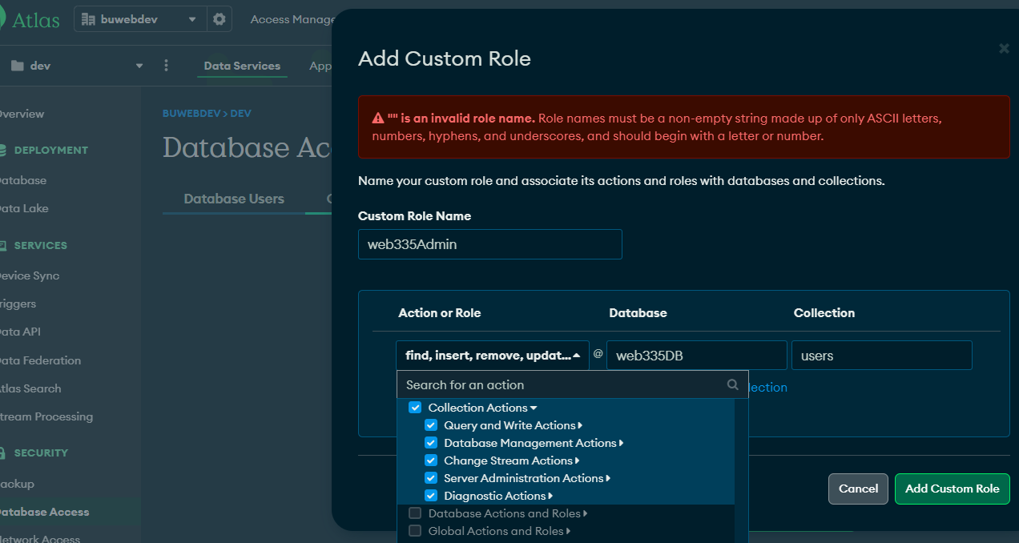

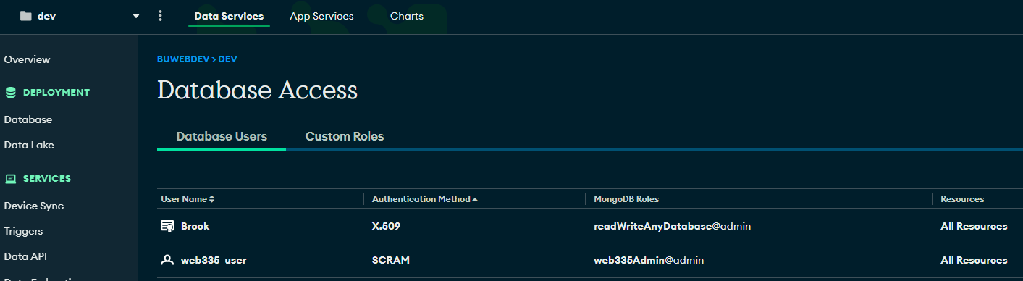

The red X marks indicate hours of unnecessary research and work into creating/customizing an SSL CA certificate and .pem file in order to connect via X.509 method, which was the selected default when generating the connection string for mongosh. 🙁

