BACHELOR OF COMPUTER SCIENCE
SCHOOL OF COMPUTER SCIENCE
BINA NUSANTARA UNIVERSITY
JAKARTA

ASSESSMENT FORM
Course: SCIE6063001– Computational Physics
Method of Assessment: Case Study
Semester/Academic Year : 1/2024-2025

Name of Lecturer : Fabian Surya Pramudya, B.Sc., M.Sc., Ph.D.
Date : 04 September 2024
Class : Mathematics
Topic : Voltage and Current, Resistance and Capacitance, Induction and inductance, Electromagnetic Oscillation and
Alternating Current

Group Members : | 1 Nicholas Brandon Chang - 2702288065  2_________________________________  3_________________________________  4_________________________________  5_________________________________  6_________________________________  7_________________________________  8_________________________________

Student Outcomes:
(SO 1) Mampu menganalisis masalah komputasi yang kompleks dan mengaplikasikan prinsip komputasi dan keilmuan lain yang sesuai untuk mengidentifikasi solusi.
Able to analyze a complex computing problem and to apply principles of computing and other relevant disciplines to identify solutions

Learning Objectives:
(LObj 1.2) Mampu menerapkan prinsip komputasi dan disiplin ilmu terkait lainnya untuk mengidentifikasi solusi
Able to apply principles of computing and other relevant disciplines to identify solutions

No | Assessment criteria | Weight | Excellent (85 - 100) | Good (75-84) | Average (65-74) | Poor (0 - 64) | Score | (Score x Weight)
1 | Ability to design a computational simulation of basic electrical circuits using Python Power Electronic | 25% | The design is correct and can work well without errors | The design is correct and can work well with some errors. | The design is correct but cannot work well | The design is incorrect and cannot work well
2 | Ability to explain the concept and real-world application of Resistance and Capacitance, dan Circuits Design and Analysis | 25% | The steps are complete and the explanations are clearly stated. | The steps are complete and the explanations are well stated | The steps are not complete and the explanations are less appropriate. | The steps are not complete and the explanations are inappropriate
3 | Ability to solve problems in topics of Circuits Design & Analysis, Induction and inductance, and Electromagnetic Oscillation and Alternating Current | 25% | Able to solve in both numerical and computational approaches well | Able to solve in both numerical and computational approaches well with some errors. | Able to solve in either numerical or computational approaches well with some errors | Unable to solve in either numerical or computational approaches
4 | Analyze the computational simulation result of Voltage and Current, Resistance and Capacitance, Circuits Design & Analysis to create scientific reports | 25% | The steps are complete and the explanations are clearly stated. | The steps are complete and the explanations are well stated | The steps are not complete and the explanations are less appropriate. | The steps are not complete and the explanations are inappropriate
 | Total Score: ∑(Score x Weight) |  |  |  |  |  |  | 100

Remarks:

Individual Assignment
The case below is an open-ended problem, which has multiple answers. Answer these problems in the combination of numerical approach and computational approach using Python Power Electronics. Beside your numerical answer, attach your circuit topology, parameters, and simulation output graph. Submit your answer in as a single .PDF file

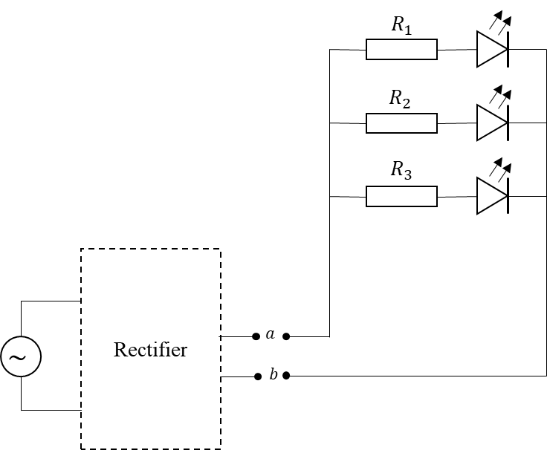
ASSESSMENT METHOD
Instructions
Case Study Problem

You are planning to conduct a small electronic project. You are planning to make a simple LED circuit (see diagram). The circuit contains three green LED lights that connected using parallel connections. From the LED specification sheet, you know that the LED will works on a minimum voltage of 2 $V$. Also, you gain information that the LED will break if the current that flow through it exceed 20 $mA$. For that, you need to use some resistor to limit the current that flow through the LED.

To power the circuit, you are planning to use a micro hydro generator that you already have. However, you realize that you need to convert the current from AC to DC so you can light up the LED. But you don’t have the proper converter at the moment. So, you decide to make your own rectifier, a basic RLC rectifier, from only the components you have (see table) at hand. Assume that your component supply is large enough, so you can use any number of each component.

Assume that your LED does not have any internal resistance. The LED circuit will be connected to the rectifier at point $a$ and $b$ (see diagram). The generator has an output of 5 $V$ with frequency of 20 $Hz$. So, what is your solution for the basic RLC rectifier? Assume that each component on the table (including the EMF) has internal resistance of 0.1 $Ω$.

No | Component | Value
1 | Resistor | $$3 Ω$$
2 |  | $$24 Ω$$
3 |  | $$36 Ω$$
4 |  | $$100 Ω$$
5 |  | $$130 Ω$$
6 |  | $$220 Ω$$
7 |  | $$510 Ω$$
8 | Capacitor | $$1.0 μF$$
9 |  | $$3.3 μF$$
10 |  | $$22 μF$$
11 | Inductor | $$2 μH$$
12 |  | $$5.1 μH$$
13 |  | $$2 mH$$
14 |  | $$400 mH$$

- [LO3 25%] Submit your topology plan for the RLC rectifier circuit
- [LO2 25%] Provide a brief explanation of the reason you chose the component set.
- [LO1 25%] Submit the value of each of the components that you are using, including the numerical reason why this setting will work.
- [LO4 25%] Submit your modeling output graphs using Python Power Electronics to prove that your setting compy to the minimum voltage and maximum current requirements.

Answer :
- Topology Plan for the RLC Rectifier Circuit

- Provide a brief explanation of the reason you chose the component set
  - Resistor (R):
    - Resistor-resistor digunakan untuk membataskan arus listrik yang mengalir melalui LED untuk melindungi mereka dari overloading.
  - Inductor (L):
    - Inductor digunakan untuk membantu menghaluskan waveform AC yang rectified untuk menghasilkan arus DC yang lebih stabil.
  - Capacitor (C):
    - Capacitor bekerja sama dengan inductor sebagai bagian dari LC filter untuk lebih menghaluskan output DC yang sudah rectified.
  - Diode (D):
    - Diode digunakan untuk mengkonversikan arus AC menjadi arus DC agar lebih aman digunakan oleh perangkat“

- Submit the value of the components you are using, including the numerical reason
  - Minimum voltage = 2V

LED maximum current = 20 mA
LED maximum current = 0,02 A

Generator output voltage 5V

Frequency = 20 Hz

Internal Resistance = 0.1 Ω
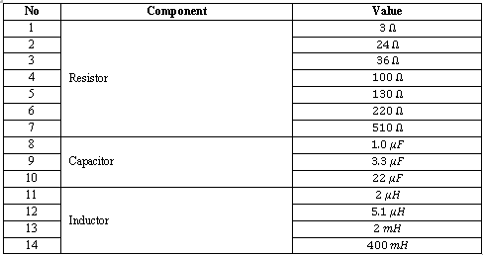

$\frac{1}{Rp}=\frac{1}{R1}+\frac{1}{R2}+\frac{1}{R3}$
$\frac{1}{Rp}=\frac{1}{1}+\frac{1}{1}+\frac{1}{1}$
$\frac{1}{Rp}=3$ Ω

Resistor Values :
- 3 Ω Resistor
R = $\frac{1}{3}$ . 3
R = 1 Ω

I = $\frac{V}{R}$
I = $\frac{2}{1}$
I = 2 A (Tidak dapat digunakan karena I > 0,02A)

- 24 Ω Resistor
R = $\frac{1}{3}$ . 24
R = 8 Ω

I = $\frac{V}{R}$
I = $\frac{2}{8}$
I = 0,25 A (Tidak dapat digunakan karena I > 0,02A)

- 36 Ω Resistor
R = $\frac{1}{3}$ · 36
R = 12 Ω

I = $\frac{V}{R}$
I = $\frac{2}{12}$
I = 0,167 A (tidak dapat digunakan karena I > 0,02 A)

- 100 Ω Resistor
R = $\frac{1}{3}$ · 100
R = 33,333 Ω

I = $\frac{V}{R}$
I = $\frac{2}{33,333}$
I = 0,06 A (tidak dapat digunakan karena I > 0,02 A)

- 130 Ω Resistor
R = $\frac{1}{3}$ · 130
R = 43,333 Ω

I = $\frac{V}{R}$
I = $\frac{2}{43,333}$
I = 0,046 A (tidak dapat digunakan karena I > 0,02 A)

- 220 Ω Resistor
R = $\frac{1}{3}$ · 220
R = 73,333 Ω

I = $\frac{V}{R}$
I = $\frac{2}{73,333}$
I = 0,027 A (tidak dapat digunakan karena I > 0,02 A)

- 510 Ω Resistor
R = $\frac{1}{3}$ · 510
R = 170 Ω

I = $\frac{V}{R}$
I = $\frac{2}{170}$
I = 0,012 A (dapat digunakan karena I ≤ 0,02 A)

R₁ = R₂ = R₃ = 510 Ω

Generator Resistor :
    - 3 Ω Resistor
I = $\frac{V}{R}$
I = $\frac{5}{3}$
I = 1,667 A (tidak digunakan karena I kurang mendekati 0,02 A)

    - 24 Ω Resistor
I = $\frac{V}{R}$
I = $\frac{5}{24}$
I = 0,208 A (tidak digunakan karena I kurang mendekati 0,02 A)

    - 36 Ω Resistor
I = $\frac{V}{R}$
I = $\frac{5}{36}$
I = 0,139 A (tidak digunakan karena I kurang mendekati 0,02 A)

    - 100 Ω Resistor
I = $\frac{V}{R}$
I = $\frac{5}{100}$
I = 0,05 A (tidak digunakan karena I kurang mendekati 0,02 A)

    - 130 Ω Resistor
I = $\frac{V}{R}$
I = $\frac{5}{130}$
I = 0,038 A (tidak digunakan karena I kurang mendekati 0,02 A)

    - 220 Ω Resistor
I = $\frac{V}{R}$
I = $\frac{5}{220}$
I = 0,023 A (digunakan karena I mendekati 0,02 A)

    - 510 Ω Resistor
I = $\frac{V}{R}$
I = $\frac{5}{510}$
I = 0,01 A (tidak digunakan karena I kurang mendekati 0,02 A)

rload = 220 Ω

Circuit Parameters (PPE):

Ammeter positive direction of current searah jarum jam

Capacitor_Cfilter vallue = 1 uF
Capacitor_Cfilter value = 1 · 10⁻⁶ F
Capacitor_Cfilter value = 1e-06 F

Diode voltage level = Voltmeter voltage level = 1000 V (memerlukan tegangan tinggi)
Diode direction of cathode: searah jarum jam
Voltmeter positive direction of voltage: berlawanan arah jarum jam

Inductor value = 1 mH
Inductor value = 1 · 10⁻³ H
Inductor value = 0,001 H

Resistor value = 0,01 Ω (bernilai rendah guna menjaga stabilitas tegangan dan arus)

VoltageSource peak voltage = V · $\sqrt{2}$
VoltageSource peak voltage = 5 · $\sqrt{2}$
VoltageSource peak voltage = 7,071 V

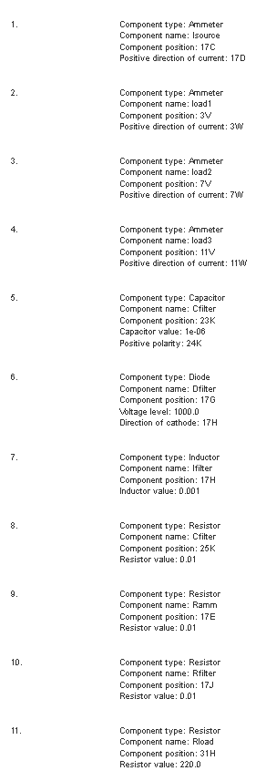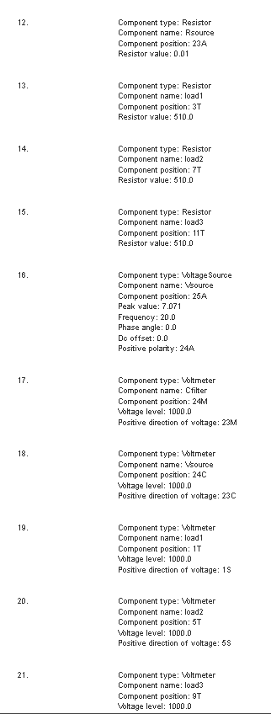
- Submit your modeling output graphs using Python Power Electronics to prove that your setting compy to the minimum voltage and maximum current requirements.

Voltage Plot Graph
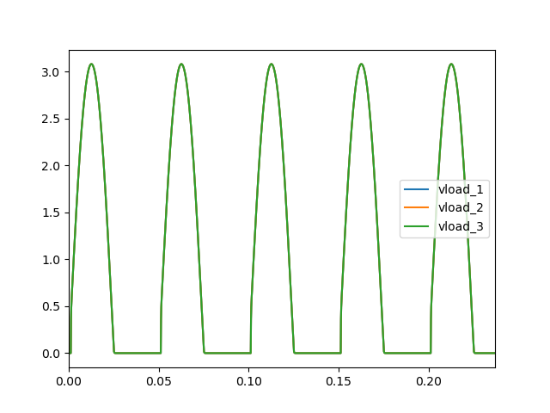

Current Plot Graph
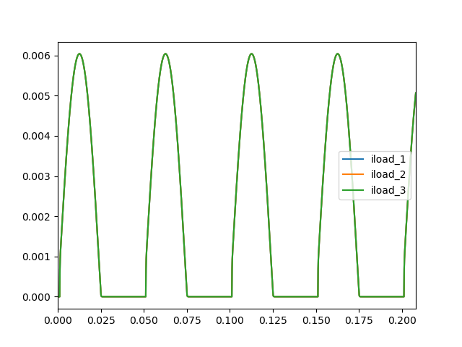

Note for Lecturers:
- The lecturers are advised to assess student’s understanding towards the topics included in the assignment.
- The students will submit their answer in .PDF format through BINUS Maya.
- The deadline of this comprehensive assignment is at the end the semester.

