MIDTERM EXAMINATION
IT311 - APPLICATION DEVELOPMENT AND EMERGING TECHNOLOGIES
First Semester, A.Y. 2026-2027

NAME:_______________________ | YEAR&SECTION:________ | DATE:________ | SCORE:__^{/50}

- MULTIPLE CHOICE: Read each question carefully. Choose the letter of the correct answer from the given choices. Encircle the letter of your chosen answer. Make sure that your answer is clear and legible. Answer all items.
- A university expects frequent requirement changes and wants continuous user feedback. Which model is most appropriate?
A. Waterfall B. Spiral C. RAD D. Agile E. Prototype
- Which section of the SRS details constraints such as regulatory compliance, hardware limitations, and language requirements?
A. System Architecture B. Non-Functional Requirements
C. Functional Requirements D. User Interface Mockups
- A developer tests the calculation feature of a payroll system separately to ensure that employee salaries are calculated correctly.
What type of testing is being performed?
A. System Testing B. Unit Testing C. Integration Testing D. UAT
- Which of the following is true about an SRS?
A. This is a stage where you get to gather the requirements needed for the system development.
B. This is also called the requirements document specification.
C. An informal report accomplished by the customer.
D. All of the following choices
- A company needs a system quickly and users can work closely with developers. Which model is most appropriate?
A. Waterfall B. Spiral C. RAD D. Agile E. Prototype
- What is the central risk-driven characteristic of the Spiral Model?
A. Absence of formal documentation requirements.
B. Explicit risk assessment and management in every iteration cycle.
C. Completion of testing before writing any application code.
D. Reliance solely on daily stand-up meetings.
- A campus executive officer is an example of a(n) ______.
A. entity B. attribute C. relationship D. data flow
- A testing team runs the exact same test automation suite for six consecutive months without updating test scripts. Defect discovery drops to near zero, yet users report bug reports in production. Explain this situation.
A. Absence-of-Errors Fallacy B. Pesticide Paradox
C. Failure of White-Box coverage D. Ineffective deployment pipelines
- A client is unsure about the system's design, so developers create an initial version for feedback. Which model is most appropriate?
A. Waterfall B. Agile C. Prototype D. Spiral E. RAD
- Which DFD level provides an overview of the entire system as a single process with external entities?
A. Level 1 DFD B. Level 2 DFD C. Context Diagram (Level 0) D. Primitive DFD
- A school checks whether its student registration module correctly sends student information to the payment module. What type of testing is appropriate?
A. Unit Testing B. Security Testing
C. Integration Testing D. Performance Testing
- Requirements analysis should be conducted first before requirements gathering. Analysis takes place so that the requirements can be refined.
A. First statement is true. Second statement is false.
B. First statement is false. Second statement is true.
C. Both statements are false.
D. Both statements are true.
- Which SDLC model is characterized by a linear, sequential flow where each phase must be fully completed before the next phase begins?
A. Agile Model B. Waterfall Model C. Spiral Model D. Prototype Model
- A project has frequent requirement changes, but development follows a fixed sequence of phases. Which model is least suitable?
A. Agile B. Spiral C. Waterfall D. RAD E. Prototype
- In an Entity-Relationship Diagram (ERD), what visual symbol represents an entity?
A. Ellipse B. Diamond C. Rectangle D. Parallelogram
- A school replaces its old student records system and transfers existing student information into the new database. What deployment activity is this?
A. Installation B. Configuration C. Data Migration D. Go-Live
- Which requirement engineering activity involves resolving conflicting requests from different user groups?
A. Requirement Negotiation and Prioritization
B. Requirement Specification
C. Requirement Traceability Mapping
D. Feasibility Analysis
- A team follows Requirements Planning → User Design → Construction → Cutover. Which model are they using?
A. Agile B. Spiral C. Waterfall D. RAD E. Prototype
- A QA engineer tests a system without looking at internal source code structure, focusing purely on inputs and expected outputs. Which approach is this?
A. White-Box Testing B. Black-Box Testing C. Glass-Box Testing D. Static Code Analysis
- How many entities should be included in a context diagram?
A. 2 B. 1 C. 0 D. 3
- A bank wants to ensure that no transaction occurs without dual-authorization. During requirement analysis, how should this process be structured?
A. As a constraint in the Non-Functional section.
B. As a sequential business workflow rule in the Functional Specification.
C. As a hardware interface requirement.
D. As a post-implementation audit verification step
- What is the primary objective of developing a prototype in the Prototype SDLC Model?
A. To deliver the final scalable production build directly to clients.
B. To clarify fuzzy user requirements and gather early user feedback.
C. To bypass phase documentation completely.
D. To automate post-deployment system monitoring.
- A barangay complaint system passes all known tests, but residents complain that submitting a complaint is confusing and takes too many steps. Which principle does this illustrate?
A. Exhaustive Testing is Impossible
B. Defects Tend to Cluster
C. Absence of Errors Does Not Mean Success
D. Testing Shows the Presence of Defects
- Which of the following represents a functional requirement for an e-commerce platform?
A. The system shall process payments within 2 seconds
B. The system shall send a confirmation email upon successful order placement.
C. The system shall maintain 99.9% uptime during peak hours.
D. The system UI shall adhere to ISO 9241 accessibility guidelines.
- A project has high risks, but the development team has little experience in risk assessment. Which model may be difficult to use?
A. Agile B. Spiral C. Waterfall D. RAD E. Prototype
- The system will allow only three attempts if you forget your system password. What type of requirement is this?
A. system requirement B. functional requirement
C. nonfunctional requirement D. software requirement
- Before testing a clinic appointment system, the team installs the required software, prepares the database, and configures the test computers.
Which STLC phase is this?
A. Requirement Analysis B. Test Case Development
C. Test Environment Setup D. Test Closure
- Compare the Waterfall and Agile SDLC models. Which statement accurately contrasts their structural philosophies?
A. Waterfall is plan-driven and predictive; Agile is iterative and adaptive.
B. Waterfall delivers continuous working builds; Agile delivers full product at project end.
C. Waterfall discourages documentation; Agile relies heavily on upfront specification reports.
D. Waterfall welcomes scope changes anytime; Agile prohibits backlog revisions.
- One employee supervises another employee. What is the degree of the relationship?
A. unary B. binary C. ternary D. mandatory one
- After a new campus portal is launched, the IT team watches server performance, checks error logs, and responds to problems reported by students. What deployment activity is being performed?
A. Installation B. Go-Live
C. Monitoring and Maintenance D. Data Migration
- What does requirement elicitation mean?
A. Converting requirements into executable code
B. Gathering and discovering requirements from stakeholders
C. Validating requirements through unit testing
D. Archiving obsolete system documentation
- A developer changes the attendance module of a school system. After the change, testers check whether login, student registration, and report generation still work. What type of testing is this?
A. Regression Testing B. Unit Testing C. UAT D. Security Testing
- Which of the following is NOT an example of a nonfunctional requirement?
A. The client shall deliver on time.
B. The client shall input numbers.
C. The client will be happy with the results.
D. The client shall use windows 10 computer.
- A client wishes to build a novel social media application but cannot precisely define how users should interact with the feed. Which model should you apply to help establish these requirements?
A. Prototype Model C. Cleanroom Software Engineering
B. Waterfall Model D. Linear Sequential Model
- A college wants to determine whether its student portal remains responsive when thousands of students log in during enrollment.
What testing should be performed?
A. Security Testing B. Regression Testing
C. Performance Testing D. Unit Testing
- The SRS shall include the functionality of the system as well as its performance. The SRS shall cover all of the needs except for the diagrams.
A. First statement is true. Second statement is false.
B. First statement is false. Second statement is true.
C. Both statements are false.
D. Both statements are true.
- A barangay system has clear and stable requirements with few expected changes. Which model is most appropriate?
A. Agile B. Spiral C. Waterfall D. RAD E. Prototype
- A developer writes unit tests to verify that a specific math function correctly calculates compound interest under various inputs. What testing level is being applied?
A. Integration Testing B. Unit Testing C. System Testing D. Acceptance Testing

- EVALUATE: Student, Student Information System, Info Storage, Subject, Login Details. Which of the following is used as the external entity in a DFD?
A. student and subject B. student information system
C. info storage D. login details
- What is the primary purpose of a Software Requirements Specification (SRS) document?
A. To outline the detailed code syntax for developer implementation
B. To establish a formal agreement between stakeholders and developers
C. To serve as a user manual for final deployment
D. To document the post-release maintenance schedule
- A developer tests a transportation booking system with many inputs but knows that it is impossible to test every possible passenger, date, destination and payment combination. Which principle applies?
A. System Testing
B. Unit Testing
C. Regression Testing
D. Security Testing
- In which development scenario is the traditional Waterfall Model most appropriate?
A. Projects with rapidly shifting and unpredictable market requirements.
B. Well-defined, stable projects with rigid regulatory.
C. Early-stage startups building a Minimum Viable Product (MVP).
D. Open-source projects driven by community contributions
- A company wants to use RAD for a large and highly complex system involving many teams. What is the main concern?
A. RAD may be difficult to manage.
B. RAD does not allow user involvement.
C. RAD requires risk assessment.
D. RAD does not support rapid development.
E. RAD requires fixed requirements.
- While testing a clinic management system, testers discover that most of the errors occur in the appointment scheduling module. Which principle does this demonstrate?
  - Testing depends on context
  - Defects tend to cluster
  - Pesticide paradox
  - Early testing saves time
- A developer must be assigned to exactly one system. What is the relationship participation of the Developer entity?
A. mandatory one B. optional one C. one D. One to one
- For a municipal information system, the testing team decides who will test, what tools will be used, how long testing will take, and how much it will cost. Which STLC phase is this?
A. Test Planning B. Test Case Development
C. Test Execution D. Test Closure
- A school has fixed requirements and wants each development phase completed before the next begins. Which model is most appropriate?
A. Agile B. Spiral C. Waterfall D. RAD E. Prototype
- What is the primary purpose of Regression Testing in the software testing lifecycle?
A. To verify that newly added code modifications have not adversely affected existing functionalities.
B. To evaluate load handling under stress conditions
C. To measure initial system load speed before launch
D. To ensure user interface compliance with branding guidelines.

- EVALUATE: Student, Student Information System, Info Storage, Subject, Login Details. Which of the following is used as the process or node in a DFD?
A. student and subject
B. student information system
C. info storage
D. login details
- A banking project has high risks that must be assessed during every development cycle. Which model is most appropriate?
A. Agile B. Waterfall C. RAD D. Prototype E. Spiral

“Integrity is doing the right thing, even when no one is watching.” — C.S. Lewis

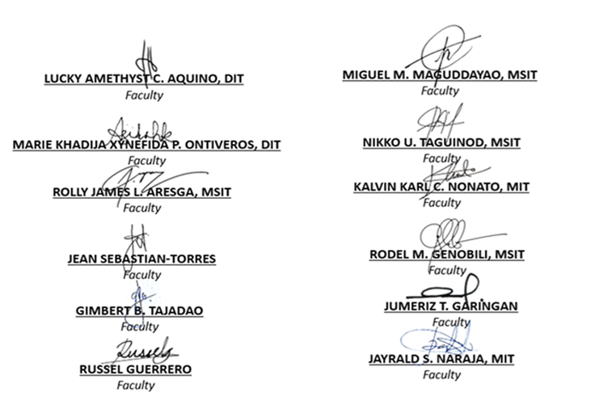
Prepared By:

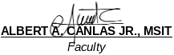

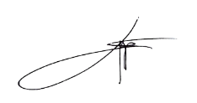
Reviewed by:

SHERWIN M. CAACBAY, MIT
BSIT Program Coordinator, CSU Carig

LEO P. PALIUANAN, PhD
BSIT Program Coordinator, CSU Aparri

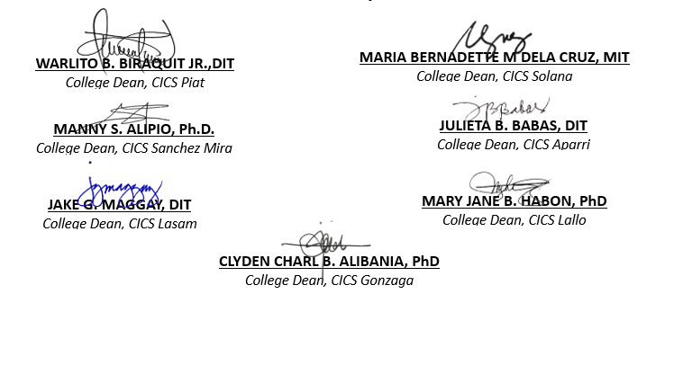
Further Reviewed by:


Approved By:

PROF.CHARMIE S. CALVO, DIT
University Dean, CICS

- D

- B

- B

- A

- C

- B

- A

- B

- C

- C

- C

- B

- B

- C

- C

- C

- A

- D

- B

- A

- B

- B

- C

- B

- B

- B
- C

- A (Waterfall is plan-driven and predictive; Agile is iterative and adaptive)

- A (Unary / Recursive relationship)

- C

- B

- A

- B

- A

- C

- A

- C

- B

- A

- B

- C

- B

- A

- B

- A

- A

- C

- A

- B

- E

