MIDTERM EXAMINATION
IT311 - APPLICATION DEVELOPMENT AND EMERGING TECHNOLOGIES
First Semester, A.Y. 2026-2027

NAME:_______________________ | YEAR&SECTION:________ | DATE:________ | SCORE:__^{/50}

- MULTIPLE CHOICE: Read each question carefully. Choose the letter of the correct answer from the given choices. Encircle the letter of your chosen answer. Make sure that your answer is clear and legible. Answer all items.
- A university expects frequent requirement changes and wants continuous user feedback. Which model is most appropriate?
A. Waterfall B. RAD C. Prototype D. Agile E. Spiral
- Which section of the SRS details constraints such as regulatory compliance, hardware limitations, and language requirements?
A. User Interface Mockups B. System Architecture
C. Non-Functional Requirements D. Functional Requirements
- A developer tests the calculation feature of a payroll system separately to ensure that employee salaries are calculated correctly.
What type of testing is being performed?
A. Unit Testing B. System Testing C. Integration Testing D. UAT
- Which of the following is true about an SRS?
A. This is also called the requirements document specification.
B. All of the following choices
C. This is a stage where you get to gather the requirements needed for the system development.
D. An informal report accomplished by the customer.
- A company needs a system quickly and users can work closely with developers. Which model is most appropriate?
A. Spiral B. Agile C. Prototype D. RAD E. Waterfall
- What is the central risk-driven characteristic of the Spiral Model?
A. Absence of formal documentation requirements.
B. Reliance solely on daily stand-up meetings.
C. Explicit risk assessment and management in every iteration cycle.
D. Completion of testing before writing any application code.
- A campus executive officer is an example of a(n) ______.
A. attribute B. data flow C. relationship D. entity
- A testing team runs the exact same test automation suite for six consecutive months without updating test scripts. Defect discovery drops to near zero, yet users report bug reports in production. Explain this situation.
A. Pesticide Paradox B. Absence-of-Errors Fallacy
C. Ineffective deployment pipelines D. Failure of White-Box coverage
- A client is unsure about the system's design, so developers create an initial version for feedback. Which model is most appropriate?
A. Prototype B. RAD C. Agile D. Waterfall E. Spiral
- Which DFD level provides an overview of the entire system as a single process with external entities?
A. Primitive DFD B. Level 2 DFD C. Context Diagram (Level 0) D. Level 1 DFD
- A school checks whether its student registration module correctly sends student information to the payment module. What type of testing is appropriate?
A. Integration Testing B. Security Testing
C. Unit Testing D. Performance Testing
- Requirements analysis should be conducted first before requirements gathering. Analysis takes place so that the requirements can be refined.
A. Both statements are false.
B. Both statements are true.
C. First statement is true. Second statement is false.
D. First statement is false. Second statement is true.
- Which SDLC model is characterized by a linear, sequential flow where each phase must be fully completed before the next phase begins?
A. Prototype Model B. Waterfall Model C. Agile Model D. Spiral Model
- A project has frequent requirement changes, but development follows a fixed sequence of phases. Which model is least suitable?
A. Waterfall B. Spiral C. Prototype D. RAD E. Agile
- In an Entity-Relationship Diagram (ERD), what visual symbol represents an entity?
A. Parallelogram B. Diamond C. Rectangle D. Ellipse
- A school replaces its old student records system and transfers existing student information into the new database. What deployment activity is this?
A. Go-Live B. Installation C. Configuration D. Data Migration
- Which requirement engineering activity involves resolving conflicting requests from different user groups?
A. Requirement Specification
B. Requirement Traceability Mapping
C. Feasibility Analysis
D. Requirement Negotiation and Prioritization
- A team follows Requirements Planning → User Design → Construction → Cutover. Which model are they using?
A. Waterfall B. Spiral C. RAD D. Agile E. Prototype
- A QA engineer tests a system without looking at internal source code structure, focusing purely on inputs and expected outputs. Which approach is this?
A. White-Box Testing B. Black-Box Testing C. Static Code Analysis D. Glass-Box Testing
- How many entities should be included in a context diagram?
A. 1 B. 0 C. 3 D. 2
- A bank wants to ensure that no transaction occurs without dual-authorization. During requirement analysis, how should this process be structured?
A. As a hardware interface requirement.
B. As a constraint in the Non-Functional section.
C. As a sequential business workflow rule in the Functional Specification.
D. As a post-implementation audit verification step
- What is the primary objective of developing a prototype in the Prototype SDLC Model?
A. To deliver the final scalable production build directly to clients.
B. To bypass phase documentation completely.
C. To clarify fuzzy user requirements and gather early user feedback.
D. To automate post-deployment system monitoring.
- A barangay complaint system passes all known tests, but residents complain that submitting a complaint is confusing and takes too many steps. Which principle does this illustrate?
A. Exhaustive Testing is Impossible
B. Absence of Errors Does Not Mean Success
C. Defects Tend to Cluster
D. Testing Shows the Presence of Defects
- Which of the following represents a functional requirement for an e-commerce platform?
A. The system shall send a confirmation email upon successful order placement.
B. The system shall process payments within 2 seconds
C. The system UI shall adhere to ISO 9241 accessibility guidelines.
D. The system shall maintain 99.9% uptime during peak hours.
- A project has high risks, but the development team has little experience in risk assessment. Which model may be difficult to use?
A. RAD B. Waterfall C. Spiral D. Agile E. Prototype
- The system will allow only three attempts if you forget your system password. What type of requirement is this?
A. nonfunctional requirement B. functional requirement
C. system requirement D. software requirement
- Before testing a clinic appointment system, the team installs the required software, prepares the database, and configures the test computers.
Which STLC phase is this?
A. Test Case Development B. Requirement Analysis
C. Test Environment Setup D. Test Closure
- Compare the Waterfall and Agile SDLC models. Which statement accurately contrasts their structural philosophies?
A. Waterfall welcomes scope changes anytime; Agile prohibits backlog revisions.
B. Waterfall discourages documentation; Agile relies heavily on upfront specification reports.
C. Waterfall delivers continuous working builds; Agile delivers full product at project end.
D. Waterfall is plan-driven and predictive; Agile is iterative and adaptive.
- One employee supervises another employee. What is the degree of the relationship?
A. unary B. binary C. mandatory one D. ternary
- After a new campus portal is launched, the IT team watches server performance, checks error logs, and responds to problems reported by students. What deployment activity is being performed?
A. Monitoring and Maintenance B. Data Migration
C. Installation D. Go-Live
- What does requirement elicitation mean?
A. Archiving obsolete system documentation
B. Validating requirements through unit testing
C. Gathering and discovering requirements from stakeholders
D. Converting requirements into executable code
- A developer changes the attendance module of a school system. After the change, testers check whether login, student registration, and report generation still work. What type of testing is this?
A. Security Testing B. Regression Testing C. Unit Testing D. UAT
- Which of the following is NOT an example of a nonfunctional requirement?
A. The client shall input numbers.
B. The client shall deliver on time.
C. The client will be happy with the results.
D. The client shall use windows 10 computer.
- A client wishes to build a novel social media application but cannot precisely define how users should interact with the feed. Which model should you apply to help establish these requirements?
A. Waterfall Model B. Linear Sequential Model
C. Cleanroom Software Engineering D. Prototype Model
- A college wants to determine whether its student portal remains responsive when thousands of students log in during enrollment.
What testing should be performed?
A. Unit Testing B. Regression Testing
C. Security Testing D. Performance Testing
- The SRS shall include the functionality of the system as well as its performance. The SRS shall cover all of the needs except for the diagrams.
A. Both statements are true.
B. First statement is true. Second statement is false.
C. Both statements are false.
D. First statement is false. Second statement is true.
- A barangay system has clear and stable requirements with few expected changes. Which model is most appropriate?
A. Prototype B. RAD C. Spiral D. Waterfall E. Agile
- A developer writes unit tests to verify that a specific math function correctly calculates compound interest under various inputs. What testing level is being applied?
A. Unit Testing B. System Testing C. Integration Testing D. Acceptance Testing

- EVALUATE: Student, Student Information System, Info Storage, Subject, Login Details. Which of the following is used as the external entity in a DFD?
A. info storage B. student and subject
C. login details D. student information system
- What is the primary purpose of a Software Requirements Specification (SRS) document?
A. To outline the detailed code syntax for developer implementation
B. To serve as a user manual for final deployment
C. To document the post-release maintenance schedule
D. To establish a formal agreement between stakeholders and developers
- A developer tests a transportation booking system with many inputs but knows that it is impossible to test every possible passenger, date, destination and payment combination. Which principle applies?
A. Security Testing
B. System Testing
C. Unit Testing
D. Regression Testing
- In which development scenario is the traditional Waterfall Model most appropriate?
A. Projects with rapidly shifting and unpredictable market requirements.
B. Early-stage startups building a Minimum Viable Product (MVP).
C. Well-defined, stable projects with rigid regulatory.
D. Open-source projects driven by community contributions
- A company wants to use RAD for a large and highly complex system involving many teams. What is the main concern?
A. RAD does not support rapid development.
B. RAD does not allow user involvement.
C. RAD requires fixed requirements.
D. RAD requires risk assessment.
E. RAD may be difficult to manage.
- While testing a clinic management system, testers discover that most of the errors occur in the appointment scheduling module. Which principle does this demonstrate?
  - Early testing saves time
  - Pesticide paradox
  - Defects tend to cluster
  - Testing depends on context
- A developer must be assigned to exactly one system. What is the relationship participation of the Developer entity?
A. optional one B. one C. One to one D. mandatory one
- For a municipal information system, the testing team decides who will test, what tools will be used, how long testing will take, and how much it will cost. Which STLC phase is this?
A. Test Case Development B. Test Closure
C. Test Execution D. Test Planning
- A school has fixed requirements and wants each development phase completed before the next begins. Which model is most appropriate?
A. Waterfall B. Agile C. Spiral D. RAD E. Prototype
- What is the primary purpose of Regression Testing in the software testing lifecycle?
A. To ensure user interface compliance with branding guidelines.
B. To verify that newly added code modifications have not adversely affected existing functionalities.
C. To evaluate load handling under stress conditions
D. To measure initial system load speed before launch

- EVALUATE: Student, Student Information System, Info Storage, Subject, Login Details. Which of the following is used as the process or node in a DFD?
A. login details
B. student information system
C. student and subject
D. info storage
- A banking project has high risks that must be assessed during every development cycle. Which model is most appropriate?
A. Spiral B. Agile C. RAD D. Prototype E. Waterfall

“Integrity is doing the right thing, even when no one is watching.” — C.S. Lewis

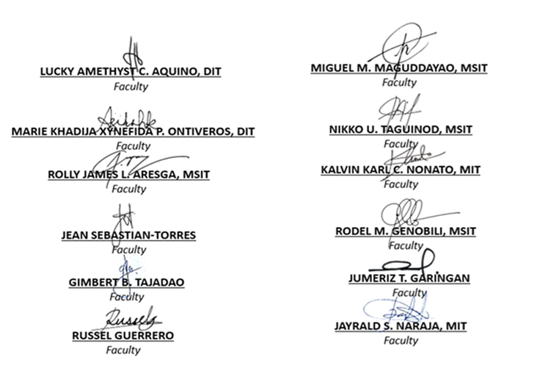
Prepared By:

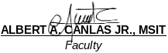

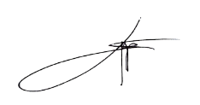
Reviewed by:

SHERWIN M. CAACBAY, MIT
BSIT Program Coordinator, CSU Carig

LEO P. PALIUANAN, PhD
BSIT Program Coordinator, CSU Aparri


Further Reviewed by:


Approved By:

PROF.CHARMIE S. CALVO, DIT
University Dean, CICS

- D

- C

- A

- C

- D

- C

- D

- A

- A

- C

- A

- D

- B

- A

- C

- D

- D

- C

- B

- D

- C

- C

- B

- A

- C

- B
- C

- D (Waterfall is plan-driven and predictive; Agile is iterative and adaptive)

- A (Unary / Recursive relationship)

- A

- C

- B

- A

- D

- D

- B

- D

- A

- B

- D

- D

- C

- E

- C

- D

- D

- A

- B

- B

- A

