MIDTERM EXAMINATION
Second Semester, A.Y. 2026-2027
TABLE OF SPECIFICATION
IT311 - APPLICATION DEVELOPMENT AND EMERGING TECHNOLOGIES
TOPIC | OBJECTIVES | HOURS TAUGHT | LEARNING OUTCOME |  |  |  |  |  | TOTAL NUMBER OF ITEMS
TOPIC | OBJECTIVES | HOURS TAUGHT | Remembering | Understanding | Applying | Analyzing | Evaluating | Creating | TOTAL NUMBER OF ITEMS
2. Requirements Analysis and Modeling  2.1 Software Requirements Specification  2.2 Steps of Requirement Analysis  2.3 Entity Relationship Diagram  2.4 Data Flow Diagram | - Define and understand SRS components and specifications  - Identify and apply key steps in requirement analysis  - Interpret and construct Entity Relationship Diagrams  - Understand and analyze Data Flow Diagrams | 19 | 4,26,33,7,20 | 2,24,36,40  ,12,17,31,15  ,29,10,39,49 | 21,45 |  |  |  | 19
SDLC Models  3.1 Waterfall  3.2 RAD  3.3 Spiral  3.4 Agile  3.5 Prototype Model | - Analyze phases and applicability of the Waterfall model  - Analyze Rapid Application Development methodology  - Identify and analyze risk-driven Spiral SDLC phases  - Evaluate iterative Agile processes and practices  - Apply and analyze prototyping in software engineering | 16 | 13,6,22 | 42 | 34 | 14,37,47,5,  18,43,25,  50,1,28,9 |  |  | 16
Software Testing and Deployment  4.1 Types of Software  4.2 Software Testing Principles  4.3 Software Testing Life Cycle  4.4 Deployment Activities | - Differentiate and apply various software testing types  - Apply testing principles to scenario analysis  - Implement phases of the Software Testing Life Cycle  - Apply software deployment procedures | 15 |  | 48 | 3,11,19,32  35,38,23,  31,44,41,27  ,46,16,30, | 8 |  |  | 15
Total |  | 40 |  |  |  |  |  |  | 50



Prepared by:
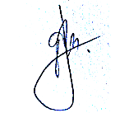
GIMBERT B. TAJADAO
Faculty

LUCKY AMETHYST C. AQUINO, DIT
Faculty
MIGUEL M. MAGUDDAYAO, MSIT
Faculty



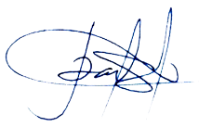

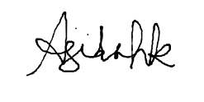
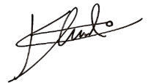
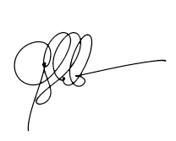


RUSSEL GUERRERO
Faculty

JAYRALD S. NARAJA, MIT
Faculty

JUMERIZ T. GARINGAN
Faculty

MARIE KHADIJA XYNEFIDA P. ONTIVEROS, DIT
Faculty

NIKKO U. TAGUINOD, MSIT
Faculty

KALVIN KARL C. NONATO, MIT
Faculty

ROLLY JAMES L. ARESGA, MSIT
Faculty

RODEL M. GENOBILI, MSIT
Faculty

JEAN SEBASTIAN-TORRES
Faculty

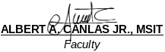

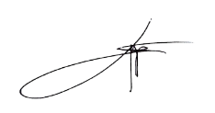
Reviewed by:
LEO P. PALIUANAN, PhD
BSIT Program Coordinator, CSU Aparri

SHERWIN M. CAACBAY, MIT
BSIT Program Coordinator, CSU Carig

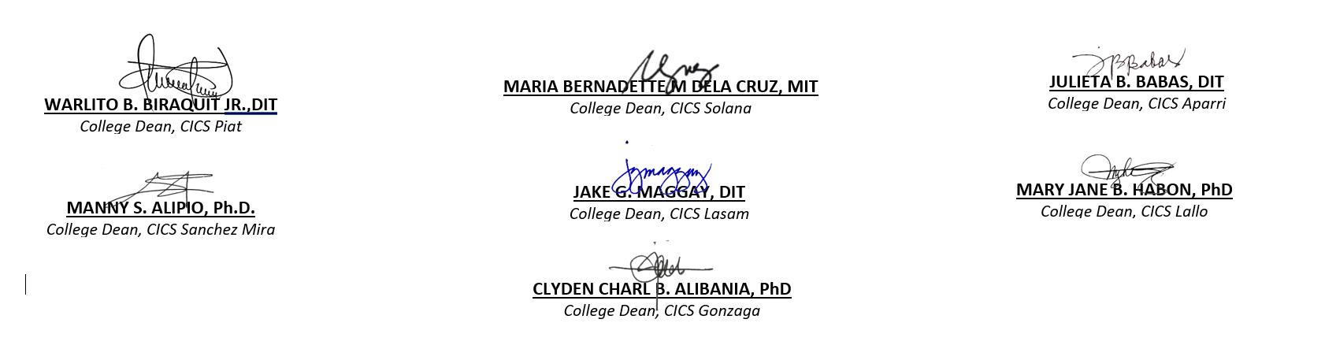
Further Reviewed by:

Approved by:



PROF. CHARMIE S. CALVO, DIT
University Dean, CICS

