Unit 1

Requirement Analysis and Modeling

 Introduction
Requirement Analysis and Modeling are significant steps in developing any kinds of software. It reviews all requirements and provides a graphical view of the entire system using diagrams. After the completion of the analysis, it is expected that the understandability of the project may improve significantly. This unit covers the topics on Software Requirement Specification, Steps in Requirement Analysis, Data Flow Diagram and Entity Relationship Diagrams, and create Data Dictionaries Files.

 Unit Learning Outcomes
By the end of the unit, students should be able to:
- Understand the importance of Software Requirements Specification Report in developing system application.
- Make a graphical view of frontend and backend structural design of the system by creating a model using ERD and DFD.
- Create a Data Dictionaries Files for database design.
- Write a System Analysis Report.

 Activating Prior Knowledge
10 items Diagnostic Test

Topic 1: Software Requirement Specification
Time Allotment: 1 Hour

Learning Objectives
At the end of this unit, students will be able to
- Understand the importance and use of Software Requirements Specification Report in Software Development
- Learn the different features and properties of a good SRS Document
- Construct a Software Requirements Specification Report

 Presentation of Contents
The production of the requirements stage of the software development process is Software Requirements Specifications (SRS) (also called a requirements document). This report lays a foundation for software engineering activities and is constructing when entire requirements are elicited and analyzed. SRS is a formal report, which acts as a representation of software that enables the customers to review whether it (SRS) is according to their requirements. Also, it comprises user requirements for a system as well as detailed specifications of the system requirements.
The SRS is a specification for a specific software product, program, or set of applications that perform particular functions in a specific environment. It serves several goals depending on who is writing it. First, the SRS could be written by the client of a system. Second, the SRS could be written by a developer of the system. The two methods create entirely various situations and establish different purposes for the document altogether. The first case, SRS, is used to define the needs and expectation of the users. The second case, SRS, is written for various purposes and serves as a contract document between customer and developer.

Software Requirement Specification Report Sample Content
- Introduction.
- Functional data description.
- Subsystem description.
- System modeling and simulation results.
- Products.
- Appendices.

Types of Requirements
The two types of requirements are
- Functional requirements:
  - input/output
  - Processing.
  - Error handling.
- Non-functional requirements:
  - Physical environment (equipment locations, multiple sites, etc.).ber
  - Interfaces (data medium etc.).
  - User & human factors (who are the users, their skill level etc.).
  - Performance (how well is system functioning).
  - Documentation.
  - Data (qualitative stuff).
  - Resources (finding, physical space).
  - Security (backup, firewall).
  - Quality assurance (max. down time, MTBF, etc.).

Characteristics of good SRS

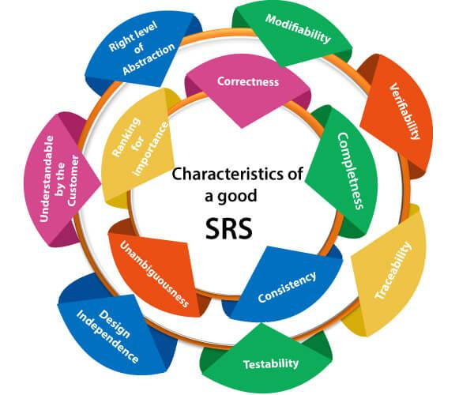
Following are the features of a good SRS document:
1. Correctness: User review is used to provide the accuracy of requirements stated in the SRS. SRS is said to be perfect if it covers all the needs that are truly expected from the system.
2. Completeness: The SRS is complete if, and only if, it includes the following elements:
(1). All essential requirements, whether relating to functionality, performance, design, constraints, attributes, or external interfaces.
(2). Definition of their responses of the software to all realizable classes of input data in all available categories of situations.
(3). Full labels and references to all figures, tables, and diagrams in the SRS and definitions of all terms and units of measure.
3. Consistency: The SRS is consistent if, and only if, no subset of individual requirements described in its conflict. There are three types of possible conflict in the SRS:
(1). The specified characteristics of real-world objects may conflicts. For example,
(a) The format of an output report may be described in one requirement as tabular but in another as textual.
(b) One condition may state that all lights shall be green while another states that all lights shall be blue.
(2). There may be a reasonable or temporal conflict between the two specified actions. For example,
(a) One requirement may determine that the program will add two inputs, and another may determine that the program will multiply them.
(b) One condition may state that "A" must always follow "B," while other requires that "A and B" co-occurs.
(3). Two or more requirements may define the same real-world object but use different terms for that object. For example, a program's request for user input may be called a "prompt" in one requirement's and a "cue" in another. The use of standard terminology and descriptions promotes consistency.
4. Unambiguousness: SRS is unambiguous when every fixed requirement has only one interpretation. This suggests that each element is uniquely interpreted. In case there is a method used with multiple definitions, the requirements report should determine the implications in the SRS so that it is clear and simple to understand.
5. Ranking for importance and stability: The SRS is ranked for importance and stability if each requirement in it has an identifier to indicate either the significance or stability of that particular requirement.
Typically, all requirements are not equally important. Some prerequisites may be essential, especially for life-critical applications, while others may be desirable. Each element should be identified to make these differences clear and explicit. Another way to rank requirements is to distinguish classes of items as essential, conditional, and optional.
6. Modifiability: SRS should be made as modifiable as likely and should be capable of quickly obtain changes to the system to some extent. Modifications should be perfectly indexed and cross-referenced.
7. Verifiability: SRS is correct when the specified requirements can be verified with a cost-effective system to check whether the final software meets those requirements. The requirements are verified with the help of reviews.
8. Traceability: The SRS is traceable if the origin of each of the requirements is clear and if it facilitates the referencing of each condition in future development or enhancement documentation.

There are two types of Traceability:
1. Backward Traceability: This depends upon each requirement explicitly referencing its source in earlier documents.
2. Forward Traceability: This depends upon each element in the SRS having a unique name or reference number.
The forward traceability of the SRS is especially crucial when the software product enters the operation and maintenance phase. As code and design document is modified, it is necessary to be able to ascertain the complete set of requirements that may be concerned by those modifications.
9. Design Independence: There should be an option to select from multiple design alternatives for the final system. More specifically, the SRS should not contain any implementation details.
10. Testability: An SRS should be written in such a method that it is simple to generate test cases and test plans from the report.
11. Understandable by the customer: An end user may be an expert in his/her explicit domain but might not be trained in computer science. Hence, the purpose of formal notations and symbols should be avoided too as much extent as possible. The language should be kept simple and clear.
12. The right level of abstraction: If the SRS is written for the requirements stage, the details should be explained explicitly. Whereas,for a feasibility study, fewer analysis can be used. Hence, the level of abstraction modifies according to the objective of the SRS.

Properties of a good SRS document
The essential properties of a good SRS document are the following:
Concise: The SRS report should be concise and at the same time, unambiguous, consistent, and complete. Verbose and irrelevant descriptions decrease readability and also increase error possibilities.
Structured: It should be well-structured. A well-structured document is simple to understand and modify. In practice, the SRS document undergoes several revisions to cope up with the user requirements. Often, user requirements evolve over a period of time. Therefore, to make the modifications to the SRS document easy, it is vital to make the report well-structured.
Black-box view: It should only define what the system should do and refrain from stating how to do these. This means that the SRS document should define the external behavior of the system and not discuss the implementation issues. The SRS report should view the system to be developed as a black box and should define the externally visible behavior of the system. For this reason, the SRS report is also known as the black-box specification of a system.
Conceptual integrity: It should show conceptual integrity so that the reader can merely understand it. Response to undesired events: It should characterize acceptable responses to unwanted events. These are called system response to exceptional conditions.
Verifiable: All requirements of the system, as documented in the SRS document, should be correct. This means that it should be possible to decide whether or not requirements have been met in an implementation.

Software Requirement Specification Example:
Please click this link: click here

 Application
Think of a System for a company (example: Bus Reservation, E-commerce, and Online Registration) and enlist its Product Functions and Functional Requirements. Please read the page 4 to 6 of the Software Requirement Specification Example above to learn how to do this activity.

Topic 2: Steps in Requirement Analysis
Time Allotment: 30 mins

Learning Objectives
At the end of this unit, students will be able to
• Understand the different Steps in Requirement Analysis

Presentation of Contents
Requirement analysis is significant and essential activity after elicitation. We analyze, refine, and scrutinize the gathered requirements to make consistent and unambiguous requirements. This activity reviews all requirements and may provide a graphical view of the entire system. After the completion of the analysis, it is expected that the understandability of the project may improve significantly. Here, we may also use the interaction with the customer to clarify points of confusion and to understand which requirements are more important than others.
Analysis Objectives
- Identify customer’s needs.
- Evaluate system for feasibility.
- Perform economic and technical analysis.
- Allocate functions to system elements.
- Establish schedule and constraints.
- Create system definitions.
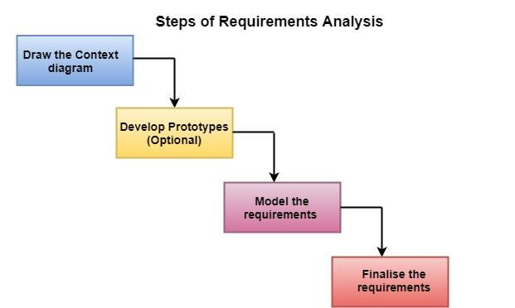
- Draw the context diagram: The context diagram is a simple model that defines the boundaries and interfaces of the proposed systems with the external world. It identifies the entities outside the proposed system that interact with the system. The context diagram of student result management system is given below:
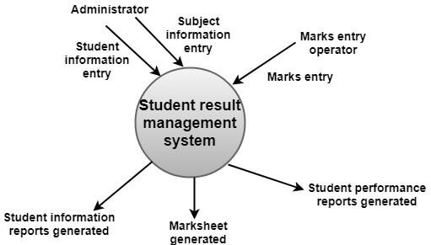
- Development of a Prototype (optional): One effective way to find out what the customer wants is to construct a prototype, something that looks and preferably acts as part of the system they say they want.
We can use their feedback to modify the prototype until the customer is satisfied continuously. Hence, the prototype helps the client to visualize the proposed system and increase the understanding of the requirements. When developers and users are not sure about some of the elements, a prototype may help both the parties to take a final decision.
Some projects are developed for the general market. In such cases, the prototype should be shown to some representative sample of the population of potential purchasers. Even though a person who tries out a prototype may not buy the final system, but their feedback may allow us to make the product more attractive to others.
The prototype should be built quickly and at a relatively low cost. Hence it will always have limitations and would not be acceptable in the final system. This is an optional activity.
Types of Prototyping
  - Throwaway Prototyping
    - prototype only used as a demonstration of product requirements
    - finished software is engineered using another paradigm
  - Evolutionary Rapid Prototyping
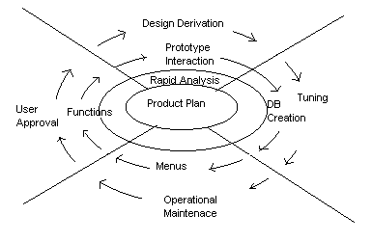
    - prototype is refined to build the finished system
- Model the requirements: This process usually consists of various graphical representations of the functions, data entities, external entities, and the relationships between them. The graphical view may help to find incorrect, inconsistent, missing, and superfluous requirements. Such models include the Data Flow diagram, Entity-Relationship diagram, Data Dictionaries, State-transition diagrams, etc.
Types of Model
  - Data model - shows relationships among system objects
  - Functional model - description of the functions that enable the transformations of system objects
  - Behavioral model - manner in which software responds to events from the outside world
- Finalise the requirements: After modeling the requirements, we will have a better understanding of the system behavior. The inconsistencies and ambiguities have been identified and corrected. The flow of data amongst various modules has been analyzed. Elicitation and analyze activities have provided better insight into the system. Now we finalize the analyzed requirements, and the next step is to document these requirements in a prescribed format.

Application
Create a context diagram of the system you’ve chosen in the previous activity.

Topic 3: Entity Relationship Diagram
Time Allotment: 1 Hour

Learning Objectives
At the end of this unit, students will be able to
- Understand the purpose of ERD
- Know the different components of ERD
- Learn how to create an ERD

Presentation of Contents
ER-modeling is a data modeling method used in software engineering to produce a conceptual data model of an information system. Diagrams created using this ER-modeling method are called Entity-Relationship Diagrams or ER diagrams or ERDs.
Purpose of ERD
- The database analyst gains a better understanding of the data to be contained in the database through the step of constructing the ERD.
- The ERD serves as a documentation tool.
- Finally, the ERD is used to connect the logical structure of the database to users. In particular, the ERD effectively communicates the logic of the database to users.
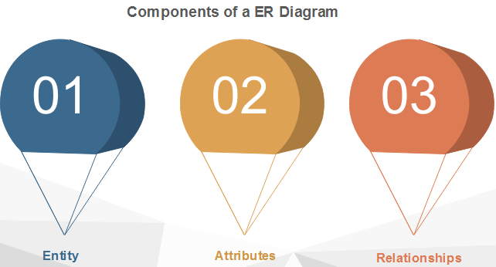

- Entity - An entity can be a real-world object, either animate or inanimate, that can be merely identifiable. An entity is denoted as a rectangle in an ER diagram. For example, in a school database, students, teachers, classes, and courses offered can be treated as entities. All these entities have some attributes or properties that give them their identity.
Entity Set
An entity set is a collection of related types of entities. An entity set may include entities with attribute sharing similar values. For example, a Student set may contain all the students of a school; likewise, a Teacher set may include all the teachers of a school from all faculties. Entity set need not be disjoint.
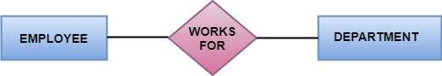

- Attributes - Entities are denoted utilizing their properties, known as attributes. All attributes have values. For example, a student entity may have name, class, and age as attributes. There exists a domain or range of values that can be assigned to attributes. For example, a student's name cannot be a numeric value. It has to be alphabetic. A student's age cannot be negative, etc.
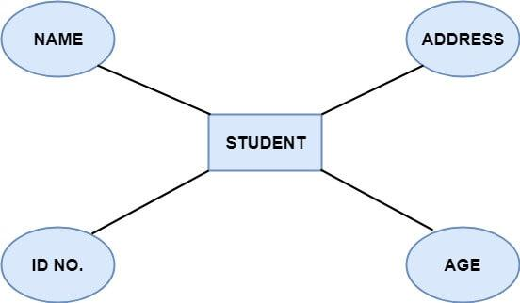
There are four types of Attributes:
- Key attribute - Key is an attribute or collection of attributes that uniquely identifies an entity among the entity set. For example, the roll_number of a student makes him identifiable among students.
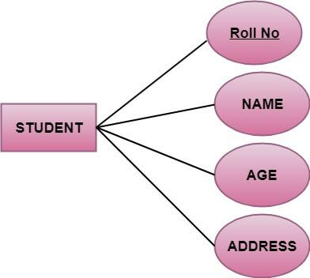
There are mainly three types of keys:
  - Super key: A set of attributes that collectively identifies an entity in the entity set.
  - Candidate key: A minimal super key is known as a candidate key. An entity set may have more than one candidate key.
  - Primary key: A primary key is one of the candidate keys chosen by the database designer to uniquely identify the entity set.
- Composite attribute - An attribute that is a combination of other attributes is called a composite attribute. For example, In student entity, the student address is a composite attribute as an address is composed of other characteristics such as pin code, state, country.
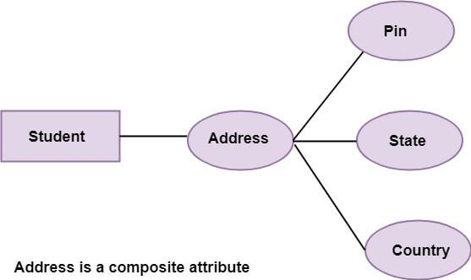
- Single-valued attribute - Single-valued attribute contain a single value. For example, Social_Security_Number.
- Multi-valued attribute - If an attribute can have more than one value, it is known as a multi-valued attribute. Multi-valued attributes are depicted by the double ellipse. For example, a person can have more than one phone number, email-address, etc. 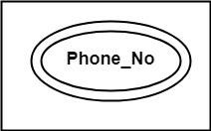
- Derived attribute - Derived attributes are the attribute that does not exist in the physical database, but their values are derived from other attributes present in the database. For example, age can be derived from date_of_birth. In the ER diagram, Derived attributes are depicted by the dashed ellipse. 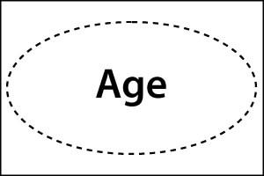
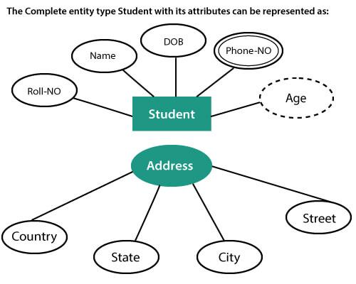
- Relationship - The association among entities is known as relationship. Relationships are represented by the diamond-shaped box. For example, an employee works_at a department, a student enrolls in a course. Here, Works_at and Enrolls are called relationships.
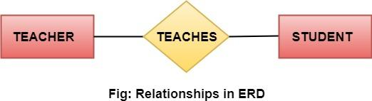
Relationship set
A set of relationships of a similar type is known as a relationship set. Like entities, a relationship too can have attributes. These attributes are called descriptive attributes.

Degree of a relationship set
The number of participating entities in a relationship describes the degree of the relationship. The three most common relationships in E-R models are:
- Unary (degree1) - This is also called recursive relationships. It is a relationship between the instances of one entity type. For example, one person is married to only one person.
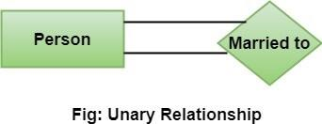
- Binary (degree2) - It is a relationship between the instances of two entity types. For example, the Teacher teaches the subject.
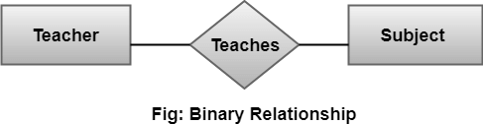
- Ternary (degree3) - It is a relationship amongst instances of three entity types. In fig, the relationships "may have" provide the association of three entities, i.e., TEACHER, STUDENT, and SUBJECT. All three entities are many-to-many participants. There may be one or many participants in a ternary relationship.
In general, "n" entities can be related by the same relationship and is known as n-ary relationship.
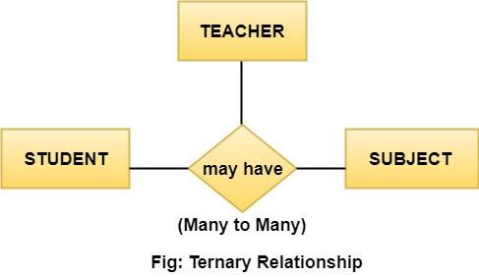
Cardinality
Cardinality describes the number of entities in one entity set, which can be associated with the number of entities of other sets via relationship set.
Types of Cardinalities
- One to One: One entity from entity set A can be contained with at most one entity of entity set B and vice versa. Let us assume that each student has only one student ID, and each student ID is assigned to only one person. So, the relationship will be one to one.
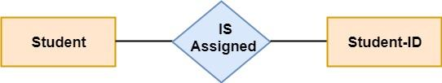
Using Sets, it can be represented as:
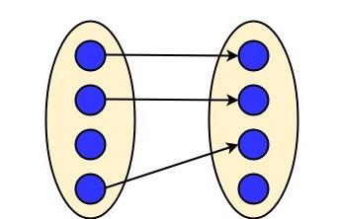
- One to many: When a single instance of an entity is associated with more than one instances of another entity then it is called one to many relationships. For example, a client can place many orders; a order cannot be placed by many customers.
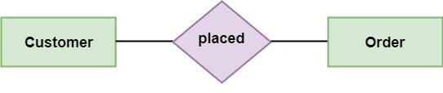
Using Sets, it can be represented as:
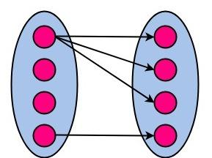
- Many to One: More than one entity from entity set A can be associated with at most one entity of entity set B, however an entity from entity set B can be associated with more than one entity from entity set A. For example - many students can study in a single college, but a student cannot study in many colleges at the same time.
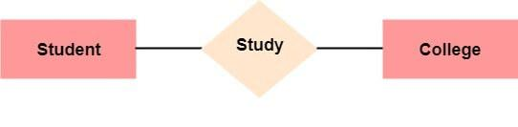
Using Sets, it can be represented as:
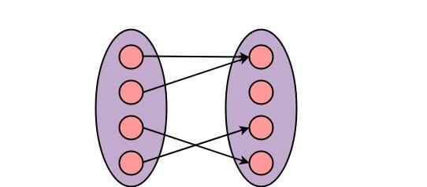
- Many to Many: One entity from A can be associated with more than one entity from B and vice-versa. For example, the student can be assigned to many projects, and a project can be assigned to many students.
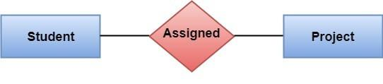
Using Sets, it can be represented as:
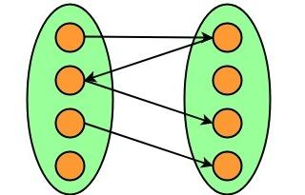

Application
Create a Entity Relationship Diagram using the system you have chosen in the previous activity.

Topic 4: Data Flow Diagram
Time Allotment: 1 Hour

Learning Objectives
At the end of this unit, students will be able to
- Understand the use of Data Flow Diagram
- Know the different symbols used in DFD
- Understand the Levels of Data Flow Diagram
- Learn the different Data Flow Diagram Errors
- Learn the different DFD Diagramming Rules

Presentation of Contents

A Data Flow Diagram (DFD) is a traditional visual representation of the information flows within a system. A neat and clear DFD can depict the right amount of the system requirement graphically. It can be manual, automated, or a combination of both.
It shows how data enters and leaves the system, what changes the information, and where data is stored.
The objective of a DFD is to show the scope and boundaries of a system as a whole. It may be used as a communication tool between a system analyst and any person who plays a part in the order that acts as a starting point for redesigning a system. The DFD is also called as a data flow graph or bubble chart.

The following observations about DFDs are essential:
- All names should be unique. This makes it easier to refer to elements in the DFD.
- Remember that DFD is not a flow chart. Arrows is a flow chart that represents the order of events; arrows in DFD represents flowing data. A DFD does not involve any order of events.
- Suppress logical decisions. If we ever have the urge to draw a diamond-shaped box in a DFD, suppress that urge! A diamond-shaped box is used in flow charts to represents decision points with multiple exists paths of which the only one is taken. This implies an ordering of events, which makes no sense in a DFD.
- Do not become bogged down with details. Defer error conditions and error handling until the end of the analysis.
Standard symbols for DFDs are derived from the electric circuit diagram analysis and are shown in fig:
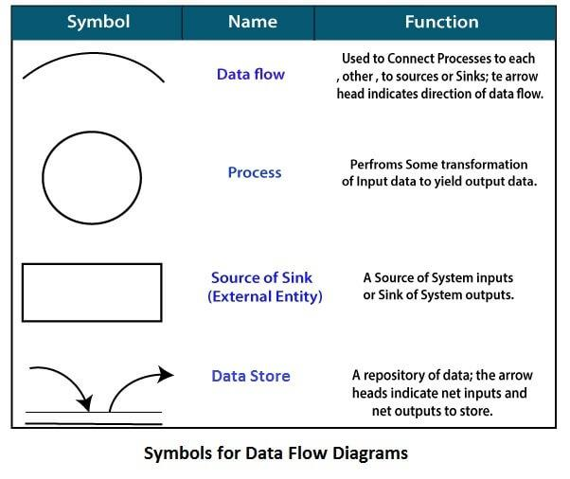

Symbols For Data Flow Diagram
- Circle: A circle (bubble) shows a process that transforms data inputs into data outputs.
- Data Flow: A curved line shows the flow of data into or out of a process or data store.
- Data Store: A set of parallel lines shows a place for the collection of data items. A data store indicates that the data is stored which can be used at a later stage or by the other processes in a different order. The data store can have an element or group of elements.
- Source or Sink: Source or Sink is an external entity and acts as a source of system inputs or sink of system outputs.

Levels in Data Flow Diagrams (DFD)
The DFD may be used to perform a system or software at any level of abstraction. Infact, DFDs may be partitioned into levels that represent increasing information flow and functional detail. Levels in DFD are numbered 0, 1, 2 or beyond. Here, we will see primarily three levels in the data flow diagram, which are: 0-level DFD, 1-level DFD, and 2-level DFD.

0-level DFDM
It is also known as fundamental system model, or context diagram represents the entire software requirement as a single bubble with input and output data denoted by incoming and outgoing arrows. Then the system is decomposed and described as a DFD with multiple bubbles. Parts of the system represented by each of these bubbles are then decomposed and documented as more and more detailed DFDs. This process may be repeated at as many levels as necessary until the program at hand is well understood. It is essential to preserve the number of inputs and outputs between levels, this concept is called leveling by DeMacro. Thus, if bubble "A" has two inputs x1 and x2 and one output y, then the expanded DFD, that represents "A" should have exactly two external inputs and one external output as shown in fig:
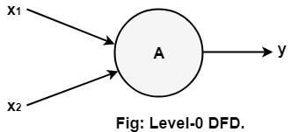
The Level-0 DFD, also called context diagram of the result management system is shown in fig. As the bubbles are decomposed into less and less abstract bubbles, the corresponding data flow may also be needed to be decomposed.

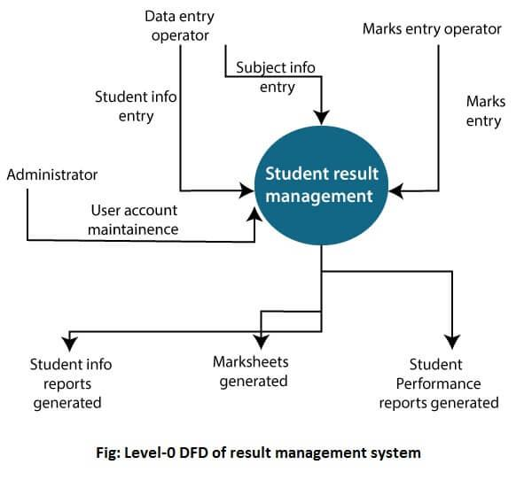
1-level DFD
In 1-level DFD, a context diagram is decomposed into multiple bubbles/processes. In this level, we highlight the main objectives of the system and breakdown the high-level process of 0-level DFD into subprocesses.
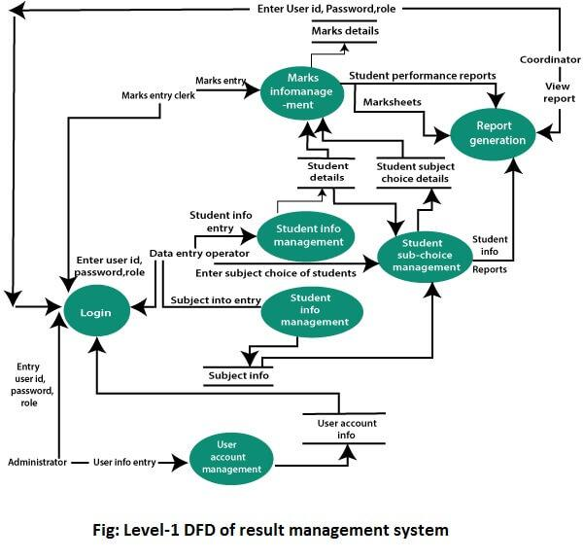
2-Level DFD
2-level DFD goes one process deeper into parts of 1-level DFD. It can be used to project or record the specific/necessary detail about the system's functioning.

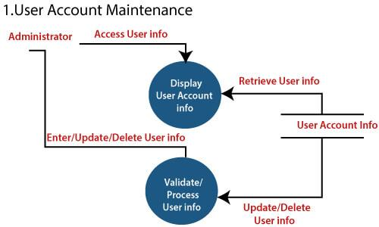
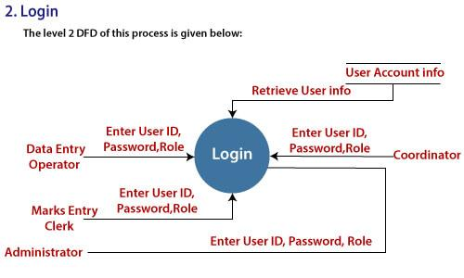
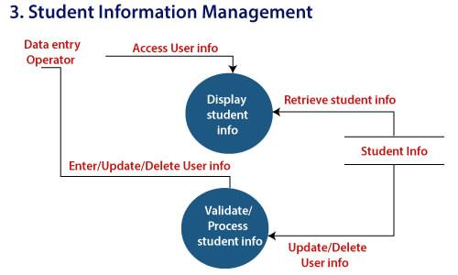
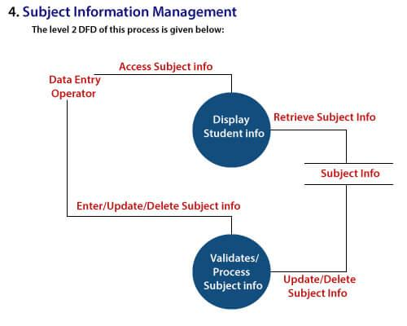
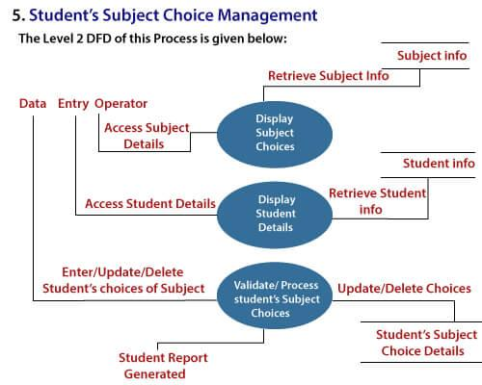
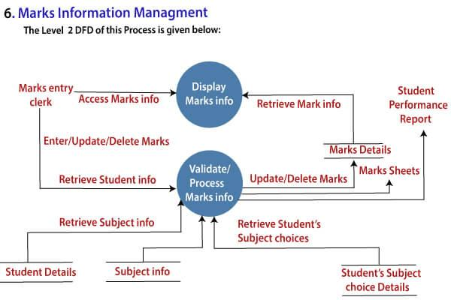

Data Flow Diagram Errors
The following conditions are errors that occur when drawing a data flow diagram:
- A process with only input data flow or only output data flow from it.
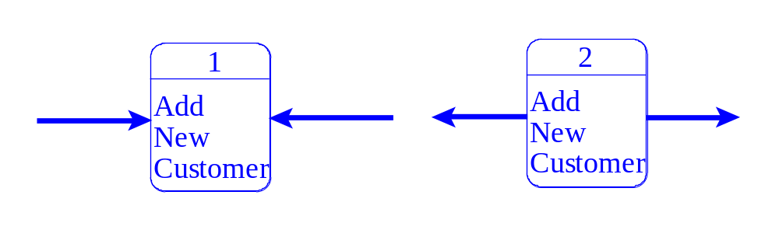
- Data stores or external entities are connected directly to each other, in any combination.
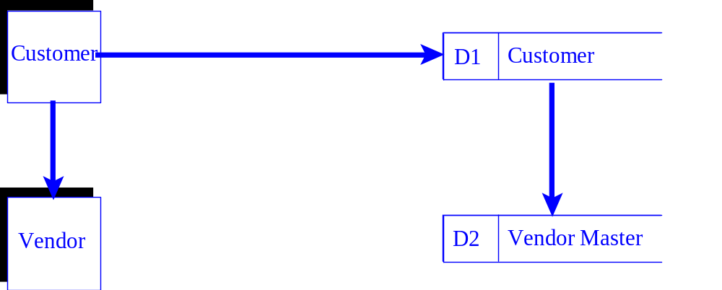
- Incorrectly labeling data flow or objects
Examples are:
  - Labels omitted from data flow or objects.
  - Data flow labeled with a verb.
  - Processes labeled with a noun.
- Too many processes on a data flow diagram.
  - Nine is the suggested maximum.
- Omitting data flow from the diagram
- Unbalanced decomposition between a parent process and a child diagram
  - The data flow in and out of a parent process must be present on the child diagram.

DFD Diagramming Rules
PROCESS
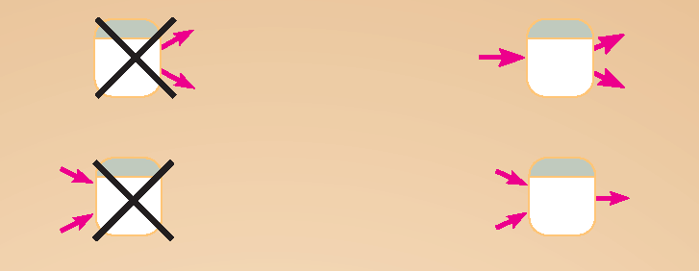
No process can have only outputs or only inputs…processes must have both outputs and inputs.
Process labels should be verb phrases.
DATA STORE
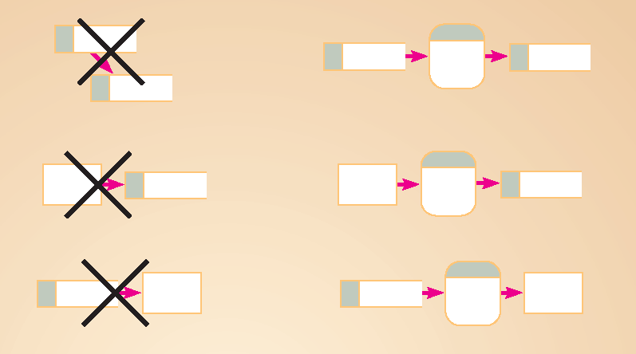
All flows to or from a data store must move through a process.
Data store labels should be noun phrases.
SOURCE/SINK

No data moves directly between external entities without going through a process.
Interactions between external entities without intervening processes are outside the system and therefore not represented in the DFD.

DATA FLOW
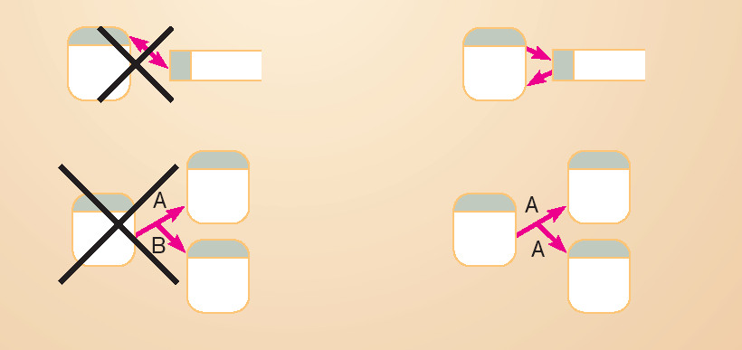
Bidirectional flow between process and data store is represented by two separate arrows.
Forked data flow must refer to exact same data item (not different data items) from a common location to multiple destinations.

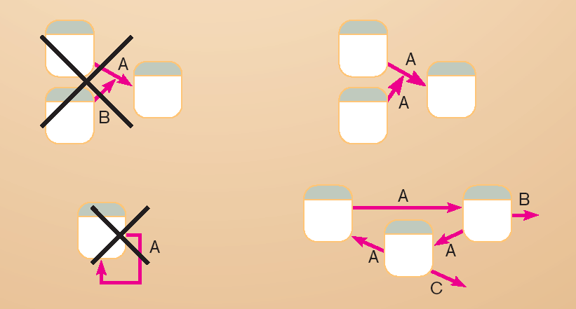
Joined data flow must refer to exact same data item (not different data items) from multiple sources to a common location.
Data flow cannot go directly from a process to itself, must go through intervening processes.
- Data flow from a process to a data store means update (insert, delete or change).
- Data flow from a data store to a process means retrieve or use.
- Data flow labels should be noun phrases.

Application
Create a Data Flow Diagram using the system you have chosen in the previous activity.

Topic 5: Data Dictionaries
Time Allotment: 30 Minutes

Learning Objectives
At the end of this unit, students will be able to
- Learn the different uses of Data Dictionaries
Presentation of Contents
A data dictionary is a file or a set of files that includes a database's metadata. The data dictionary hold records about other objects in the database, such as data ownership, data relationships to other objects, and other data. The data dictionary is an essential component of any relational database. Ironically, because of its importance, it is invisible to most database users. Typically, only database administrators interact with the data dictionary.
The data dictionary, in general, includes information about the following:
- Name of the data item
- Aliases
- Description/purpose
- Related data items
- Range of values
- Data structure definition/Forms
- The name of the data item is self-explanatory.
The name of the data item is self-explanatory.
Aliases include other names by which this data item is called DEO for Data Entry Operator and DR for Deputy Registrar.
Description/purpose is a textual description of what the data item is used for or why it exists.
Related data items capture relationships between data items e.g., total_marks must always equal to internal_marks plus external_marks.
Range of values records all possible values, e.g. total marks must be positive and between 0 to 100.
Data structure Forms: Data flows capture the name of processes that generate or receive the data items. If the data item is primitive, then data structure form captures the physical structures of the data item. If the data is itself a data aggregate, then data structure form capture the composition of the data items in terms of other data items.
The mathematical operators used within the data dictionary are defined in the table:
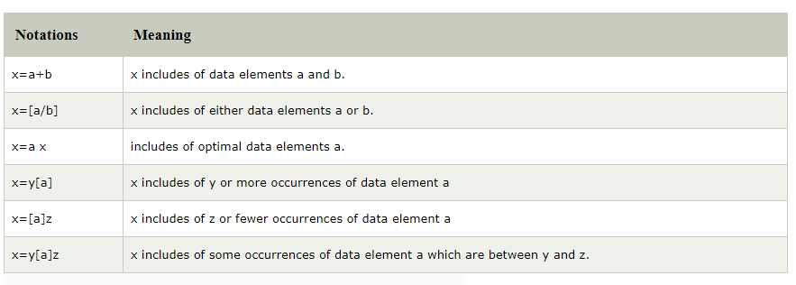
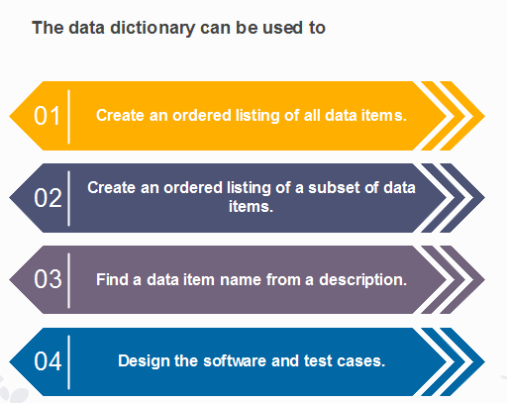

To understand the data dictionary further, please watch the video on this link
https://youtu.be/aOVN0v-HWcQ.

 Feedback
As a group, write a System Analysis Report using the template on this link (System Report Format). Your group will be assigned your subject teacher.

Reflection
In this section, I want to know how much and how you will improve the things you have learned on this subject. To do this, write a journal based from the question given below.
- What do you think is the importance of Requirements Analysis and Modeling in developing software application?
- What other topics do you think are needed to be included on this unit which are useful in writing System Requirements Specification Report and System Analysis Report?

