Sir:

I am writing to express my sincere intent to continue my service in the university as a Physical Education Part-Time Instructor. It has been an honor and privilege to be part of this institution, where I have gained valuable experiences, developed my professional skills, and contributed to the academic community.

Throughout my service, I have remained committed to fulfilling my duties with dedication, responsibility, and integrity. I value the trust and opportunities given to me by the university, and I am motivated to continue serving with the same passion and commitment.

As a Physical Education instructor, I strive to promote not only physical fitness and sportsmanship among students but also discipline, teamwork, and holistic development. I believe that my continued service will allow me to further contribute to the goals and mission of the institution while supporting the growth and success of the students and the university as a whole.

With this, I respectfully express my desire to continue my service and remain a productive member of the university community. I am hopeful for your kind consideration of my request.

Thank you very much.

Respectfully yours,

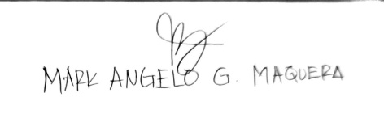
Part-Time Instructor

