Unit 1

INTRODUCTION TO PROGRAMMING USING C#

Introduction

Computer programming is a way of giving computers instructions about what they should do next. These instructions are known as code, and computer programmers write code to solve problems or perform a task.
The end goal is to create something: that could mean anything from a web page, or a piece of software, or even just a pretty picture. That’s why computer programming is often described as a mix between art and science; it’s technical and analytical, yet creative at the same time.
In this module students will be introduced to the world of C# programming. It will likewise teach students the different symbols in flowcharting at the same time use them in designing a flowchart. They will also learn on how to formulate algorithms and apply them in constructing input and output statements in a C# program. Several exercises and activities are included at the end of the module to further enhance their skills in flowcharting and algorithm.


Unit Learning Outcomes

At the end of the unit, you will be able to:

- Enumerate the different symbols used in flowcharting
- Draw a flowchart
- Formulate algorithm
- Manipulate C# IDE
- Apply input/output statements in a C# program

Topic: Introduction to Programming Using C#

Time Allotment: 5 hours lecture; 12 hours laboratory


Activating Prior Knowledge

What is PROGRAMMING?

K | W | L
(What You Know) | (What You want to | (What You Learned and
 | Learn) | still Want to Learn)


Presentation of Content

STEPS IN PROGRAM PLANNING AND DEVELOPMENT

Definition of a Program

Programming is the creation of an ordered set of instructions to solve a problem with a computer. The instructions sometimes referred to as codes make up a computer program.
Computer Program is a collection of instructions that performs a specific task when executed by a computer designed by a computer programmer. Programming needs a language called Programming Language to communicate with computers.

Steps in the Programming Process
All programming involves creating something that solves a problem. The problems can range from something of great scientific or national importance, through to something as trivial as relieving personal boredom!
This section describes one approach to solving such problems - think of it as a rough guide to the things you should do when entering the land of programming.
Most good programs require good planning before they are written. They follow specific steps similar to the steps in problem solving. They are:
- Problem definition
You need to understand the problem before you can expect to get a correct solution to the problem. What information (inputs), is given to you to use to solve the problem? What will the solution (outputs) of the problem, look like? What calculations (processes), will be used to change the input information into the desired output?
- Algorithm design
Break the problem into the steps of what must be done to solve the problem. List what tasks need to be done to solve the problem. An English outline is a good tool for doing the job. Expand the outline into a complete solution. It should list all the steps that need to be done, in the correct order they need to be done in.
- Desktop testing
In this step, you pretend to be a computer and execute the steps in the algorithm. Be careful to follow the algorithm exactly! Don't add steps, or leave out any steps. Don't rearrange the steps. If you don't get the right answer to the problem, then you have an error in the algorithm. Fix it and try again until you get the right answer.
- Coding
Once the algorithm, or complete outline works correctly, you need to translate the algorithm into a computer language that your computer understands.
- Testing and debugging
Now, enter the program into the computer, enter some test data, and have the computer execute the program. If you get the correct answer to the problem, the program works! Otherwise, look for errors in the program and try again.
- Documentation (optional)
You may want to write a user’s manual in order for users of your program will know how to use it properly and step by step. Once the program works correctly, you want make sure the documentation is up to date and be ready to maintain the program. Good programs get better during the life-time as people think of better way to do things and additional tasks the program might do.

Program Logic Formulation
Logical reasoning – the use of logical thinking in order to find results or draw conclusions

Algorithm
An algorithm is a logical sequence of steps for solving a problem that can be translated into a computer program.
Two ways of implementing an algorithm:
- Pseudocode
- Flowchart

Flowcharts and Pseudocodes
A pseudocode is an artificial and informal language that helps programmers develop algorithms. It is usually a combination of English words and some keywords of a programming language.
A flowchart is a diagram that represents the sequence of operations in a process. It is a graphic representation of an algorithm.

Flowcharting Symbols
Oval |  | Terminal. Marks the starting or  ending point of the flowchart
Rectangle |  | Process. Represents a single step, or an entire sub-process within a larger process
Parallelogram |  | Input/Output. Represents material or information entering or leaving the system
Circle |  | Connector. Indicates that the flow continues where a matching symbol has been placed
Arrow |  | Flow Lines. Lines indicate the sequence of steps and the direction of flow
Pentagon |  | Off-Page Connector. Indicates that the process continues off page
Diamond |  | Decision. A branching point; lines representing different decisions  emerge from different points of the diamond
Hexagon |  | Initialization. Used to prepare components of a program

Notations commonly used in Flowcharting

Notation | Meaning
+  -  *  /  **  ( )  =  >  <  < >  > =  < =  Y  N | Addition  Subtraction  Multiplication  Division  Exponentiation  Grouping  Equal to  Greater than  Less than  Not Equal to  Greater than or Equal to  Less than or Equal to  Yes  No

In making a flowchart, declaration of variables is also given attention. These variables will represent certain values. A variable is a storage location capable of containing a certain type of data that can be modified during
program execution.

Algorithms and flowcharts are two different ways of presenting the process of solving a problem. Algorithms consist of a set of steps for solving a particular problem, while in flowcharts, those steps are usually displayed in shapes and process boxes with arrows. So flowcharts can be used for presenting algorithms. This page will introduce some examples of algorithm flowcharts.
Flowcharts are diagrams that visually present the process of solving problems. The steps of creating algorithms flowcharts are described below. On this page you will find some flowchart examples explaining the algorithms.

Rules of Drawing Flowcharts for Algorithms
There are some basic shapes and boxes included in flowcharts that are used in the structure of explaining steps of algorithms. Knowing how to use them while drawing flowcharts is crucial. Here are some rules that should be known:
- All boxes of flowcharts are connected with arrows to show the logical connection between them,
- Flowcharts will flow from top to bottom,
- All flowcharts start with a Start Box and end with a Terminal Box,

Examples of Flowcharts for Algorithms
These examples will help you get a better understanding of flowchart techniques.

Example 1: Calculate the Interest of a Bank Deposit
Algorithm:
- Step 1: Read amount,
- Step 2: Read years,
- Step 3: Read rate,
- Step 4: Calculate the interest with formula "Interest=Amount*Years*Rate/100
- Step 5: Print interest,

Flowchart:
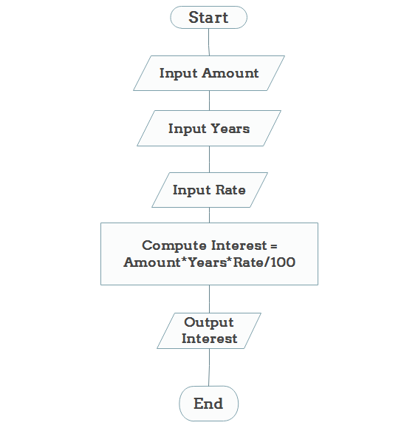

Example 2: Determine and Output Whether Number N is Even or Odd
Algorithm:
- Step 1: Read number N,
- Step 2: Set remainder as N modulo 2,
- Step 3: If remainder is equal to 0 then number N is even, else number N is odd,
- Step 4: Print output.

Flowchart:
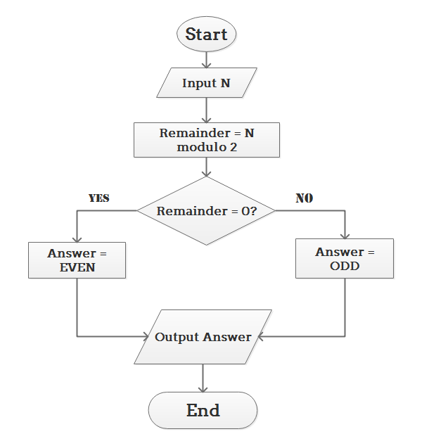

Example 3: Determine Whether a Temperature is Below or Above the Freezing Point
Algorithm:
- Step 1: Input temperature,
- Step 2: If it is less than 32, then print "below freezing point", otherwise print "above freezing point"

Flowchart:
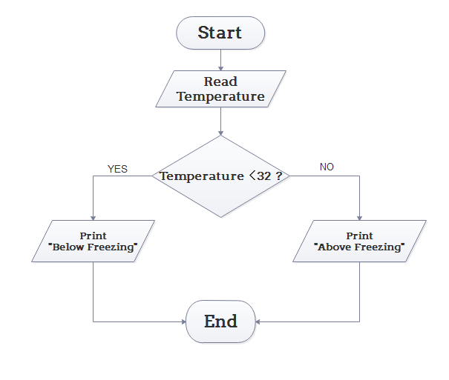

Example 4: Determine Whether A Student Passed the Exam or Not:
Algorithm:
- Step 1: Input grades of 4 courses M1, M2, M3 and M4,
- Step 2: Calculate the average grade with formula "Grade=(M1+M2+M3+M4)/4"
- Step 3: If the average grade is less than 60, print "FAIL", else print "PASS".

Flowchart:
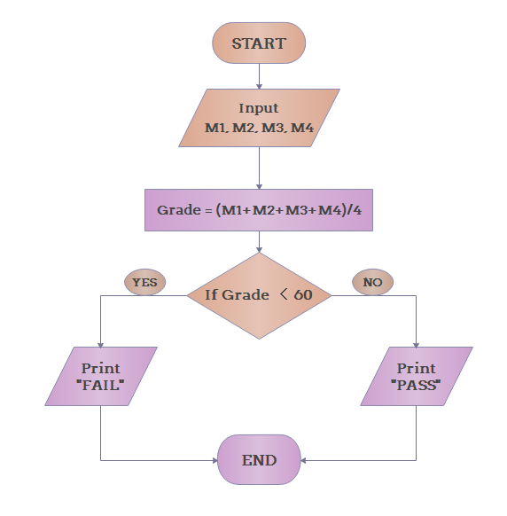

History of C#
During the development of the .NET Framework, the class libraries were originally written using a managed code compiler system called Simple Managed C (SMC). In January 1999, Anders Hejlsberg formed a team to build a new language at the time called Cool, which stood for "C-like Object Oriented Language" Microsoft had considered keeping the name "Cool" as the final name of the language, but chose not to do so for trademark reasons. By the time the .NET project was publicly announced at the July 2000Professional Developers Conference, the language had been renamed C#, and the class libraries and ASP.NET runtime had been ported to C#.

C#'s principal designer and lead architect at Microsoft is Anders Hejlsberg, who was previously involved with the design of Turbo Pascal, Embarcadero Delphi (formerly CodeGear Delphi, Inprise Delphi and Borland Delphi), and Visual J++. In interviews and technical papers he has stated that flaws in most major programming languages (e.g. C++, Java, Delphi, and Smalltalk) drove the fundamentals of the Common Language Runtime (CLR), which, in turn, drove the design of the C# language itself.
James Gosling, who created the Java programming language in 1994, and Bill Joy, a co-founder of Sun Microsystems, the originator of Java, called C# an "imitation" of Java; Gosling further said that "[C# is] sort of Java with reliability, productivity and security deleted. “Klaus Kraft and Angelika Langer (authors of a C++ streams book) stated in a blog post that "Java and C# are almost identical programming languages. Boring repetition that lacks innovation," "Hardly anybody will claim that Java or C# are revolutionary programming languages that changed the way we write programs," and "C# borrowed a lot from Java - and vice versa. Now that C# supports boxing and unboxing, we'll have a very similar feature in Java." In July 2000, Anders Hejlsberg said that C# is "not a Java clone" and is "much closer to C++" in its design.
Since the release of C# 2.0 in November 2005, the C# and Java languages have evolved on increasingly divergent trajectories, becoming somewhat less similar. One of the first major departures came with the addition of generics to both languages, with vastly different implementations. C# makes use of reification to provide "first-class" generic objects that can be used like any other class, with code generation performed at class-load time. Furthermore, C# has added several major features to accommodate functional-style programming, culminating in the LINQ extensions released with C# 3.0 and its supporting framework of lambda expressions, extension methods, and anonymous types. These features enable C# programmers to use functional programming techniques, such as closures, when it is advantageous to their application. The LINQ extensions and the functional imports help developers reduce the amount of "boilerplate" code that is included in common tasks like querying a database, parsing an xml file, or searching through a data structure, shifting the emphasis onto the actual program logic to help improve readability and maintainability.

C# used to have a mascot called Andy (named after Anders Hejlsberg). It was retired on January 29, 2004.

C# was originally submitted to the ISO subcommittee JTC 1/SC 22 for review, under ISO/IEC 23270:2003, was withdrawn and was then approved under ISO/IEC 23270:2006.

MAJOR PARTS OF A C# PROGRAM

A C# program basically consists of the following parts:
- Namespace declaration
- A class
- Class methods
- Class attributes
- A Main method
- Statements & Expressions
- Comments
Let us look at a simple code that would print the words "Hello World":

using System;
namespace HelloWorldApplication
{
class HelloWorld
{
static void Main(string[] args)
{
/* my first program in C# */ Console.WriteLine("Hello World"); Console.ReadKey();
}
}
}

When the above code is compiled and executed, it produces the following result:
Hello World

Let us look at various parts of the above program:
- The first line of the program using System; - the using keyword is used to include the System namespace in the program. A program generally has multiple using statements.
- The next line has the namespace declaration. A namespace is a collection of classes. TheHelloWorldApplication namespace contains the class HelloWorld.
- The next line has a class declaration, the class HelloWorld contains the data and method definitions that your program uses. Classes generally would contain more than one method. Methods define the behavior of the class. However, the HelloWorld class has only one method Main.
- The next line defines the Main method, which is the entry point for all C# programs. The Main method states what the class will do when executed
- The next line /*...*/ will be ignored by the compiler and it has been put to add additional comments in the program.
- The Main method specifies its behavior with the statement Console.WriteLine("Hello World");
WriteLine is a method of the Console class defined in the System namespace.
This statement causes the message "Hello, World!" to be displayed on the screen.
- The last line Console.ReadKey(); is for the VS.NET Users. This makes the program wait for a key press and it prevents the screen from running and closing quickly when the program is launched from Visual Studio .NET.
It's worth to note the following points:
- C# is case sensitive.
- All statements and expression must end with a semicolon (;).
- The program execution starts at the Main method.
- Unlike Java, file name could be different from the class name.

Compile & Execute a C# Program:
If you are using Visual Studio.Net for compiling and executing C# programs, take the following steps:
- Start Visual Studio.
- On the menu bar, choose File, New, Project.
- Choose Visual C# from templates, and then choose Windows.
- Choose Console Application.
- Specify a name for your project, and then choose the OK button.
- The new project appears in Solution Explorer.
- Write code in the Code Editor.
- Click the Run button or the F5 key to run the project. A Command Prompt window appears that contains the line Hello World.
You can compile a C# program by using the command-line instead of the Visual Studio IDE:
- Open a text editor and add the above-mentioned code.
- Save the file as helloworld.cs
- Open the command prompt tool and go to the directory where you saved the file.
- Type csc helloworld.cs and press enter to compile your code.
- If there are no errors in your code, the command prompt will take you to the next line and would generate helloworld.exe executable file.
- Next, type helloworld to execute your program.
- You will be able to see "Hello World" printed on the screen.

C# - Basic Syntax

C# is an object-oriented programming language. In Object-Oriented Programming methodology, a program consists of various objects that interact with each other by means of actions. The actions that an object may take are called methods. Objects of the same kind are said to have the same type or, more often, are said to be in the same class.

For example, let us consider a Rectangle object. It has attributes like length and width. Depending upon the design, it may need ways for accepting the values of these attributes, calculating area and display details.

Let us look at an implementation of a Rectangle class and discuss C# basic syntax, on the basis of our observations in it:

using System;
namespace RectangleApplication
{
class Rectangle
{
// member ariables
double length;
double width;
public void Acceptdetails()
{
length = 4.5;
width = 3.5;
}
public double GetArea()
{
return length * width;
}
public void Display()
{
Console.WriteLine("Length: {0}", length);
Console.WriteLine("Width: {0}", width);
Console.WriteLine("Area: {0}", GetArea());
}
}
class ExecuteRectangle
{
static void Main(string[] args)
{
Rectangle r = new Rectangle();
r.Acceptdetails();
r.Display();
Console.ReadLine();
}
}
}

When the above code is compiled and executed, it produces the following result:

Length: 4.5
Width: 3.5
Area: 15.75

The using Keyword

The first statement in any C# program is using System; The using keyword is used for including the namespaces in the program. A program can include multiple using statements.

The class Keyword

The class keyword is used for declaring a class.

Comments in C#
Comments are used for explaining code. Compilers ignore the comment entries. The multiline comments in C# programs start with /* and terminates with the characters */ as shown below:

/* This program demonstrates the basic syntax of C# programming language */

Single-line comments are indicated by the '//' symbol. For example,
//end class Rectangle

Member Variables
Variables are attributes or data members of a class, used for storing data. In the preceding program, the Rectangle class has two member variables named length and width.

Member Functions
Functions are set of statements that perform a specific task. The member functions of a class are declared within the class. Our sample class Rectangle contains three member functions: AcceptDetails, GetArea and Display.

Instantiating a Class
In the preceding program, the class ExecuteRectangle is used as a class, which contains the Main() method and instantiates the Rectangle class.

Identifiers
An identifier is a name used to identify a class, variable, function, or any other user-defined item. The basic rules for naming classes in C# are as follows:
- A name must begin with a letter that could be followed by a sequence of letters, digits (0 - 9) or underscore. The first character in an identifier cannot be a digit.
- It must not contain any embedded space or symbol like ? - +! @ # % ^ & * ( ) [
] { } . ; : " ' / and \. However, an underscore ( _ ) can be used.
- It should not be a C# keyword.

C# Keywords

Keywords are reserved words predefined to the C# compiler. These keywords cannot be used as identifiers; however, if you want to use these keywords as identifiers, you may prefix the keyword with the @ character.
In C#, some identifiers have special meaning in context of code, such as get and set, these are called contextual keywords.
The following table lists the reserved keywords and contextual keywords in C#:
Reserved Keywords
abstract | as | base | bool | break | byte | case
catch | char | checked | class | const | continue | decimal
default | delegate | do | double | else | enum | event
explicit | extern | false | finally | fixed | float | for
foreach | goto | if | implicit | in | in (generic modifier) | int
interface | internal | is | lock | long | namespace | new
null | object | operator | out | out (generic modifier) | override | params
private | protected | public | readonly | ref | return | sbyte
sealed | short | sizeof | stackalloc | static | string | struct
switch | this | throw | true | try | typeof | uint
ulong | unchecked | unsafe | ushort | using | virtual | void
volatile | while
Contextual Keywords
add | alias | ascending | descending | dynamic | from | get
global | group | into | join | let | orderby | partial (type)
partial (method) | remove | select | set


APPLICATION

- Given the algorithm below, draw a flowchart that accepts two numbers and compute for the sum, after which, print the two numbers with the computed sum.
Algorithm:
Define variables needed:
num1 = first number
num2 = second number
sum = sum of the two numbers

Input num1 and num2
Compute the sum, where sum = num1 + num2
Print num1, num2 and sum

- Draw a flowchart that will accept the name of a student, his prelim grade, midterm grade and final grade. It should likewise compute the average of the student. The flowchart will display the name of the student and the computed average.
- Write an Algorithm & Flowchart to convert temperature from Fahrenheit to Celsius.
- Write an Algorithm & Flowchart to find Area and Perimeter of Circle
- Create a simple program that would display your personal information and educational background.
- Make a simple program that would compute the average of the following grades:
Prelim – 83
Midterm – 88
Final Term - 92


REFLECTION

- What do you think is the essence of studying Programming as an Information Technology Student? What benefit can you derive from it especially in your everyday life?

________________________________________________________________________________________________________________________________________________________________________________________________________________________________________________________________________________________________________________________________________________________________________________________________________________________________________________________________________________________________________________________________________________________________________________________________________________________________________________________________________________________________________________________________________________________________________________________________________________________________________________________________________________________________________________________________



Deitel Harvetet. Al., Pearson Prentice Hall, Visiual C#.Net How to Program

Jeff Kent (2008) Visual C# 2008 DeMyTIFIED, McGraw Hill Osborne

https://www.edrawsoft.com/algorithm-flowchart-examples.html

