

College of Information and Computing Sciences

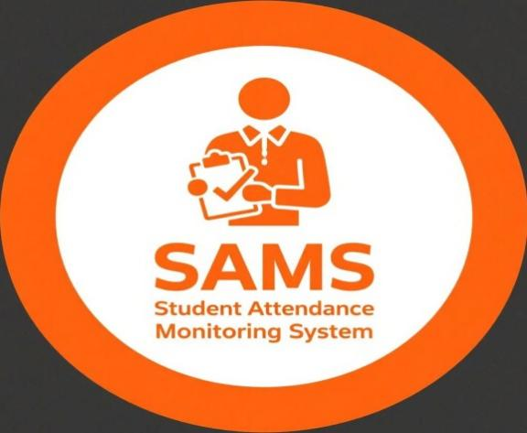
Student Attendance Monitoring System
Software Requirement Specification

Information Technology Project 2025

Submitted by:

MIA ELAIZA COLUMNA
MELODY ESLABON
MARIE JOYCE LONGAKIT
RENALYN DELA ROSA
LJ ROSE UGALE

Submitted to:

ALBERT ABINAN CANLAS

Date of submission
AUGUST 2025
Table of Contents
Table of Contents ii
Revision History ii
1. Introduction 3
1.1 Purpose 3
1.2 Document Conventions 4
1.3 Intended Audience and Reading Suggestions 4
1.4 Product Scope 5
1.5 References 5
2. Overall Description 6
2.1 Product Perspective 6
2.2 Product Functions 7
2.3 User Classes and Characteristics 8
2.4 Operating Environment 8
2.5 Design and Implementation Constraints 9
2.6 Project Documentation 9
2.7 User Documentation 9
2.8 Assumptions and Dependencies 9
3. External Interface Requirements 10
3.1 User Interfaces 10
3.2 Hardware Interfaces 12
3.3 Software Interfaces 12
3.4 Communications Interfaces 12
4. System Features 13
4.1 E-R Diagram 13
4.2 Activity Diagram 14
5. Other Nonfunctional Requirements 15
5.2 Performance Requirements 15
5.3 Safety Requirements 15
5.4 Security Requirements 16
5.5 Software Quality Attributes 16
5.6 Business Rules 17
6. Other Requirements 17
Appendix A: Glossary 17

Revision History
Name | Date | Reason For Changes | Version

- INTRODUCTION

1.1 Purpose

This document, Software Requirements Specification (SRS), describes the entire scope of both functional and non-functional requirements of the Student Attendance Monitoring System (SAMS). Basically, it acts as a map guiding the stages of the system's lifecycle and also, making sure that the result is a product that meets the goals of the institution and the requirements of its users. The SRS is very important for the developers, testers as well as the stakeholders for them to understand the system's operations, possibilities, and limitations.
The new system is aimed at the replacement of the old manual attendance procedures that are usually inefficient, inaccurate, and time-consuming. The system that tracks attendance by automation is saving time and money, as well as increasing the accuracy of data. Educators will have less work if they let the system manage their records and if there will no manual tabulations or logbooks in physical forms.
SAMS provides administrators and educators with the necessary resources to not only track attendance but also uncover behavioral patterns that help in planning how to react to the situation before it happens. The system encourages the idea of openness and honesty by granting pupils and their guardians the privilege of taking a look at attendance records. Such characteristics as these habits and support institutional policies of the academic performance and student discipline.
The content of this document includes system modules such as a student login, teacher submissions, admin reports, real-time alerts and how they interact to accomplish educational goals. Furthermore, inferring the significance of analytics and reports in providing users with the identification of known issues and potential solutions. These features are being introduced in order to spread the idea of being proactive and responsive which is also accommodating student development.
Such an SRS document really makes interaction between the project members more efficient and helps them to be on the same page regarding user requirements and technical implementation. It basically lays down a formal plan to help eliminate confusion, define responsibilities and record the advancement of the student's attendance tracking system throughout all stages of the design, development and implementation.

1.2 Document Conventions

The document uses RFC (Request for Comments) IEEE Software requirements specification (SRS) format as its base to facilitate the clarity, uniformity, and normalization of the whole documentation. Firstly, the major font is Times New Roman, size 12, with the main features written in bold and numbered according to their hierarchy for the user's convenience.All the figures are designed following UML 2.0 standards so as to keep the recognized by the industry modeling conventions that are very evident and universally understood.The use case examples are depicted by the Alistair Cockburn method, which comprises goal-driven descriptions, primary actors, precondition, main flow, and alternative flow.Tables and lists have been styled uniformly with the features that are clear, have borders and are aligned to make them easy to read.Words are defined in the glossary section so that the reader can understand them and abbreviations are explained at first use.Precision of all measurement units have been done in accordance with the International System of Units (SI).On the other hand, the IEEE citation style is being strictly followed both for references and citations so as to ensure proper attribution of sources.

1.3 Intended Audience and Reading Suggestions
The primary audience for this document is project supervisors, developers, QA testers, and system administrators. The content of each chapter in the document follows the normal flow of software development stages. The readers, depending on their duties, may obtain the sections that are the closest to their field of work. For instance, developers can drill down to the functionalities and features of the system, whereas project managers may get a grasp of the general description and limitations.
The document is very briefly outlined as follows:
1. Introduction
2. Overall Description
3. System Features and Functional Requirements
4. External Interface Requirement
5. Nonfunctional Requirements
6. Appendices.

1.4 Product Scope

SAMS is a web-based application that replaces manual attendance records with automated scanning. Students use ID cards with RFID or QR codes to record their attendance. The system not only logs entries but also generates reports, sends alerts to parents, and maintains a history of attendance for review. It improves accuracy, saves time, and ensures accountability in schools.
This system provides a centralized platform to record, manage, and monitor student attendance. Teachers can mark attendance digitally, and reports are generated automatically for administrators and students. The system ensures transparency, reduces manual workload, and supports both web and mobile platforms.

The system works as follows:

Teachers log in to the system to record student attendance by subject and date. The attendance is immediately saved to a secure database. Administrators can view attendance reports by class, section, or student. Students and their guardians can log in to view attendance records in real time. Notifications are triggered for excessive absences or if a threshold is crossed. All attendance data can be exported in PDF or Excel format.

1.5 References

IEEE Software Requirements Specification Template

ISO RFID and QR Code Technology Standards

Systems like MyClassAttendance and i-Attend

PHP Laravel Official Documentation

My SQL/ Postgre SQL User Manuals

2. Overall Description

2.1 Product Perspective
The Student Attendance Monitoring System is a local standalone application that is intended to substitute traditional manual and spreadsheet-based attendance tracking methods. It simplifies the process by automating attendance verification, recording, and reporting, which in turn minimizes the possibility of human error, and saves time for teachers and administrators. The system may work as a standalone or be combined with other academic platforms like learning management systems (LMS) and school information systems to make the operation more efficient. It is available on web browsers and mobile devices, thus offering flexibility to users at the location or those who use it from a distance.
The system is equipped with features that make it possible for real-time attendance monitoring, sending automatic notifications to parents, and securely storing data. The emphasis in its design is on being adaptable, which means allowing the integration with biometric devices, cloud storage, and the use of advanced analytics tools for performance and trend analysis in the future. This feature of being able to keep up with the technological and operational development of the institution, therefore, makes them compatible.

2.2 Product Functions
Student Attendance Monitoring Systems come with multiple facilities which mainly cover the basics functions of efficient and transparent attendance tracking. The system allows the teachers to take the daily student attendance through a safe web or mobile interface. Students can have access to check their attendance records during the day, letting more excellent accountability and personal monitoring. School administrators receive complete toolkits to create, evaluate, and extract reports in academic departments.
Functional Requirements:
Admin:
- Can manage the user account (add/edit/remove teachers and students) operations.
- Can obtain attendance data in the form of tables or charts for a class, a department, or an individual and also can get a report.
- Can set configuration for attendance limits and create alerts.
- Can render the captured attendance information in PDF or Excel format.
Teacher:
- Can securely log into their teacher dashboard.
- Can pick out a class and specify the attendance status of each student as present, absent, or late.
- Can check the attendance record of each class.
Student:
- Can securely log into their student dashboard.
- Can get access to their attendance report and daily records.
- Can get alerts through SMS or email about absences

[DIAGRAM FOR STUDENT MONITORING SYSTEM]

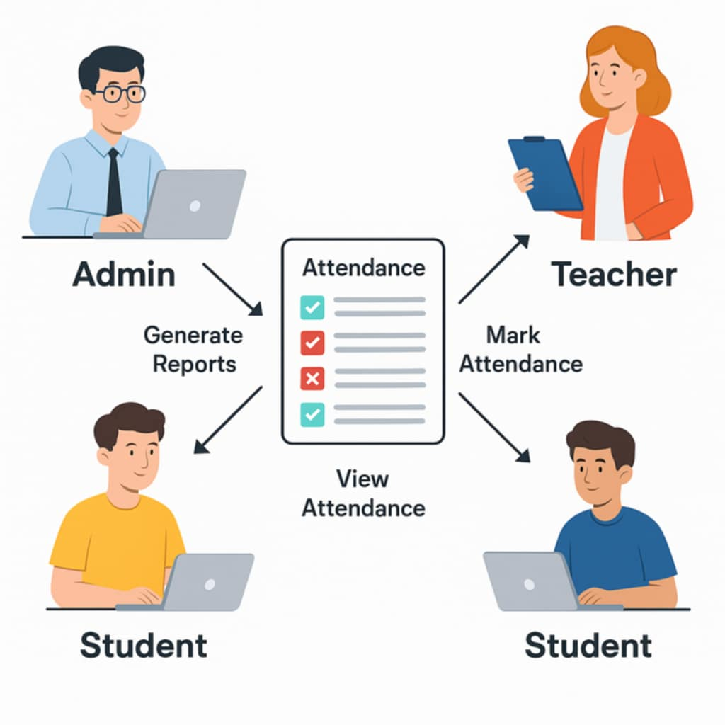

2.3 User Classes and Characteristics

The system has three user types: administrators, teachers, and students. Administrators have the rights of the whole system and are in charge of it. Teachers are the ones who take care of attendance, in which they mark the presence, and they also review the class record. Students are only allowed to check their attendance.
Descriptions of User Classes:
Administrators: Skilled in technology with the role of supervision. They are able to use the entire system without any restrictions.
Teachers: Knowledgeable of the educational situation in the classroom, having average technical skills. They can use the features of their classes

2.4 Operating Environment

The system will be hosted on a web server (Windows or Linux) and use PHP (Laravel) for backend operations. Users can access it through normal web browsers like Chrome or Firefox, and it will be linked to a MySQL or PostgreSQL database.

Hardware Requirements:
At least 8 GB RAM server with 100GB SSD storage
Desktop computers or tablets for teachers and admin
Mobile phones with internet for students
Software Requirements:
The backend is written in PHP or

2.5 Design and Implementation Constraints

Responsive design is a must for the system so that it can function smoothly on both desktop and mobile platforms. In order to keep the system safe from unauthorized access, user authentication, and role-based access should be put in place. Besides that, the system will also provide the encryption of all sensitive data such as student personal records and attendance logs.
Dependence on third-party APIs for communication (SMS, email) can be a risk, however, the design should be such that these are modular to allow easy replacement or updates without any impact on the rest of the system. Data should be according to normalization standards in order to eliminate redundancy and allow efficient queries. The architecture should be designed in a modular way for the ease of maintenance and scalability.

2.6 Project Documentation
Project Charter:
The project vase, roles as well as responsibilities, and timetable are defined here. An automated attendance system is the core idea, and thus, the main objective of the project is set.
Project Proposal: Explains the problems caused by manual attendance, the proposed solution, anticipated benefits, system overview, and general requirements. It is a document that was submitted for getting the green light before the implementation phase.

2.7 User Documentation
The system will be supported by a comprehensive user manual that will serve as a guide on how to perform a login and generate attendance reports as well as the entire system usage. It will be equipped with the necessary tools such as images, sequentially organized step guides, and easy solution to the problem experienced during the module navigation as per the role (Admin, Teacher, Students).

2.8 Assumptions and Dependencies
Users are expected to be familiar with the use of digital systems. A good internet connection is assumed to be available at all times within the institution. It is accounted for that the system is reliant on any available third-party APIs for

3. System Features and Function al Requirements

3.1 Use case Diagram:

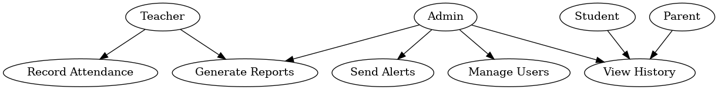

3.2 Use Case Scenarios

ID | Use Case Name | Actor | Description | Precondition | Main Flow | Postcondition | Alternate Flow
UC-01 | Record Attendance | Teacher | Teacher records student attendance for a specific class and date. | Teacher is logged in and has access to the class list. | - Teacher logs in.  - Selects class and date.  - Marks Present/Absent/Late.  - Submits attendance.  5. System saves data. | Attendance stored for reporting. | If offline, store locally and sync later.
UC-02 | View Attendance History | Student | Student views personal attendance records. | Student is logged in. | - Student logs in.  - Navigates to Attendance tab.  - System retrieves records.  4. Displays records. | Student sees complete history. | If no records, display “No data available.”
UC-03 | Generate Reports | Admin / Teacher | Generate attendance reports for classes or students. | Admin/teacher logged in with permissions. | - User logs in.  - Goes to Reports.  - Selects type.  4. System compiles & displays report. | User can download/export report. | If no data, show “No data available.”
UC-04 | Send Alerts | System | Sends notification to parents when a student is absent. | Parent contact info stored and opted in. | - Attendance marked absent.  - System verifies opt in.  3. Sends SMS/email to parent. | Parent receives notification. | If sending fails, log error.
UC-05 | Manage Users | Admin | Admin creates, edits, or removes user accounts. | Admin logged in. | - Admin logs in.  - Goes to User Management.  - Selects Add/Edit/Delete.  4. System updates database. | User account changes saved. | If invalid data, system prompts correction.

3.3 Software Interfaces
The system is going to communicate with a MySQL database for the storage of records. APIs will be utilized to synchronize the front-end requests with the back-end server. In short, the authentication and data retrieval are handled by RESTful APIs.

3.4 Communications Interfaces
User to server communication, as per the design, will be carried out via HTTPS to ensure there is no breaching of security. Email and SMS notifications are the result of the services of some externally used APIs such as SendGrid or Twilio. These interfaces provide users with notifications in the form of the attendance status or alerts of the system.
SMS gateway or email server for notification delivery

4. System Features

4.1 E-R Diagram

Entities:

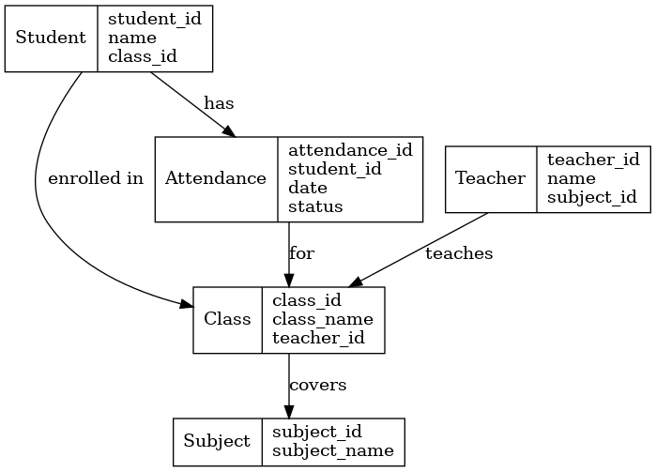

4.2Activity Diagram

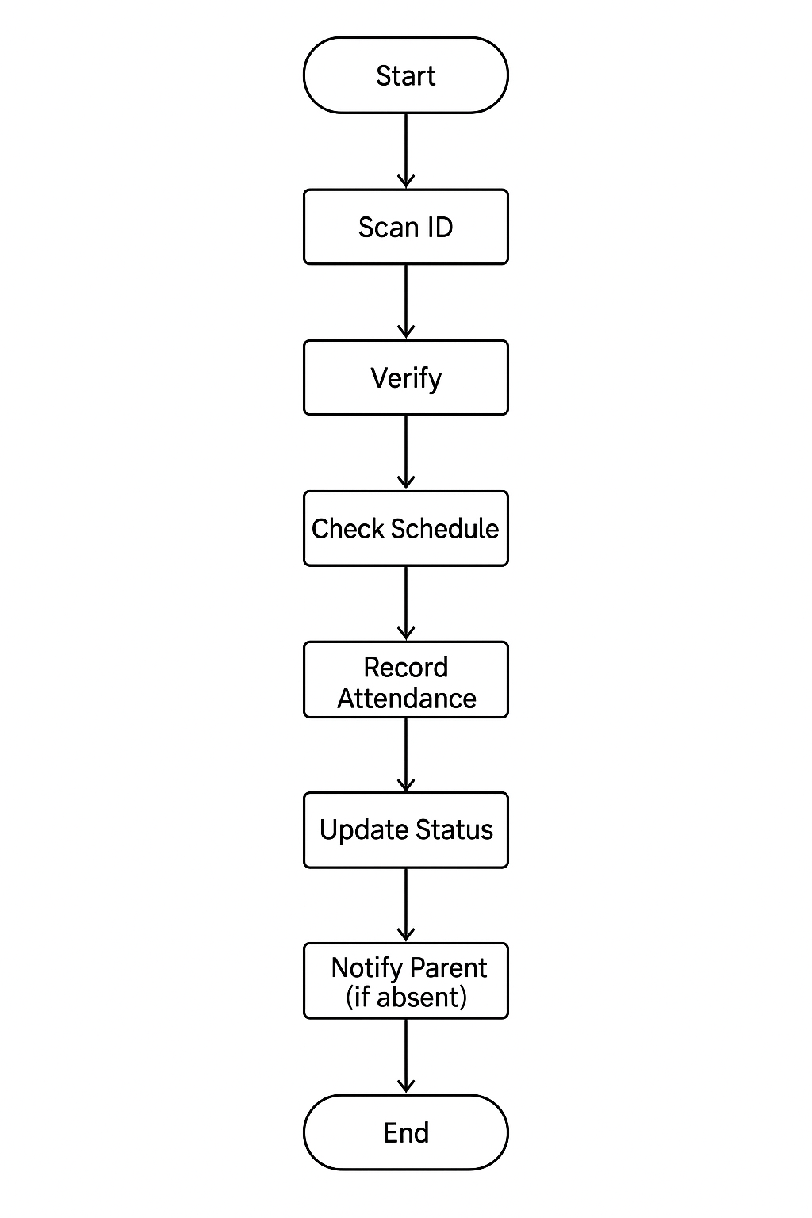
5.Other Non-Functional Requirements

5.1 Performance Requirements
Through the daily school routines, the attendance recording system needs to be a high efficiency machine with minimal disruption. As part of the identification procedure, the system is expected to confirm the student's identity and show the outcome within 2 seconds, thus the whole attendance recording, status updating, and potential parent notification process should be finished within 5 seconds in the case of normal working conditions. If a student is absent, the system has to send a notification to the parent automatically within 1 minute. Also, it should be possible to do 50 ID scans at the same time without the system getting slow or less effective and at the same time, the system has to be correct in matching IDs to student profiles 99.9% of the time. The system, as part of the school hours, can be down (not available) for only 0.5% of the time and the error messages must be delivered within 2 seconds if the verification or the schedule check fails. Moreover, the system needs to be designed in such a way that it can be expanded to accommodate 10,000 students without the need for a complete redesign of the system, thus providing reliability and institution-growth adaptability as a result of long-term usage.

5.2 Safety Requirements
To avoid any kinds of injuries, data loss, or operational failures, the attendance recording system has to be the foremost to uphold data and system security as its priority objectives. Any student and parent information should be saved in a database secured with encryption so that there is no access from unauthorized persons. The system should have dependable backup devices for the restoration of attendance records in situations of hardware failure, power outages, or system crashes. Besides, only authenticated people must be permitted through sufficient security measures to authorize changes to schedules, records, or system settings. The system is required to experience a smooth failure transition when it is the case of technical errors, providing a clear error message, and not revealing any sensitive data. The system must also have a security feature that will alert through the notification of a system in real-time check for and respond to the occurrence of any sorts of abnormal activities, such as instances of repeated scanning of IDs resulting in failure which may signify misuse and pose security threats. Furthermore, as part of the system's maintenance of the highest standards of data privacy, it must adhere to privacy regulations in place in order to protect personal data and to avoid any legal issues that may arise.

5.3 Security Requirements
The attendance monitoring system shall maintain the confidentiality, integrity, and availability of all data and system functions. Any communication between devices and the server needs to be encrypted. Secure protocols such as HTTPS with TLS must be used. User authentication should be based on a set of unique credentials and the implementation of role-based access control must be used to restrict the activities of users to the permissions assigned to them. Passwords should be saved in a manner that involves the use of strong hashing algorithms and the passwords should never be in plain text. The system is required to register all access and changes to the data for auditing purposes and at the same time be able to spot, for instance, numerous attempts at login that fail, thus, to be able to cause account lockout automatically. Backups of data have to be encrypted and stored in a location that is secure so that no one can get to the backup without authorization. The system should be developed in such a way that it is highly resistant to security threats that are very common, for example, a SQL injection, cross-site scripting (XSS), and denial-of-service (DoS) attacks. Besides, regular security updates and vulnerability assessments must be carried out to guarantee a safe environment.

5.4 Software Quality Attributes
An attendance recording system should be a dependable one where the accuracy of data and the system's good functionality are kept all through the normal and peak usage. This device ought to have availability of not less than 99.5% during the period of a school day, that is, the time that the system is in use. There should be a possibility of a system that is able to handle or accommodate more students, staff, and users at the same time without losing its excellent performance. Updates, bug fixes, and adding new features should be simple and should only cause the least possible operation interruption. The attendance system needs to have a friendly interface that even a student who has never had the system can use it properly and very easily. Besides, it should be accessible in future devices and can be used on different platforms, and even with the least changes in the configuration. Any security threat or crime of data should be protected against and kept at the very least; that is, a security breach should ensure that data's confidentiality, data integrity, and availability. Also, the machine should not waste time when performing an attendance task; instead, it should work quickly utilizing a small amount of the system's resources and be able to respond to a user's command even when it is heavily loaded.

5.5 Business Rules
- Valid ID Requirement – In order to record attendance, only student IDs that are registered in the system database are acceptable.
- Single Attendance per Session – A student may only be allowed to be present once for a scheduled class or school day.
- Automatic Absence Notification – If a student is marked absent and it is after the scheduled cutoff time then a notification must be sent to the parent or guardian.
- Attendance Cutoff Time – Attendance becomes valid only if the records have been submitted within a certain time frame (e.g., first 15 minutes of class).
- Authorized Access – Those (teachers, administrators) who have permission may only change or delete the attendance records.
- Schedule Dependency – Knowing that there is an assigned class or schedule for the student at that time, only then can attendance be recorded.
- Data Retention – The records of attendance kept in the system are required to be stored for a minimum period of five years for compliance and reporting purposes.
- Exception Handling – The persons responsible for the event (late arrivals, early dismissals, and excused absences) must be recorded along with correct remarks for accurate reporting.
- Backup and Recovery Policy – Methods of backing up attendance data must be carried out daily so as to avoid data loss.
- Compliance with Privacy Laws – Safe handling of attendance data must be in line with the respective data privacy laws.

6 . Other Requirements

Several other essential requirements must be in place for the attendance recording system to properly function. These include compliance with all relevant laws and regulations such as the Philippine Data Privacy Act, and also, the system must be in line with institutional policies. Data backups should be scheduled at least once every 24 hours, with automated incremental backups as a preferred option. A system should be able to work harmoniously with other school management software and communication platforms that are already in place as well as supporting English and Filipino languages for a wider range of users. There should be a provision for offline attendance recording, where data can be automatically synchronized once the connection is re-established. Proper user manuals, training materials, and other technical documents need to be there to support the administration and the staff. The system is required to keep a record of the complete audit trail of all attendance record changes for the purpose of accountability and in case of technical support, it should be available during school hours with a maximum waiting time of four working hours for urgent issues. Furthermore, people should be able to use the software on their desktops, tablets, and mobile devices without any loss in the quality of the service, and there should be some built-in performance monitoring tools that can keep track of the essential metrics of the software such as processing speed, uptime, and error rates.

Appendix A: Glossary

This glossary provides the definitions of the key terms that are related to the system of recording attendance. Those terms are the software, ID scanning, verification, schedule, attendance recording, status updates, and parent notifications. Moreover, it clarifies the notions such as a cutoff time that defines when an attendance is valid, an audit trail that guarantees accountability and data privacy that safeguards personal information.

