# 智慧相機

1. 匯入ML Kit函式庫，以實作圖像辨識
2. 建立一個ImageView顯示拍照後的影像
3. 建立兩個Button並實作拍照及旋轉照片的功能
4. 建立一個ListView顯示圖像辨識的結果與可信度
5. 點選拍照及旋轉90度按鈕後，將圖像進行辨識並輸出結果

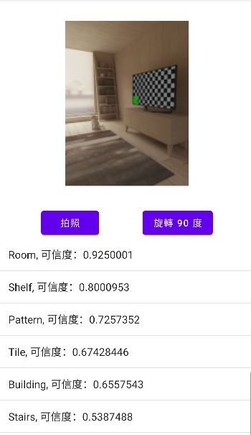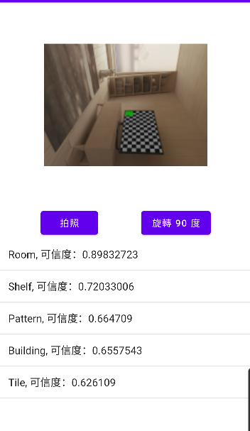

# 介面設計

1.繪製activity_main.xml

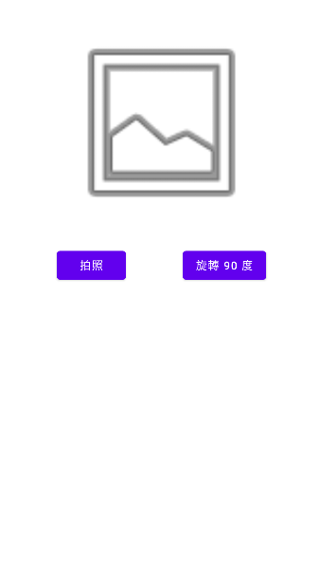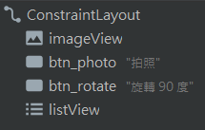

2.對應XML如下

**<?xml version="1.0" encoding="utf-8"?>**

**<androidx.constraintlayout.widget.ConstraintLayout**

**xmlns:android="http://schemas.android.com/apk/res/android"**

**xmlns:app="http://schemas.android.com/apk/res-auto"**

**xmlns:tools="http://schemas.android.com/tools"**

**android:layout_width="match_parent"**

**android:layout_height="match_parent"**

**tools:context=".MainActivity">**

**<ImageView**

**android:id="@+id/imageView"**

**android:layout_width="250dp"**

**android:layout_height="250dp"**

**android:layout_marginTop="32dp"**

**app:layout_constraintEnd_toEndOf="parent"**

**app:layout_constraintStart_toStartOf="parent"**

**app:layout_constraintTop_toTopOf="parent"**

**app:srcCompat="@android:drawable/ic_menu_gallery" />**

**<Button**

**android:id="@+id/btn_photo"**

**android:layout_width="wrap_content"**

**android:layout_height="wrap_content"**

**android:layout_marginTop="32dp"**

**android:text="拍照"**

**app:layout_constraintStart_toStartOf="parent"**

**app:layout_constraintEnd_toStartOf="@+id/btn_rotate"**

**app:layout_constraintTop_toBottomOf="@+id/imageView" />**

**<Button**

**android:id="@+id/btn_rotate"**

**android:layout_width="wrap_content"**

**android:layout_height="wrap_content"**

**android:text="旋轉 90 度"**

**app:layout_constraintStart_toEndOf="@+id/btn_photo"**

**app:layout_constraintEnd_toEndOf="parent"**

**app:layout_constraintTop_toTopOf="@+id/btn_photo" />**

**<ListView**

**android:id="@+id/listView"**

**android:layout_width="match_parent"**

**android:layout_height="0dp"**

**app:layout_constraintTop_toBottomOf="@+id/btn_photo"**

**app:layout_constraintBottom_toBottomOf="parent"/>**

**</androidx.constraintlayout.widget.ConstraintLayout>**

# 程式設計

package com.italkutalk.lab19

import android.content.ActivityNotFoundException

import android.content.Intent

import android.graphics.Bitmap

import androidx.appcompat.app.AppCompatActivity

import android.os.Bundle

import android.provider.MediaStore

import android.widget.*

import androidx.core.view.drawToBitmap

import com.google.mlkit.vision.common.InputImage

import com.google.mlkit.vision.label.ImageLabeling

import com.google.mlkit.vision.label.defaults.ImageLabelerOptions

import java.io.IOException

class MainActivity : AppCompatActivity() {

private var angle = 0f

override fun onActivityResult(requestCode: Int,

resultCode: Int, data: Intent?) {

super.onActivityResult(requestCode, resultCode, data)

if (requestCode == 0 && resultCode == RESULT_OK) {

val image = data?.extras?.get("data") ?: return

val bitmap = image as Bitmap

val imageView = findViewById<ImageView>(R.id.imageView)

imageView.setImageBitmap(bitmap)

recognizeImage(bitmap)

}

}

override fun onCreate(savedInstanceState: Bundle?) {

super.onCreate(savedInstanceState)

setContentView(R.layout.activity_main)

findViewById<Button>(R.id.btn_photo).setOnClickListener {

val intent = Intent(MediaStore.ACTION_IMAGE_CAPTURE)

try {

startActivityForResult(intent, 0) //發送 Intent

} catch (e: ActivityNotFoundException) {

Toast.makeText(this,

"此裝置無相機應用程式", Toast.LENGTH_SHORT).show()

}

}

findViewById<Button>(R.id.btn_rotate).setOnClickListener {

val imageView = findViewById<ImageView>(R.id.imageView)

angle += 90f

imageView.rotation = angle

val bitmap = imageView.drawToBitmap()

recognizeImage(bitmap)

}

}

private fun recognizeImage(bitmap: Bitmap) {

try {

val labeler = ImageLabeling.getClient(

ImageLabelerOptions.DEFAULT_OPTIONS

)

val inputImage = InputImage.fromBitmap(bitmap, 0)

labeler.process(inputImage)

.addOnSuccessListener { labels ->

val result = arrayListOf<String>()

for (label in labels) {

val text = label.text

val confidence = label.confidence

result.add("$text, 可信度：$confidence")

}

val listView = findViewById<ListView>(R.id.listView)

listView.adapter = ArrayAdapter(this,

android.R.layout.simple_list_item_1,

result

)

}

.addOnFailureListener { e ->

Toast.makeText(this,

"發生錯誤", Toast.LENGTH_SHORT).show()

}

} catch (e: IOException) {

e.printStackTrace()

}

}

}