Final Report:
AI Job Salary Analysis
  - By Bruno Sanchez Parra

Problem Statement:
The rapid expansion of AI-related employment has created inconsistent and overlapping job titles across industries, making it difficult for job seekers and analysts to understand how AI roles differ in compensation, experience expectations, work arrangements, and market positioning. This project aims to identify meaningful categories of AI jobs across North America and explain the characteristics that distinguish them and what can be expected of them.
By using data leveraged from multiple job postings related to Artificial Intelligence & technology jobs, I was able to tackle this task. The source dataset contained 51,932 postings and 22 variables. After initial cleaning and filtering by country labels, the analysis used 8,766 postings labeled as being in the United States or Canada

Data Wrangling:
I started the data wrangling process with obtaining the AI Jobs Dataset 2026 through KaggleHub. It loaded both an organized dataset and a raw postings file, then used the organized dataset for subsequent analysis. Its 22 variables included job title, employer characteristics, location, country, work arrangement, salary range, experience level, education, skills, specialization, and applicant count.
Initial checks found no missing values in the organized dataset and no exact duplicate rows. These checks established completeness at the table level, but did not establish that every field was accurate or that different rows represented distinct underlying vacancies. Unique URLs and collection timestamps can prevent otherwise similar postings from appearing as exact duplicates.
Three industry categories containing one posting each were excluded, leaving 51,929 rows. Company-size labels were standardized by combining two nearly equivalent descriptions of the 1,000–5,000 employee range. Education descriptions were also consolidated. In particular, the ambiguous requirement “Master's or PhD” was assigned to a master's category, a simplification that should be considered when interpreting education features.

The country filter retained the United States, Canada, and Mexico, but no Mexican records were present. The resulting dataset contained 4,370 postings labeled United States and 4,396 labeled Canada. Therefore, the geographic coverage was limited to the two represented countries, subject to the accuracy of those labels.
Salary ranges were parsed into lower and upper bounds. The prediction target was the arithmetic midpoint of those bounds. Although the exploratory notebook called this quantity “Median Salary,” it is a range midpoint, not the median of observed employee salaries. It also does not measure accepted offers or total compensation.

Exploratory Data Analysis:
Composition of the postings
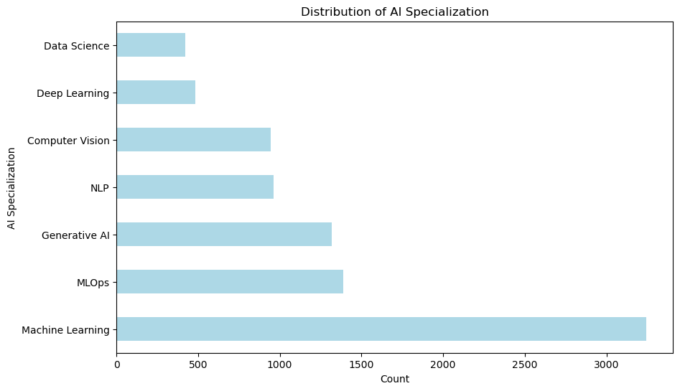
Machine Learning accounted for the majority of the postings with 3,245 postings, followed by MLOps with ~1400 and Generative AI with ~1,300. NLP and Computer Vision contributed ~950 postings, respectively, while Deep Learning and Data Science had ~500 and ~425. These figures describe the composition of this dataset and should not be interpreted as population estimates of demand across the AI labor market.

Mid-level positions represented ~4,500 postings, or approximately 50.2% of the sample. Senior roles accounted for ~2,500 postings and entry-level roles for ~1,725.
Remote positions were the largest work-arrangement group, with ~4,000 postings, followed by ~3,000 hybrid and ~1,800 on-site postings. Full-time employment accounted for ~7,500 postings, or approximately 85.2% of the sample. Counts across the ten retained industries were relatively similar.

Job titles and technical skills
For detailed title and skill comparisons, the analysis focused on titles with more than 100 postings. This subset contained 19 titles and 8,741 rows, excluding 25 rows from the full country-filtered sample. The restriction made comparisons less sensitive to very small groups, but it also excluded uncommon titles that may still represent meaningful roles.
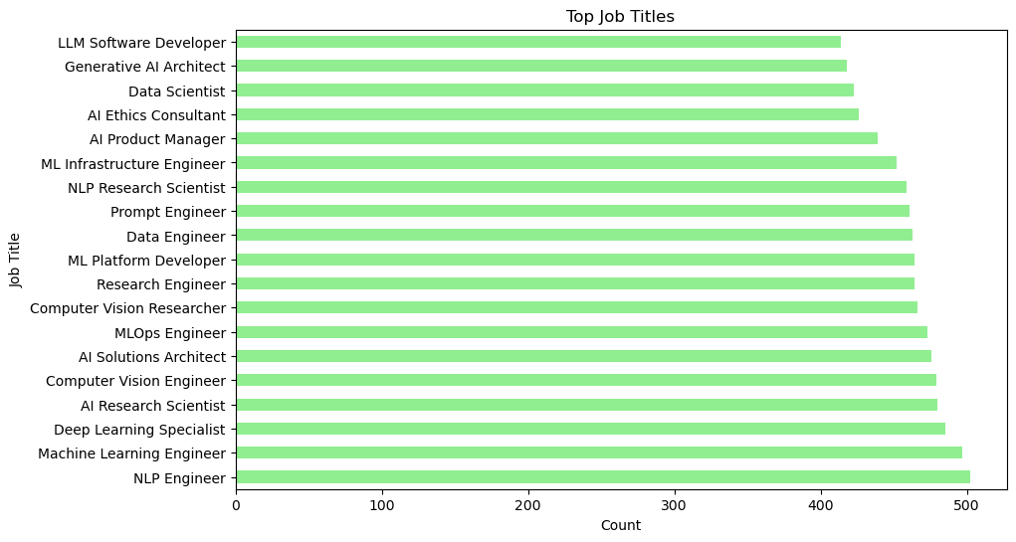
The recorded skill-frequency analysis identified Pandas as the most common skill, appearing in approximately 46.0% of this subset. Several traditional machine-learning tools and methods appeared in approximately 39–40% of postings, including LightGBM, Scikit-learn, Random Forest, Regression, XGBoost, NumPy, Supervised Learning, and Feature Engineering. PyTorch appeared in approximately 22.1%, while several MLOps tools appeared in approximately 19%.

Overall frequency did not capture how strongly skills distinguished individual specializations. The analysis therefore calculated skill prevalence within each specialization and subtracted prevalence across the full popular-title subset. The resulting values were percentage-point differences, not percentage increases.
Specialization | Examples of distinguishing skills in the analysis
Computer Vision | OCR, ResNet, OpenCV, YOLO, image processing
Data Science | Matplotlib, Statsmodels, SQL, A/B testing, data visualization
Deep Learning | Backpropagation, CNNs, CUDA, neural networks, Keras
Generative AI | Vector databases, LangChain, retrieval-augmented generation, fine-tuning, OpenAI API
MLOps | Git, model monitoring, Kubeflow, Kubernetes, Terraform
Machine Learning | Feature engineering, supervised learning, NumPy, XGBoost, regression
NLP | GPT, BERT, spaCy, tokenization, Transformers
These patterns support interpreting the dataset's specialization labels as distinct technical skill profiles. A skill's overall popularity and its usefulness for identifying a particular specialization are different properties. For example, a specialized tool can be uncommon across the full sample but highly characteristic of one group.
Industry, work arrangement, and applicant volume
Within the popular-title subset, a chi-square test comparing industry and specialization produced a statistic of 61.93 and a p-value of 0.2141. A second test comparing specialization and work arrangement produced a statistic of 8.71 and a p-value of 0.7279. Neither test provided sufficient evidence to reject independence at a conventional 0.05 significance level. These results do not prove that the variables are unrelated.
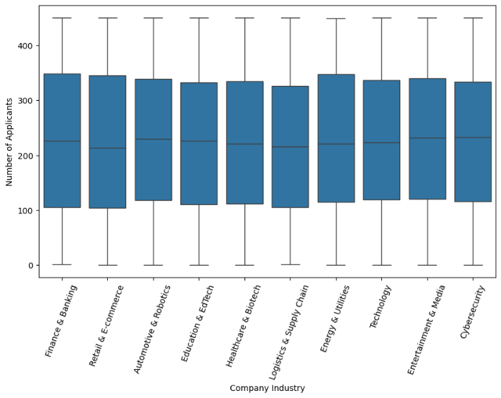
Applicant counts showed substantial overlap across specializations, industries, work arrangements, and experience levels. Median counts by specialization ranged from 212 for Generative AI to 238 for Data Science, while within-group standard deviations were approximately 128–132 applicants. The descriptive results suggested that differences within groups were much larger than differences between their typical applicant counts. The analysis did not establish causal effects or build an applicant-volume prediction model.

Preprocessing and Model Selection
Feature Engineering
The modeling dataset retained all 8,766 country-filtered postings. It contained 22 predictors: one normalized years-of-experience feature, three education indicators, three experience-level indicators, and fifteen binary skill indicators. Required experience ranged from zero to twelve years and was scaled to the interval from zero to one. Education was represented by bachelor's, master's, and PhD categories. Skill indicators used case-insensitive matching of complete comma-separated items, avoiding partial-name matches.
These feature choices defined the information available to the models. Hyperparameters, in contrast, controlled how each model learned from that information. For example, the number of selected skills was fixed during preprocessing, while tree depth was varied during Random Forest tuning. No additional scaling step was included in the model search. Linear Regression used 20 predictors after removing two reference-category indicators; Random Forest retained all 22.
Training and Evaluation Approach
The data were divided into 7,012 training rows and 1,754 test rows using an 80/20 random split with a fixed seed of 42. Saved row identifiers kept predictors aligned with their salary targets. Five-fold shuffled cross-validation on the training set guided hyperparameter selection, and both model families used the same fold configuration.
Mean absolute error (MAE) was the primary evaluation metric because it expresses the average absolute prediction error in salary units. Root mean squared error (RMSE) provided a measure that gives greater weight to large errors. R² measured performance relative to variation in the test targets. A mean-predicting DummyRegressor provided a simple reference for assessing whether the job features improved prediction.
Hyperparameter Tuning Strategy
Hyperparameters are settings specified before model fitting, such as whether Linear Regression includes an intercept or how deep a Random Forest tree can grow. They differ from learned parameters, such as regression coefficients and tree split thresholds, which are estimated from the training data. This project compared a small set of hyperparameter combinations for each model and selected the combination with the lowest average validation MAE.
For each candidate configuration, five-fold cross-validation fitted the model on four training folds and evaluated it on the remaining fold, repeating the process until every fold had served as validation data. Both searches used KFold(n_splits=5, shuffle=True, random_state=42), providing matching validation partitions. The scoring setting was neg_mean_absolute_error: the search maximized the negative score, which is equivalent to minimizing MAE. Scores were converted back to positive error values for reporting.
Linear Regression used RandomizedSearchCV with n_iter=4. Because its search space contained exactly four combinations, the search evaluated every combination rather than sampling only part of the space. Random Forest used GridSearchCV to evaluate all eight combinations in its search space. This required 20 cross-validation fits for Linear Regression and 40 for Random Forest, followed by one refit of each selected configuration on all 7,012 training rows. The 1,754 test rows were excluded from these searches and used afterward for the recorded model comparison.
The fixed random seeds supported reproducibility; they were not tuned for better scores. Likewise, n_jobs controlled computation rather than model quality. Both searches used n_jobs=-1 to parallelize candidate evaluation, while each forest used n_jobs=1 to avoid parallelizing at both levels. Training scores were retained alongside validation scores to assess overfitting. The validation standard deviations describe variation across these five folds, not confidence intervals, and the winning validation scores are not independent evaluations because they also guided selection. The earlier preprocessing limitations are discussed in Section 8.

