**UTM TCL3 DMP Data Format and Uploading Instructions**

This document describes the procedures for transmitting UTM TCL3 data to NASA. The requirements for the individual MOPS (CNS1, SAA2, etc.) have been transmitted previously in the form of tables. They are also located in the github repository at <https://github.com/nasa/utm-apis/tree/master/tcl3-data-apis>

**Important links:**

Primary Github link:

<https://github.com/nasa/utm-apis/tree/master/tcl3-data-apis>

**Supporting Files and Examples**

<https://github.com/nasa/utm-apis/tree/master/tcl3-data-apis/files>

**Swaggerhub links**

<https://app.swaggerhub.com/apis/utm/tcl3-flight-data>

<https://app.swaggerhub.com/apis/utm/tcl3-cns>

<https://app.swaggerhub.com/apis/utm/tcl3-con>

<https://app.swaggerhub.com/apis/utm/tcl3-saa>

<https://app.swaggerhub.com/apis/utm/tcl3-dat-4-99>

<https://app.swaggerhub.com/domains/utm/tcl3-dat-test-schema>

**Requirements Table**

<https://github.com/nasa/utm-apis/blob/master/tcl3-data-apis/files/requirements_table.xlsx>

**Instructions**

Before reading the below, examine the requirement tables above. They contain a summary view mapping MOP test IDs to required files.

**Part I: CNS, SAA, and CON**

Before you begin, make sure your organization has been registered by contacting [Abraham.k.ishihara@nasa.gov](mailto:Abraham.k.ishihara@nasa.gov).

**Preliminaries:**

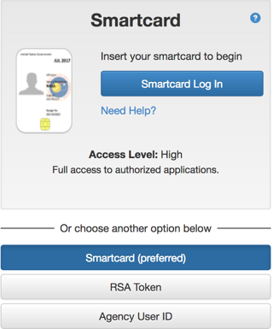**Step 1:** Log into utmregistry.arc.nasa.gov. You will be prompted to enter your IDMAX credentials.

**Step 2:** Click operators



**Step 3:** Select UVINS



**Step 4:** Upload data as described below

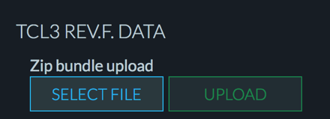

Once the file is uploaded it will go in the state UPLOADED. After about 10 minutes, you will be notified by email if there are any initial formatting errors.

CNS, SAA, and CON tests are vehicle-centric. In these scenarios, a vehicle (uvin) submits a flight plan (gufi) and performs one or more tests (for example CNS1 and SAA2). For each gufi flown, you must generate **a single zip file**. The contents of each zip file MUST contain

(a) a single FLIGHT_DATA json file

(b) a single json file for EACH test performed during this gufi. For example: if you perform CNS1, you must generate a file containing the json object CNS1_MOP (See swaggerhub for data model definitions)

(c) if applicable, associated non-JSON files such as pdf, kml, bin etc.

**Format:**

(1) For FLIGHT_DATA files, use the following naming convention:

{yourOrganizationName}-{dateOfFlightInYYYYMMDD}-{UTCtakeoffTimeInHHMM }-{FLIGHT_DATA}.json

e.g. UASORG-20180415-1320-FLIGHT_DATA.json

(2) For the individual MOP files use the following naming convention:

MOP file name format: {yourOrganizationName}-{dateOfFlightInYYYYMMDD}-{UTCtakeoffTimeInHHMM }-{MOPnameAndNumber}.json

e.g: UASORG-20180415-1320-CNS1.json

e.g: UASORG-20180329-1945-SAA3.json

e.g: UASORG-20180401-1655-CON5.json

(3) For test sites performing the CNS3_MOP test, use the following name convention for RF files:

File name format:

- If you are submitting a single RF file, use the following file format:

UTM-{yourOrganizationName}-{dateOfFlightInYYYYMMDD}-{UTCtakeoffTimeInHHMM }.bin

e.g: UTM-UASORG-20180231-1459-rfData.bin

- If multiple RF files were captured at the same date/time, use the following format:

UTM-{yourOrganizationName}-{dateOfFlightInYYYYMMDD}-{UTCtakeoffTimeInHHMM }-{freq.MHz}-{samplingRateSPS}-rfData.bin

e.g: For a signal of 725MHz at 2G samples/sec:

UTM-NYUASTS-20180326-1455-725MHz-2GSPS-rfData.bin

Note: Use the appropriate binary file extension (e.g. *.bin, *.dat, *txt, etc)

(4) PDF Files for CNS

As explained in the template “UTM-TCL3-DMP-RevF-CNS.pptx,” use the following convention to name your 'UTM-TCL3-DMP-RevF-CNSPDF' PDF file:

CNS PDF file name format: UTM-{yourOrganizationName}-CNS-{0} or{1,2,..,n}.pdf

Examples:

- If all the CNS flight (i.e. GUFI) PDF files have the same content then the file name will be: UTM-UASORG-CNS-0.pdf

- If a few the CNS flight (i.e. GUFI) PDF files have the same content then each version of the file name will be:

UTM-UASORG-CNS-1.pdf, UTM-UASORG-CNS-2.pdf, UTM-UASORG-CNS-3.pdf

- If all the CNS flight (i.e. GUFI) PDF files have different content then each file name will be: UTM-UASORG-CNS-1.pdf, UTM-UASORG-CNS-2.pdf, UTM-UASORG-CNS-3.pdf,…

(5) PDF Files for CON

As explained in the template “UTM-TCL3-DMP-RevF-CON.pptx”, use the following convention to name your 'UTM-TCL3-DMP-RevF-CONPDF' PDF file:

CON PDF file name format: UTM-{yourOrganizationName}-CON-{0} or{1,2‚...,n}.pdf

Examples:

- If all the CON flight (i.e. GUFI) PDF files have the same content then the file name will be: UTM-UASORG-CON-0.pdf

- If a few CON flight (i.e. GUFI) PDF files have the same content then each version of the file name will be:

UTM-UASORG-CON-1.pdf, UTM-UASORG-CON-2.pdf, UTM-UASORG-CON-3.pdf,…

- If all the CON flight (i.e. GUFI) PDF files have different content then each file name will be: UTM-UASORG-CON-1.pdf, UTM-UASORG-CON-2.pdf, UTM-UASORG-CON-3.pdf,…

(6) For test sites performing the CON2 and/or CON4 tests, use the following convention to name your 'UTM-TCL3-DMP-RevF-CONKML' files:

File name format: UTM-{yourOrganizationName}-CON-{0} or{1,2..n}.kml

Example:

- If all the CON flight (i.e. GUFI) KML files have the same content then the file name will be:

UTM-UASORG-CON-0.kml

- If a few CON flight (i.e. GUFI) KML files have the same content then each version of the file name will be:

UTM-UASORG-CON-1.kml, UTM-UASORG-CON-2.kml, UTM-UASORG-CON-3.kml ‚…

- If all the CON flight (i.e. GUFI) PDF files have different content then each file name will be:

UTM-UASORG-CON-1.kml, UTM-UASORG-CON-2.kml, UTM-UASORG-CON-3.kml,…

(7) PDF Files for SAA

As explained in the template “UTM-TCL3-DMP-RevF-SAA.pptx”, use the following convention to name your 'UTM-TCL3-DMP-RevF-SAAPDF' PDF files:

UTM-{yourOrganizationName}-SAA-{0} or{1,2,…,n}.pdf

Examples:

- If all the SAA flight (i.e. GUFI) PDF files have the same content then the file name will be UTM-UASORG-SAA-0.pdf

- If a few SAA flight (i.e. GUFI) PDF files have the same content then each version of the file name will be

UTM-UASORG-SAA-1.pdf, UTM-UASORG-SAA-2.pdf, UTM-UASORG-SAA-3.pdf,…

- If all the CNS flight (i.e. GUFI) PDF files have different content then each file name will be UTM-UASORG-SAA-1.pdf, UTM-UASORG-SAA-2.pdf, UTM-UASORG-SAA-3.pdf,…

(8) In order to complete the flight report, all of the MOP files (*.json, *.pdf, *kml, *.bin, etc) should be packaged into a single compressed file (*.zip), with the following name convention:

Compressed file name format:

{yourOrganizationName}-{dateOfFlightInYYYYMMDD}-{UTCtakeoffTimeInHHMM}-{MOPtestsDone}.zip

e.g. UASORG-20180415-1320-CNS1CNS2SAA5.zip

e.g. UASORG-20180329-1945-SAA1SAA2SAA3SAA6CON1.zip

**Example Zip Folder and File Names**

The following examples of zip folder and file names are provided for different tests involving single/multiple MOPS during a single flight (each zip folder corresponds to a single GUFI (flight)):

Ex.1) CNS1

UASORG-20180415-1320-CNS1.zip

-UASORG-20180415-1320-FLIGHT_DATA.json

-UASORG-20180415-1320-CNS1.json

-UTM-UASORG-CNS-0.pdf

Ex.2) CNS1, CNS2

UASORG-20180415-1320-CNS1CNS2.zip

-UASORG-20180415-1320-FLIGHT_DATA.json

-UASORG-20180415-1320-CNS1.json

-UASORG-20180415-1320-CNS2.json

-UTM-UASORG-CNS-0.pdf

Ex.3) CNS1, CNS2, CNS3

UASORG-20180415-1320-CNS1CNS3.zip

-UASORG-20180415-1320-FLIGHT_DATA.json

-UASORG-20180415-1320-CNS1.json

-UASORG-20180415-1320-CNS3.json

-UTM-UASORG-CNS-0.pdf

-UTM-UASORG-20180415-1320-725MHz-2GSPS-rfData.bin

Ex.4) CNS3, SAA1, SAA5

UASORG-20180415-1320-CNS3SAA1SAA5.zip

-UASORG-20180415-1320-FLIGHT_DATA.json

-UASORG-20180415-1320-CNS3.json

-UASORG-20180415-1320-SAA1.json

-UASORG-20180415-1320-SAA5.json

-UTM-UASORG-CNS-2.pdf

-UTM-UASORG-20180415-1320-725MHz-2GSPS-rfData.bin

-UTM-UASORG-SAA-0.pdf

Ex.5) CNS1, CNS3, SAA6, CON2

UASORG-20180415-1320-CNS1CNS3SAA6CON2.zip

-UASORG-20180415-1320-FLIGHT_DATA.json

-UASORG-20180415-1320-CNS1.json

-UASORG-20180415-1320-CNS3.json

-UASORG-20180415-1320-SAA6.json

-UASORG-20180415-1320-CON2.json

-UTM-UASORG-CNS-2.pdf

-UTM-UASORG-20180415-1320-725MHz-2GSPS-rfData.bin

-UTM-UASORG-CON-0.pdf

-UTM-UASORG-CON-0.kml

Ex.6) SAA3, SAA4, SAA5, CON1, CON2, CON4

UASORG-20180415-1320-SAA3SAA4SAA5CON1CON2CON4.zip

-UASORG-20180415-1320-FLIGHT_DATA.json

-UASORG-20180415-1320-SAA3.json

-UASORG-20180415-1320-SAA4.json

-UASORG-20180415-1320-SAA5.json

-UASORG-20180415-1320-CON1.json

-UASORG-20180415-1320-CON2.json

-UASORG-20180415-1320-CON4.json

-UTM-UASORG-SAA-1.pdf

-UTM-UASORG-CON-3.pdf

-UTM-UASORG-CON-2.kml

**Part II: DAT**

The DAT MOPS are USS-centric. They are not necessarily bound to a particular (uvin,gufi) pair. They are generally bound to a USS Instance and a corresponding flight test card. Before you begin, make sure your USS has been registered as an organization by contacting [Abraham.k.ishihara@nasa.gov](mailto:Abraham.k.ishihara@nasa.gov).

**Preliminaries:**

**Step 1:** Log into utmregistry.arc.nasa.gov. You will be prompted to enter your IDMAX credentials.

**Step 2:** Select the USS icon

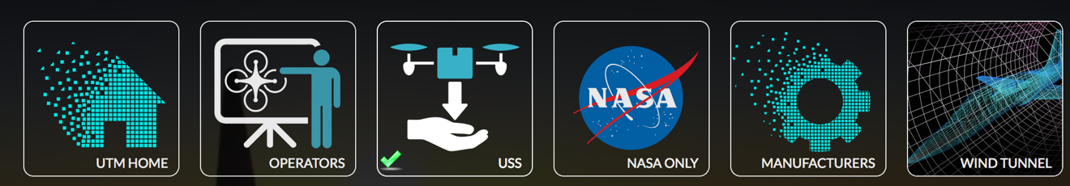

**Step 3:** Select USS Instances



**Step 4:** Click register new instance (if not already registered)



In general every USS Instance involved in data collection (DAT) mops must be created.

**Step 5:** Create the instance.

Fill in all fields

Ensure Instance UUID is the instance UUID that was used in the USS discovery registration process.

Instance Name can be any human readable identifier

Time Submitted, Time Available Begin, Time Available End are defined here

https://app.swaggerhub.com/apis/utm/ussdiscovery

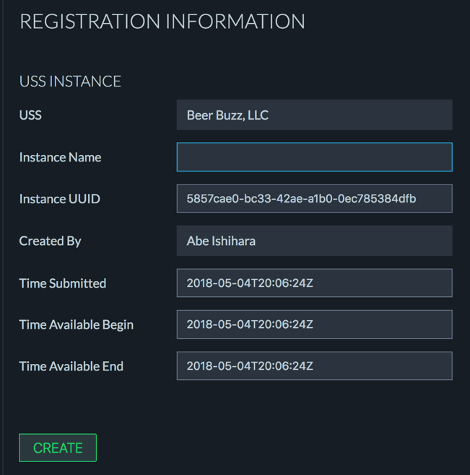

**Step 6:** Create the instance

**Step 7:** Upload data as described below



Once the file is uploaded it will go in the state UPLOADED. After about 10 minutes, you will be notified by email if there are any initial formatting errors.

DAT4:

This MOP involves UAS_ID performance metrics. For each USS Instance, generate one and only one DAT4 json file that contains the DAT4 json data model. Name the file

{ussName}-{dateInYYYYMMDD}-{ussInstanceID}-DAT4.json

In this data model, the (uvin,gufi) pair corresponds to the vehicle being identified. It therefore must be a valid uvin and gufi submitted to some USS. In addition, since we will require data from this vehicle, the operator of this vehicle must submit a single zip file containing FLIGHT_DATA (see above). **If this is not clear, please contact the DMP team.**

DAT99:

For each USS Instance, generate one and only one DAT99 json file that contains the DAT99 json data model. In this case, there is only a single json object for each file since this MOP measures temporal metrics associated with the registration of a USS instance and this can only happen once. Name the file {ussName}-{dateInYYYYMMDD}-{ussInstanceID}-DAT99.json

For each instance there will be a DAT4 or DAT99 or both associated with it. Create zip folder and put these files (at most 2) in it. Name the zip folder

{ussName}-{ussInstanceID}-DAT4_99.zip

Create a zip folder for each instance that performed these tests. Upload this zip file to the relevant uss instance page.

For **DAT2-3 and DAT5**. Create a single file for each json data model described in

<https://app.swaggerhub.com/domains/utm/tcl3-dat-test-schema/v1>

Name the files {ussName}-{dateOfFlightInYYYYMMDD}-{UTCtakeoffTimeInHHMM }-{ussInstanceID}-DAT23.json or {ussName}-{dateOfFlightInYYYYMMDD}-{UTCtakeoffTimeInHHMM}-{ussInstanceID}-DAT5.json

Collect **all json files that are associated with a uss instance** and package in a **single** zip folder named:

{ussName}-{ussInstanceID}-DAT23_5.zip and upload it to the site.

Upload this zip file to the relevant uss instance page.