It takes 15 years. The bar chart is attached below:

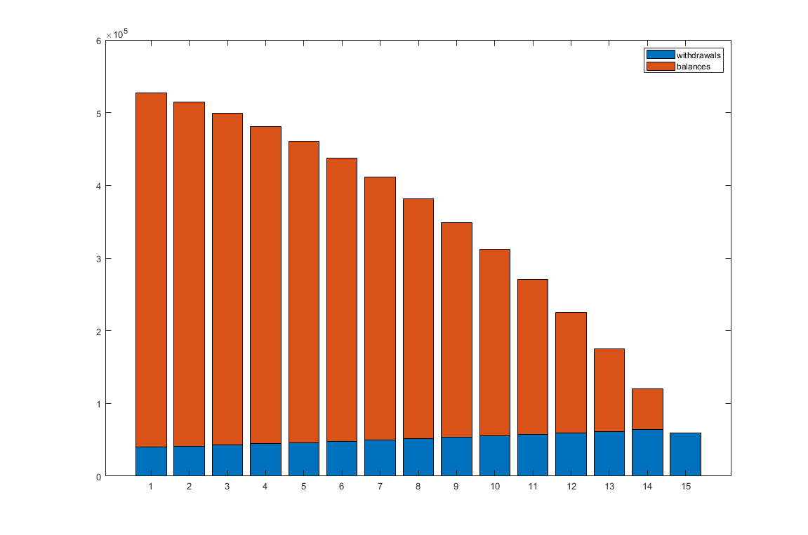

Code:

capital = 500000;

ret = 5.5 / 100;

withdraw = 40000;

inf_rate = 3.5 / 100;

inc_rate = 0.025 / 100;

withdraw_list = [];

balances_list = [];

withdraw_list(end+1) = withdraw;

remained_amount = capital*(1 + ret) - withdraw;

balances_list(end+1) = remained_amount;

year = 1;

while remained_amount >= 0

year = year + 1;

inf_rate = inf_rate + inc_rate;

withdraw = withdraw * (1 + inf_rate);

withdraw_list(end+1) = withdraw;

remained_amount = remained_amount*(1 + ret) - withdraw;

balances_list(end+1) = remained_amount;

end

if balances_list(end) < 0

withdraw_list(end) = withdraw_list(end) + balances_list(end);

balances_list(end) = 0;

end

% bar plot

figure;

bar([withdraw_list', balances_list'], 'stacked');

legend('withdrawals', 'balances');