**Year: 2020 Name: ID:**

1. Problem Statements

In this report, we consider:

* Downloading and importing AAPL's daily stock price data into matlab.
* Plotting the curves of open, high, low, close price data series.
* Find the mean and standard deviation of close price.
* Determine how many days for the close price to be above the mean price.
* Suppose buy 100 shares if open price is below $200 and sell 100 shares if open price is above $290, and determine the number of shares owned after the period and the net increase of the portfolio value.

1. Methods and Results

The purpose of this project was to implementing a simple trading strategy and calculate the portfolio statistics. We also investigated how to plot the price data, calculate the mean and standard deviation. As you can see from figure 1, the OHLC data are plotted.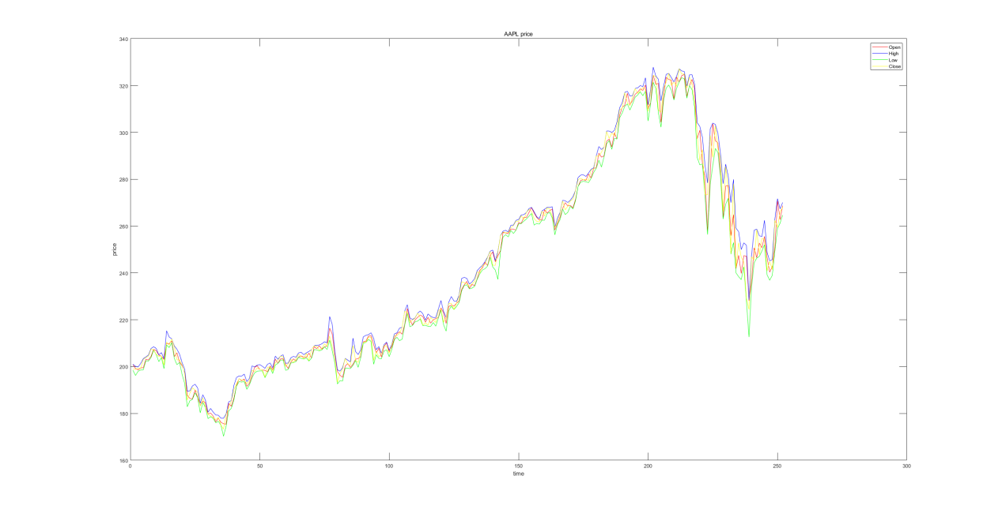

The mean close price is 240.3923, and the standard deviation is 42.9115. There are 116 days when close prices of APPL stock to be above the mean price. After implementing the trading strategy of buy 100 shares when open price is below $200, and sell 100 shares when open price is above $290, I calculated that the number of shares owned after the period is 1100. In order to calculate the net increase in the value of my portfolio, I first recorded the buy and sell price of each trade, thus I can calculate the cash in flow during this period, which is $47,9690. And for the stocks, the total net increase includes both the cash in flow of buying and selling shares and the nominal increase of holding the shares, the total net increase is $57,3638.

1. Summary and conclusions

In conclusion, our numerical results show that after implementing this trading strategy, we can obtain $57,3638 net increase in the value of our portfolio, which would be quite profitable because AAPL' stock price increased quite a lot during this period.

1. Appendix: Matlab Codes

A = csvread('AAPL.csv', 1, 1);

% Plot the curves for the prices

figure;

colors = {'r', 'b', 'g', 'y'};

for i = 1:4

plot(A(:, i), colors{i});

hold on

end

legend({'Open', 'High', 'Low', 'Close'});

xlabel('time');

ylabel('price');

title('AAPL price');

% Find the mean and std

mean_price = sum(A(:, 4)) / numel(A(:, 4));

std_price = std(A(:, 4));

mean_price

std_price

% How many days above the mean of close price

n_days = sum(A(:, 4) > mean_price);

n_days

% Trade strategy analysis

total_days = numel(A(:, 1));

init_shares = 1000;

buy_price_line = 200;

sell_price_line = 290;

buy_prices = [];

sell_prices = [];

current_shares = init_shares;

for i = 1:total_days

% First, check if we can sell

if current_shares >= 100 && A(i, 1) > sell_price_line

sell_prices(end+1) = A(i, 1);

current_shares = current_shares - 100;

elseif A(i, 1) < buy_price_line

buy_prices(end+1) = A(i, 1);

current_shares = current_shares + 100;

end

end

% Number of shares owned

n_shares_owned = current_shares;

% Now calcuate the cash flow first

cash_in_flow = 100*(sum(sell_prices) - sum(buy_prices));

cash_in_flow

% Then calculate the net increase in our portfolio( including stocks and

% cash)

net_increase = n_shares_owned * A(end, 4) - init_shares * A(1, 1) + cash_in_flow;

net_increase