Users guide to the DateView web-based geochronology database

Bruce M. Eglington

Saskatchewan Isotope Laboratory, Department of Geological Sciences,
University of Saskatchewan, 114 Science Place, Saskatoon, S7N 5E2,
Canada
(e-mail: bruce.eglington@usask.ca)

Users guide to the DateView web-based geochronology database 1
Introduction 2
System requirements 2
Database structure 2
Accessing the database 4
Querying the database 6
Viewing records in the database 8
Editing records in the database 13
Graphing the results of queries 17
Acknowledgments 24
References 24
Appendix A: Configuring the Borland Database Engine (BDE) Error! Bookmark not defined.

Introduction
Systematic collation, assessment and processing of isotopic and geochronological data is best achieved by means of a structured database which permits appropriate querying to extract relevant data. Typical queries which earth scientists have with respect to isotope data include:
- what is the age of a particular geological unit or event?
- what dates (and associated uncertainties) are available in a specified area?
- how do dates obtained by means of different isotope decay schemes compare with each other in a specified area or for a specified formation?
- what is the geological significance of these dates and how confident is one of the individual values?
- how do dates from one area or geological entity compare with those from other areas?
- how do initial ratios vary with time in some area?
- what is the geographic distribution of dates in some area relative to their geological interpretation?
- is there a systematic variation in age relative to blocking temperature for selected isotope decay schemes amongst a particular group of dates?
DateView is a PC-based package which has been designed with these objectives in mind. It facilitates the compilation of relevant geochronological data by individuals whilst also providing a framework for subsequent sharing of data amongst groups of staff where appropriate.

System requirements

The user interface for DateView was developed with Delphi^{(TM)} v. 6 and Intraweb v. 7.0.20. It is designed for implementation on computers using standard internet browsers such as Internet Explorer tested with version 6), Netscape (version 7.1 and above) and Safari. The data are stored in a client/server relational database using the Firebird open-source system. The web version of DateView is an extension of the desktop version which was based on Paradox^{(TM)} v. 7 tables for use on Windows^{(TM)} computers (Eglington, 2003).

Database structure
Data are stored in multiple tables linked using a unique record id value for each record. Lookup and referential master tables are available for all important fields. The data in these lookup tables are user customisable. They ensure that the database does not contain duplicate records as a result of minor typographic errors, etc. Data records in the main data table are arranged such that dates are linked to:
- a specified area e.g. a country,
- a geological unit,
- a selected lithology e.g. granite,
- a specified isotope decay scheme e.g. U-Pb radiogenic
- a specific way of calculating the date within this decay scheme e.g. by regression
- the material analysed (e.g. zircon)
- technique used for analysis e.g. SHRIMP
- a simple interpretation of the meaning of the date
- and a qualitative measure of the geological confidence in the date and its associated interpretation.

Individual data records also contain fields for more quantitative information as regards the statistical evaluation of the date calculation performed. Each record in the main data table may also be linked to a table containing details of the samples used to derive the values stored in the main table. These details currently comprise sample number, whether the sample was included in the date calculation and the longitude and latitude at which the sample was collected. A convention has been adopted in which latitude south of the equator is expressed as a negative value. All latitude and longitude values are expressed in decimal units. A further table, also linked to each record in the main data table, allows the user to define groups of records which have some particular relevance. For example, all data associated with a particular orogenic event may be given a name such as "orogenesis 1". The DateView software refers to these values as 'group descriptors'. It is also possible to associate each record with particular structural provinces or terranes, geochemical associations, tectonic settings or stratigraphic boundaries and to define the reference source from which the data were obtained.

Data fields have been structured to store parameters required to describe the various regression and age calculation techniques described in the literature (McIntyre et al., 1966; York, 1966; York, 1969; Brooks et al., 1972; Ludwig, 1980; Davis, 1982; Wendt, 1984; Kent et al., 1990; Harmer and Eglington, 1991; Zheng, 1992; Eglington and Harmer, 1993; Ludwig and Titterington, 1994; Ludwig, 1998) Thus the database also includes fields to describe the statistical validity of the date calculation, the type of weighting applied to augment calculated errors where scatter exceeds that which can be explained by the analytical uncertainties and the model used for specific calculations e.g. in the case of model source ²³⁸U/²⁰⁴Pb. In cases where both an upper and lower concordia intercept are relevant and need to be queryable, these should be stored as two separate records according to the specific model adopted to explain the discordia effects (Eglington and Harmer, 1993). Subsequent plots and data queries are based only on the value stored in the primary date field, not in the field reserved for 'other intercept'. This latter field, and its associated uncertainties, are purely supplementary information.

New data may be added to the DateView database manually from the keyboard. Future development will facilitate importing from suitably structured XML files.

Accessing the database
Access to the database is via the web site http://krakatoa.usask.ca although this will probably change in future once the test phase is complete and more users need access. At this stage, faster database and web servers will be installed.

Casual users may login to the system using the userid “guest” with a password “guest” but regular users should register and define their userid and password. Users intending to submit data to the database will need to contact the developer (bruce.eglington@usask.ca) to obtain edit and insert rights to the database.

The first screen visible to the user will look like that shown in

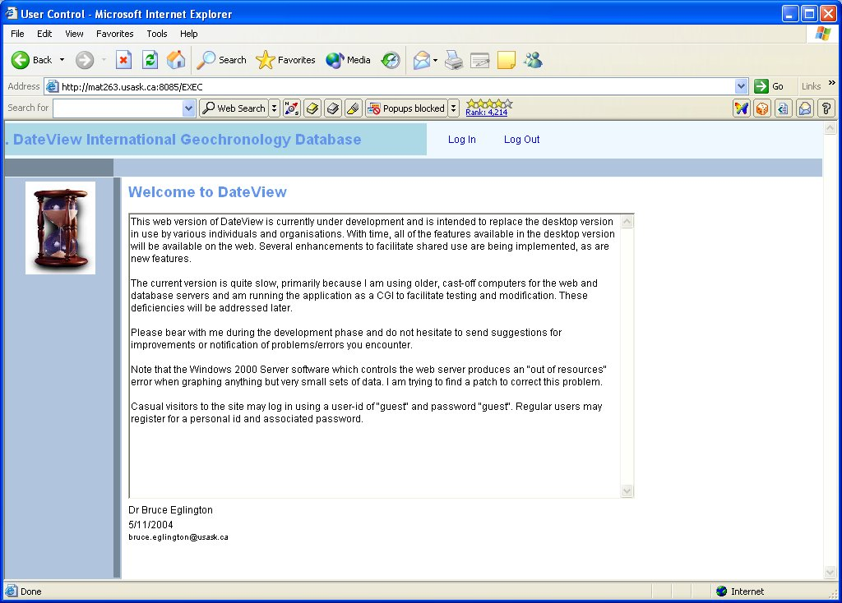
Figure 1. View of start-up screen for DateView. Users need to Login to the system by clicking on the appropriate link at the top of the window.

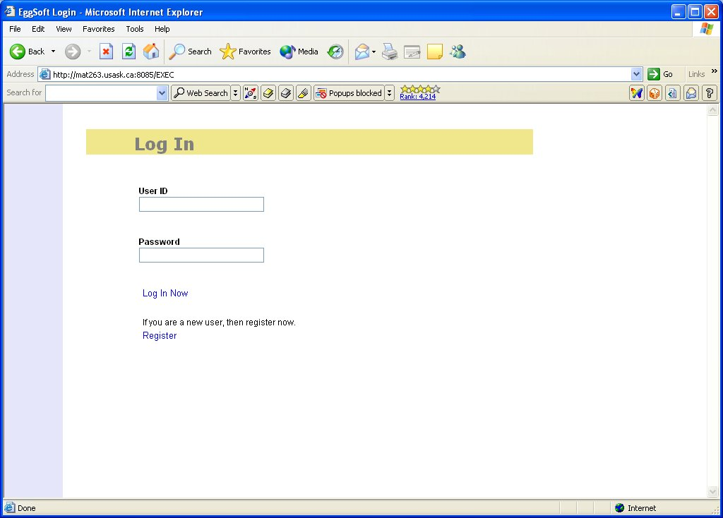
Figure 2. Login screen for DateView. Userid and password are both case sensitive.

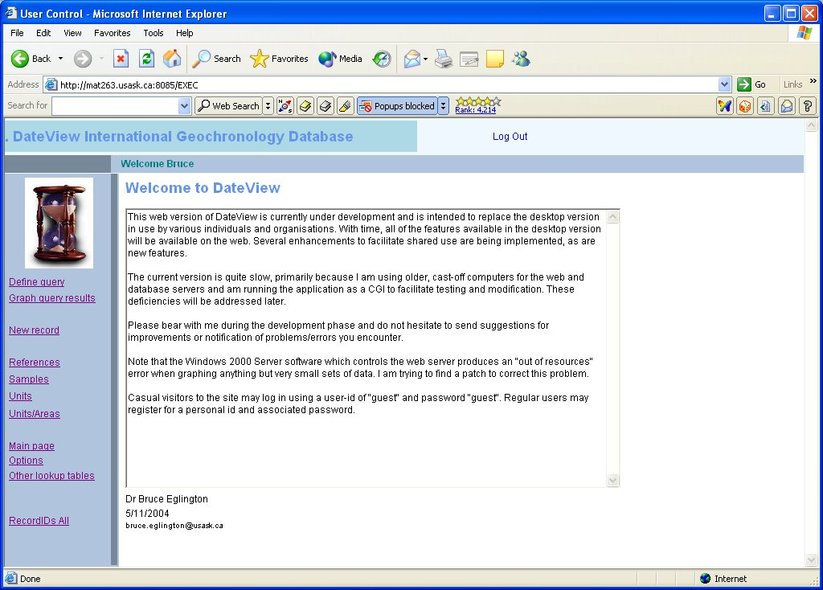
Figure 3. Main page DateView. This page provides access to the query definition forms, graph selection, options definitions, and other forms required by the user. The first choice of a user will typically be “Define query”.

Querying the database
Queries of the database may be based on combinations of the following fields:
- area
- stratigraphic unit
- lithology
- isotope system / technique
- material analysed / method used
- interpretation
- group descriptors
- rank (for the specified interpretation)
- a range of dates
- statistical validity of the analysis (based either on MSWD or probability of fit)
- whether the data records have decay constant uncertainties specified or not

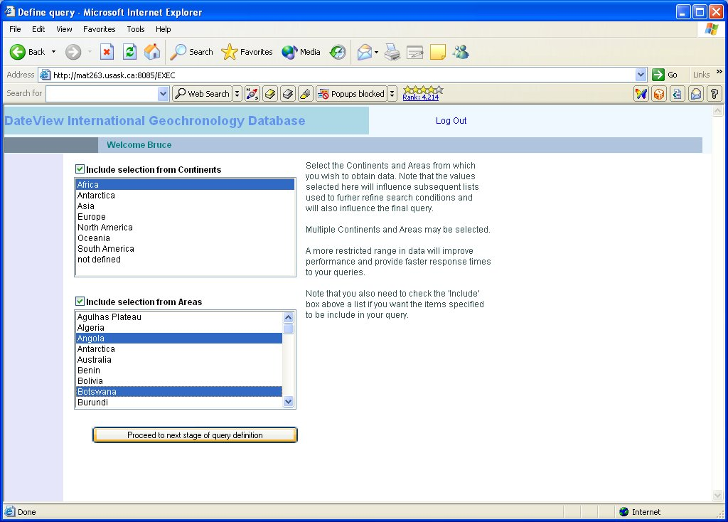
Figure 4. First stage of query definition. For optimum performance, users should specify at least one continent and one or more areas. The check boxes for each of the lists should also be checked if selections made in a list are to be included in the query. The main purpose of this stage of the query definition is to limit the amount of information which needs to be obtained from the database server and transmitted across the internet. Fewer data transmitted means faster response time.

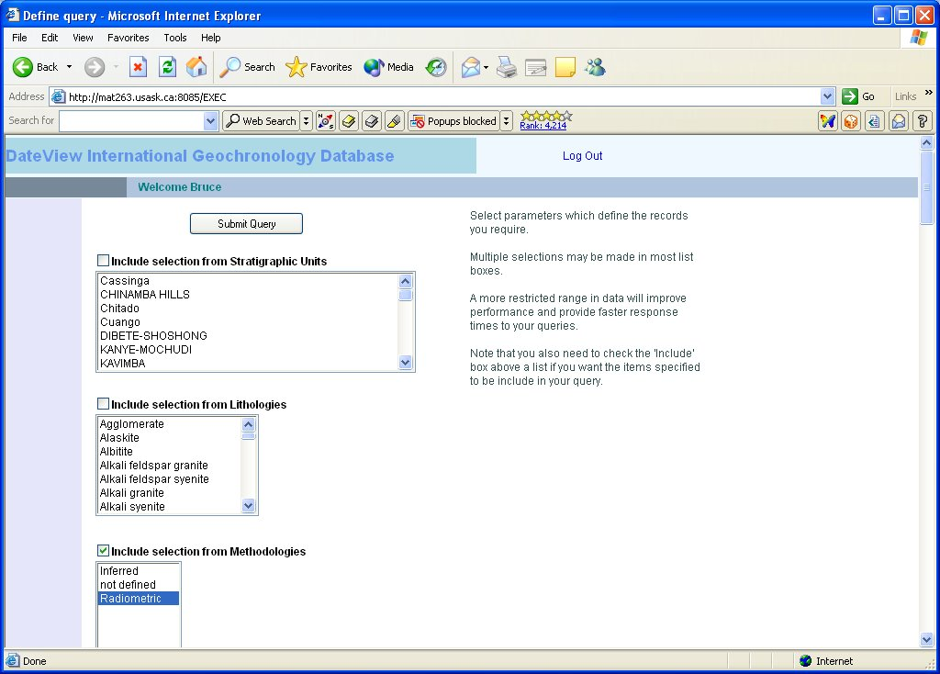
Figure 5. Second stage of query definition. This stage narrows down the list of records. At least one of the ‘Include’ boxes needs to be checked. If a user wants all records from a particular area (defined in the previous stage of definition), then a selection from one of the “Methodology” options is the easiest way to achieve this. Note that this image only shows part of the screen for this stage of query definition.

Selecting any of items one to seven of this list provides access to a drop-down list of available values which may be selected and added to a compound and/or query, as illustrated in Error: Reference source not found. Multiple combinations of values within each parameter may be combined in a logical 'or' sequence which is 'and’ed with other variables selected. Once the user is happy with the selections made, the query may be executed and the resultant records may be viewed in a number of ways.

Viewing records in the database

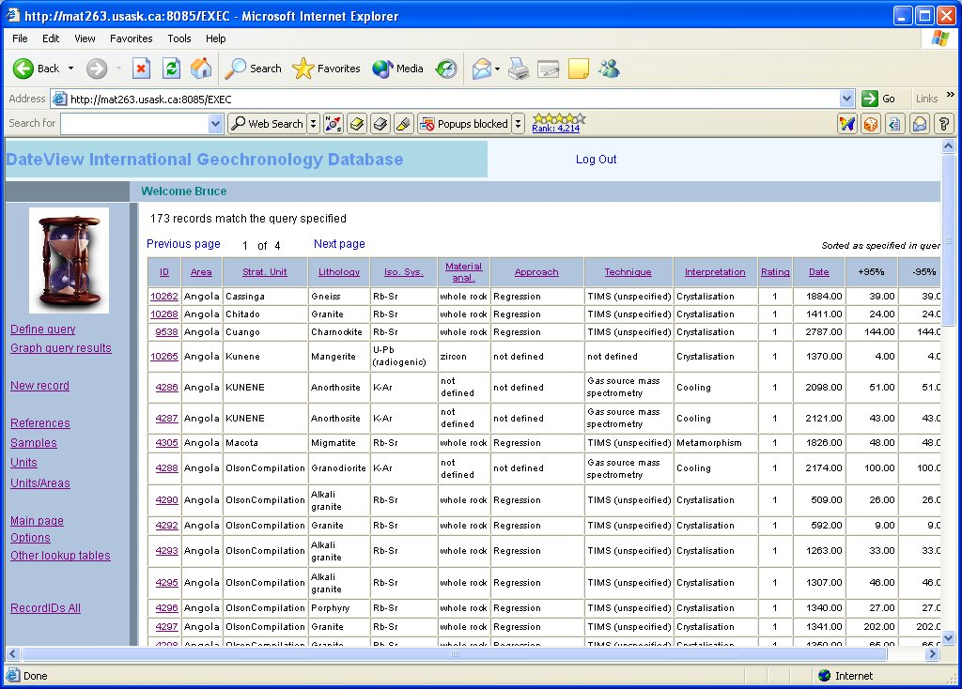
Figure 6. View of records returned for the query defined. Users may resort the list by clicking on column headings and may step through pages as appropriate. Clicking on the unique ID number at the left of the grid will provide details of information available for the record concerned.

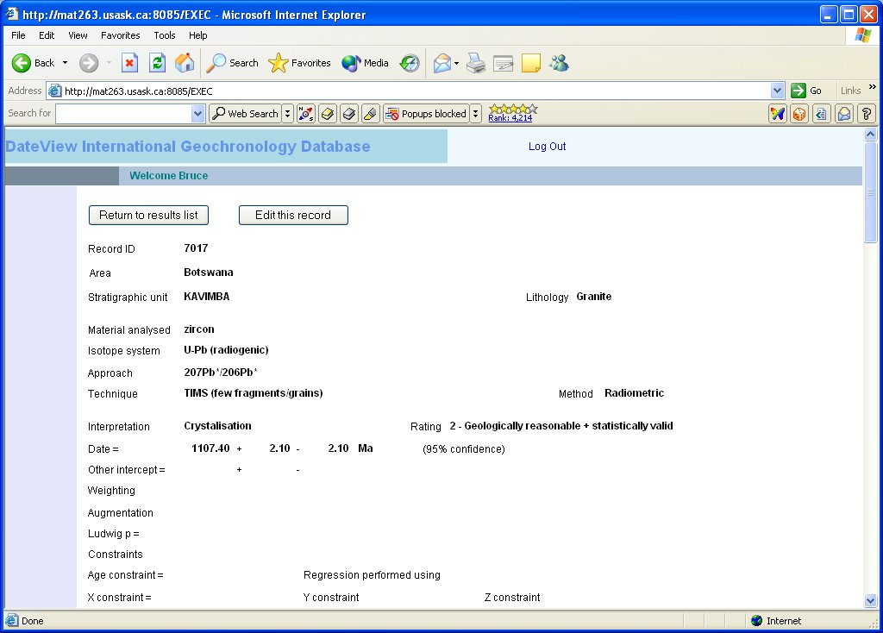
Figure 7. More details

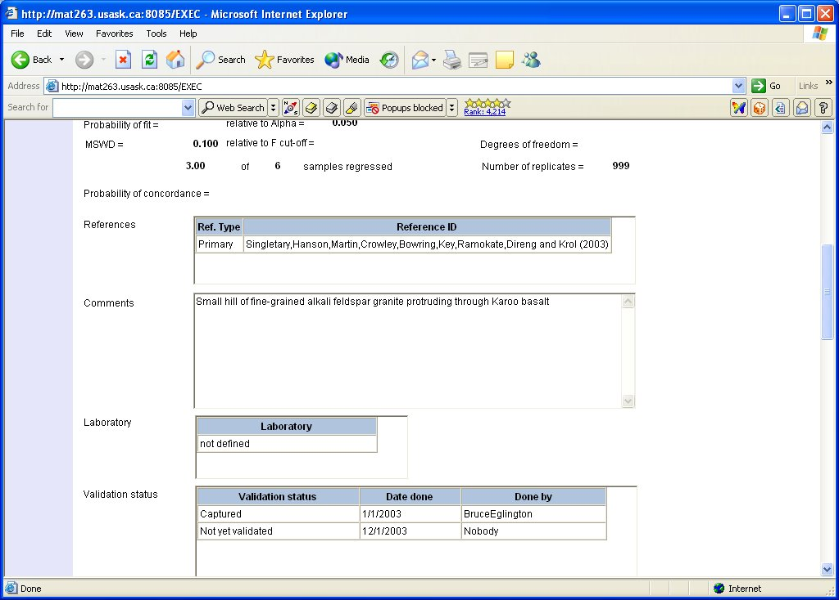
Figure 8. V.

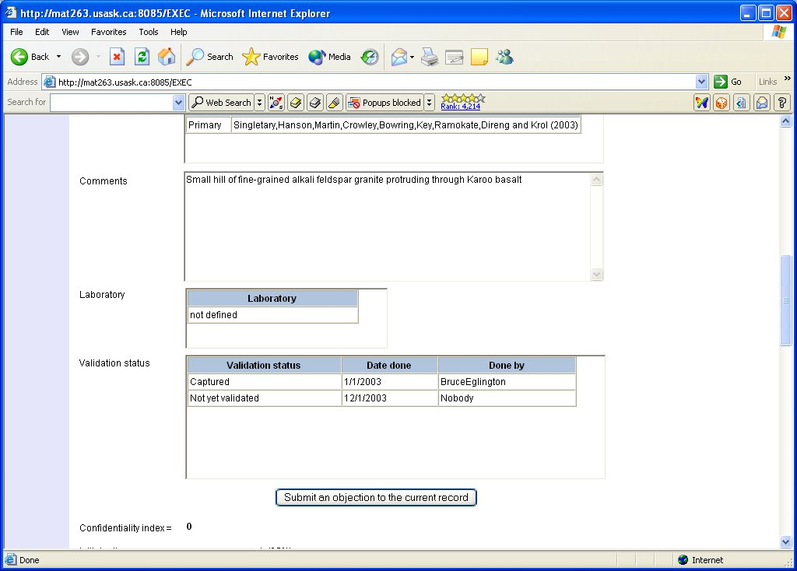
Figure 9. V.

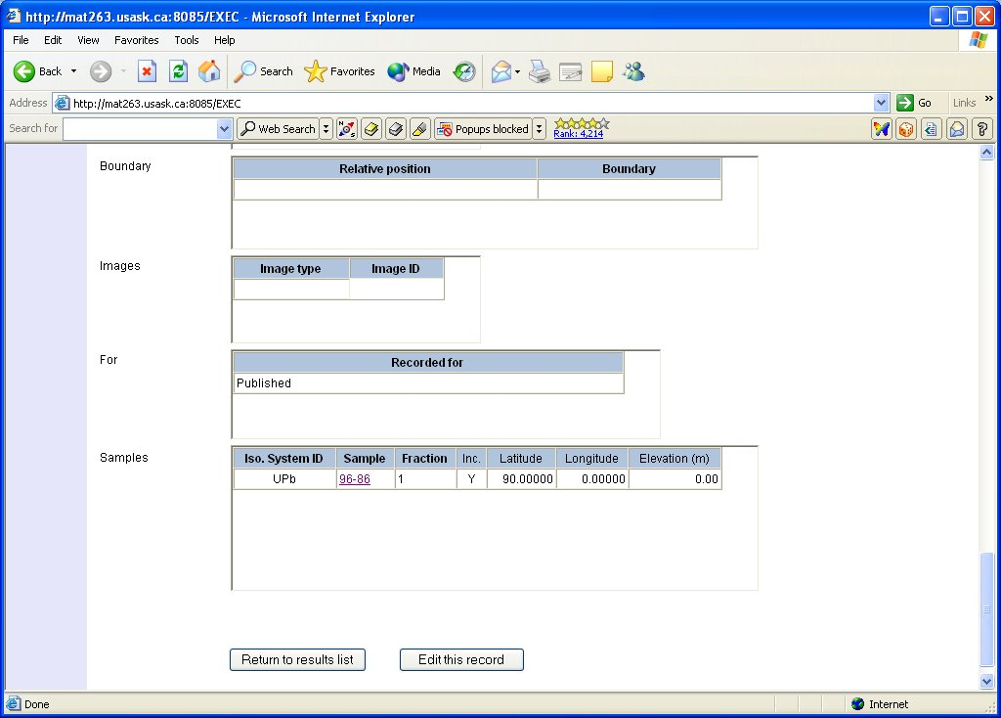
Figure 10. V.

Editing records in the database

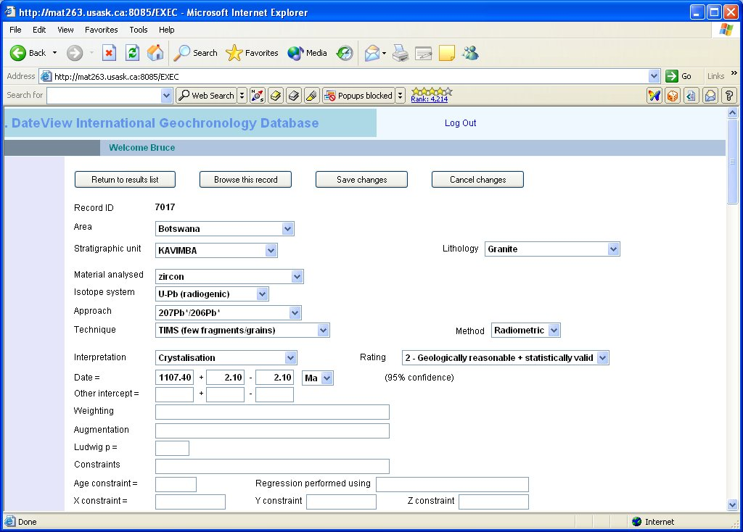
Figure 11. V.

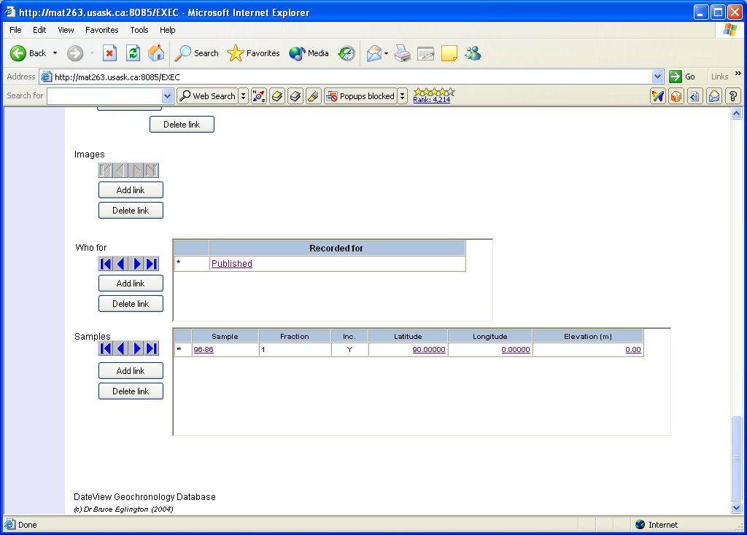
Figure 12. V.

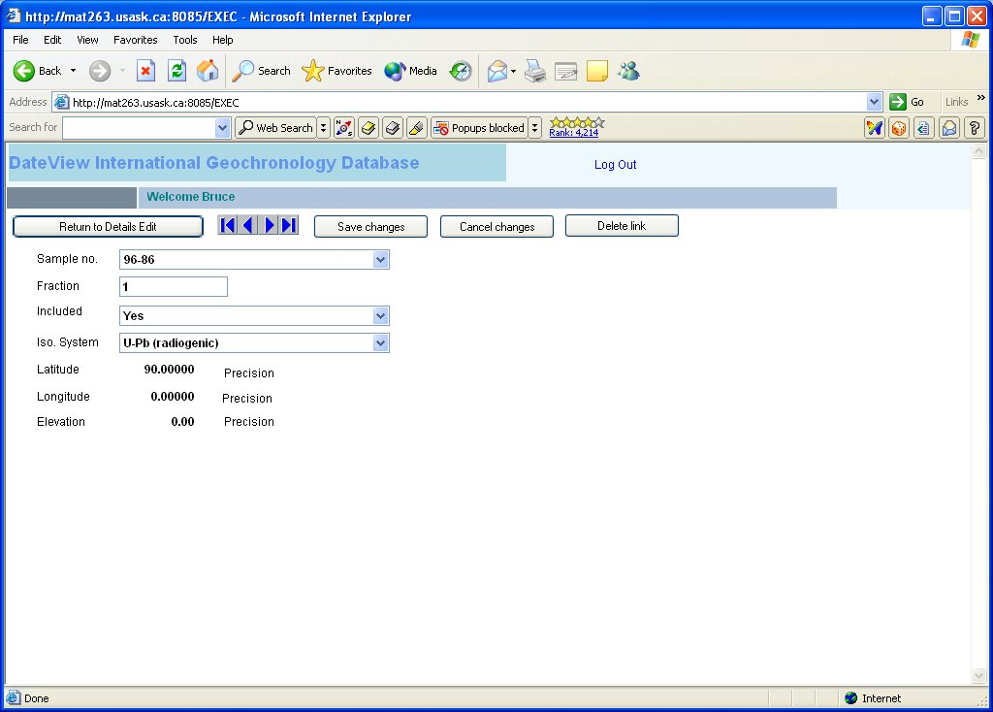
Figure 13. V.

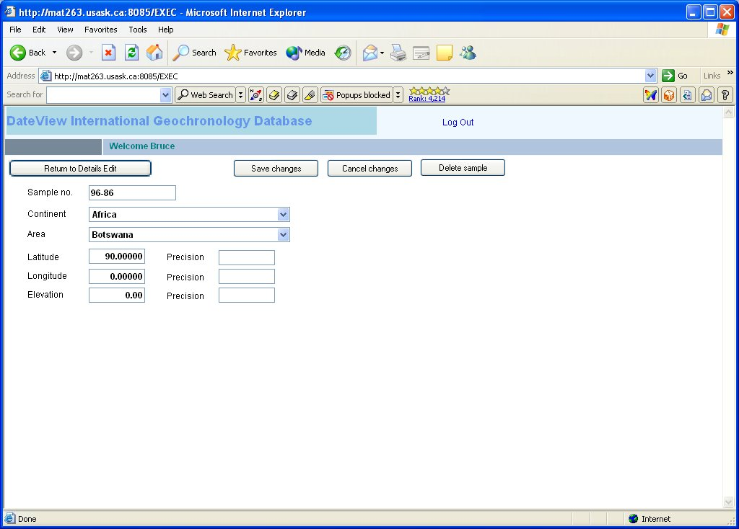
Figure 14. V.

It is possible to print the results of a query. These include geochronology, sample locality and reference details at this stage. Reporting is accomplished using the ReportBuilder^{(TM)} software.

Graphing the results of queries
Several graphical representations of the data extracted in a query are available. Two types of plot are generally applicable. One illustrates the data in terms of the interpretation associated with each date and the other shows the data as a series of symbols relating to specified age ranges. In both cases, the user is able to define the values and legend captions to be used via the Graph\Options menu. Error: Reference source not found to Error: Reference source not found illustrate these menu views.

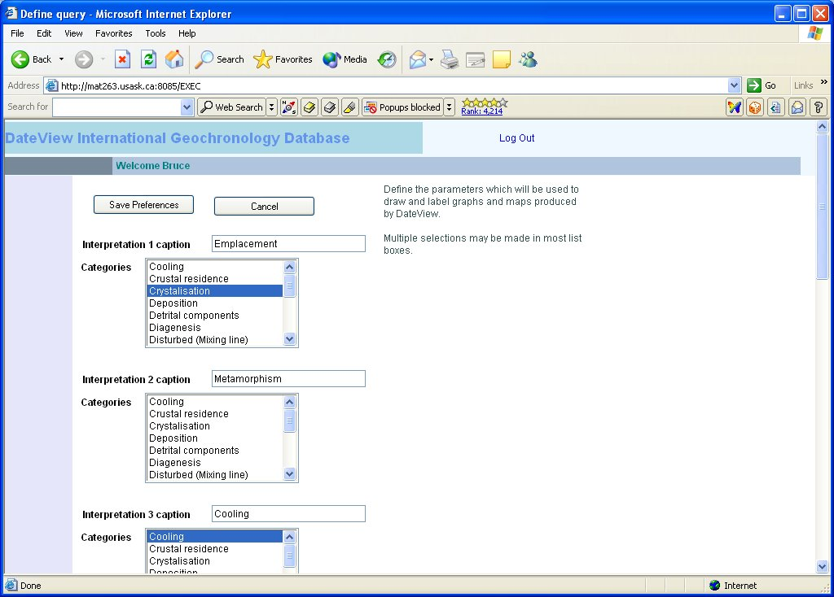
Figure 15. V.

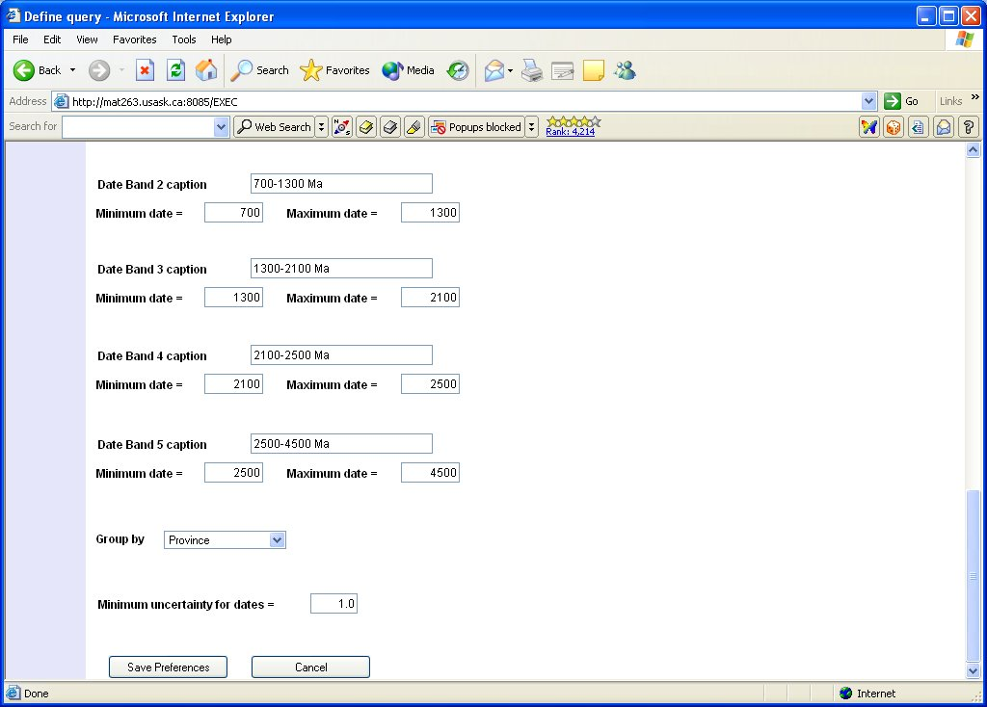
Figure 16. V.

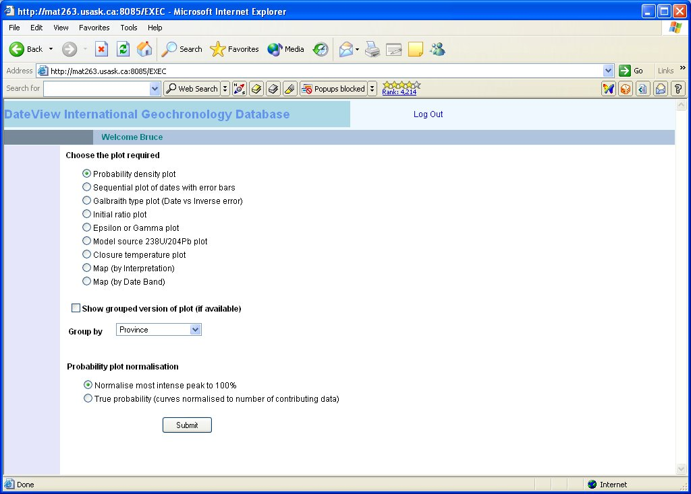
Figure 17. V.

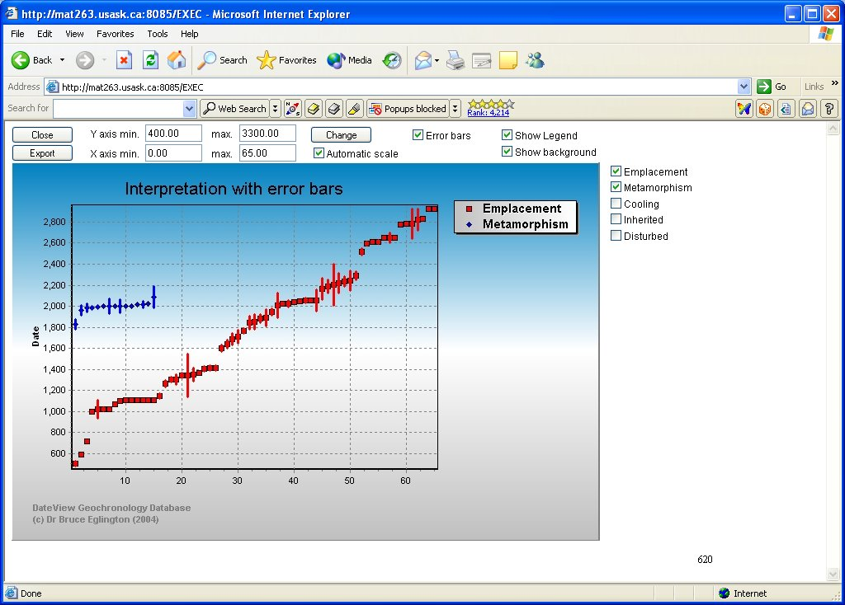
Figure 18. V.

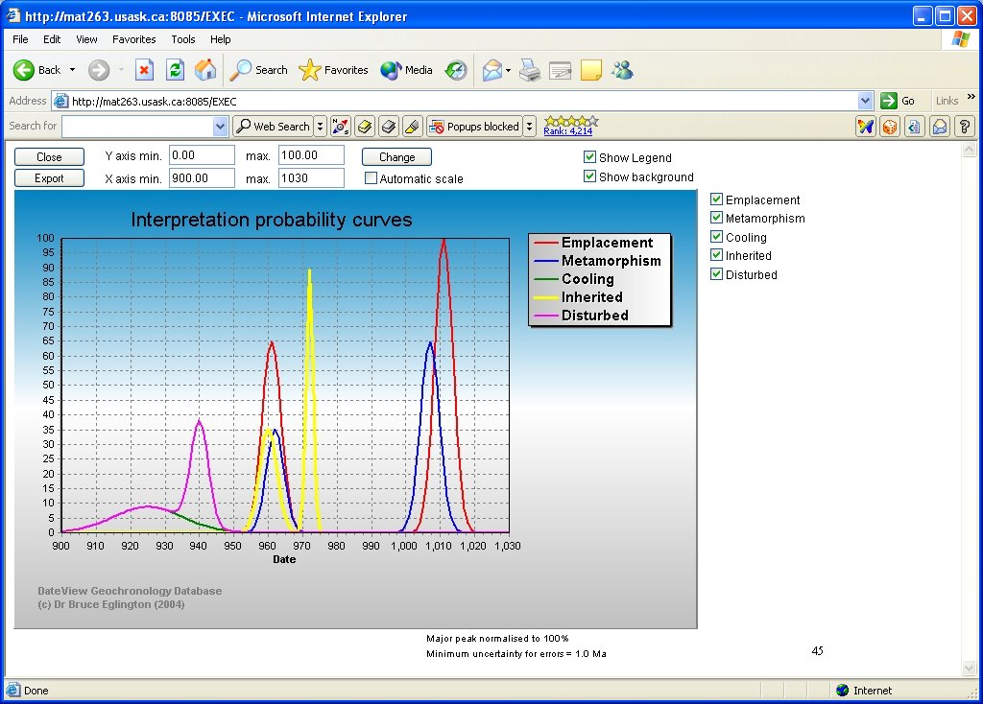
Figure 19. V.

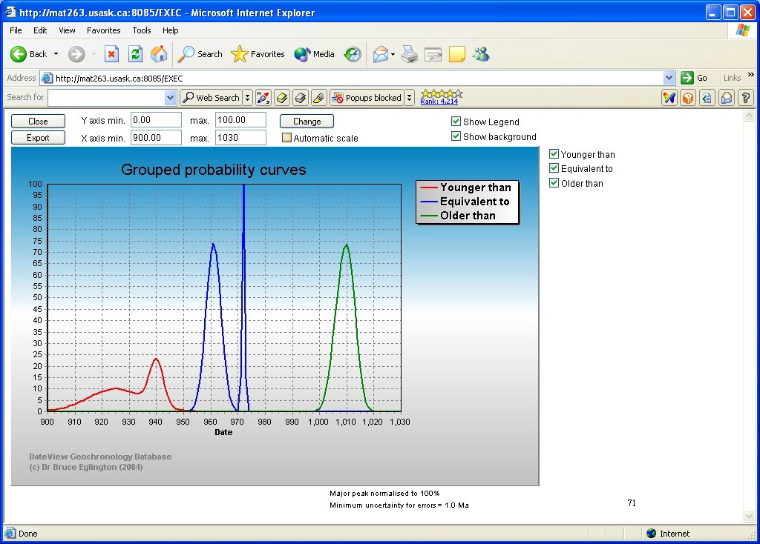
Figure 20. V.

In the case of 'interpretation' graphs (Error: Reference source not found), the user may specify up to five items to be shown in the legend. Each item comprises a combination of up to two specific interpretations which are selected from drop-down lists. For the 'age range' graphs, the user may specify up to five intervals by providing captions for the legend and beginning and ending dates for each interval (Error: Reference source not found).

Specific graphs which are provided in the current version of DateView are:
- sequential plot of date and uncertainty for each of the specified interpretations. This plot provides an overview of the individual data records reported by the query. Data are colour coded according to the interpretation associated with each date (Error: Reference source not found). In situations where 'group descriptors' have also been specified in the query, data are also colour coded to reflect the associated descriptor and provided in a separate plot.
- a plot of inverse of the 1 sigma uncertainty for each date relative to the deviation of the date from the weighted mean of all dates selected in the query (Galbraith, 1988). Data records are presented with different symbols according to the interpretation associated with each date. This form of diagram is sometimes useful to distinguish between different periods of geological activity.
- a summed probability distribution of the dates for each interpretation (Error: Reference source not found). The probability curves presented in this plot are normalised to 100% for the most intense peak of all the interpretations plotted. This plot also provides a weighted average date of all the records selected, together with an estimate of the statistical validity of this average. The latter is presented as a Mean Square of Weighted Deviates (MSWD) value and a Probability of Fit value. In situations where 'group descriptors' have also been specified in the query, summed probability curves are also provided for all dates associated with each descriptor in a separate plot (Error: Reference source not found).

- plots of initial ratio, epsilon value or ²³⁸U/²⁰⁴Pb (μ) relative to date, again with symbols reflecting the interpretation associated with the date. If 'group descriptors' are specified, it is possible to graph these results to reflect the groups concerned (Error: Reference source not found).
- an x-y plot of longitude versus latitude with symbols based on interpretation or age band. If areas are specified in the query, the software will also extract data from a supplementary database table, called AreaBound, for data delineating a simplified outline of the area concerned (see Error: Reference source not found).
- a plot of date versus assumed blocking temperature for the specific combination of material analysed, method of analysis and isotope system. Values may be associated with these combinations under Edit / Lookup tables. This option requires that one or more 'group descriptors' have been specified in the query and the plot is shown with date and blocking temperatures coded for each descriptor.

Acknowledgments

References

Brooks,C., Hart,S.R. and Wendt,I. (1972). Realistic use of two-error regression treatments as applied to rubidium-strontium data. Rev. Geophys. Space Phys., 10, 551-577.
Davis,D.W. (1982). Optimum linear regression and error estimation applied to U-Pb data. Can. J. Earth Sci., 19, 2141-2149.
Eglington B.M. (in press). DateView: a Windows geochronology database.
Eglington,B.M. and Harmer,R.E. (1993). A review of the statistical principles of geochronometry: II. Additional concepts pertinent to radiogenic U-Pb studies. S. Afr. J. Geol., 96, 9-21.
Galbraith,R.F. (1988). Graphical display of estimates having differing standard errors. Technometrics, 30, 271-281.
Harmer,R.E. and Eglington,B.M. (1991). A review of the statistical principles of geochronometry: towards a more consistent approach for reporting geochronological data. S. Afr. J. Geol., 93, 845-856.
Kent,J.T., Watson,G.S. and Onstott,T.C. (1990). Fitting straight lines and planes with an application to radiometric dating. Earth Planet. Sci. Lett., 97, 1-17.
Ludwig,K.R. (1980). Calculation of uncertainties of U-Pb isotope data. Earth Planet. Sci. Lett., 46, 212-220.
Ludwig,K.R. (1998). On the treatment of concordant uranium-lead ages. Geochim. Cosmochim. Acta, 62, 665-676.
Ludwig,K.R. and Titterington,D.M. (1994). Calculation of ²³⁰Th/U isochrons, ages, and errors. Geochim. Cosmochim. Acta, 58, 5031-5042.
McIntyre,G.A., Brooks,C., Compston,W. and Turek,A. (1966). The statistical assessment of Rb-Sr isochrons. J. Geophys. Res., 71, 5459-5468.
Wendt,I. (1984). A three-dimensional U-Pb discordia plane to evaluate samples with common lead of unknown isotopic composition. Isotope Geosc., 2, 1-12.
York,D. (1966). Least-squares fitting of a straight line. Canadian Journal of Physics, 44, 1079-1086.
York,D. (1969). Least-squares fitting of a straight line with correlated errors. Earth Planet. Sci. Lett., 5, 320-324.
Zheng,Y.-F. (1992). The three-dimensional U-Pb method: generalized models and implications for U-Pb two-stage systematics. Chem. Geology, 100, 3-18.

