**UC-15: Payment order:** The system sends the order information to the receiver message box, and the receiver the order.

**UC-16: Evaluation：**The order is completed and the user can evaluate the order.

**Use Case UC-（15）Payment order**

|  |
| --- |
| Use Case UC-（15）Payment order |
| Related Requirement’s: REQ10, table1-2  Initiating Actor: All of: receivers  Actor’s Goal: The receivers finish the whole process.  Participating Actors: data processing center, information system  Preconditions: The receivers take the food and takeout  Post conditions: The receivers finished the whole process.  Flow of Events for Main Success Scenario: The receiver got the food and takeout. The system confirmed the order information, and gave the payment order. The receivers pay money to this process. |

**Use Case UC-（16）Evaluation**

|  |
| --- |
| Use Case UC-（16）Evaluation |
| Related Requirement’s: REQ11, table1-2  Initiating Actor: All of: receivers  Actor’s Goal: give the system feedback  Participating Actors: Data processing center, evaluation order, information system  Preconditions: The receivers wrote the evaluation order.  Post conditions: none  Flow of Events for Main Success Scenario: The receivers wrote the evaluation order, the system got the command, and get the feedback. |

UC-4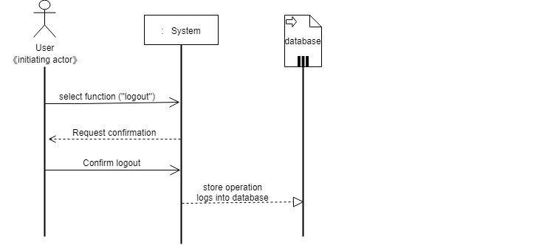

UC-13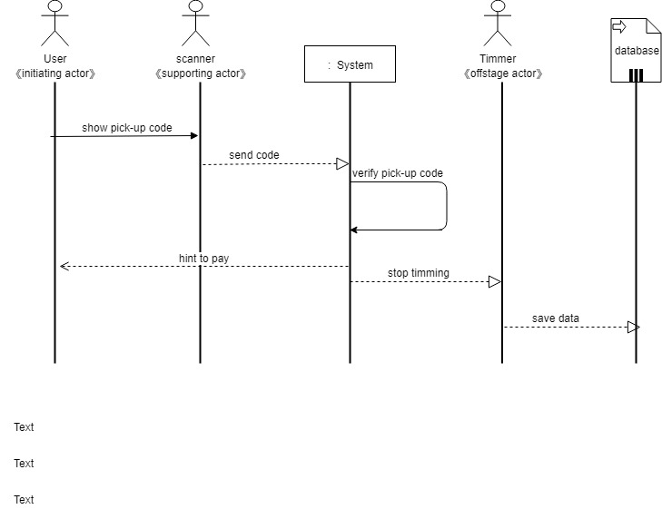

UC-16

