1. Site: https://softexrecife.joyclass.com

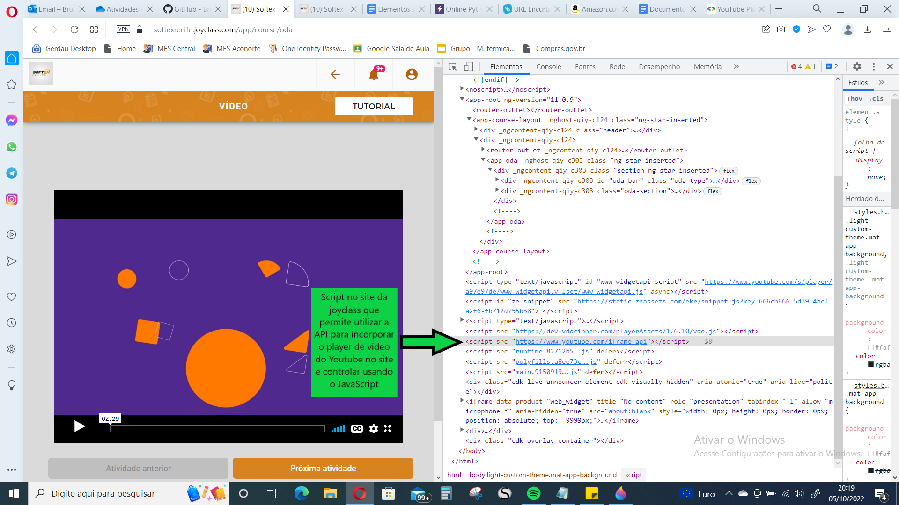

1. Site: https://www.amazon.com.br

