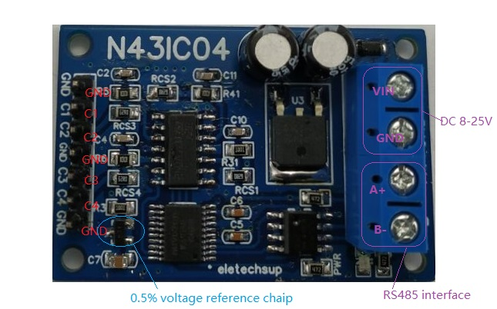

**Features:**

1: Operating Voltage : DC 8-24V

2: Operating Current : 10-15MA

3: MODBUS RTU Command support 03 06 16 function code

4 The measurement range is 0-10mA, 0-20mA and 0-50mA, depending on the back of the module

5 The current resolution is 0.001 m A with a measurement accuracy of 1% and can be calibrated if the error is greater than 1%

6 :MODBUS commands can be made serial Hyper Terminal (serial assistant) OR PLC Enter;

7 :Under the MODBUS command mode, it can support up to 247 devices in parallel

8 :Size: 45 * 30 * 15mm

9 :Weight: 10 g

Modbus RTU Command Please refer to : "N43IC04 modbus rtu protocol"

**Hookup:**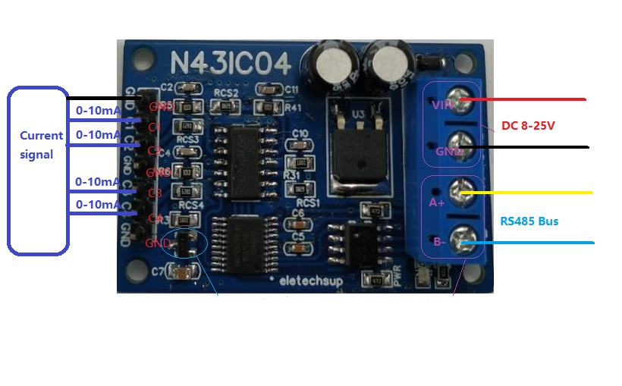

**RS485 bus connection method**

