**N4D3E16 16CH RS485 IO controller commamd**

**MODBUS Command (function code 06 is Control command,03 is Read status command 0x0001-0x0010 registers support 16 (0X10) Command)**

Note :

1 MODBUS command must be HEX

2 Slave ID (device address) must be consistent with the DIP switches (A0-A5)

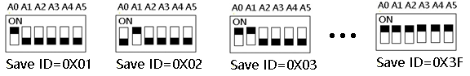

9600 Band ,8 Data bits,None Parity,1 Stop Bit

Function code

|  |  |  |  |  |
| --- | --- | --- | --- | --- |
| RS485 address  (Station address)  (1) | Function (1) | Register address (2) | Read number (2) | CRC16 (2) |
|  | 03 Read |  |  |  |
|  | 06 Write |  |  |  |
|  | 16(0x10)  Write multiple registers |  |  |  |

|  |  |  |  |  |  |
| --- | --- | --- | --- | --- | --- |
| Function code | Register address | Register contents | Number of bytes | Register value | Remarks |
| 03 06  16(0X10) | 0x0001-0x0010  (1-32) | Output port status | 2 | 0X0000  0X0001 | 0X0000 No output  0X0001 Has output |
| 03 06 | 0X0070  (112) | Output port status(bit) | 2 | 0  1 | 0X0070:1-16 Output channels  Only support open and close commands. 1 open 0 close |
| 03 | 0x0081-0x0090  (129-144) | Input port status | 2 | 0X0000  0X0001 | NPN Input  0X0000 No input  0X0001 Has input |
| 03 | 0X00C0  (192) | Input port status (bit) | 2 | 0 No input  1 Has input | 0X00C0:1-16 Input channels |
| 03 06 | 0x00F9  (249) | Remote IO Sender | 2 | 0.2 seconds | 0 Disabled(default)  1-255: 0.2-51 seconds to send once |
| 03 06 | 0x00FA  (250) | Remote IO Receiver | 2 |  | 0 Disabled(default)  1 Enable |
| 03 06 | 0x00FC  (252) | automatic reporting selection | 2 |  | 0: Select automatic report register: 0x0081-0x090  1: Select automatic report register: 0X00C0 |
| 03 06 | 0x00FD  (253) | Input port status automatic reporting function | 2 | secondS | 0: Query function(default) 1-255: Automatically report, the unit is second.  1: Report every 1 second  2: Report every 2 seconds  10: Report every 10 seconds Maximum interval of 255 seconds |
| 03 | 0x00FE  (254) | 485 address | 2 |  | DIP switch settings  Read only |
| 03 06 | 0x00FF  (255) | Baud rate | 2 | 0x0000-0x0005 | 0~5 0:1200  1:2400 2:4800  3:9600（default）  4:19200  5: Factory reset |

**MODBUS** 06 Command (**Control command** ,HEX):

|  |  |  |  |  |  |  |  |  |
| --- | --- | --- | --- | --- | --- | --- | --- | --- |
| Bytes Number | 1 | 2 | 3 | 4 | 5 | 6 | 7 | 8 |
| MODBUS Definitions | Slave ID | Function | Address | | Data | | CRC Check | |
| Function | Device Address | Function | Channel number | | Command | Delay time | CRC Check | |
| Open | 0x00-0x2F | 0x06 | 0x0001-  0x0008 | | 0x01 | 0x00 | 2Bytes CRC | |
| Close | 0x00-0x2F | 0x06 | 0x0001-  0x0008 | | 0x02 | 0x00 | 2Bytes CRC | |
| Toggle (Self-locking) | 0x00-0x2F | 0x06 | 0x0001-  0x0008 | | 0x03 | 0x00 | 2Bytes CRC | |
| Latch Inter-locking) | 0x00-0x2F | 0x06 | 0x0001-  0x0008 | | 0x04 | 0x00 | 2Bytes CRC | |
| Momentary (Non-locking) | 0x00-0x2F | 0x06 | 0x0001-  0x0008 | | 0x05 | 0x00 | 2Bytes CRC | |
| Delay | 0x00-0x2F | 0x06 | 0x0001-  0x0008 | | 0x06 | 0x00-0xff | 2Bytes CRC | |
| Open all | 0x00-0xFE | 0x06 | 0x0000 | | 0x07 | 0x00 | 2Bytes CRC | |
| Close all | 0x00-0xFE | 0x06 | 0x0000 | | 0x08 | 0x00 | 2Bytes CRC | |

Remarks:

1 Momentary mode, delay time is 1 seconds

2 Delay mode, delay time is 1-255 seconds

3 0x0001-0x0010 registers not only support 06 function code, but also support 16 (0X10) function code

Return command：

Command is active, return to send commands; instruction is invalid no return.

**MODBUS** 03 Command (**Read status command** ,HEX):

|  |  |  |  |  |  |  |  |  |
| --- | --- | --- | --- | --- | --- | --- | --- | --- |
| Bytes Number | 1 | 2 | 3 | 4 | 5 | 6 | 7 | 8 |
| MODBUS Definitions | Slave ID | Function | Address | | Data | | CRC Check | |
| Function | Device Address | Function | Starting register address | | Register length | | CRC Check | |
| Read Channel 1 State | 0x00-0x2F | 0x03 | 0x0001 | | 0x0001 | |  | |
| Read Channel 2 State | 0x00-0x2F | 0x03 | 0x0002 | | 0x0001 | |  | |
| Read 2 consecutive channels status | 0x00-0x2F | 0x03 | 0x0001-0x0003 | | 0x0002 | |  | |
| Read 3 consecutive channels status | 0x00-0x2F | 0x03 | 0x0001-0x0002 | | 0x0003 | |  | |
| Read all 8 channels status | 0x00-0x2F | 0x03 | 0x0001 | | 0x0008 | |  | |
|  |  |  |  | |  | |  | |
| Read input1 status | 0x00-0xFE | 0x03 | 0x0081 | | 0x0001 | |  | |
| Read input2 status | 0x00-0xFE | 0x03 | 0x0082 | | 0x0001 | |  | |
| Read input3 status | 0x00-0xFE | 0x03 | 0x0083 | | 0x0001 | |  | |
| Read input4 status | 0x00-0xFE | 0x03 | 0x0084 | | 0x0001 | |  | |
| Read the status of 2 consecutive input ports | 0x00-0xFE | 0x03 | 0x0081-0x0087 | | 0x0002 | |  | |
| Read the status of 3 consecutive input ports | 0x00-0xFE | 0x03 | 0x0081-0x0086 | | 0x0003 | |  | |
| Read 8 input port status | 0x00-0xFE | 0x03 | 0x0081 | | 0x0008 | |  | |

Read status command returns (function code 03, HEX format):

|  |  |  |  |  |  |
| --- | --- | --- | --- | --- | --- |
| Bytes length | 1 | 1 | 1 |  | 2 |
| MODBUS Definitions | Slave ID | Function | data length | data | CRC16 Check |
| Function | Device Address | Function | data length | Relay state  0x0001 open  0x0000 close | CRC16 Check |
| Channel 1  open | 0x00-0x1F | 0x03 | 0x02 | 0x0001 |  |
| Channel 1  close | 0x00-0x1F | 0x03 | 0x02 | 0x0000 |  |
| Channel 2  open | 0x00-0x1F | 0x03 | 0x02 | 0x0001 |  |
| Channel 2  close | 0x00-0x1F | 0x03 | 0x02 | 0x0000 |  |
| Channel 1 open  Channel 2 open | 0x00-0x1F | 0x03 | 0x04 | 0x0001 0x0001 |  |
| Channel 1 open  Channel 2 close | 0x00-0x1F | 0x03 | 0x04 | 0x0001 0x0000 |  |
| Channel 1 close  Channel 2 open | 0x00-0x1F | 0x03 | 0x04 | 0x0000 0x0001 |  |
| Channel 1 close  Channel 2 close | 0x00-0x1F | 0x03 | 0x04 | 0x0000 0x0000 |  |
|  |  |  |  |  |  |
| Input 1 On | 0x00-0xFE | 0x03 | 0x02 | 0x0001 |  |
| Input 1 Off | 0x00-0xFE | 0x03 | 0x02 | 0x0000 |  |
| Input 2 On | 0x00-0xFE | 0x03 | 0x02 | 0x0001 |  |
| Input 2 Off | 0x00-0xFE | 0x03 | 0x02 | 0x0000 |  |
| Input 1 On  Input 2 On | 0x00-0xFE | 0x03 | 0x04 | 0x0001 0x0001 |  |
| Input 1 On  Input 2 Off | 0x00-0xFE | 0x03 | 0x04 | 0x0001 0x0000 |  |
| Input 1 Off  Input 2 On | 0x00-0xFE | 0x03 | 0x04 | 0x0000 0x0001 |  |
| Input 1 Off  Input 2 Off | 0x00-0xFE | 0x03 | 0x04 | 0x0000 0x0000 |  |

MODBUS commands you can use "Modbus Poll" input, as shown below

（CRC check generated automatically）

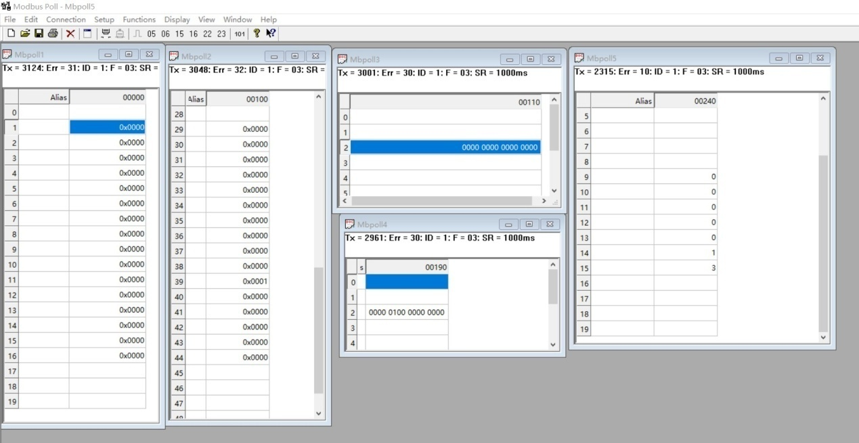

You can also use HyperTerminal serial input, as shown below

（Manually add CRC check）

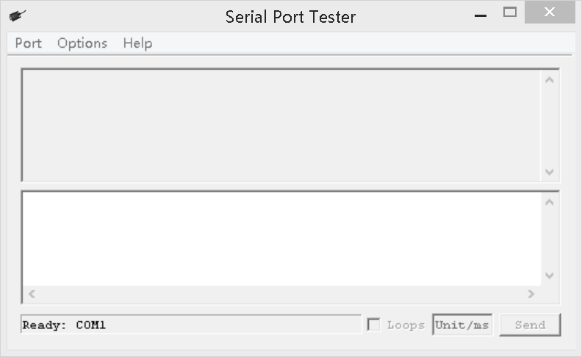

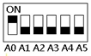

Examples (Slave ID is 1,DIP switch state)

Channel 1 Open ：01 06 00 01 01 00 D9 9A

Channel 1 Close ：01 06 00 01 02 00 D9 6A

Channel 1 Toggle：01 06 00 01 03 00 D8 FA

Channel 1 Latch：01 06 00 01 04 00 DA CA

Channel 1 Momentary: 01 06 00 01 05 00 DB 5A

Channel 1 Delay 10 seconds : 01 06 00 01 06 0A 5B AD

Channel 1 Delay 100 seconds: 01 06 00 01 06 64 DA 41

Channel 2 Open ：01 06 00 02 01 00 29 9A

Channel 2 Close ：01 06 00 02 02 00 29 6A

Channel 2 Toggle ：01 06 00 02 03 00 28 FA

Channel 2 Latch ：01 06 00 02 04 00 2A CA

Channel 2 Momentary : 01 06 00 02 05 00 2B 5A

Channel 2 Delay 10 seconds : 01 06 00 02 06 0A AB AD

Channel 2 Delay 100 seconds : 01 06 00 02 06 64 2A 41

Open all：01 06 00 00 07 00 8B FA

Close all：01 06 00 00 08 00 8E 0A

16 (0X10) function code (only supports 0x0001-0x0010 registers)

Open all：01 10 00 01 00 10 20 01 00 01 00 01 00 01 00 01 00 01 00 01 00 01 00 01 00 01 00 01 00 01 00 01 00 01 00 01 00 01 00 F5 B0

Close Channels1-4：01 10 00 01 00 04 08 02 00 02 00 02 00 02 00 CB 5A

Close Channels 5-8：01 10 00 05 00 04 08 02 00 02 00 02 00 02 00 3A 95

Read state (assuming that the channel 1 is open, the channel 2 is close).

Read channel 1 state ：01 03 00 01 00 01 D5 CA

Return open：01 03 02 00 01 79 84

Read channel 2 state ：01 03 00 02 00 01 25 CA

Return close：01 03 02 00 00 B8 44

Read channel 1 and channel 2 state ：01 03 00 01 00 02 95 CB

Return channel open and channel 2 close ：01 03 04 00 01 00 00 AB F3

Read 1-8 channel input status：01 03 00 81 00 08 14 24

Return all input channels OFF：01 03 10 00 00 00 00 00 00 00 00 00 00 00 00 00 00 00 00 E4 59

Return input channel 1 ON：01 03 10 00 01 00 00 00 00 00 00 00 00 00 00 00 00 00 00 25 59

1. **Read Output port status(One bit, one channel)**

Send data

|  |  |  |  |  |
| --- | --- | --- | --- | --- |
| RS485 address  (Station address)  (1) | Function (1) | Register address (2) | Read number (2) | CRC16(2) |

Returns data

|  |  |  |  |  |
| --- | --- | --- | --- | --- |
| RS485 address  (Station address)  (1) | Function (1) | Number of bytes (1) | data (n) | CRC16(2) |

RS485 address:0x01-0xFE

Function code 0x03

Register address：0x0070 corresponds to channel 1-16 output port status

Read number：0x0001

For example: Read 1-16 channel output port status:

Send data(RS485 address is 1)：01 03 00 70 00 01 85 D1

Returns data：01 03 02 02 02 38 E5

01 RS485 address，03 Function，02 length，38 E5 crc16

0202 refers to the status of the output port, the second and tenth bits are 1, and the other bits are 0. So channels 2 and 10 are open, and the other channels are closed.

1. **Write Output port status(One bit, one channel)**

Send data

|  |  |  |  |  |
| --- | --- | --- | --- | --- |
| RS485 address  (Station address)  (1) | Function (1) | Register address (2) | Read number (2) | CRC16(2) |

Returns data

|  |  |  |  |  |
| --- | --- | --- | --- | --- |
| RS485 address  (Station address)  (1) | Function (1) | Number of bytes (1) | data (n) | CRC16(2) |

RS485 address:0x01-0xFE

Function code 0x06

Register address：0x0070 corresponds to channel 1-16 output port status

Read number：0x0001

For example: Open channel 1/2/3, other channels close:

Send data(RS485 address is 1)：01 06 00 70 00 07 C9 D3

Returns data：01 06 00 70 00 07 C9 D3

01 RS485 address，06 Function，C9 D3 crc16

00 70 refers to the registers of 1-16 channels; 0007 refers to 1-3 channels open and 4-16 channels closed.

1. **Read input port status(One register, one channel)**

Send data

|  |  |  |  |  |
| --- | --- | --- | --- | --- |
| RS485 address  (Station address)  (1) | Function (1) | Register address (2) | Read number (2) | CRC16(2) |

Returns data

|  |  |  |  |  |
| --- | --- | --- | --- | --- |
| RS485 address  (Station address)  (1) | Function (1) | Number of bytes (1) | data (n) | CRC16(2) |

RS485 address:0x01-0xFE

Function code 0x03

Register address：0x0081-0x0090 IN1-IN16 channels input port status

Read number：0x0001-0x0010

0X000 No input, NPN input, the port is high or floating;

0X0001 has input, NPN input, the port is low level;

For example: Read channel IN1 port value:

Send data(RS485 address is 1)：01 03 00 81 00 01 D4 22

Returns data：01 03 02 00 01 79 84

01 RS485 address，03 Function，02 length，79 84 crc16

00 01 means there is input. NPN input, then port IN1 is low level

For example: Read channel IN2 port value:

Send data(RS485 address is 1)：01 03 00 82 00 01 24 22

Returns data：01 03 02 00 00 B8 44

01 RS485 address，03 Function，02 length，B8 44 crc16

00 00 means no input. NPN input, then port IN2 is floating or high level.

1. **Read input port status(One bit, one channel)**

Send data

|  |  |  |  |  |
| --- | --- | --- | --- | --- |
| RS485 address  (Station address)  (1) | Function (1) | Register address (2) | Read number (2) | CRC16(2) |

Returns data

|  |  |  |  |  |
| --- | --- | --- | --- | --- |
| RS485 address  (Station address)  (1) | Function (1) | Number of bytes (1) | data (n) | CRC16(2) |

RS485 address:0x01-0xFE

Function code 0x03

Register address：0x00C0 IN1-IN16 channels input port status

Read number：0x0001

The 16-bit data of 0x00C0 Register indicates the input status of channels IN1-IN16, 0 means no input, 1 means input

For example: Read channel IN1-IN16 port value:

Send data(RS485 address is 1)：01 03 00 C0 00 01 84 36

Returns data：01 03 02 00 80 B9 E4

01 RS485 address，03 Function，02 length，B9 E4 crc16

00 80 represents the input status of IN1-IN16, the eighth bit is 1, the other bits are 0; it means that IN8 has input, and other channels have no input

1. **Remote IO Sender**

Send data

|  |  |  |  |  |
| --- | --- | --- | --- | --- |
| RS485 address  (Station address)  (1) | Function (1) | Register address (2) | Read number (2) | CRC16(2) |

Returns data

|  |  |  |  |  |
| --- | --- | --- | --- | --- |
| RS485 address  (Station address)  (1) | Function (1) | Number of bytes (1) | data (n) | CRC16(2) |

RS485 address:0x01-0xFE

Function code 0X03 read / 0x06 write

Register address：0x00F9

Read number：0x0001

Configure this register, the N4D3E16 board will actively send IN1-IN16 input status to control the output ports CH1-CH16 of another N4D3E16 board, and the RS485 addresses of the two boards must be the same. The unit is 0.2 seconds. 0 prohibited 1-255 means sending once every 0.2-51 seconds

For example, if remote IO sending is currently prohibited, it should be changed to allow remote IO sending:

0.2 seconds, send data(RS485 address is 1)： 01 06 00 F9 00 01 98 3B

0.4 seconds, send frame (address is 1) 01 06 00 F9 00 02 D8 3A

0.6 seconds, send frame (address is 1) 01 06 00 F9 00 03 19 FA

0.8 seconds, send frame (address is 1) 01 06 00 F9 00 04 58 38

1 second, send frame (address is 1) 01 06 00 F9 00 05 99 F8

Disable remote IO sending: send frame (address is 1) 01 06 00 F9 00 00 59 FB

1. **Remote IO Receiver**

Send data

|  |  |  |  |  |
| --- | --- | --- | --- | --- |
| RS485 address  (Station address)  (1) | Function (1) | Register address (2) | Read number (2) | CRC16(2) |

Returns data

|  |  |  |  |  |
| --- | --- | --- | --- | --- |
| RS485 address  (Station address)  (1) | Function (1) | Number of bytes (1) | data (n) | CRC16(2) |

RS485 address:0x01-0xFE

Function code 0X03 read / 0x06 write

Register address：0x00FA

Read number：0x0001

When Remote IO Receiver is allowed, please configure this register to 1.

Note: When this register is configured as 1, register 0x0070 does not return 06 function code

If allow remote IO reception: send frame (address is 1) 01 06 00 FA 00 01 68 3B

If prohibit remote IO reception: send frame (address is 1) 01 06 00 FA 00 00 A9 FB

1. **Automatic report selection register**

Send data

|  |  |  |  |  |
| --- | --- | --- | --- | --- |
| RS485 address  (Station address)  (1) | Function (1) | Register address (2) | Setting Content (2) | CRC16(2) |

Returns data

|  |  |  |  |  |
| --- | --- | --- | --- | --- |
| RS485 address  (Station address)  (1) | Function (1) | Register address  (2) | Register value (2) | CRC16(2) |

RS485 address:0x01-0xFE

Function code 0X03 read / 0x06 write

Register address：0x00FC

Setting Content：1Bytes

For example :

1 Select register 0x0080-0x090 to report automatically:

Send data(RS485 address is 1)：01 06 00 FC 00 00 49 FA

2 Select register 0x00C0 to report automatically:

Send data(RS485 address is 1)：01 06 00 FC 00 01 88 3A

1. **Set Input port status reporting function(316 channels set at the same time)**

Send data

|  |  |  |  |  |
| --- | --- | --- | --- | --- |
| RS485 address  (Station address)  (1) | Function (1) | Register address (2) | Setting Content (2) | CRC16(2) |

Returns data

|  |  |  |  |  |
| --- | --- | --- | --- | --- |
| RS485 address  (Station address)  (1) | Function (1) | Register address  (2) | Register value (2) | CRC16(2) |

RS485 address:0x01-0xFE

Function code 0X03 read / 0x06 write

Register address：0x00FD

Setting Content：1Bytes

For example : For example, the current query function should be changed to automatic reporting:

Automatically report in 1 second, send frame (address is 1) 01 06 00 FD 00 01 D9 FA

Automatically report in 2 second, send frame (address is 1) 01 06 00 FD 00 02 99 FB

Automatically report in 3 second, send frame (address is 1) 01 06 00 FD 00 03 58 3B

Automatically report in 4 second, send frame (address is 1) 01 06 00 FD 00 04 19 F9

Automatically report in 5 second, send frame (address is 1) 01 06 00 FD 00 05 D8 39

Automatically report in 10 second, send frame (address is 1) 01 06 00 FD 00 0A 98 3D

Disable reporting function: send frame (address is 1) 01 06 00 FD 00 00 18 3A

1. **Read baud rate**

Send data

|  |  |  |  |  |
| --- | --- | --- | --- | --- |
| RS485 address  (Station address)  (1) | Function (1) | Register address (2) | Read number (2) | CRC16(2) |

Returns data

|  |  |  |  |  |
| --- | --- | --- | --- | --- |
| RS485 address  (Station address)  (1) | Function (1) | Number of bytes (1) | data (n) | CRC16(2) |

Function code 0x03

Register address：0x00FF

Read number：0x0001

For example:

send data(RS485 address is 1)：01 03 00 FF 00 01 B4 3A

Returns data：01 03 02 00 03 F8 45

01 RS485 address，03 Function，02 length，F8 45 crc16

03 means the current baud rate is 9600bps

Baud rate corresponds to the number: 0: 1200 1: 2400 2: 4800 3: 9600 4: 19200

1. **Write baud rate**

Send data

|  |  |  |  |  |
| --- | --- | --- | --- | --- |
| RS485 address  (Station address)  (1) | Function (1) | Register address (2) | Setting Content (2) | CRC16(2) |

Returns data

|  |  |  |  |  |
| --- | --- | --- | --- | --- |
| RS485 address  (Station address)  (1) | Function (1) | Register address  (2) | Register value (2) | CRC16(2) |

Function code 0x06

Register address：0x00FF

Setting Content：2Bytes(0-4)

For example, Change the baud rate to 4800bps:

send data(RS485 address is 1)：01 06 00 FF 00 02 38 3B

Returns data：01 06 00 FF 00 02 38 3B

Baud rate corresponds to the number: 0: 1200 1: 2400 2: 4800 3: 9600 4: 19200

5: Factory reset

Note: 1 The baud rate will be updated when the module is powered up again!

2 The factory setting can be restored when the baud rate corresponding to the number is 5. For example: 01 06 00 FF 00 05 79 F9