Problem 1.1

1. Using the formula

$${SIR}_{i}=\frac{G_{ii}p_{i}}{\sum_{j≠i}{G_{ii}p_{i}}+n_{i}}$$

$$p_{i}\left[t+1\right]= \frac{γ_{i}}{{SIR}_{i}[t]}p_{i}[t]$$

*(The attachment file:1.1_a.excel)*

The result is shown in the figure below

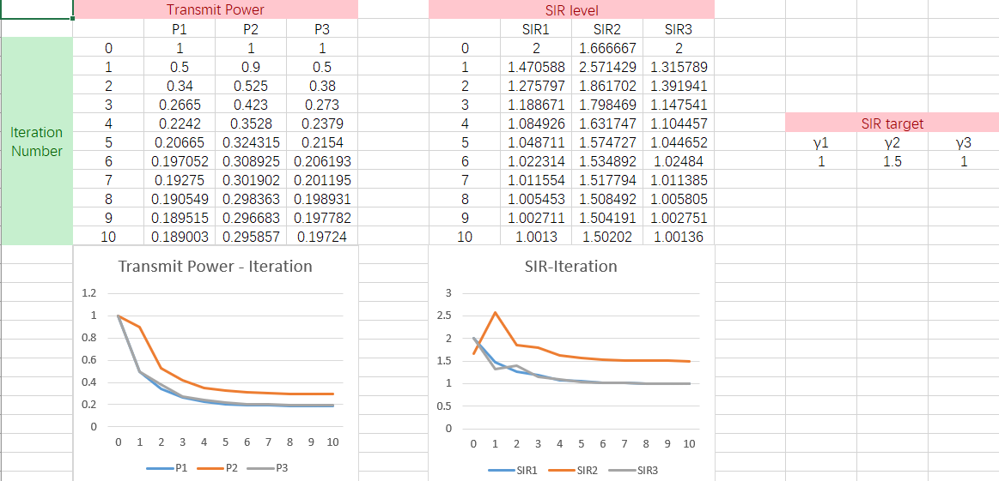

1. From the figure in a, we can see that the equilibriums are P1 = 0.19, P2 = 0.30, P3 = 0.20

Then using the same formula, the result is shown below

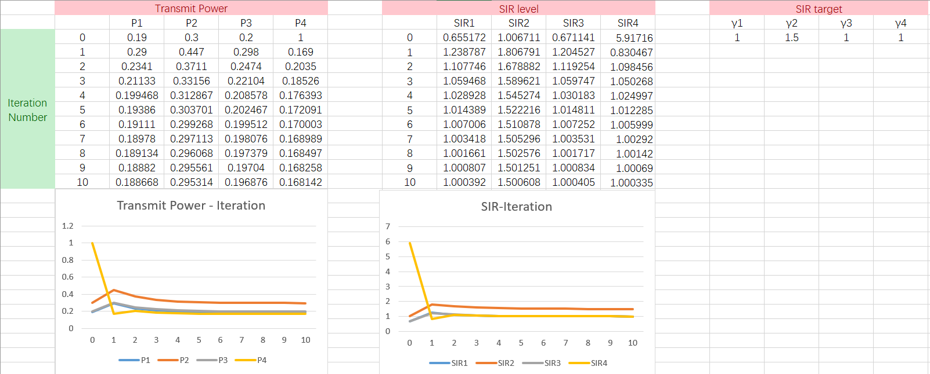

The figure shows that the transmit power of links 1,2,3 raised immediately after the link 4 joined, but come back to the same equilibrium point with a slightly descend.

Problem 1.4

1. There is a Nash equilibrium, and it is (b,b) with payoff (3,2)
2. Change the 0 in (6,0) to any number larger than 2

Problem 2.3

If the slots are allocated starting from the slot with highest clickthrough rate.

If b1[1] > b2[1]; Alice payoff is 500r - b2[1]

If b1[1] < b2[1]; Alice loses the top spot and will get the slot with clickthrough rate of 300, because Bob will get the first slot, and he will not be able to get another slots which means Alice will get the next slot. The payoff is 300r – b1[2]

If the slots are allocated starting from the slot with lowest clickthrough rate.

If b1[1] > b2[1]; Alice payoff is 200r - b2[1]

If b1[1] < b2[1]; Alice loses the top spot and will get the slot with clickthrough rate of 300, because Bob will get the first slot, and he will not be able to get another slots which means Alice will get the next slot. The payoff is 300r – b1[2]

1. There is a dominate strategy.

If the slots are allocated starting from the slot with highest clickthrough rate.

To maximum the payoff, Alice should make 500r - b2[1] = 300r, which makes Alice’s bid {200r, 0, whatever}

If the slots are allocated starting from the slot with highest clickthrough rate.

To maximum the payoff, Alice should make 200r - b2[1] = 300r, which is not possible, so the bid for first two slot is 0, which makes Alice’s bid {0, 0, whatever}

(*Note that in these two bids, ‘0’ represents the lower bound for the auction.*)

Problem 2.5

a)

Because bidder 1 knows the value of the seat for bidder 2, she will have to bid each seat for larger than $10, thus makes her payoff negative. Therefore, bidder 1 will not get the seat, and bidder 2 will be charged for $10, the payoff of him is $2 since not one sit next him.

b)

In this case, bidder 1 will make the bid for two seats at the lowest price that is larger than $12, thus she will bid the two seats for $13. The payoff of bidder 1 is $15 - $13 = $2.

The payoff of a) and b) is the same, but in a), a seat is unused, thus the charged price is $10 for a single seat, while in b), the charged price is $13 for two seats.