4.3

a) To get $b^{*}$, solving ${(A}^{T}A)b= A^{T}c$

$$\left[\begin{matrix}6 & 3 & 4 \\ 3 & 6 & 3 \\ 4 & 3 & 6\end{matrix}\right]b=\left[\begin{matrix}9 \\ 6 \\ 8\end{matrix}\right]$$

And the answer is $b^{T}=[\frac{29}{28}, \frac{3}{14},\frac{15}{28}]$

b) By taking derivative of ${\left\|Ab-c\right\|}_{2}^{2}+ λ{\left\|b\right\|}_{2}^{2}$, and set the derivative to 0, we have

$${(A}^{T}A)b+λb= A^{T}c$$

The equivalent matrix is

$$\left[\begin{matrix}6+λ & 3 & 4 \\ 3 & 6+λ & 3 \\ 4 & 3 & 6+λ\end{matrix}\right]b=\left[\begin{matrix}9 \\ 6 \\ 8\end{matrix}\right]$$

The attached file 4.3.py is used to solve this equation, required matplotlib, scipy and numpy, and the result is shown below

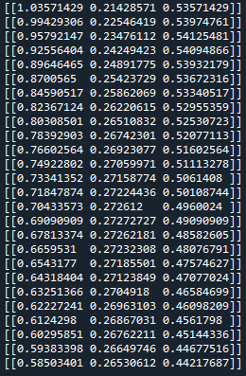

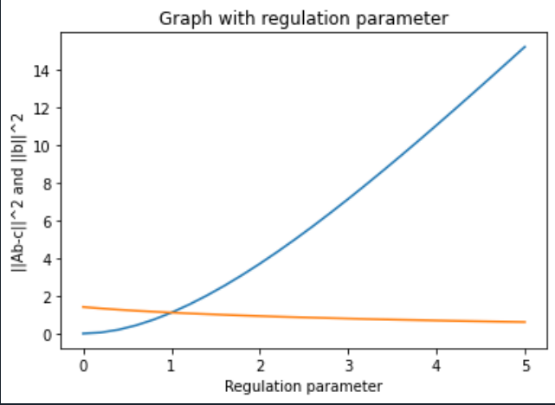

4.4

a) $f^{''}\left(x\right)=0$ for all real x, so it is both convex and concave

b) $f^{''}\left(x\right)= -\frac{4}{{3x}^{2}}<0$ for all $x>0$, so it is concave

c) $f^{''}\left(x\right)={4e}^{2x}>0$ for all real x, so it is convex

d) The Hessian matrix of this function is $\left[\begin{matrix}-6 & 0 \\ 0 & -8\end{matrix}\right]$, and the eigenvalues are -6 and -8, both less than 0, so this function is concave

e) The Hessian matrix of this function is $\left[\begin{matrix}0 & 1 \\ 1 & 0\end{matrix}\right]$, and the eigenvalue is 1,which is less than 0, so this function is convex