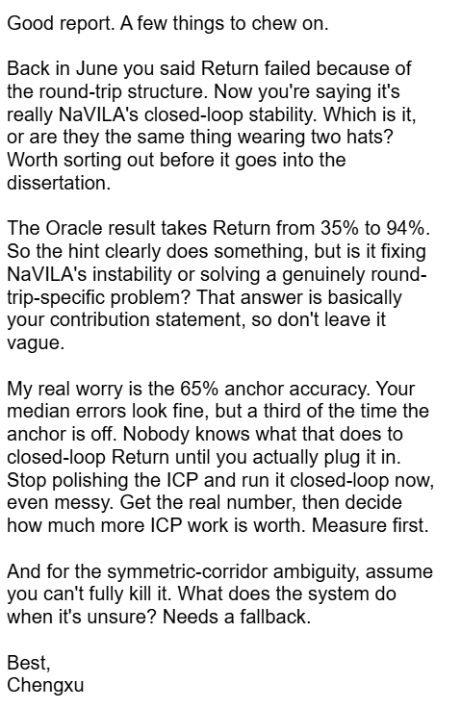
Part One: Defining the Cause(s) of Return Failure (Response to Chengxu's First Question)
We believe that Return failures in the pure NaVILA baseline (with no route-memory/hint mechanism of any kind) can be attributed to two causal layers that are independent of one another, yet compound and amplify each other — rather than a single cause. This is also our answer to the question of whether it's the round-trip structure or NaVILA's own closed-loop stability: both are real, independent factors — they are not the same thing wearing two hats.
Layer 1: A stability deficiency in NaVILA's own closed-loop navigation, most clearly visible during the Return phase
The evidence for this layer comes from concrete failure patterns observed within the Return phase itself:
- Left-right oscillation with no effective forward progress: In the v4 baseline random-episode testing, episode 366 completed Outbound successfully, but during Return it "became stuck in alternating left/right 45-degree turns from approximately step 3750 onward," and timed out at step 7051 still 7.441 m from the start, with no effective forward progress the entire time. This is a classic visual-decision failure: the VLM oscillates between two actions and never converges on a direction.
- Failing to issue a stop in time despite entering the success radius, causing the robot to overshoot the target: In the 30-episode v4 baseline, several episodes judged as Return failures had a final distance to start that was actually very small — e.g. 0.550 m, 0.589 m, 0.761 m, 0.000 m — well below the success radius in effect at the time, yet none were counted as successes. This suggests the robot very likely physically reached, or came extremely close to, the start, but the VLM failed to issue a stop command at the right moment, so it kept moving and ended up somewhere else. This lines up directly with the hypothesis that the VLM's stop judgment is decoupled from its true position.
- Physically getting stuck against a wall or a dead-end in a corridor: Analysis at the per-step trajectory level shows cases during Return where the robot repeatedly moves toward a wall or a corridor dead-end and enters a state where it can no longer make forward progress. This is not a route-selection error — it's a systematic bias in the VLM's local visual judgment, repeatedly choosing actions oriented toward non-traversable space.
- Stopping prematurely despite distance steadily shrinking: Also from trajectory-level analysis — in some episodes, the robot's distance to the start decreases continuously and smoothly during Return, but the VLM makes an "arrived" judgment based on the current visual input and issues a stop before actually reaching the target. This is a distinct failure mechanism from oscillation/getting stuck: the former is "should have stopped but didn't," the latter is "stopped when it shouldn't have." Together they show that the VLM's arrival judgment itself is unstable, not biased in a single direction.
Conclusion for this layer: Even entirely apart from the round-trip context, the Return phase's own behavior already shows clear, repeatedly observed deficiencies in NaVILA's visual decision-making stability and stop-timing judgment — non-convergent oscillation, physical stalling, missing the stop window, and premature false-positive stops. All four patterns point to the same root cause: the VLM's arrival judgment and action selection lack a reliable anchor to its true current position.
Layer 2: The round-trip context itself is a structural failure factor independent of Layer 1
The core evidence for this layer is the H1/H2 isolation experiment from 2026-06-06: the same path that Episode 0's Return phase needed to traverse was run in isolation as a standard, non-round-trip outbound task (Episode 705), and NaVILA achieved success=1.0, SPL=0.807. This directly rules out the hypothesis that the training distribution doesn't cover this path direction. But when the exact same path — even using this already-verified-successful native instruction, and even with oracle pose resetting the start-position error to zero — was placed back into the round-trip Return phase, it still failed (final distance to start = 11.351 m).
Conclusion for this layer: The path itself is navigable, instruction quality itself is not the problem, and start-pose error is not a sufficient explanation either — the round-trip context itself (phase transition, visual history accumulated during Outbound, a mismatch between the Return-phase starting view and expectation) is a failure source that exists independently of Layer 1, and it compounds with Layer 1's stability deficiencies. As the analysis put it at the time, round-trip context "remains a separate failure factor" that "can still break Return even with a dataset instruction that succeeds as a clean single-trip episode."

