Setup instructions:

* Truffle v5.4.29
* Solidity v0.5.16
* Node v16.13.2
* Web3.js v1.5.3
* lite-server v2.3.0
* Ganache v2.5.4

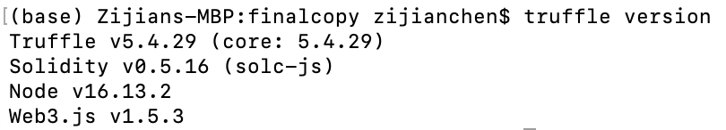

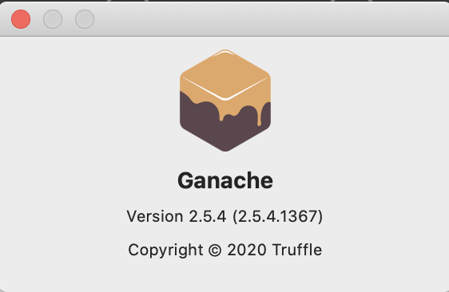

* Install the nodejs javascript runtime environment:

<https://nodejs.org/en/download/>



* Install the Truffle IDE globally from the windows terminal:

npm uninstall -g truffle

npm install -g truffle@v5.1.10

* Install liteserver globally from the windows terminal:

npm install -g lite-server

or goto: https://www.npmjs.com/package/lite-server

* Install Ganache:

http://truffleframework.com/ganache and click the download button

you should see Ganache started at http://127.0.0.1:7545

1. Run Ganache, then select “QuickStart” option

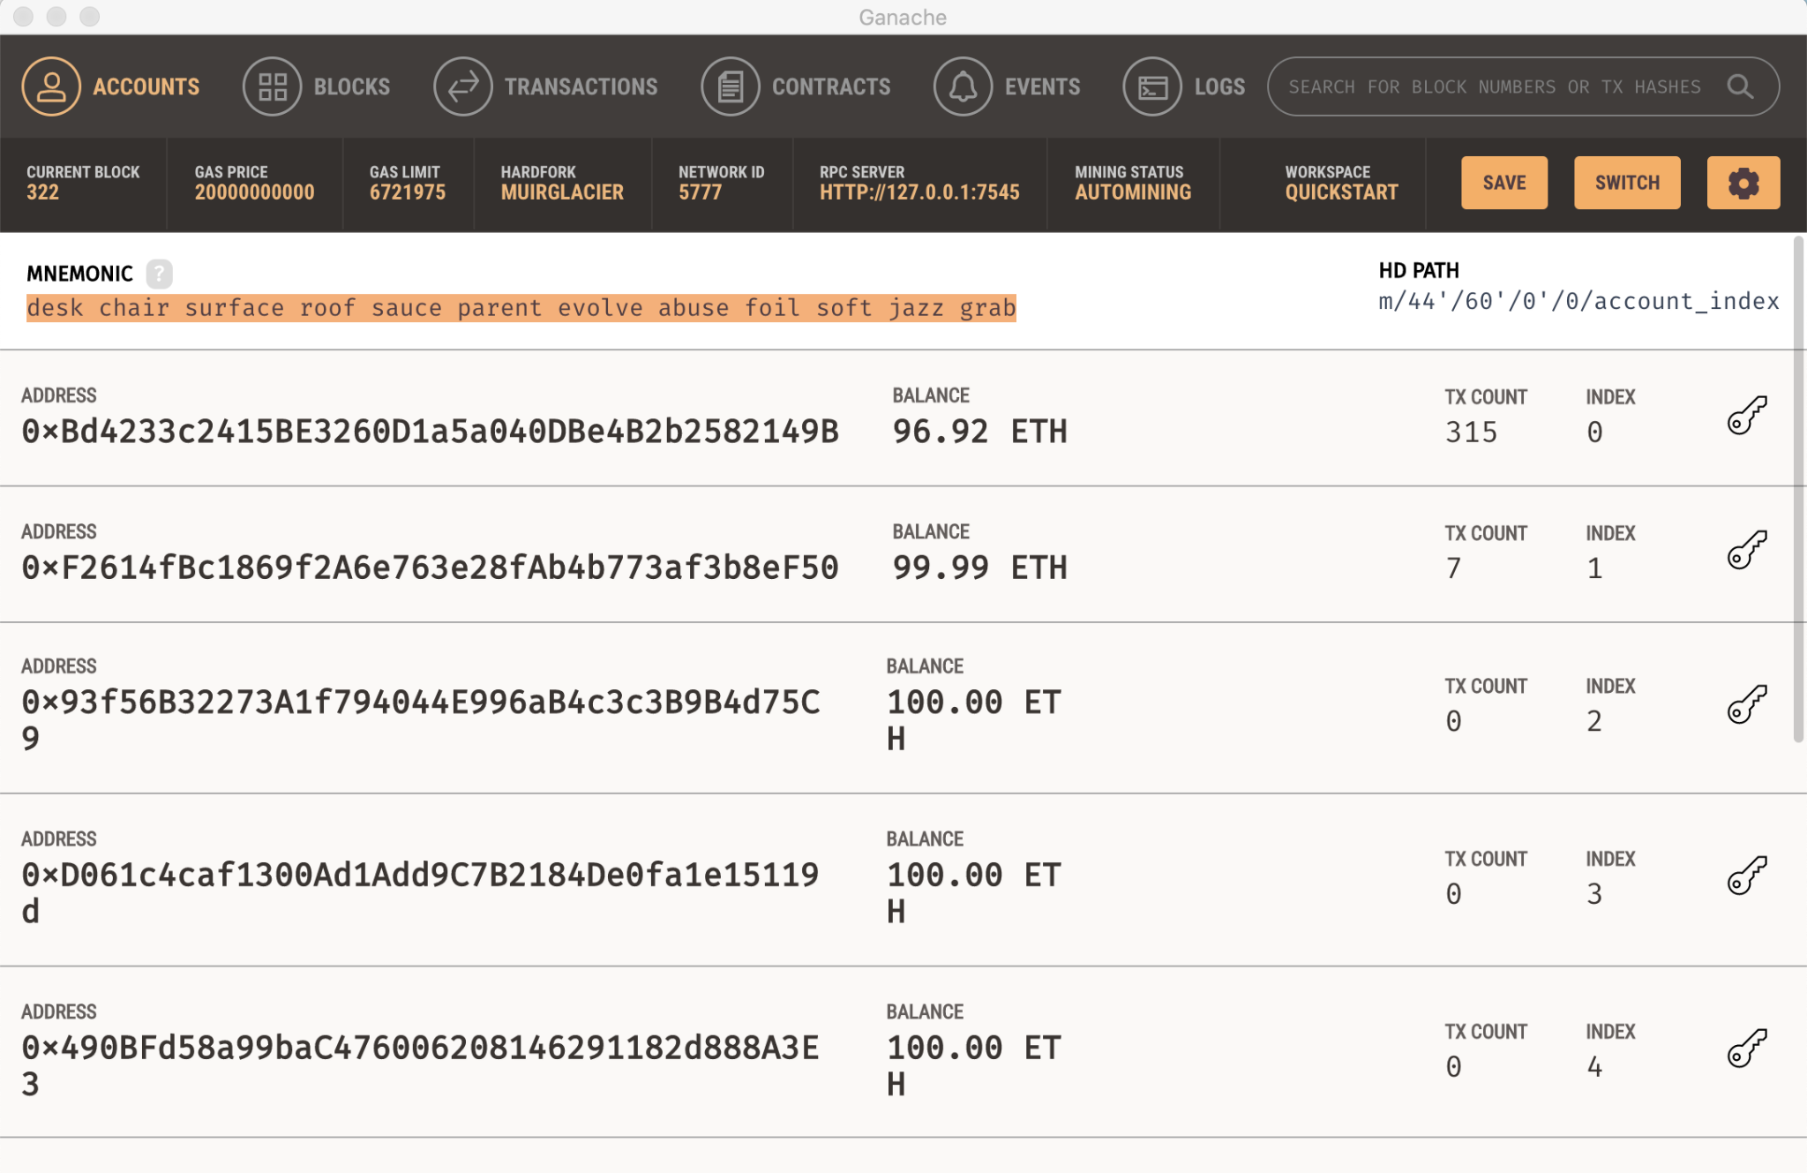

* Install MetaMask in your default browser:

https://metamask.io/download.html

* Configure MetaMask with Ganache:

1. Select: "No, I already have a seed phrase", import wallet
2. Copy the MNEMONIC from Ganache and paste it into "Enter your secret twelve-word phrase here to restore your vault. Wallet Seed:"
3. Select “Provide a password”
4. Select “Import”
5. Then, goto: Main Ethereum Network Dropdown List (top right) and select Custom RPC copy RPC server address from Ganache (should be HTTP://127.0.0.1:7545) and paste it to new RPC URL in the Chain ID field write Ganache's Chain ID: 1337.
6. Close the Custom RPC setup window by clicking X

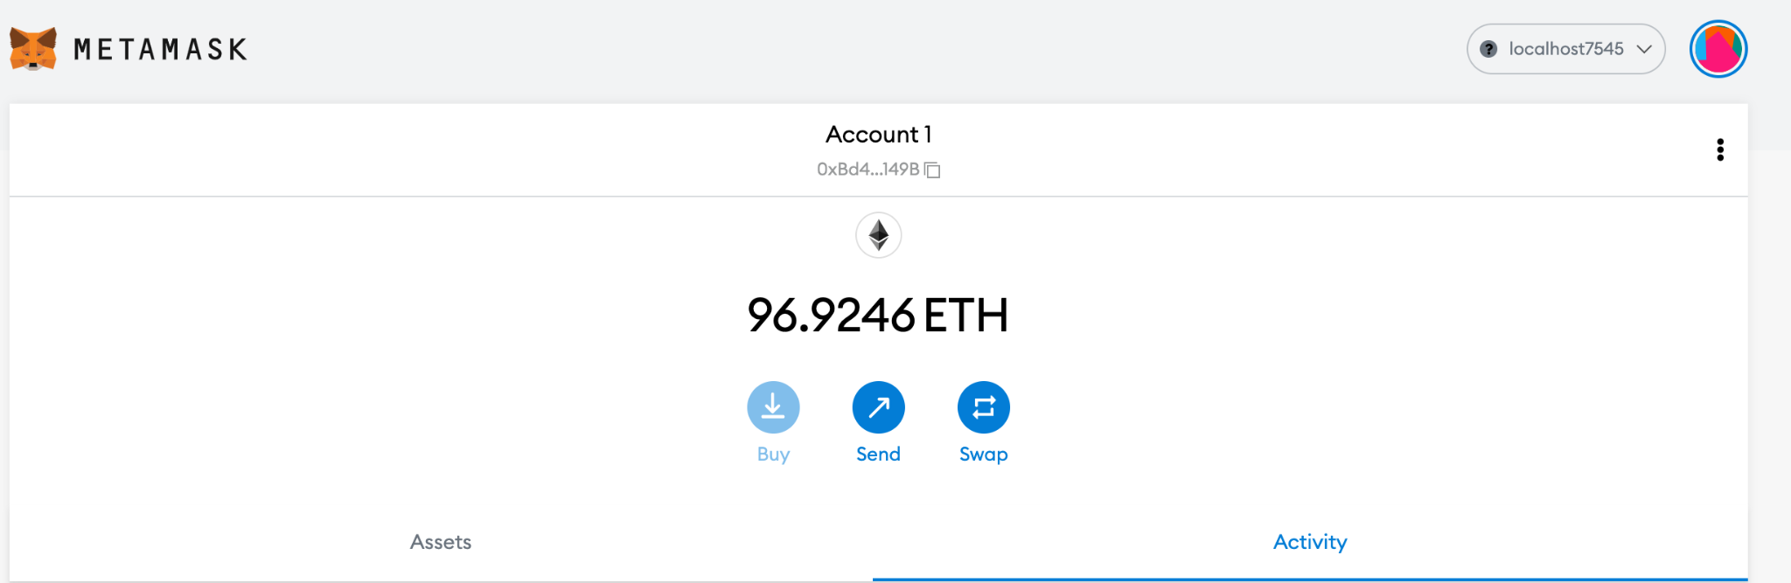

* To start the project:

Enter the project directory.

Run command: truffle migrate --reset

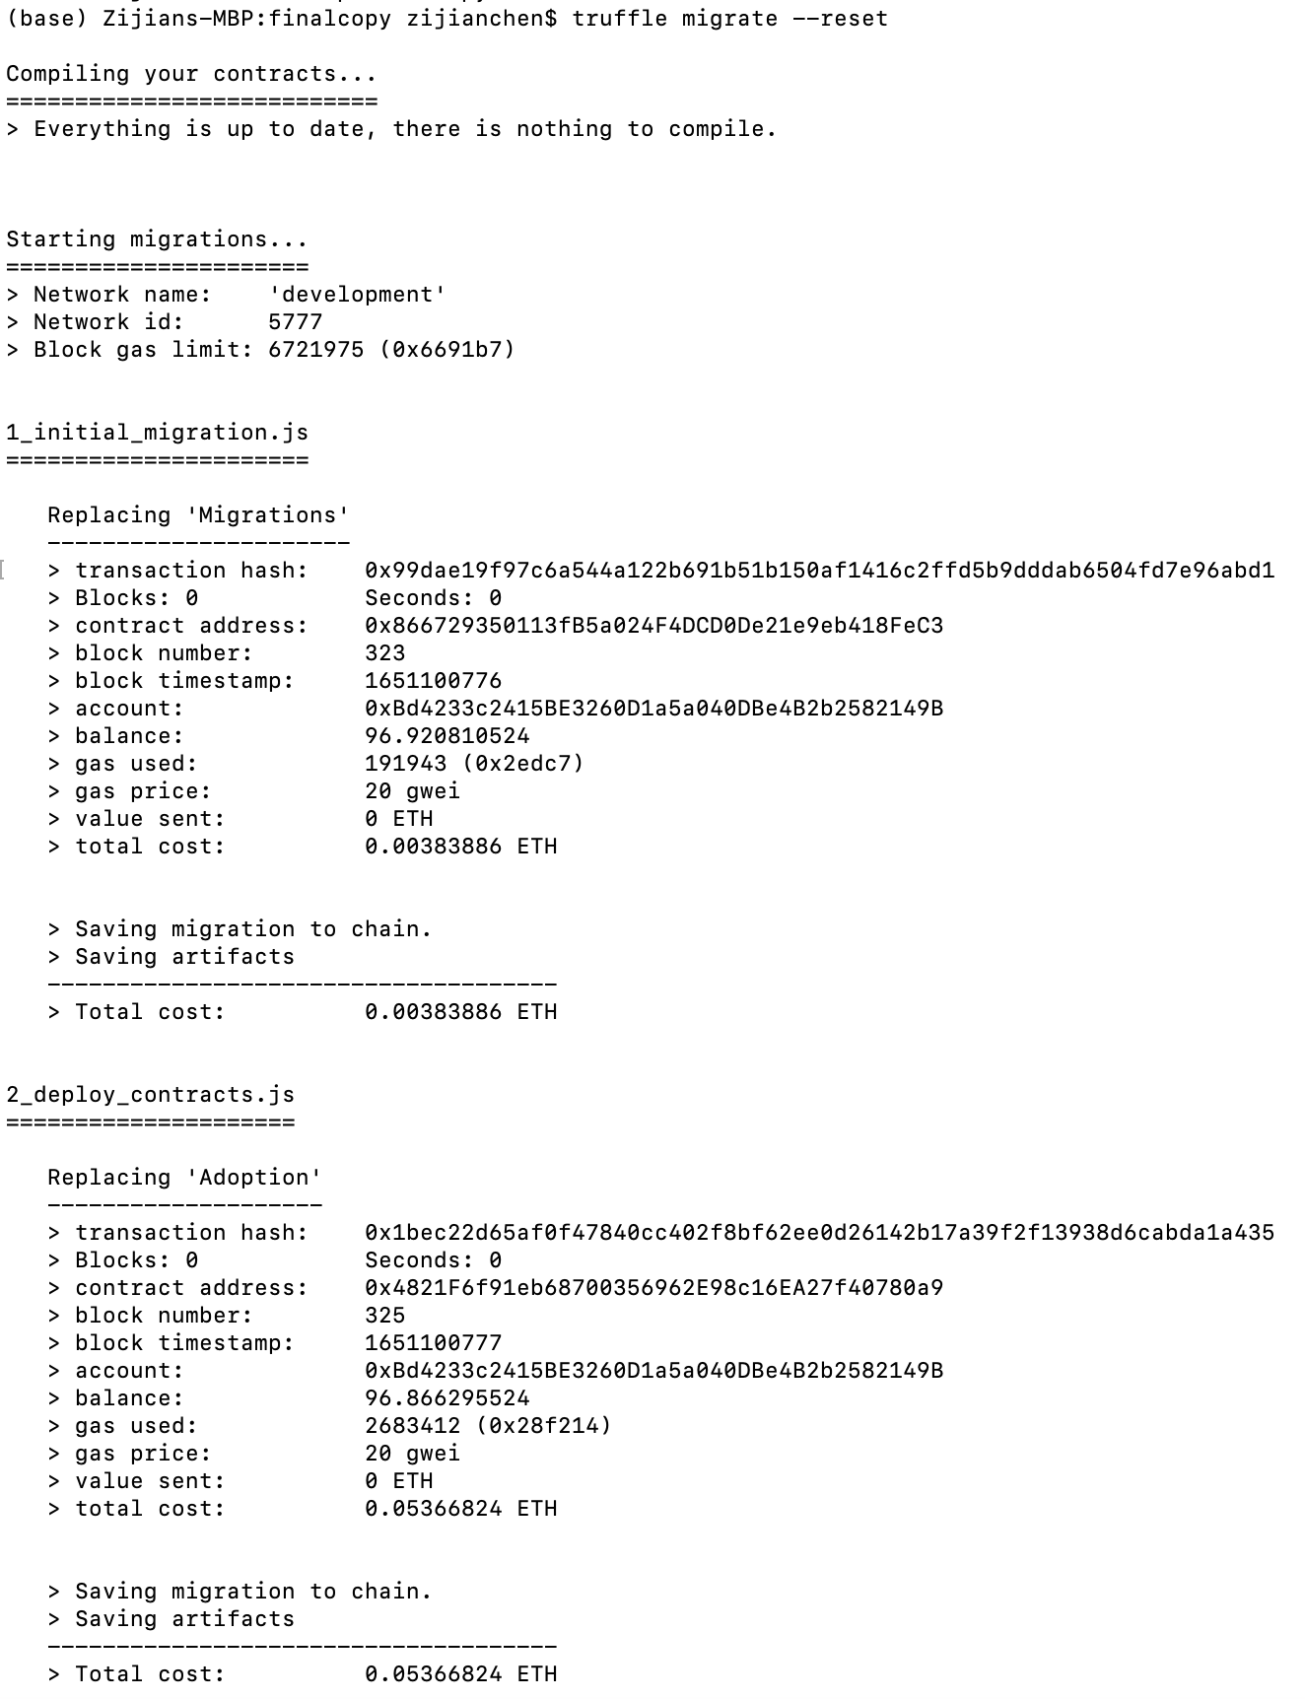

Run command: npm run dev

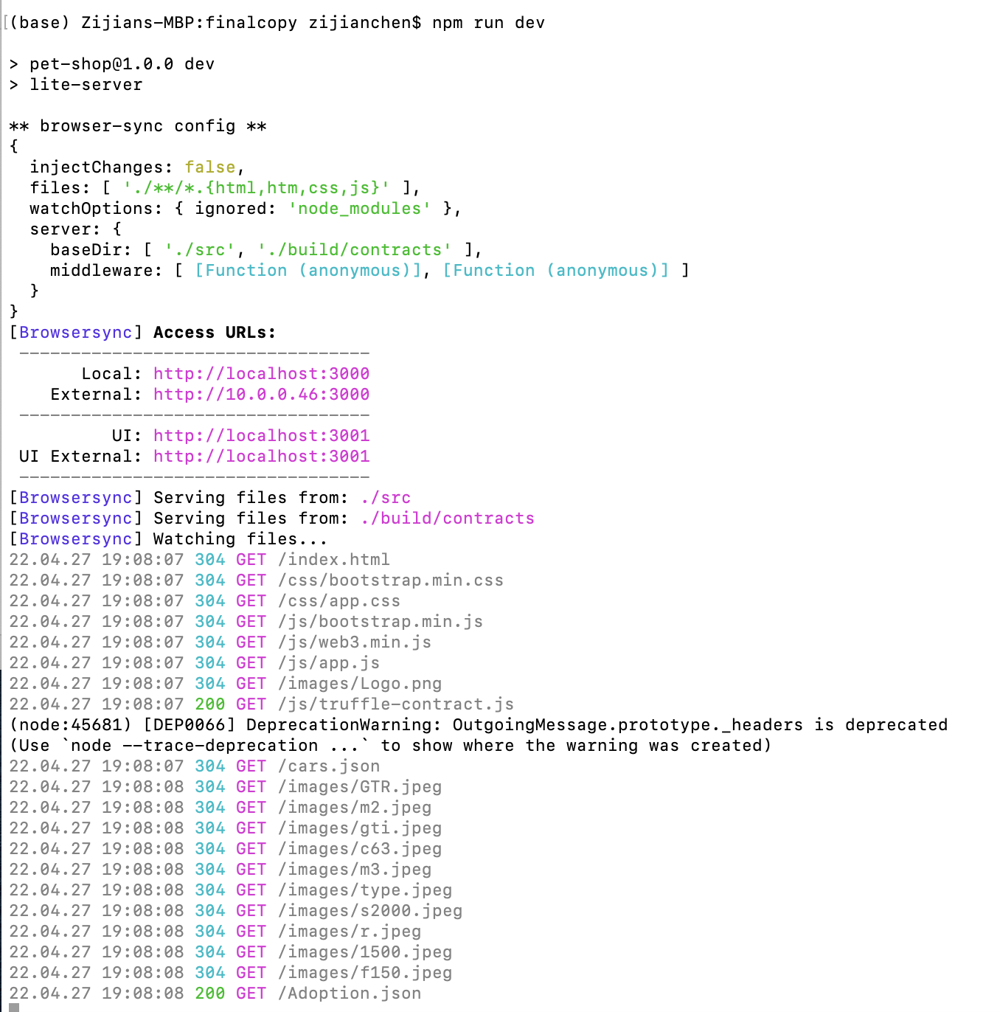

The website will be opened automatically in the browser.

