Name: Zhang, Bruce Date: 11/13/2025
(last name, first name)
NYU ID: yz8063
Course Section Number: 001

Project Part II Report

Total in points: __________________
Professor’s Comments:

Affirmation of my Independent Effort: Bruce Zhang

1 Data Lake Design and Implementation

1.1 Introduction
A small data lake was implemented, consisting of multiple health-related datasets that could be used by an insurance company to forecast chronic diseases and related risks. The data lake is organized into raw and processed zones, and currently integrates two structured data sources:
- BRFSS 2024 individual-level survey data (Behavioral Risk Factor Surveillance System)
- CDC WONDER state-level provisional mortality statistics
This design prepares the data to feed to the logical schema and enterprise data architecture in the following steps.

1.2 Data Lake Structure
The data lake is organized in the following folder layout:
- data_lake/raw/
  - Raw_data_sources.txt: contains information and sources for the raw datasets, considering the sizes of the original data
- data_lake/processed/
  - brfss_clean_semantic.csv : person level behavioral and health variables
  - cdc_wonder_clean.csv: state-level mortality counts by age group
  - raw_data_conversion.py: python script for cleaning raw data and converting into desired formats
This separation supports reproducibility, that is any processed artifact can be recreated from the raw file using the cleaning script.

1.3 Source 1: BRFSS 2024
The original BRFSS 2024 public-use file was downloaded in SAS transport format. From the full set of 301 variables, a subset of fields relevant to chronic disease risk modeling was retained. These include:
- Demographics: _STATE, _AGE80, SEXVAR, _EDUCAG, INCOME3
- Lifestyle: _SMOKER3, DRNKANY6, _EXERANY2, RFDRHV9, _BMI5
- Health outcomes and preventive care: _DIABETE4, _CVDCRHD4, _CVDSTRK3, _FLUSHOT7, _PNEUMO3
- Identifiers: SEQNO, _PSU
Several cleaning steps were applied:
- Byte decoding: values imported as byte strings were decoded into human-readable strings.
- Column renaming: BRFSS codes were renamed to semantic names to align with the logical schema, e.g.:
  - _STATE: state_fips
  - SEXVAR: gender
  - _DIABETE4: diabetes_status, etc.
- Code-to-label mapping: categorical codes were mapped to readable formats, referring to BRFSS documentation. Binary health indicators were mapped to “Yes”, “No”, or missing.
- BMI normalization: _BMI5 was divided by 100 to convert BRFSS’s stored integer into standard BMI value.
By abiding from the steps above, brfss_clean_semantic.csv presents a person-level structured dataset ready to populate the Person, Lifestyle, and HealthOurcome entities of the logical schema.

1.4 Source 2: CDC WONDER Provisional Mortality Statistics
State-level mortality data were queried from CDC WONDER’s “Provisional Mortality Statistics” interface. The results were grouped at a manageable grain (Residence State, Ten-Year Age Groups), and exported as an Excel file.
Several cleaning steps were applied:
- Column pruning: non-essential or repetitive columns such as Notes, Residence Code, Sex Code, duplicate age-group columns were removed to simplify the structure.
- Column renaming: attributes were renamed to better align with the logical schema: Residence → state_name, Ten-Year Age Groups → age_group, and Deaths → deaths.
- Numeric conversions: the deaths column was converted from text to integer, and any non-numeric values were coerced to NaN.
- State identifier: state_names and state_fips attributes serve as the integration key across datasets.
The curated output, cdc_wonder_clean.csv, is a state-level structured dataset used to populate the StateHealthStats entity.

1.5 Support for Hybrid and Unstructured Data
Although current sources of data mainly focus on structured CSV files, the data lake design is intentionally extensible to unstructured data as well. The envisioned UnstructuredDataMetadata table in the logical schema corresponds to data_lake/unstructured/ or cloud storage container, which would be discussed in section 3. Documents like clinical guidelines, PDF reports could be stored in such directories. The metadata schema should provide a consistent way to register and relate the unstructured objects to the structured BRFSS and CDC datasets.

1.6 Connection to the Logical Schema
The processed layer of the data lake is designed to map directly to the logical entities:
- brfss_clean_semantic.csv → Person, Lifestyle, and HealthOutcome tables
- cdc_wonder_clean.csv → StateHealthStats table
- unstructured/ files → represented via UnstructuredDataMetadata
This alignment would allow additional ingestion and transformation work to be carried out within the data lake, without requiring changes to the downstream applications or the logical schema. Therefore, the insurance company can progressively incorporate new structured and unstructured data sources while preserving a coherent enterprise data architecture.

2 Logical Schema Design and Optimization

2.1 Introduction
This section presents the logical database schema required to support a hybrid data architecture that incorporates both structured and unstructured data, as outlined in the project specification. The logical schema is designed following the ER modeling principles introduced in Part I, but itself does not serve as an extension of the enterprise-wide conceptual model. It represents a more focused schema focusing on the analytical needs of health-related datasets collected in the prior section.
The structured portion integrates survey data from the Behavioral Risk Factor Surveillance System (BRFSS) with macro-level mortality data from CDC WONDER. A metadata structure is introduced to incorporate unstructured assets like clinical notes, PDF guidelines or other external web documents, within the data lake.

2.2 Logical Schema Overview
The resulting schema consists of the following five entities:
- Person: the demographic attributes extracted from BRFSS
- Lifestyle: behavioral and lifestyle indicators
- HealthOutcome: self-reported chronic conditions and preventive behaviors from BRFSS
- StateHealthStats: state-level mortality indicators from CDC WONDER
- UnstructuredDataMetadata: metadata layer enabling integration of unstructured data into the hybrid data lake

2.3 Entity Definitions
Person: represents the primary entity at the individual granularity.
Attribute | Description
sequence_id (PK) | Unique respondent ID from BRFSS
state_fips | Links to StateHealthStats
age | Age
gender | Male/Female
education_level | Education level of the respondent
income_level | Annual income level of the respondent

Lifestyle: lifestyle behaviors form a logically separable subset of attributes and therefore are normalized into a separate entity.
Attribute | Description
sequence_id (PK, FK) | Reference to Person
smoking_status | Categorical
alcohol_use | Categorical
heavy_drinker | Categorical
exercise_status | Categorical
bmi | Continuous

HealthOutcome: health outcome attributes are independent of lifestyle attributes, and separating them reduces non-key dependencies.
Attribute | Description
sequence_id (PK, FK) | Reference to Person
diabetes_status | Yes/No
heart_disease | Yes/No
stroke_history | Yes/No
flu_shot | Yes/No
pneumonia_shot | Yes/No

StateHealthStats: aggregated state-level health outcome data for hybrid linkage.
Attribute | Description
state_fips (PK) | State identifier
age_group | CDC age grouping
deaths | Mortality count

UnstructuredDataMetadata: unstructured assets for the hybrid data model.
Attribute | Description
file_id (PK) | Unique file identifier
file_path | Path in data lake/cloud storage
file_type | pdf/txt/json, etc.
ingestion_ts | Ingestion timestamp
Linked_sequence_id (FK) | Link to Person
Linked_state_fips (FK) | Link to StateHealthStats
Description | Free-text description to the file

2.4 Relationship Summary
- Person ↔ Lifestyle: 1-to-1
- Person ↔ HealthOutcome: 1-to-1
- Person ↔ StateHealthStats: N-to-1
- UnstructuredDataMetadata ↔ Person: N-to-0 or 1
- UnstructuredDataMetadata ↔ StateHealthStats: N-to-0 or 1

2.5 Optimization and Normalization Explanation
The schema was normalized according to standard relational principles.

2.5.1 First Normal Form (1NF)
All tables contain atomic values, fixed column names, and no repeating groups. For example:
- BRFSS behavioral attributes were cleaned and mapped to atomic categorical values.
- CDC WONDER age groups were preserved as atomic labels (e.g. “45-54 years:).

2.5.2 Second Normal Form (2NF)
2NF requires eliminating partial dependencies on composite keys.
- Lifestyle attributes were removed from Person because they do not depend on the primary key sequence_id as a whole.
- Similarly, health outcome attributes form a conceptually independent component and therefore were decomposed into a separate table.
The above reasonings lead to Person → Lifestyle and Person → HealthOutcome relationships and remove the partial dependencies.

2.5.3 Third Normal Form (3NF)
3NF eliminates transitive dependencies.
- State-level attributes depend only on state_fips, and not on Person attributes, so StateHealthStats is isolated.
- Unstructured metadata is fact-independent and does not coexist in any structured table.
The above reasonings lead to a fully normalized schema with minimal redundancy and clear PK, FK dependencies.

2.5.4 Hybrid Model Optimization
The UnstructuredDataMetadata table is introduced to unify structured BRFSS/CDC WONDER data with unstructured assets. This enables lineage tracking of files stored in the enterprise data lake. Therefore, hybrid integration is achieved without violating normalization.

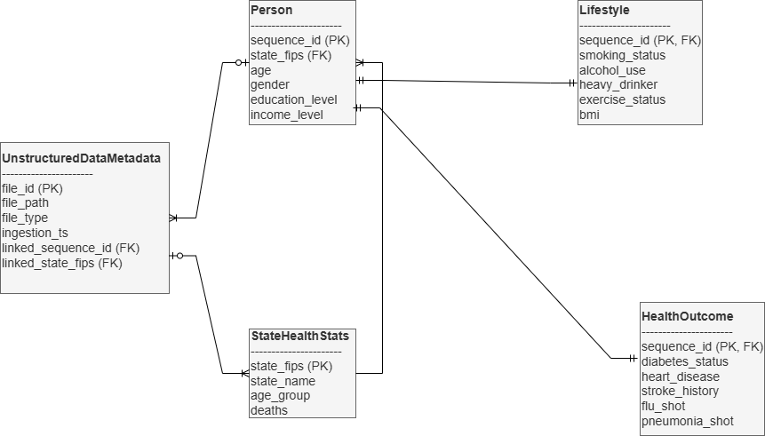
Figure 1: ER Diagram Specification

3 Cloud Platform Integration
In this section the design of such a cloud platform would be outlined. The designed data lake is assumed to be deployed on Microsoft Azure Storage. The goal is to define a cloud-native layout that mirrors the local data lake structure and can be used by downstream analytical components, and in our narrative for helping the insurance companies to make decisions when evaluating customers.
A single Azure Storage Account is used with three logical contains:
- raw: holds immutable copies of ingested source files
  - brfss/BRFSS_2024.XPT (referencing the original BRFSS SAS transport file)
  - cdc/Provisional Mortality Statistics, 2018 through Last Week.xls (referencing the CDC WONDER data with specifications)
- processed: holds immutable copies of ingested source files

In this design, the processed container serves as the primary interface between the data lake and the logical relational schema. The brfss_clean_semantic.csv file is mapped directly into the Person, Lifestyle, and HealthOutcome tables via ETL processes, while cdc_wonder_clean.csv is loaded into the StateHealthStats entity. Both files use state_fips as a shared key, making it straightforward to perform cross-level analyses linking individual behaviors to state-level mortality rates.
The unstructured container is linked to the UnstructuredDataMetadata entity in the logical schema. Each unstructured object is uniquely stored in Azure, registered with a file_id and file_path, optionally associated with a linked_sequence_id or linked_state_fips. The design satisfies the hybrid requirement by providing a clear pattern for integrating both structured and unstructured data under a unified cloud-based data lake architecture.
The above proposed structure demonstrates how an insurance company could operationalize the same design using standard Azure services such as Blob Storage, Azure Data Factory for ingestion, and Azure SQL Database or Synapse Analytics for consuming the curated structured data.

