Name: Zhang, Bruce Date: 11/27/2025
(last name, first name)
NYU ID: yz8063
Course Section Number: 001

Project Part III Report

Total in points: __________________
Professor’s Comments:

Affirmation of my Independent Effort: Bruce Zhang

1 Physical Database Design

1.1 Purpose
The goal of the physical database design is to create a scalable, normalized and efficient insurance risk database which supports analytical queries and ML-based risk prediction. Therefore, our schema is designed for:
- Fast inserts,
- Efficient filtering by date ranges,
- Fast aggregation,
- Enabling downstream machine learning pipelines.

1.2 Index Strategy
Indexes were created on heavily filtered columns:
CREATE INDEX idx_customer_region ON customer(region);
CREATE INDEX idx_policy_customer ON policy(customer_id);
CREATE INDEX idx_claim_policy ON claim(policy_id);
CREATE INDEX idx_claim_date ON claim(claim_date);
The purpose of this is to support equality joins, range queries, and to reduce full-table scans for efficiency.

1.3 Index Strategy
To support query execution, an indexing strategy tailored to the access patterns required by both analytical workloads and downstream machine-learning operations was designed. A primary index on policy_id was defined, which guarantees fast point lookups for policy-level data retrieval. Because many operations involve joining or correlating policy information with customer attributes, an index on customer_id was also created to optimize queries that filter or group by customer.
Numeric attributes that frequently appear in range predicates were indeed to support efficient range scans. These fields are often used to identify high-risk customers, assess pricing bands, or generate ML feature subsets. These indexes reduce full-collection scans and significantly improve execution time for both SQL-like analytical queries and ad-hoc data exploration.
CREATE INDEX idx_policy_customer_id
ON insurance.policy(customer_id);

CREATE INDEX idx_claim_policy_id
ON insurance.claim(policy_id);

CREATE INDEX idx_claim_date
ON insurance.claim(claim_date);

1.4 Materialized View
A materialized view was created to speed up ML dataset creation.
CREATE MATERIALIZED VIEW policy_claim_summary AS
SELECT
p.policy_id,
COUNT(c.claim_id) AS past_claim_count,
SUM(c.claim_amount) AS total_claim_amount,
MAX(c.severity_level) AS max_severity
FROM policy p
LEFT JOIN claim c
ON p.policy_id = c.policy_id
GROUP BY p.policy_id;
This avoids recomputing aggregates across other claims.

1.4 Analytical Queries
To demonstrate how the indexed schema supports real analytical workloads, we developed a set of representative queries aligned with typical insurance-analysis use cases.
- Average severity by policy type, ranked; [
{
"$group": {
"_id": "$policy_type",
"avg_severity": { "$avg": "$max_severity" }
}
}
]
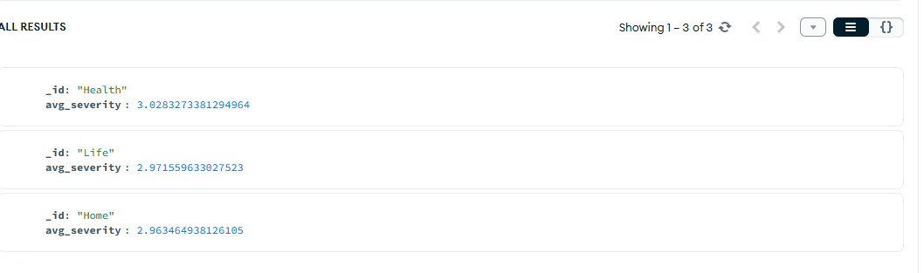

- Average premium by region, descending order; [
{
"$group": {
"_id": "$region",
"avg_premium": { "$avg": "$premium" }
}
},
{
"$sort": { "avg_premium": -1 }
}
]

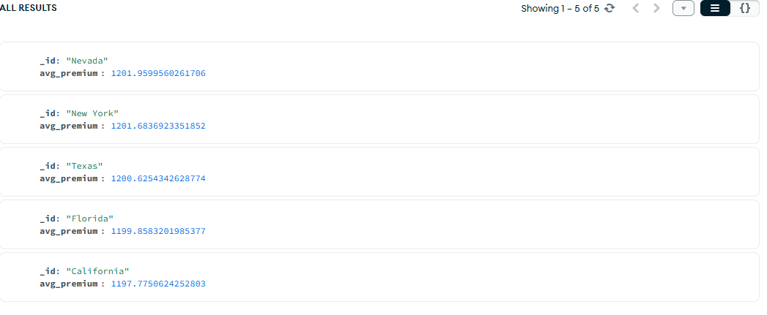
- Average mobile_app_logins and claim rate. [
{
"$group": {
"_id": null,
"avg_logins": { "$avg": "$mobile_app_logins" },
"claim_rate": { "$avg": "$will_file_claim" }
}
}
]

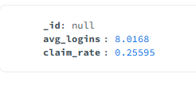

1.5 Cloud Integration & Data Lake
To meet cloud integration requirements and enable possible collaborative access to the dataset in realistic settings, processed insurance dataset has been deployed to MongoDB Atlas, which is a fully managed cloud database platform. Atlas’s flexible document-based schema allows numerical, categorical, and engineered fields to coexist without rigid schema definitions, rapid iteration on features, which are required by the ML pipeline. The service offers built-in security, global accessibility and the possibility of updating easily via PyMongo. 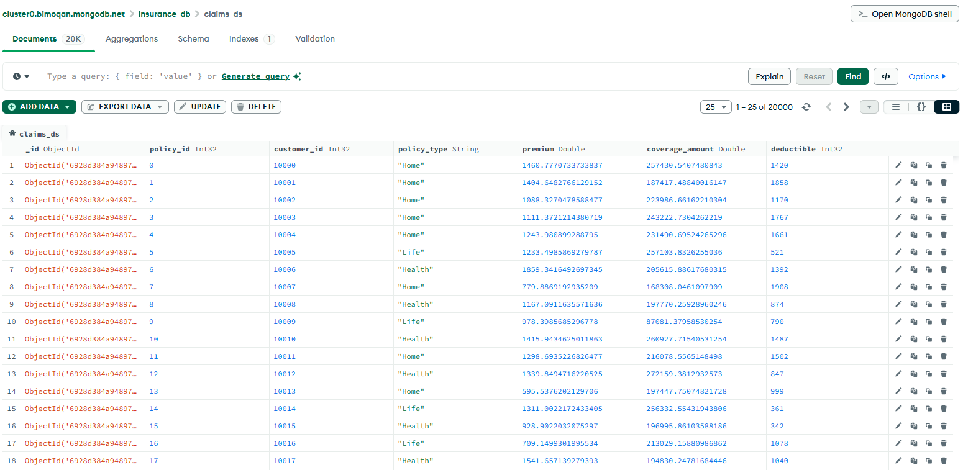

Our data lake architecture continues to evolve as additional datasets and ML-ready features are gradually introduced. MongoDB Atlas already provides the core characteristics of a modern data lake: schema flexibility, support for semi-structured JSON-like documents, horizontal scalability, and the ability to ingest new datasets without rigid schema enforcement.

2 Machine Learning Pipeline

2.1 Purpose
We trained ML models to predict whether a customer will file an insurance claim within the next year, using the cleaned and engineered dataset stored in our database.

2.2 Dataset Generation
Using the example tuples cleaned and collected from prior data lake from Project Part II, we have utilized synthetic methods to generate semantically realistic dataset containing 20,000 policy records, which includes:
- Policy financial attributes (premium, deductible, and coverage)
- Customer demographics (age, gender, and region)
- Behavior features (engagement_score, mobile_app_logins)
- Risk indicators (smoker_flag, property_risk_index)
- Historical claim metrics
- Engineered features (policy_age_days)
Class distribution:

Label | Count | %
0 (No Claim) | 12,094 | 60.47
1 (Will File Claim) | 7,906 | 39.53

The data is reasonably realistic and balanced.

2.3 Feature Engineering
We used one-hot encoding for all of the usable categorical variables, including policy_type, marital_status, region, employment_status, and gender. In addition, a new engineered variable policy_age_days has been created by converting policy_start_date into datetime variable, and finding the elapsed days until 2025-01-01. In order to protect privacy, all of the names of the clients have been removed.

2.4 Model Training
Two models, logistic regression classifier and random forest classifier have been selected, where the logistic regression model serves as the baseline linear model, being fast and highly interpretable. As of the result, the logistic regression model achieves an accuracy of 0.7588 within an AUC of 0.718, whereas the random forest classifier achieves an accuracy of 0.766, and AUC of 0.784, attributing to the ability of capturing strong feature interactions. Random forest performs significantly better, indicating nonlinear predictive structures in the engineered dataset.

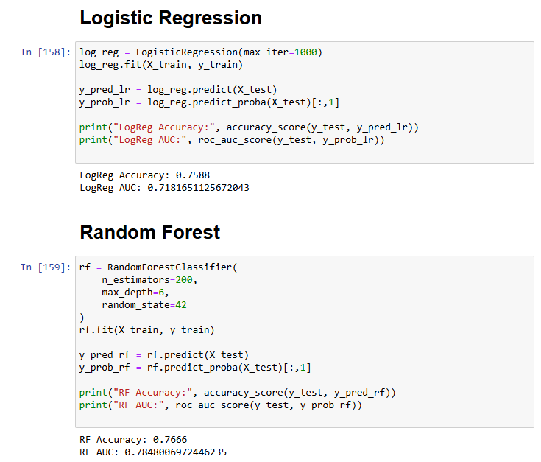

2.5 Feature Importance
Following is the feature importance plot from the random forest model.
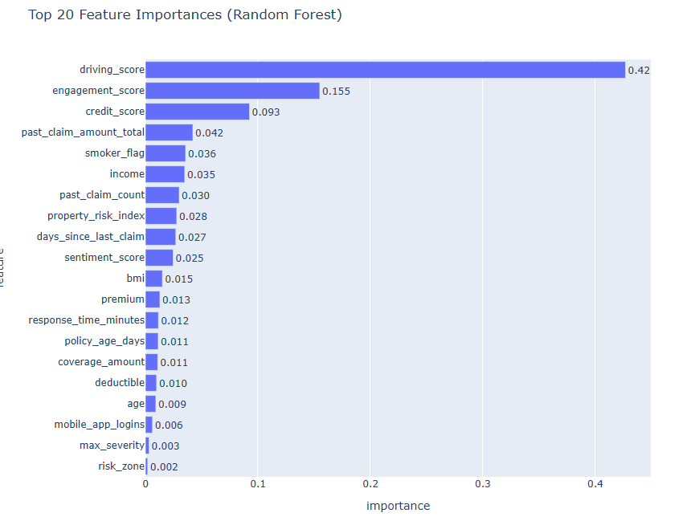
The top predictors included driving_score, sentiment_score, credit_score, smoker_flag, etc. The features highly align with real-world insurance risk-factors, highlighting the explainability of the random forest model.
2.6 ROC Curve Comparison
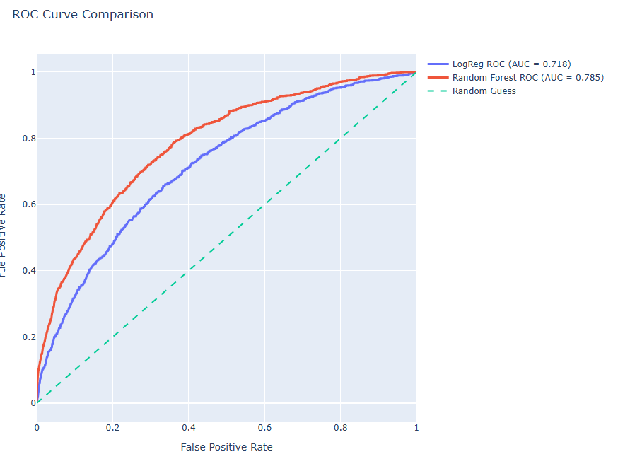
In the plot above, we are able to observe that both models outperformed random guessing, and that random forest model curve dominates over logistic regression model, having a better risk ranking ability. A 0.06 gap between the AUCs is practically meaningful.

In conclusion, the database layer successfully supports ML tasks, and the ML models trained on the generated dataset perform realistically. Random forest is so far the best-performing model; the workflow could be expanded and deployed to cloud for automated scoring.

