Name: Zhang, Bruce Date: 12/19/2025
(last name, first name)
NYU ID: yz8063
Course Section Number: 001

Project Final Report (Part I, II, III + IV)

Total in points: __________________
Professor’s Comments:

Affirmation of my Independent Effort: Bruce Zhang

Please refer to the Github repository or the Streamlit page for more information and app: https://github.com/BruceZhang1015/Database_Systems
https://insurance-underwriting.streamlit.app/

1 Introduction 2
2 Conceptual Model Building (Part I) 3
2.1 Methodology 3
2.1.1 Business Case Analysis 3
2.1.2 Normalization and Grouping Practices 3
2.1.3 Model Implementation in Erwin 3
2.2 Key Modeling Decisions 4
2.2.1 Time-dependent Relationships 4
2.2.2 Two Foreign Keys from the Same Parent 4
2.2.3 Composite Primary Keys 4
2.2.4 Optionality 4
2.2.5 Subject Areas and Color Codes 4
2.3 Model Overview 5
3 Data Lake Design and Implementation (Part II) 7
3.1 Data Lake Structure 7
3.2 Support for Hybrid and Unstructured Data 7
3.3 Connection to the Logical Schema 7
4 Logical Schema Design and Optimization (Part II) 8
4.1 Logical Schema Overview 8
4.2 Entity Definitions 8
4.3 Relationship Summary 10
3 Physical Database Design (Part III) 11
3.1 Index Strategy 11
3.2 Materialized View 12
3.3 Cloud Integration & Data Lake 12
4 Machine Learning Pipeline (Part III) 13
4.1 Dataset Generation 13
4.2 Feature Engineering 14
4.3 Model Training 14
4.4 Feature Importance 14
4.5 ROC Curve Comparison 16
5 End-to-End Risk-Aware Underwriting Application (Part IV) 16
5.1 Business Use Case Revisited 17
5.2 System Architecture Overview 18
5.3 End-to-End Application Workflow 21
5.4 Governance, Maintainability, and Extensibility 21
6 Limitations and Future Directions 22

1 Introduction
Modern insurance underwriting increasingly relies on the integration of heterogeneous data sources, scalable data architectures, and predictive analytics to support timely and accurate decision-making. Traditional underwriting workflows often depend on manual review and rule-based assessments, which can be inefficient, difficult to scale, and slow to adapt to evolving risk patterns. As insurers gain access to richer structured and unstructured data, there is a growing need for end-to-end data systems that can transform raw data into actionable risk insights while maintaining transparency, governance, and operational reliability.
This project addresses this challenge by designing and implementing a Risk-Aware Insurance Underwriting System that integrates enterprise data modeling, data lake architecture, physical database implementation, machine learning, and application-layer deployment. The goal of the project is not only to develop predictive models, but also to demonstrate how these models can be operationalized within a complete data-driven system that supports real-time underwriting decisions.
The project is organized into four progressive phases. The first phase focuses on enterprise data architecture and conceptual modeling, establishing the business context and defining core entities, relationships, and constraints relevant to insurance underwriting. The second phase extends this foundation by designing a data lake and logical schema capable of integrating structured and unstructured data from multiple sources, enabling flexible analytics and feature engineering. The third phase translates the logical design into a physical database implementation and introduces a machine learning pipeline for predicting claim likelihood using historical policy and customer data. The final phase operationalizes the system through an end-to-end underwriting application. A trained machine learning model is embedded within an interactive web application that accepts user inputs, performs real-time risk prediction, applies business decision logic, and persists outcomes to an online operational datastore.
By integrating data architecture, database systems, and machine learning into a cohesive solution, this project illustrates a practical approach to modern insurance underwriting. The resulting system highlights how data-driven risk assessment can improve efficiency and consistency in underwriting decisions, while remaining extensible to future enhancements such as automated retraining, explainability, and large-scale deployment.
Note: this report serves as a general coverage for Part I-IV works. For detailed information and use cases, please refer to the reports and documents under the specific part. Github page and streamlit page are also available.

2 Conceptual Model Building (Part I)
This part of the project mainly focuses on the development of an Enterprise Data Architecture (EDA) model that supports traditional business analytics and reporting. The goal is to translate unstructured business cases into a logical data model that not only captures the relationships between the entities such as Accounts, Associates, and Contracts but also supports the business needs.
The EDA model was designed and established using Erwin Data Modeler 15.0 (Trial) with logical/physical configuration.

2.1 Methodology

2.1.1 Business Case Analysis
The slides serve as the source of clarification on business requirements. Each of the slides provided narrative scenarios which support the design decisions of Account, Associate, Contract, Customer and their associated attributes. Key actions from the slides include:
- Extracted nouns (candidate entities such as Account, Contract, Associate, Customer).
- Extracted verbs (candidate relationships such as owns, manages, pays).
- Grouped similar interactions to identify potential bridge entities.

2.1.2 Normalization and Grouping Practices
Normalization and grouping were performed to ensure minimal redundancy and clear referential flow. The following are guiding principles.
- Normalization: Data is not repeatedly stored in multiple places.
- Temporal modeling: EffectiveFrom and EffectiveTo with the datatype ‘DATE’ are added to relationships that may change over time.
- M:N relationships resolution: Associative entities are added to manage many-to-many relationships, such as AccountBilling, ContractParty, etc.
- Semantic roles: Conceptually different links from the same parent have been distinguished from naming.

2.1.3 Model Implementation in Erwin
The model was implemented in Erwin Data Modeler 15.0. Implementation steps include:
- Created entities and key attributes following the field-level schema.
- Used Non-identifying relationships to represent primary key-foreign key dependencies.
- Used create associative entity feature in Erwin as well as manual implementation for M:N relationships.
- Assigned appropriate cardinalities and optionalities.
- Applied consistent naming conventions.
- Color-coded entities by domain or subject area to improve readability.
The above steps produced a unified and normalized enterprise data model containing four primary domains.

2.2 Key Modeling Decisions

2.2.1 Time-dependent Relationships
A bridge table has been introduced for every M:N relationship. The bridge tables include attributes of EffectiveFrom and EffectiveTo to capture temporal validity including Employment, AccountBilling, etc.

2.2.2 Two Foreign Keys from the Same Parent
The Contract entity connects to the Account entity twice through two independent non-identifying relationships, and therefore creates two foreign keys, OwnerAccountID and PayerAccountID. Although both foreign keys originate from the same attribute of the same parent table, they represent different semantic roles:
- OwnerAccountID: the company or organization that owns the contract.
- PayerAccountID: the account responsible for financial payments and transactions.

2.2.3 Composite Primary Keys
Bridge entities such as AccountBilling require more than one attribute to uniquely identify a record. Each of the tables uses a composite primary key which combines the foreign keys of participating entities to maintain referential uniqueness, as well as a time attribute, in this case, EffectiveFrom and/or EffectiveTo to support versioning.

2.2.4 Optionality
In the model, not all the relationships are mandatory, and therefore not every foreign key is required to be not NULL. Therefore, optionality is explicitly defined as following:
- Mandatory parent, optional child: Child cannot exist without parent attribute.
- Optional foreign key: Certain FK fields allow NULL values to exist in order to reflect flexible and accurate business processes.

2.2.5 Subject Areas and Color Codes
- Account Domain (blue): organizational and billing entities
- Contract Domain (orange): contracts, benefits, and premiums
- Associate Domain (brown): agents, commissions, and hierarchies
- Customer Domain (white): customers, beneficiaries, and relationships

2.3 Model Overview

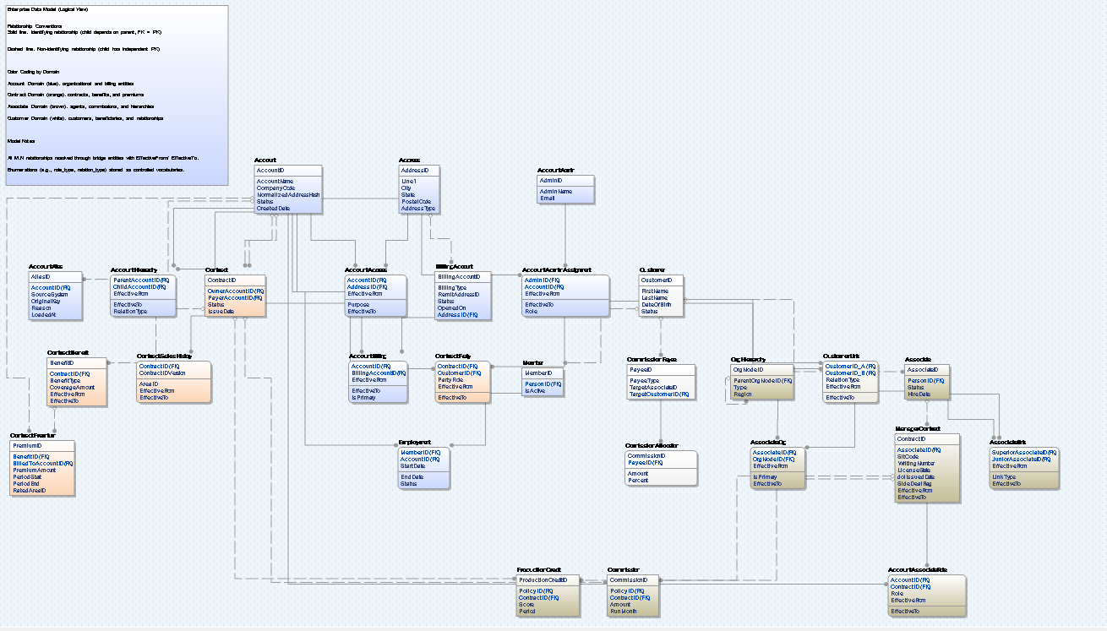
Figure 1: ERD of the Conceptual Model

3 Data Lake Design and Implementation (Part II)
A small data lake was implemented, consisting of multiple health-related datasets that could be used by an insurance company to forecast chronic diseases and related risks. The data lake is organized into raw and processed zones, and currently integrates two structured data sources:
- BRFSS 2024 individual-level survey data (Behavioral Risk Factor Surveillance System)
- CDC WONDER state-level provisional mortality statistics
This design prepares the data to feed to the logical schema and enterprise data architecture in the following steps.

3.1 Data Lake Structure
The data lake is organized in the following folder layout:
- data_lake/raw/
  - Raw_data_sources.txt: contains information and sources for the raw datasets, considering the sizes of the original data
- data_lake/processed/
  - brfss_clean_semantic.csv : person level behavioral and health variables
  - cdc_wonder_clean.csv: state-level mortality counts by age group
  - raw_data_conversion.py: python script for cleaning raw data and converting into desired formats
This separation supports reproducibility, that is any processed artifact can be recreated from the raw file using the cleaning script.

3.2 Support for Hybrid and Unstructured Data
Although current sources of data mainly focus on structured CSV files, the data lake design is intentionally extensible to unstructured data as well. The envisioned UnstructuredDataMetadata table in the logical schema corresponds to data_lake/unstructured/ or cloud storage container, which would be discussed in section 3. Documents like clinical guidelines, PDF reports could be stored in such directories. The metadata schema should provide a consistent way to register and relate the unstructured objects to the structured BRFSS and CDC datasets.

3.3 Connection to the Logical Schema
The processed layer of the data lake is designed to map directly to the logical entities:
- brfss_clean_semantic.csv → Person, Lifestyle, and HealthOutcome tables
- cdc_wonder_clean.csv → StateHealthStats table
- unstructured/ files → represented via UnstructuredDataMetadata
This alignment would allow additional ingestion and transformation work to be carried out within the data lake, without requiring changes to the downstream applications or the logical schema. Therefore, the insurance company can progressively incorporate new structured and unstructured data sources while preserving a coherent enterprise data architecture.

4 Logical Schema Design and Optimization (Part II)
This section presents the logical database schema required to support a hybrid data architecture that incorporates both structured and unstructured data, as outlined in the project specification. The logical schema is designed following the ER modeling principles introduced in Part I, but itself does not serve as an extension of the enterprise-wide conceptual model. It represents a more focused schema focusing on the analytical needs of health-related datasets collected in the prior section.
The structured portion integrates survey data from the Behavioral Risk Factor Surveillance System (BRFSS) with macro-level mortality data from CDC WONDER. A metadata structure is introduced to incorporate unstructured assets like clinical notes, PDF guidelines or other external web documents, within the data lake.

4.1 Logical Schema Overview
The resulting schema consists of the following five entities:
- Person: the demographic attributes extracted from BRFSS
- Lifestyle: behavioral and lifestyle indicators
- HealthOutcome: self-reported chronic conditions and preventive behaviors from BRFSS
- StateHealthStats: state-level mortality indicators from CDC WONDER
- UnstructuredDataMetadata: metadata layer enabling integration of unstructured data into the hybrid data lake

4.2 Entity Definitions
Person: represents the primary entity at the individual granularity.
Attribute | Description
sequence_id (PK) | Unique respondent ID from BRFSS
state_fips | Links to StateHealthStats
age | Age
gender | Male/Female
education_level | Education level of the respondent
income_level | Annual income level of the respondent

Lifestyle: lifestyle behaviors form a logically separable subset of attributes and therefore are normalized into a separate entity.
Attribute | Description
sequence_id (PK, FK) | Reference to Person
smoking_status | Categorical
alcohol_use | Categorical
heavy_drinker | Categorical
exercise_status | Categorical
bmi | Continuous

HealthOutcome: health outcome attributes are independent of lifestyle attributes, and separating them reduces non-key dependencies.
Attribute | Description
sequence_id (PK, FK) | Reference to Person
diabetes_status | Yes/No
heart_disease | Yes/No
stroke_history | Yes/No
flu_shot | Yes/No
pneumonia_shot | Yes/No

StateHealthStats: aggregated state-level health outcome data for hybrid linkage.
Attribute | Description
state_fips (PK) | State identifier
age_group | CDC age grouping
deaths | Mortality count

UnstructuredDataMetadata: unstructured assets for the hybrid data model.
Attribute | Description
file_id (PK) | Unique file identifier
file_path | Path in data lake/cloud storage
file_type | pdf/txt/json, etc.
ingestion_ts | Ingestion timestamp
Linked_sequence_id (FK) | Link to Person
Linked_state_fips (FK) | Link to StateHealthStats
Description | Free-text description to the file

4.3 Relationship Summary
- Person ↔ Lifestyle: 1-to-1
- Person ↔ HealthOutcome: 1-to-1
- Person ↔ StateHealthStats: N-to-1
- UnstructuredDataMetadata ↔ Person: N-to-0 or 1
- UnstructuredDataMetadata ↔ StateHealthStats: N-to-0 or 1
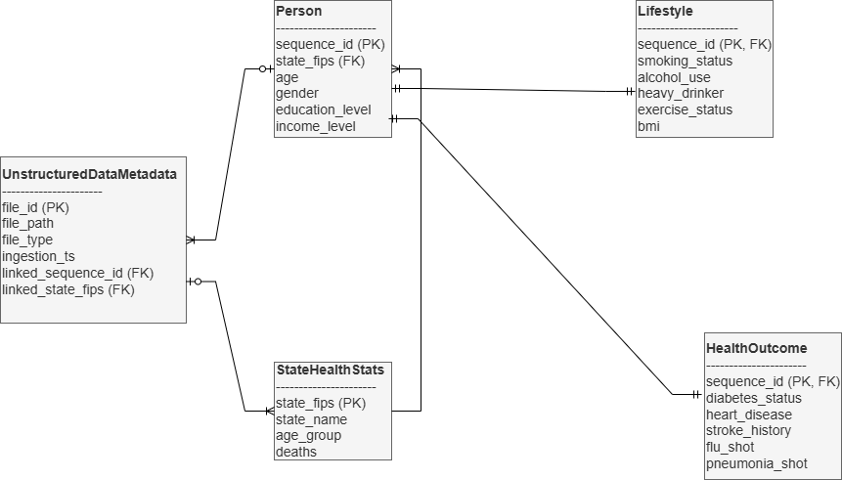
Figure 2: ER Diagram Specification

3 Physical Database Design (Part III)
The goal of the physical database design is to create a scalable, normalized and efficient insurance risk database which supports analytical queries and ML-based risk prediction. Therefore, our schema is designed for:
- Fast inserts,
- Efficient filtering by date ranges,
- Fast aggregation,
- Enabling downstream machine learning pipelines.

3.1 Index Strategy
Indexes were created on heavily filtered columns:
CREATE INDEX idx_customer_region ON customer(region);
CREATE INDEX idx_policy_customer ON policy(customer_id);
CREATE INDEX idx_claim_policy ON claim(policy_id);
CREATE INDEX idx_claim_date ON claim(claim_date);
The purpose of this is to support equality joins, range queries, and to reduce full-table scans for efficiency.
To support query execution, an indexing strategy tailored to the access patterns required by both analytical workloads and downstream machine-learning operations was designed. A primary index on policy_id was defined, which guarantees fast point lookups for policy-level data retrieval. Because many operations involve joining or correlating policy information with customer attributes, an index on customer_id was also created to optimize queries that filter or group by customer.
Numeric attributes that frequently appear in range predicates were indeed to support efficient range scans. These fields are often used to identify high-risk customers, assess pricing bands, or generate ML feature subsets. These indexes reduce full-collection scans and significantly improve execution time for both SQL-like analytical queries and ad-hoc data exploration.
CREATE INDEX idx_policy_customer_id
ON insurance.policy(customer_id);

CREATE INDEX idx_claim_policy_id
ON insurance.claim(policy_id);

CREATE INDEX idx_claim_date
ON insurance.claim(claim_date);

3.2 Materialized View
A materialized view was created to speed up ML dataset creation.
CREATE MATERIALIZED VIEW policy_claim_summary AS
SELECT
p.policy_id,
COUNT(c.claim_id) AS past_claim_count,
SUM(c.claim_amount) AS total_claim_amount,
MAX(c.severity_level) AS max_severity
FROM policy p
LEFT JOIN claim c
ON p.policy_id = c.policy_id
GROUP BY p.policy_id;
This avoids recomputing aggregates across other claims.
To demonstrate how the indexed schema supports real analytical workloads, we developed a set of representative queries aligned with typical insurance-analysis use cases.

3.3 Cloud Integration & Data Lake
To meet cloud integration requirements and enable possible collaborative access to the dataset in realistic settings, processed insurance dataset has been deployed to MongoDB Atlas, which is a fully managed cloud database platform. Atlas’s flexible document-based schema allows numerical, categorical, and engineered fields to coexist without rigid schema definitions, rapid iteration on features, which are required by the ML pipeline. The service offers built-in security, global accessibility and the possibility of updating easily via PyMongo. 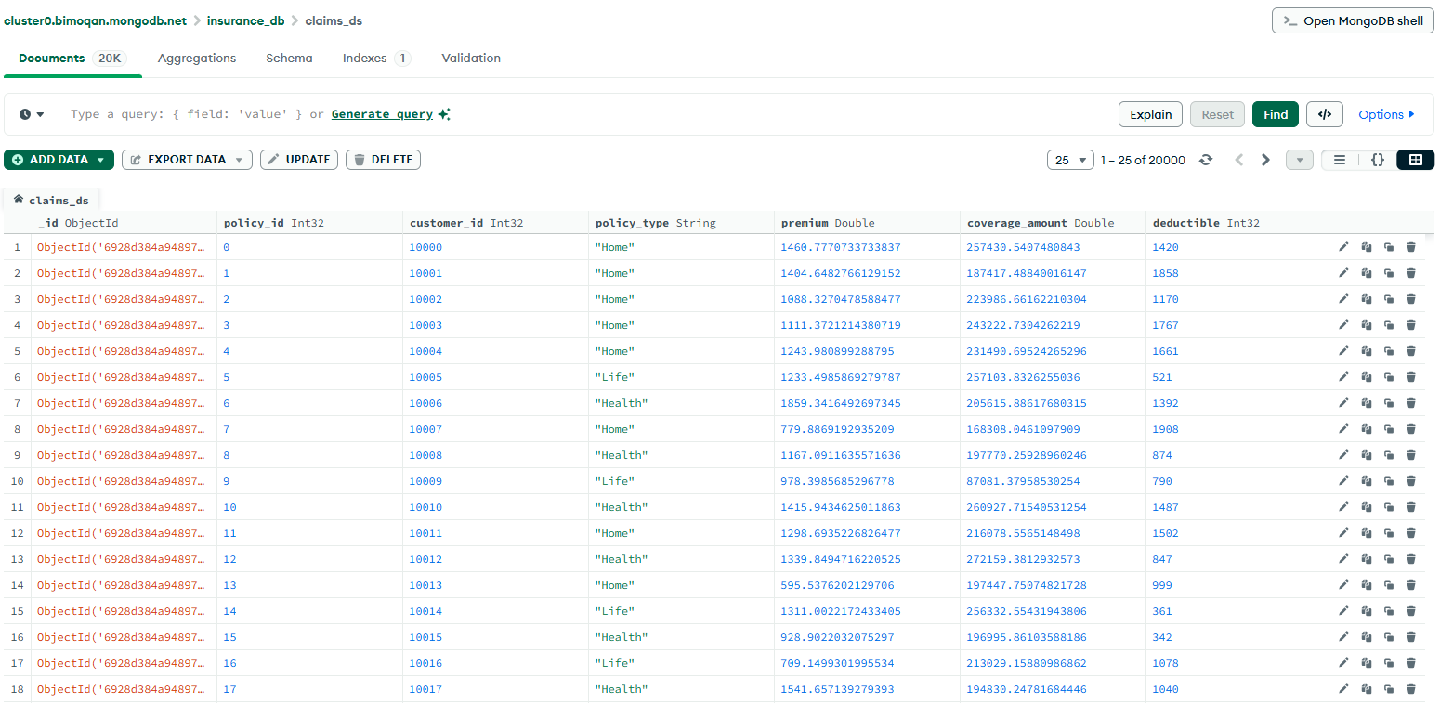
Figure 3: Database Interface via MongoDB Compass

Our data lake architecture continues to evolve as additional datasets and ML-ready features are gradually introduced. MongoDB Atlas already provides the core characteristics of a modern data lake: schema flexibility, support for semi-structured JSON-like documents, horizontal scalability, and the ability to ingest new datasets without rigid schema enforcement.

4 Machine Learning Pipeline (Part III)
Machine learning models were trained to predict whether a customer will file an insurance claim within the next year, using the cleaned and engineered dataset stored in our database.

4.1 Dataset Generation
Using the example tuples cleaned and collected from prior data lake from Project Part II, we have utilized synthetic methods to generate semantically realistic dataset containing 20,000 policy records, which includes:
- Policy financial attributes (premium, deductible, and coverage)
- Customer demographics (age, gender, and region)
- Behavior features (engagement_score, mobile_app_logins)
- Risk indicators (smoker_flag, property_risk_index)
- Historical claim metrics
- Engineered features (policy_age_days)
Class distribution:

Label | Count | %
0 (No Claim) | 12,094 | 60.47
1 (Will File Claim) | 7,906 | 39.53

The data is reasonably realistic and rather balanced, considering real-life scenarios.

4.2 Feature Engineering
One-hot encoding was used for all of the usable categorical variables, including policy_type, marital_status, region, employment_status, and gender. In addition, a new engineered variable policy_age_days has been created by converting policy_start_date into datetime variable, and finding the elapsed days until 2025-01-01. In order to protect privacy, all of the names of the clients have been removed.

4.3 Model Training
Two models, logistic regression classifier and random forest classifier have been selected, where the logistic regression model serves as the baseline linear model, being fast and highly interpretable. As of the result, the logistic regression model achieves an accuracy of 0.7588 within an AUC of 0.718, whereas the random forest classifier achieves an accuracy of 0.766, and AUC of 0.784, attributing to the ability of capturing strong feature interactions. Random forest performs significantly better, indicating nonlinear predictive structures in the engineered dataset.

4.4 Feature Importance
Following is the feature importance plot from the random forest model.
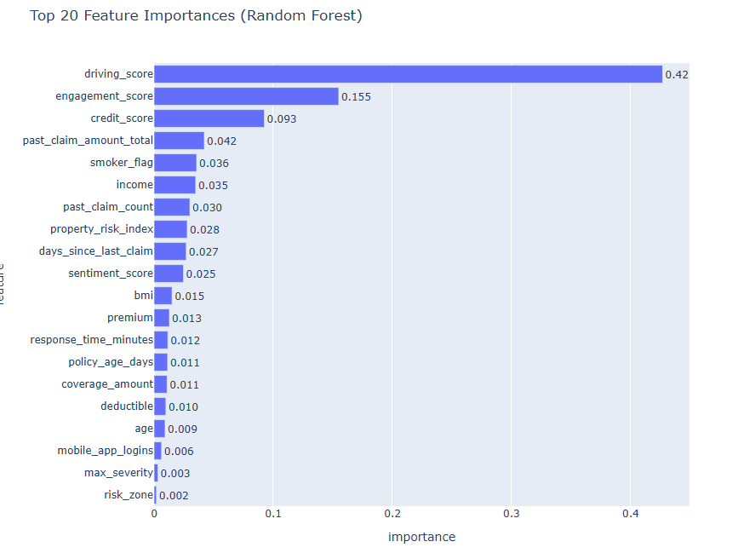
Figure 4: Feature Importance from Random Forest Model
The top predictors included driving_score, sentiment_score, credit_score, smoker_flag, etc. The features highly align with real-world insurance risk-factors, highlighting the explainability of the random forest model.

4.5 ROC Curve Comparison
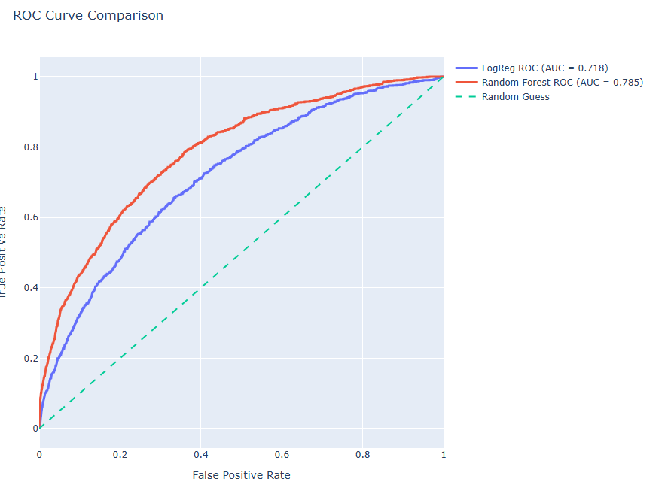
Figure 5: AUCs of Random Forest, Logistic Regression classifiers vs. Random Guess Performance

In the plot above, we are able to observe that both models outperformed random guessing, and that random forest model curve dominates over logistic regression model, having a better risk ranking ability. A 0.06 gap between the AUCs is practically meaningful.

5 End-to-End Risk-Aware Underwriting Application (Part IV)
This final phase of the project focuses on operationalizing the previously designed data architecture, physical database, and machine learning pipeline into a fully integrated, end-to-end underwriting application. The objective of this component is to demonstrate how structured and unstructured data, predictive modeling, and database technologies can be combined to support real-time, data-driven insurance underwriting decisions with minimal manual intervention.

5.1 Business Use Case Revisited
The primary business use case addressed in this phase is a risk-aware insurance underwriting workflow that supports insurance quote requests and policy updates. In this scenario, a customer initiates a request to obtain a new insurance quote or modify an existing policy. The system evaluates the request by combining historical policy data, customer attributes, behavioral indicators, and signals derived from unstructured text.
The underwriting process proceeds as follows:
- A customer submits a quote or policy update request through a front-end application.
- The system retrieves and assembles the required structured features associated with the customer and policy.
- A machine learning model predicts the likelihood that the customer will file a claim.
- The predicted probability is translated into a business-level risk tier (Low, Medium, or High).
- Based on the assigned risk tier, the system either automatically approves the request or flags it for manual underwriter review.
- The final decision and associated risk metrics are persisted to the operational data store for auditing and downstream analytics.
This workflow enables faster underwriting decisions while maintaining human oversight for high-risk cases.
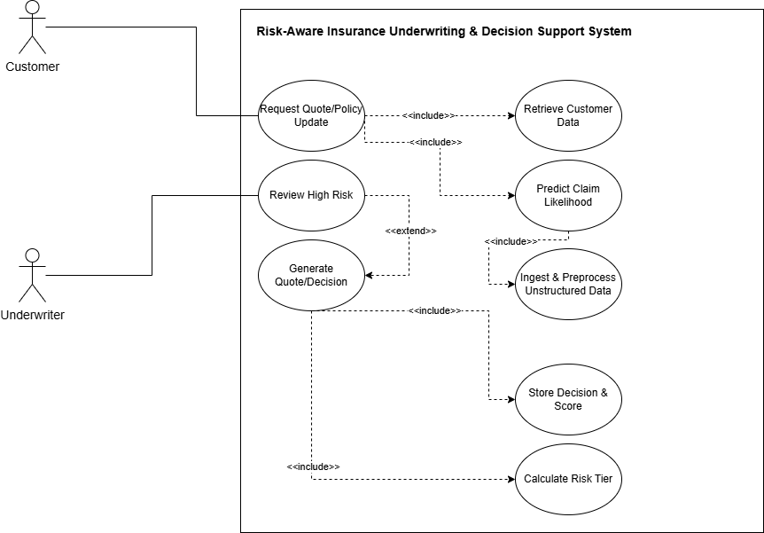
Figure 6: High-level Diagram of Risk-Aware Underwriting and Decision Support System

5.2 System Architecture Overview
The end-to-end solution follows a modular, layered architecture that clearly separates user interaction, business logic, machine learning inference, and data persistence. The system is composed of the following major components:
- Application Layer: A Streamlit-based web application provides an interactive user interface for submitting underwriting requests and displaying prediction results in real time.
- Machine Learning Layer: A trained Random Forest classification model is encapsulated within a dedicated ML module. The model artifact is serialized using joblib and loaded at runtime to perform probabilistic inference.
- Data Management Layer: MongoDB Atlas serves as an online operational datastore for persisting underwriting decisions, predicted risk scores, and input feature snapshots.
- Configuration and Environment Management: Environment variables and Streamlit secrets are used to manage database credentials and runtime configuration securely.
This architecture supports loose coupling between components, enabling independent updates to the model, application logic, or database layer without requiring system-wide changes. A figure demonstrating the flow of the system is below.
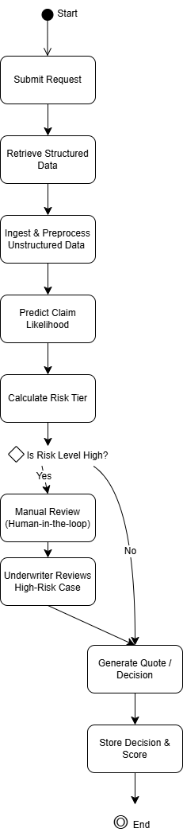
Figure 6: Flow Diagram for the System

5.3 End-to-End Application Workflow
The operational workflow begins when a user submits an underwriting request through the Streamlit interface. The application enforces input schema completeness by requiring all categorical and numerical features used during model training to be provided, thereby ensuring consistency between training and inference environments.
Once the request is submitted, the application executes the following steps:
- Input Validation and Schema Alignment
User inputs are assembled into a structured DataFrame that matches the feature schema used during model training. Categorical variables are encoded using one-hot encoding, and feature alignment is enforced to ensure compatibility with the trained model.
- Model Inference
The pre-trained Random Forest model computes the probability that the customer will file a claim. This probabilistic output enables nuanced risk assessment beyond binary classification.
- Business Decision Logic
The predicted probability is mapped to a discrete risk tier:
  - Low Risk: automatic approval
  - Medium Risk: automatic approval with caution
  - High Risk: escalation to manual underwriter review
- Persistence and Auditing
The underwriting decision, predicted risk score, and associated feature snapshot are stored in MongoDB Atlas. This design supports traceability, auditing, and future analytical use cases.
The entire workflow executes synchronously, providing real-time feedback to the user while maintaining a persistent record of all underwriting decisions.

5.4 Governance, Maintainability, and Extensibility
Several governance and maintainability considerations were incorporated into the system design. First, the machine learning model is stored as a versioned artifact along with its feature schema, enabling reproducibility and controlled model updates. Retraining can be performed offline using updated data and seamlessly deployed by replacing the model artifact.
Second, the application enforces consistent feature schemas and includes defensive preprocessing logic to handle missing or unexpected inputs gracefully. This reduces the risk of runtime failures and ensures robust operation in real-world settings.
From a data governance perspective, persisting underwriting decisions and risk scores in an operational datastore enables accountability and transparency. These records can be used for bias monitoring, compliance audits, and performance evaluation over time.
Finally, the modular architecture allows for future extensions, such as integrating automated model retraining pipelines, adding explainability tools (e.g., feature attribution methods), or deploying the application in a production cloud environment.

6 Limitations and Future Directions
While the current project demonstrates a complete end-to-end data-driven underwriting system, several extensions can be pursued to further enhance scalability, analytical depth, and production readiness.
First, although the data lake architecture was explicitly designed to be cloud-native and compatible with Microsoft Azure services, the implementation was executed in a local environment due to cost and resource constraints. In a production setting, the raw, processed, and unstructured data containers could be deployed using Azure Blob Storage, with Azure Data Factory orchestrating ingestion and transformation workflows.
Second, the volume of data used in the current system is intentionally limited to support rapid iteration and experimentation. While sufficient for demonstrating architectural integration and machine learning workflows, larger datasets would be required to train more robust and generalizable models. Future work could focus on incorporating additional historical policy records, longitudinal customer behavior data, and external risk indicators to improve model performance and stability.
Third, the current machine learning pipeline primarily leverages structured attributes and text-derived sentiment features. Although the data lake design explicitly accommodates unstructured data, the project does not include visual or non-textual modeling due to time constraints and the absence of sufficiently labeled image data. Future extensions would involve training computer vision models to extract features from image-based inputs such as accident photos, property images, or scanned documents. These extracted features could then be integrated into the existing hybrid schema to enrich risk assessment and underwriting decisions.
Finally, the end-to-end application could be extended to support advanced governance and explainability features. Integrating model interpretability techniques, such as feature attribution methods, would improve transparency for underwriters and managers.

