TryHackMe: Complimentary — my writeup
Room: Complimentary (Hacker Holidays, Day 3, Cloud)
Difficulty: Easy
Category: AWS Cognito / IAM misconfiguration

The setup
This room's about a hotel "wellness app" (Byte Lotus Wellness) that doesn't make you log in at all. You just open it and it already knows your name and shows your guest profile. No account, no password, nothing. So something has to be deciding what you're allowed to see even without a login.
The challenge: figure out how it's pulling that off, then see if you can get it to hand over more than just your own data.
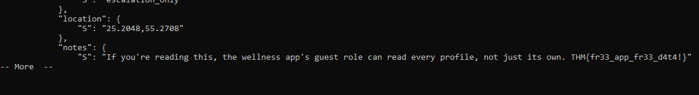

Step 1: snooping the source
First thing I did was open the site and pop open dev tools to look at the JS it was loading. Found the app's config file sitting right there in plain text:
const IDENTITY_POOL_ID = "us-east-1:836c0949-292d-485b-b532-52d5ca7bb688";
const AWS_REGION = "us-east-1";
const TABLE_NAME = "complimentary-GuestWellnessProfiles";
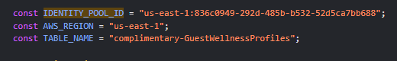
Also found the app logic, which showed it was using AWS Cognito to get credentials automatically (no login), then calling DynamoDB's getItem to pull back just your own row based on a randomly generated guestId stored in localStorage.
So Cognito hands out anonymous "guest" AWS credentials, and those credentials are then used to query a database. This is the "unauthenticated identities" feature in Cognito, meant for guest access, but only safe if the permissions attached to it are locked down properly.

Step 2: installing the AWS CLI
Didn't have this already so had to grab it for Windows. Downloaded the MSI installer from AWS, ran it, opened a fresh terminal, then checked aws --version to confirm it installed.

Step 3: getting guest credentials myself
Since the app does this automatically, I just did the same two API calls manually:
aws cognito-identity get-id --identity-pool-id us-east-1:836c0949-292d-485b-b532-52d5ca7bb688 --region us-east-1
Got back an IdentityId.
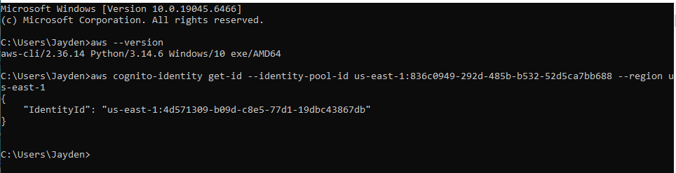
Then:
aws cognito-identity get-credentials-for-identity --identity-id <that id> --region us-east-1 --no-sign-request
This gave me a full set of temporary AWS credentials (access key, secret key, session token), completely anonymously, no account required.
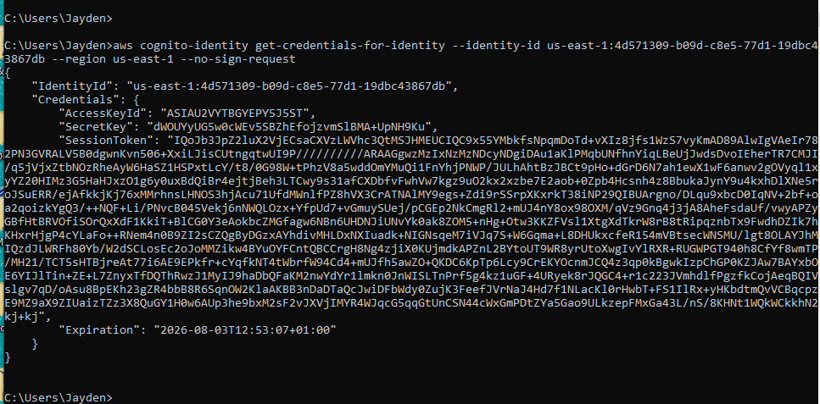

Step 4: confirming who I am
Set those creds as env vars and ran:
aws sts get-caller-identity
Confirmed I was authenticated as:
arn:aws:sts::332173347248:assumed-role/complimentary-cognito-unauth-role/CognitoIdentityCredentials
So I'd walked in the front door with zero login and was holding real (if temporary) AWS credentials.
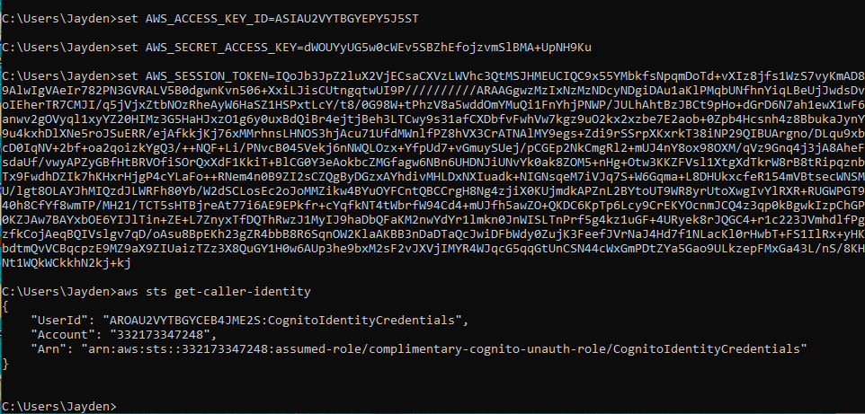

Step 5: the actual vuln
The app was only ever supposed to call getItem (fetch your own single record). But nothing stops you from trying other DynamoDB operations with those same creds. So I tried a full table scan instead:
aws dynamodb scan --table-name complimentary-GuestWellnessProfiles --region us-east-1
It worked. Dumped every guest's data: names, emails, phone numbers, locations, even plaintext passwords sitting in the table. The IAM role behind the "unauthenticated guest" identity had way broader permissions than it should've. It should only have allowed GetItem scoped to the caller's own record (Cognito supports this via IAM policy conditions), but instead it allowed scanning the whole table.
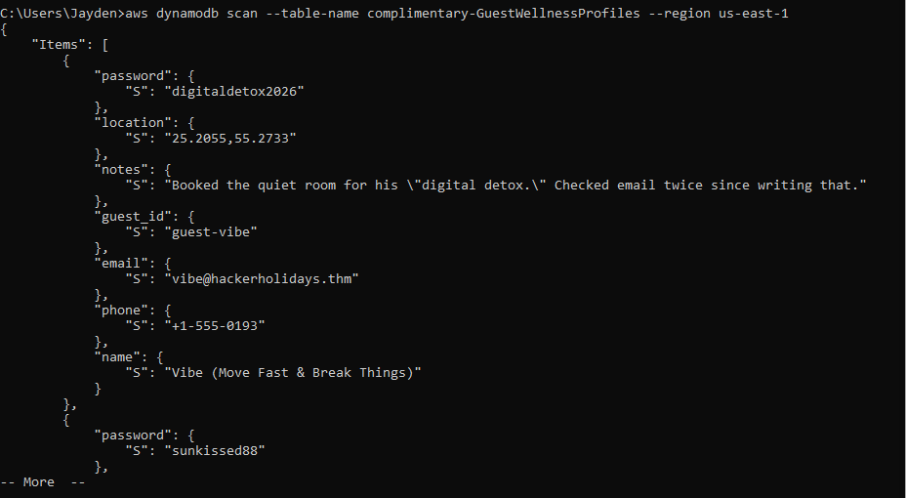

Step 6: finding the flag
Scrolled through the dump (there's a --no-cli-pager flag if you don't want to deal with the pager) looking for a guest called Lambo, since she's the one mentioned in the room briefing. Found her record and the flag was sitting right there in her notes field:
THM{fr33_app_fr33_d4t4!}
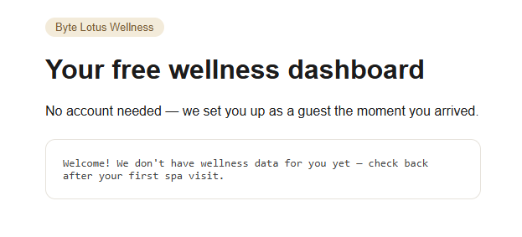

TL;DR
- App used Cognito unauthenticated identities to hand out real AWS creds with zero login.
- Pulled the Identity Pool ID straight out of the client-side JS.
- Got my own guest credentials the same way the app does, just manually via CLI.
- IAM role attached to those creds was way over-permissioned: it allowed scanning the entire DynamoDB table instead of just reading your own row.
- Scanned the table, found another guest's full profile (including a plaintext password) and the flag inside it.
Takeaway: this is a real pattern that shows up in actual cloud security assessments, not just CTF rooms. Over-permissioned "unauthenticated" IAM roles behind Cognito identity pools are a common finding. The fix would be scoping the DynamoDB policy down to GetItem only, restricted with the cognito-identity.amazonaws.com:sub condition key so each guest identity can only ever touch their own row.

