Overheard at Breakfast (TryHackMe, Hacker Holidays 2026)
OSINT room, part of the Byte Lotus Hotel series. No terminal exploits this time, just reading a chat carefully and following one small clue. Took about 10 minutes once I actually looked properly instead of skimming.

What you get given
The room just gives you one file, a screenshot of a chat between two people, Ponzi and Lambo. Nothing else to go on.
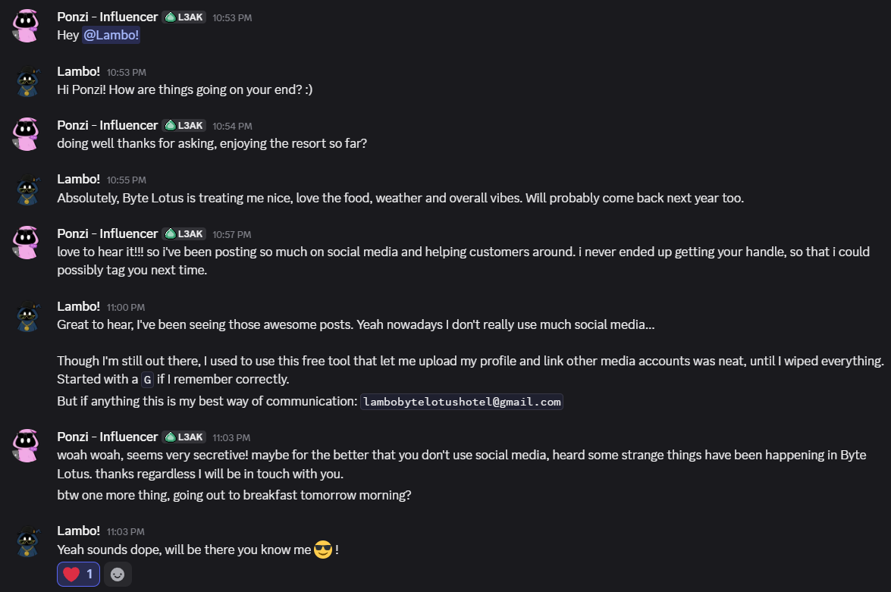
the conversation screenshot
Read through it slowly because most of it is just small talk, but Lambo drops a couple of useful things near the end: an email address (lambobytelotushotel@gmail.com), and a mention of an old tool he used to use, a free thing that let him upload a profile and link his other accounts. He says he can't remember the name properly but it started with a "G".
That's basically the whole puzzle. A free profile tool starting with G, tied to an email, is pointing pretty hard at Gravatar.

What Gravatar actually is
Quick explanation for anyone who hasn't used it. Gravatar (Globally Recognized Avatar) lets you set one profile picture that follows you around different sites, tied to your email address. The way it works under the hood is it hashes your email and uses that hash as your public profile URL, so anyone who knows your email can work out your Gravatar URL without you telling them.

Step 1, hash the email
Gravatar traditionally uses MD5 hashes. So I just ran:
echo -n "lambobytelotushotel@gmail.com" | md5sum
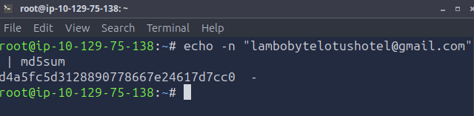
running md5sum on the email
Got back: d4a5fc5d3128890778667e24617d7cc0
The -n on echo matters here, it stops it adding a newline character at the end, which would completely change the hash if you left it in.

Step 2, check if it's a real Gravatar
Tried loading the hash straight into the avatar endpoint:
https://www.gravatar.com/avatar/d4a5fc5d3128890778667e24617d7cc0
And an actual picture loaded, a little character in sunglasses and a hat.
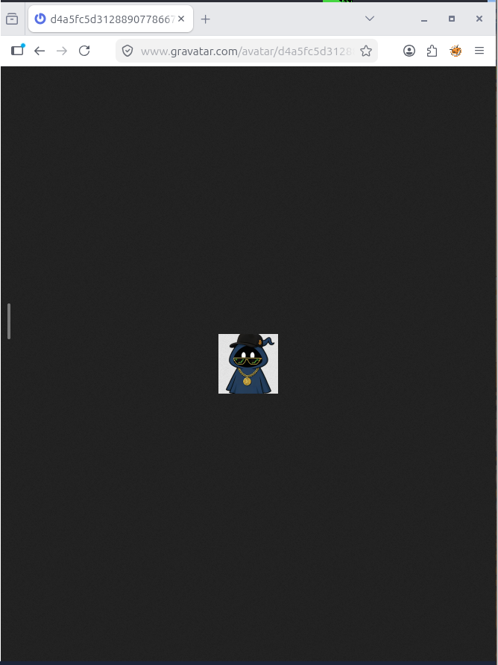
gravatar avatar confirms the hash is right
That confirms the hash is correct and Lambo does actually have a Gravatar account tied to that email.

Step 3, get the full profile not just the picture
The avatar link only gives you the image on its own. To see the actual profile page with bio and everything, you go to the newer style URL, just the hash straight after gravatar.com, no /avatar/ bit:
https://gravatar.com/d4a5fc5d3128890778667e24617d7cc0
That took me to a little preview card first, showing Lambo's profile exists and has a proper vanity URL.
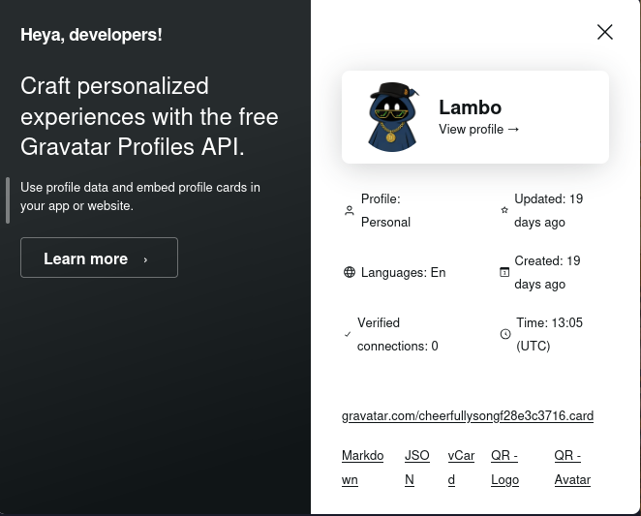
gravatar profile preview card
Then the actual profile page itself, and there's the payoff.
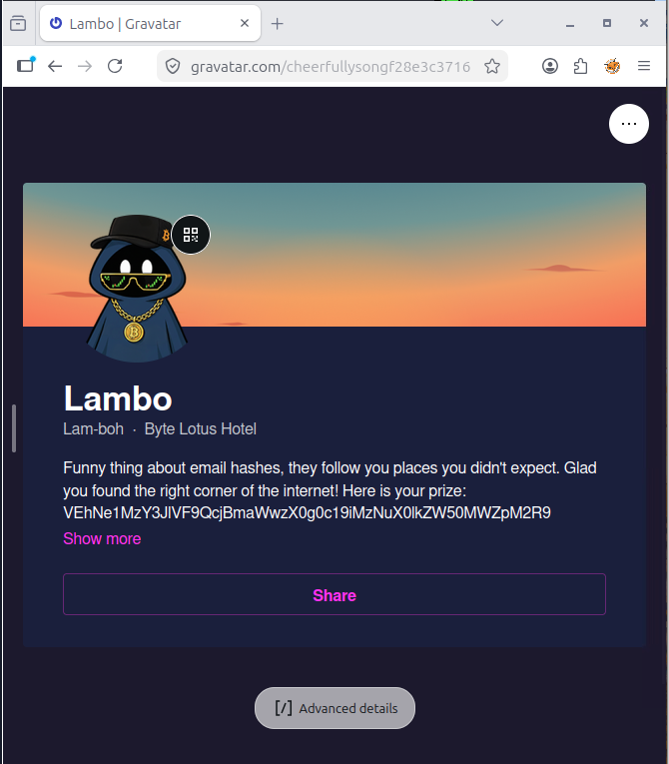
the full gravatar profile with the flag hiding in the bio
The bio straight up says "funny thing about email hashes, they follow you places you didn't expect", which felt like the room basically confirming I was on the right track, and then there's a long jumbled string sitting right there in the bio text.

Step 4, decode it
That string is Base64, you can tell because of the way it's made up of letters, numbers and odd characters, no spaces, looks random but too clean to be actually random. Ran it through a decoder:
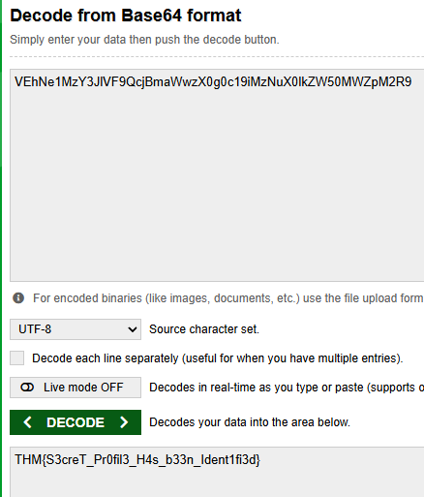
decoding the base64 string
And got the flag straight out:
THM{S3creT_Pr0fil3_H4s_b33n_Ident1fi3d}
Room done.

Takeaways
- OSINT rooms are less about tools and more about actually reading what's in front of you properly. The whole puzzle was solvable just from one screenshot of a normal conversation
- Gravatar (and services like it) will happily tell anyone your public profile if they know your email, since the lookup is just a hash of it. Worth remembering that "anonymous" doesn't always mean anonymous if your email's floating around somewhere
- Base64 shows up constantly in these rooms as a lazy way to hide a flag in plain sight, it's always worth trying to decode any weird looking jumbled text you come across, costs nothing to check

