TryHackMe: Packed Light, my writeup
Room: Packed Light (Hacker Holidays, Day 4, Network Forensics)
Difficulty: Easy
Category: PCAP analysis / covert channel

The setup
This one was about a packet capture from the guest network at the hotel. Something on the network was sending out tiny requests at really regular intervals, and the story hinted that data was being smuggled out inside traffic that looked normal on the surface.
Objective was to find the covert channel in the capture, pull out whatever was hidden in it, decode it, and get the flag.
I will be honest, I found this room harder than the last one. It was not massively complicated once I could see the whole picture, but it took me a while to actually get to that point, and I had a few moments of being stuck staring at the packet list not really knowing what I was looking at.

Step 1: getting a feel for the capture
Rather than scrolling through hundreds of packets one by one, I opened Statistics then Endpoints in Wireshark to see who was talking to who on the IPv4 tab.
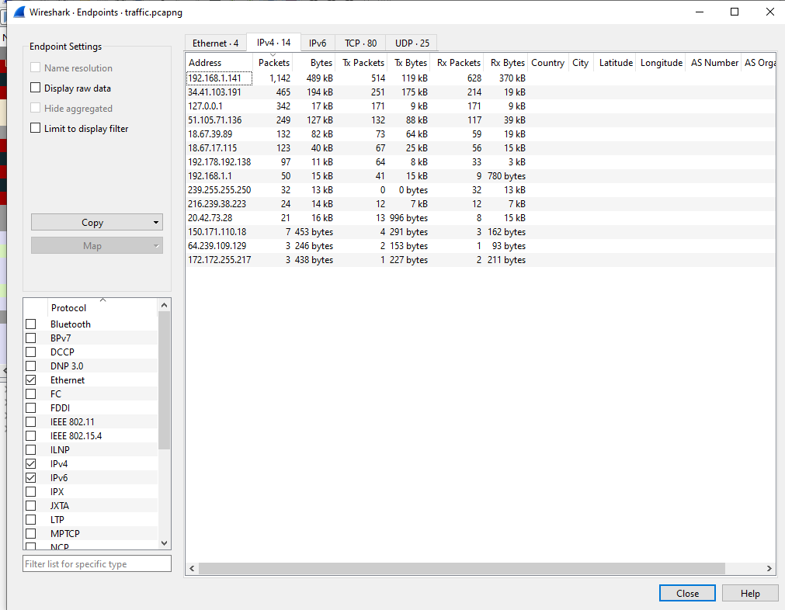
Two addresses stood out straight away. 192.168.1.141 had way more packets than anything else, which made sense as the victim machine on the guest network. Then 34.41.103.191 was the next biggest by a long way, and unlike the private addresses around it, this one was external. That pairing looked like the one worth digging into.

Step 2: filtering down to that conversation
I filtered the capture down to just that pair and HTTP traffic:
ip.addr == 34.41.103.191 && http
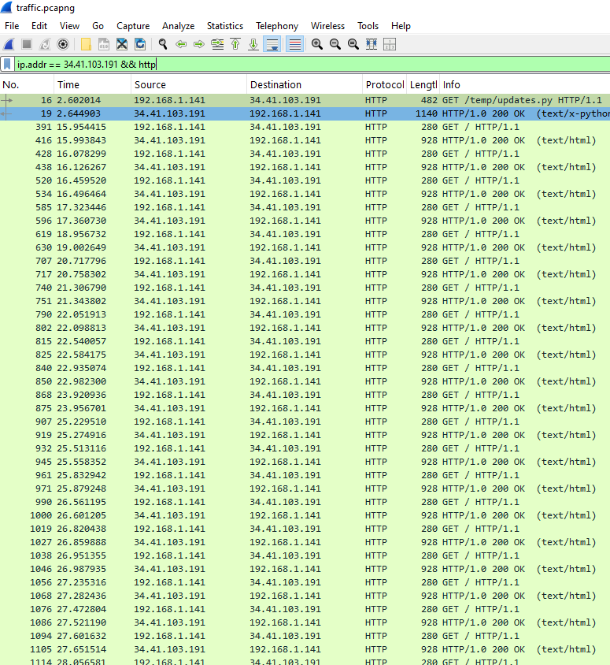
This is where it clicked a bit more. There was one early request for /temp/updates.py, which looked like whatever was actually causing all this got downloaded onto the machine. After that, there was a long, very regular run of GET / requests to the same host, roughly once a second, every single one getting a normal looking 200 OK html response back. That regularity was the giveaway the room briefing was pointing at.

Step 3: finding where the data was hiding
Since the URL itself was always just /, there was nothing to see there. So I clicked into one of the repeated GET requests and expanded the HTTP section in the packet details pane to look at the headers properly.
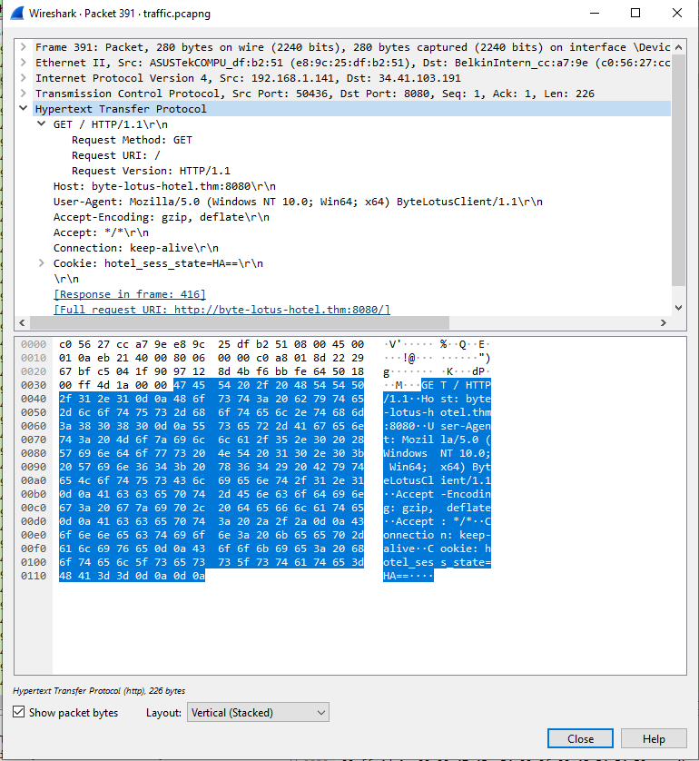
There it was, a cookie called hotel_sess_state with a short value like HA==. I checked another one of the GET requests further down the list and the value was different, AA== that time. A cookie that changes on every single request is not how a normal session cookie behaves, so this was clearly where the hidden data was living.

Step 4: pulling every value out
Clicking through every packet individually was not going to be realistic with this many requests, so I used tshark from the command line instead, which comes bundled with Wireshark. I had to sort out my PATH first since Windows did not recognise the command to begin with, but once that was fixed this pulled every cookie value out in order:
tshark -r traffic.pcapng -Y "ip.addr==34.41.103.191 && http.request.method==GET" -T fields -e http.cookie > cookies.txt
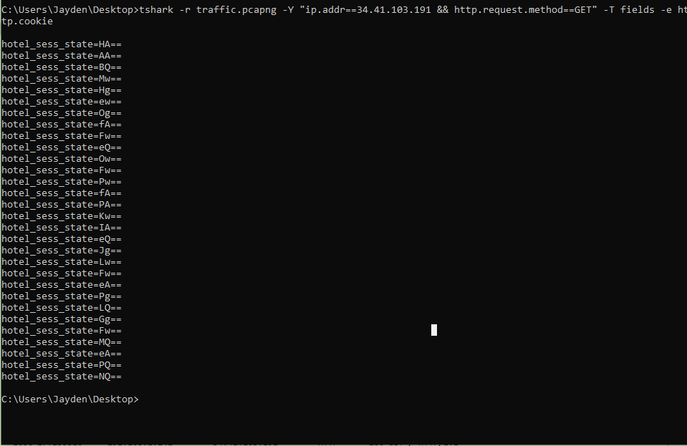
Every value was short, two base64 characters plus == padding, which meant each one decoded down to a single byte. So each request was basically smuggling out one byte at a time.

Step 5: decoding it
I wrote a small Python script to strip the hotel_sess_state= part off each line, base64 decode each value, and join all the resulting bytes together in order.
import base64

with open("cookies.txt") as f:
lines = [line.strip() for line in f if line.strip()]

raw_bytes = bytearray()
for line in lines:
value = line.split("=", 1)[1]
decoded = base64.b64decode(value)
raw_bytes.extend(decoded)

print("Decoded bytes:", raw_bytes)
print("As hex:", raw_bytes.hex())
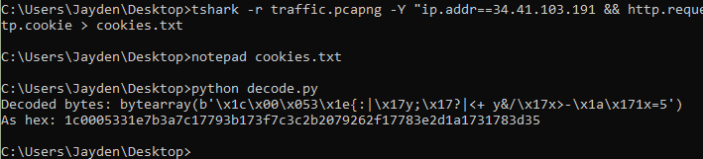
That gave me a string of bytes that was not readable at all, so there was clearly a second layer on top of the base64. My first thought was some kind of XOR, since that is a pretty common thing to see in these sorts of challenges.

Step 6: brute forcing the XOR key
Instead of guessing keys one at a time, I wrote a script to try every possible single byte key from 0 to 255 against the decoded bytes and only print the ones that came out as fully readable ASCII.
raw_bytes = bytes.fromhex("1c0005331e7b3a7c17793b173f7c3c2b2079262f17783e2d1a1731783d35")

for key in range(256):
decoded = bytes(b ^ key for b in raw_bytes)
try:
text = decoded.decode("ascii")
if all(32 <= c < 127 for c in decoded):
print(f"key={key:3d} (0x{key:02x}): {text}")
except UnicodeDecodeError:
pass
This printed a handful of results, but one of them was obviously the right one because it read as a clean sentence rather than random symbols. Key 72, or 0x48, gave:
THM{V3r4_1s_w4tch1ng_0veR_y0u}

Where I got stuck
The bit that actually slowed me down the most was realising the URL itself was not carrying any data at all, since I kept staring at the GET / line expecting something to be encoded there. It took a bit of digging around in the headers before I properly looked at the cookie value and noticed it kept changing. Also had a small detour sorting out tshark not being recognised as a command, which was just a PATH issue in the end.

TL;DR
- Used Statistics then Endpoints in Wireshark to spot the standout external IP talking to the guest machine.
- Filtered on that IP plus http and noticed a long run of identical looking GET requests happening about once a second.
- Found a cookie called hotel_sess_state that changed value on every request, which was the actual hidden channel.
- Used tshark to pull every cookie value out in order instead of clicking through each packet by hand.
- Base64 decoded each value, which gave one byte per request, then joined them all together.
- Brute forced a single byte XOR key against the joined bytes until one came out as readable text.
- Flag was THM{V3r4_1s_w4tch1ng_0veR_y0u}
Overall a good room for practicing actually reading through a capture properly instead of just looking for the obvious stuff. Took me longer than I expected for an easy rated room, but the whole chain of Wireshark, tshark, and a couple of small Python scripts felt like a genuinely useful workflow to have for anything similar in the future.

