TryHackMe Room 404
So this is one of the rooms from TryHackMe's Hacker Holidays event, called Room 404. Beginner friendly one, all about web enumeration and finding stuff developers accidentally leave exposed. Thought I'd write up how I went through it in case it helps anyone else (or future me lol).
The theme is a fake hotel called Byte Lotus, and the room briefing basically told us what to do without spelling it out too much:
"He booked the quiet room. It's not on the floor plan, not in the brochure, not on any door. But port 8080 is wide open."
Tasks were:
- Dump the exposed source code
- Find the flag

First up, scanning
Started with just a normal nmap scan, pointed at port 8080 since that's what the brief was hinting at:
nmap -sV -sC 10.130.171.197 -p 8080
Quick reminder to myself for what those flags actually do. -sV tries to figure out what version of software is running, and -sC runs a bunch of nmap's "default safe scripts" which basically just poke around and grab extra info automatically.
And honestly I got lucky here because the scan basically solved half the room for me:
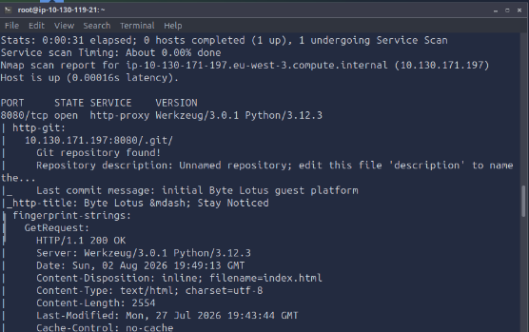
Couple things I picked out of this:
- It's a Python site, running on Flask (Werkzeug is the dev server Flask uses).
- There's a script bundled with nmap called http-git and it checks if a site has left its .git folder sitting out in the open where anyone can reach it. And yep, this one had.
I didn't fully get why that's such a big deal at first, but basically your .git folder is meant to stay private, it's not part of the actual website, it's just internal bookkeeping for version control. If it's exposed, someone can download literally the whole history of the project, including stuff that's since been "deleted" from the site.
Normally I'd have had to go hunting for hidden folders myself with gobuster or dirsearch, so having nmap just hand this to me was a nice shortcut.

Grabbing the repo
Since the .git folder was just sitting there publicly, I didn't need to poke around file by file. I used a tool called git-dumper which basically rebuilds the whole repo for you from an exposed .git folder.
pip3 install git-dumper
git-dumper http://10.130.171.197:8080/.git ./loot
That dumps everything into a folder called loot, and it comes out looking like a normal git repo I'd have cloned myself.

Digging through the history
This was the bit that actually clicked for me doing this room. Normally when you look at a website you only see what's there right now. But because we've got the actual .git folder, we've got every past version of every file too. Even stuff that got deleted later is still sitting in the history somewhere.
So instead of just opening the current files, I went and looked at the commit log:
cd loot
git log --all
git log -p
git log --all just lists every commit that's ever been made. git log -p shows you the actual changes in each commit (the diff), which is what actually mattered here.
Went back to the very first commit, called "initial Byte Lotus guest platform," and found this sitting in a diff on the README:
+Staging flag (remove before launch): THM{byt3_l0tus_n3v3r_f0rg3ts}
So basically whoever built the site left themselves a little reminder note saying "remove this before going live," and then just... never did. And even if they had removed it later, it'd still be recoverable from the commit history anyway, which I guess is the whole point of the room.

Flag
THM{byt3_l0tus_n3v3r_f0rg3ts}

Stuff I took away from this one
- Never let a .git folder end up on a live web server. Should only ever exist on your own machine or somewhere private like GitHub, not sitting next to the actual site files.
- Deleting something doesn't actually delete it from git history. If you accidentally commit a password or key, just removing it in a later commit isn't enough, it's still recoverable. You'd need to actually rotate whatever got leaked and then scrub it out of history properly (tools like git filter-repo exist for that).
- Gonna remember nmap's http-git script for future rooms, saved me a whole step of manual dirbusting.

Tools I used
- nmap (the http-git script specifically)
- git-dumper
- git log / git log -p

