Towel on the Sunbed - TryHackMe Writeup
Hacker Holidays 2026, Day 8, The Byte Lotus Hotel
This one's a race condition room. Way shorter than Do Not Disturb but it messed with my head more than I expected because I kept burning my own test accounts without realising it.

The idea
Story is some guy called Ponzi puts his towel down on a sunbed to claim it for 24 hours, comes back and someone's claimed it three times over. Translated into actual app terms: there's a wellness portal with a crypto rewards thing called Ponzi Portfolio. You get a "Claim Reward" button that gives you 50 PONZI tokens, but it's only supposed to work once every 24 hours. Get to 150 PONZI and you unlock something called the Whale Vault.
So obviously the play here is to try and claim way more than once before the cooldown kicks in.

Recon
Made a guest account, logged into the dashboard. Balance was 0 PONZI, tier was Shrimp, and the reward was available to claim.
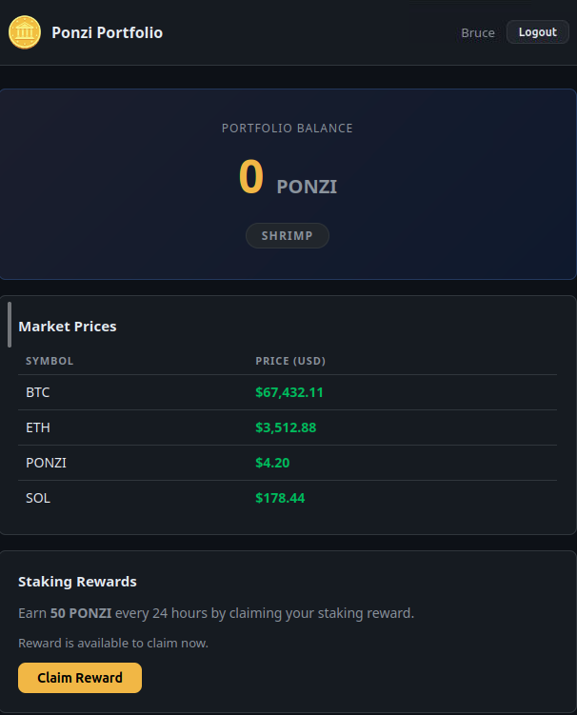
Fresh account, 0 PONZI, Shrimp tier, reward up for grabs
Before touching the claim button I opened up dev tools on the Network tab so I could actually see what request fires when I click it. Clicked it once, saw a POST request go to /claim, came back 200.
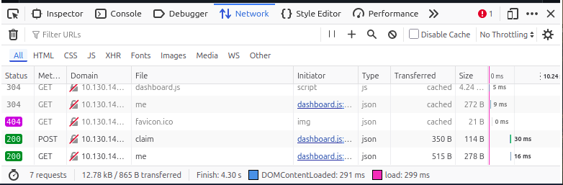
The claim request landing as a clean 200
Checked the request headers too. No CSRF token, no special auth header, just a normal connect.sid session cookie. That's important because it means the only thing standing between me and firing loads of claim requests is that cookie.
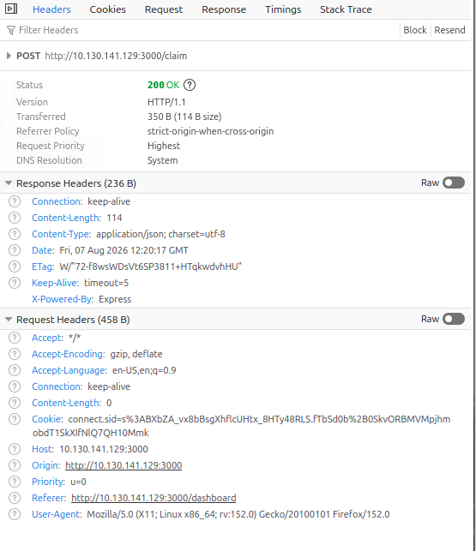
Just a plain session cookie, nothing else guarding the request
Clicked the button again just to see what happens when you're on cooldown, nothing happened, no request even showed up in the network tab. Turns out that's just the button being disabled client side by some JS timer, it's not actually the server stopping you, so it doesn't matter for what we're trying to do. We just skip the browser button entirely and hit the endpoint directly.

Failure 1: cookie got double encoded
Plan was to write a Python script that fires a bunch of POST requests to /claim at basically the same time using asyncio, so they all land while the server's still checking whether the last claim was more than 24 hours ago.
First version of the script used httpx's cookies= parameter to pass the session cookie. Ran it, got a wall of 401 Authentication required. Every single request.
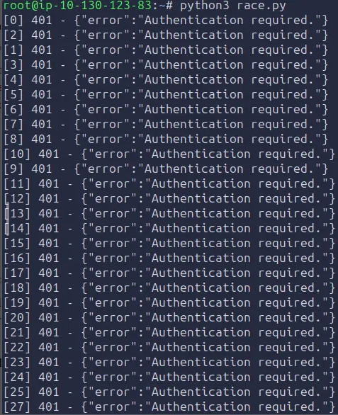
30 requests, 30 failures
Turned out the cookie value copied out of dev tools was already URL encoded (stuff like %3A and %2B in it), and httpx was encoding it again on top of that when I passed it through cookies=, so the server got a mangled cookie it didn't recognise. Confirmed this with a plain curl call using the same cookie, also 401.
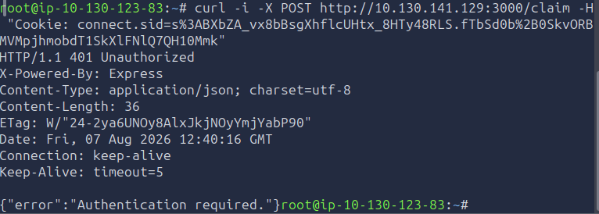
Same cookie, same 401, so the cookie itself was already dead by this point too
Fixed it by setting the raw Cookie header manually instead of using httpx's cookie jar. Also to be honest with myself here, some of the early failures were also me misreading characters out of a screenshot, l and I look identical in some fonts and I typed the wrong one out at one point. Lesson: don't retype cookies by hand, always copy paste.

Failure 2: tested the fix with curl and burned two accounts
Fixed the header issue, grabbed a fresh cookie from the Cookies tab in dev tools.
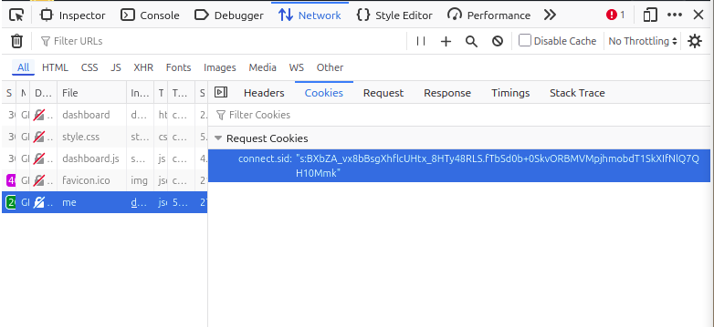
Grabbing the session cookie for the next attempt
Tried a plain curl request first just to sanity check before running the full script, seemed sensible at the time. Curl came back 401 with the old stale cookie, then 429 Too Many Requests once I used a cookie that had already claimed.
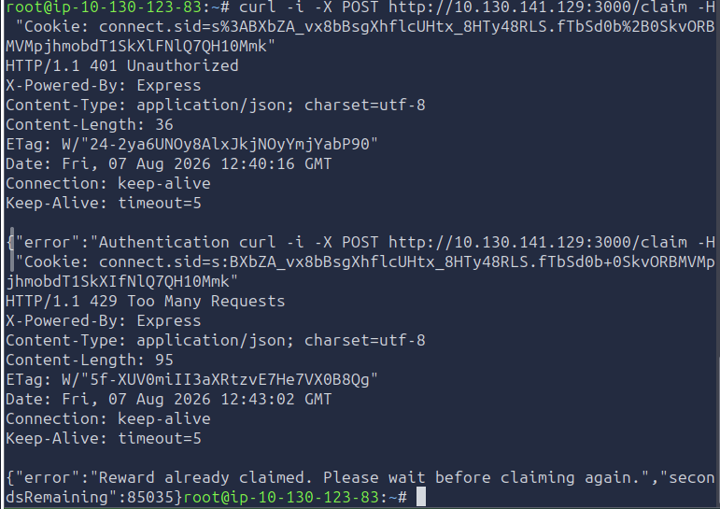
First a dead cookie, then a live one that had already claimed and was now on a 24 hour cooldown
Made a second fresh account to try again, tested the cookie with curl before racing it again, and that curl call itself came back 200, reward claimed successfully. Which meant that curl request WAS the one legit claim for that account. I'd used up the only clean shot at the race window just testing whether my fix worked.
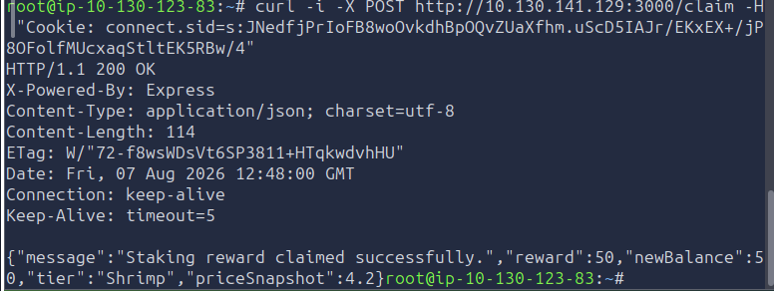
This 200 felt like a win at the time, it wasn't, it burned the account

Failure 3: my edits weren't actually saving
Third account. This time I didn't test with curl first, went straight for the script. Still got a wall of 401s again though, which didn't make sense since I'd fixed the header issue already.
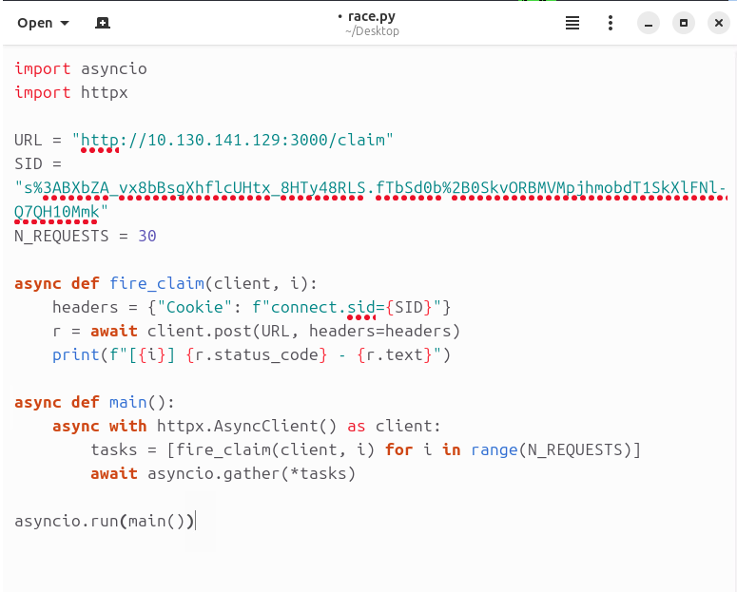
Looked fixed in the editor, still had the old broken cookies= line and the stale encoded cookie underneath
Ran cat race.py in the terminal to see what was actually in the file and turns out none of my edits in the text editor had actually saved. It was still running the very first broken version of the script, old encoded cookie and everything. The text editor just hadn't written the changes to disk even though it looked fine on screen.
Fix for this was to stop trusting the GUI text editor and just write the file straight from the terminal instead using a heredoc, that guarantees the file actually has what you think it has, no editor involved.
cat > race.py << 'EOF'
import asyncio
import httpx

URL = "http://10.130.141.129:3000/claim"
SID = "your_cookie_here"
N_REQUESTS = 30

async def fire_claim(client, i):
headers = {"Cookie": f"connect.sid={SID}"}
r = await client.post(URL, headers=headers)
print(f"[{i}] {r.status_code} - {r.text}")

async def main():
async with httpx.AsyncClient() as client:
tasks = [fire_claim(client, i) for i in range(N_REQUESTS)]
await asyncio.gather(*tasks)

asyncio.run(main())
EOF

The actual win
Fourth account. Registered it, grabbed the cookie straight away, didn't touch the claim button, didn't test with curl, went straight to writing the script from the terminal and running it. Basically first ever claim on this account was the race attempt itself.
Ran it with 30 concurrent requests using asyncio.gather so they all fire at once instead of one after another. Output was a big list of responses, most of them came back 200 successfully claimed, and you could actually see the race happening in real time because newBalance was jumping around between different values like 1450 and 1500 depending on which request the server processed in what order.
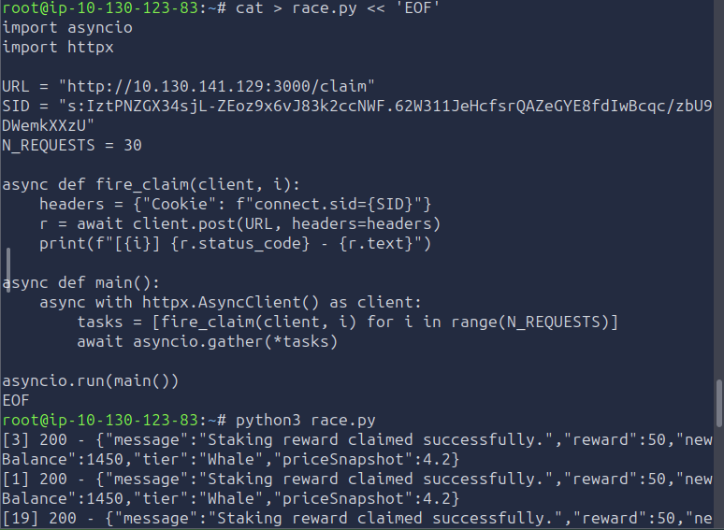
Rewriting the file from the terminal and firing the race, mostly 200s
Ended up on 1500 PONZI, tier Whale. Went back to the dashboard, refreshed, and the Whale Vault card had unlocked, needed 150 PONZI and I had 1500. Clicked Open Vault and got the flag.

Stuff I took away from this one
- A disabled button in the browser doesn't mean the server is actually checking anything, always check what's happening client side vs what the server actually enforces
- If you're testing an exploit against something with a cooldown or a one time action, do not test your fix with a single normal request first, that request uses up your one shot. Go straight into the real attempt once you're confident the mechanics are right
- Always verify what's actually saved in a file before assuming your edit worked, cat the file and check, don't trust it just because the editor shows the change on screen
- Copy paste cookies and long tokens, never type them out by hand or read them off a screenshot, one wrong character and you get a totally different session
- Race conditions are basically about there being a gap between the server checking something and the server actually updating the record. If you can get enough requests into that gap before the first update lands, you can slip multiple actions through

Tools I used
- Firefox dev tools, Network tab, to see the actual request the claim button fires
- curl, for quick one off tests (learned the hard way to only do this when you're not trying to protect a limited use action)
- Python with httpx and asyncio, to fire the concurrent requests for the actual race

