**Animal Intrusion Detection and Deterrence System**

**UIT2511 – SOFTWARE DEVELOPMENT PROJECT – I**

**A PROJECT REPORT**

***Submitted by***

**Nandhana S – 3122 21 5002 068**

**Purushothaman P – 3122 21 5002 082**

**Vijay V – 3122 21 5002 123**

**Ranjith S – 3122 21 5002 306**

**SSN COLLEGE OF ENGINEERING,**

**KALAVAKKAM**

**May 2024**

**Sri Sivasubramaniya Nadar College of Engineering**

**(An Autonomous Institution, Affiliated to Anna University)**

**BONAFIDE CERTIFICATE**

Certified that this project titled **Animal Intrusion Detection and Deterrence System** is the bonafide work of **Nandhana S(3122 21 5002 068), Purushothaman S (3122 21 5002 082), Vijay V(3122 21 5002 123) and Ranjith S(3122 21 5002 306)** and is submitted for project viva-voce examination held on 24-05-2024.

**Signature of examiner**

**Submitted on 24-05-2024**

**Internal Examiner External Examiner**

**1.INTRODUCTION:**

**1.1 Problem Description:**

In many agricultural and residential areas, animals often intrude, causing significant damage to crops, property, and posing risks to human safety. Traditional prevention methods, such as physical barriers and manual monitoring, are often ineffective, labor-intensive, or costly, prompting the need for an automated, efficient, and humane solution.

This project aims to develop an advanced Animal Intrusion Detection and Deterrence System. The system begins with an ultrasonic radar sensor that continuously monitors the area for movement. Upon detecting an animal, a thermal camera is activated to capture four images. These images are then analyzed using deep learning techniques to accurately identify the type of animal present.

Once the animal is identified, the system employs an ultrasonic frequency deterrent tailored to the specific animal. The deterrent emits sounds at frequencies that are particularly irritating to the detected animal, effectively driving it away without causing harm. This approach ensures that the deterrence is both targeted and humane.

This Animal Intrusion Detection and Deterrence System offers a precise, cost-effective, and scalable solution to mitigate human-wildlife conflicts. By integrating advanced sensor technology, thermal imaging, and deep learning, the system provides a robust method for protecting property and crops while ensuring the safety and well-being of both humans and animals.

**1.2 Motivation:**

The motivation for this project arises from direct interactions and in-depth conversations with farmers in various villages, who have candidly shared their experiences and the significant challenges they face due to animal intrusions. These discussions have illuminated the substantial economic losses that farmers endure from crop destruction caused by animals such as deer, boars, and other wildlife. The farmers' frustration is palpable, as they recount the inefficacy and high costs associated with traditional prevention methods, including physical barriers like fencing and labor-intensive manual monitoring. These methods often fail to provide reliable protection, leaving farmers vulnerable to repeated losses.

Beyond the financial impact, the farmers' narratives highlight the constant stress and physical danger they face while trying to safeguard their fields. The emotional toll of these ongoing battles against animal intrusions cannot be overstated. Farmers are not only concerned about their livelihoods but also about the safety of their families and communities, as encounters with wildlife can sometimes lead to dangerous situations.

Recognizing the severity of these issues, the need for an effective, automated solution becomes evident. This project is driven by the goal of developing a system that addresses the practical needs of farmers while ensuring humane and environmentally responsible methods. The proposed Animal Intrusion Detection and Deterrence System aims to significantly reduce the financial losses and emotional distress experienced by farmers. By providing a reliable, cost-effective, and scalable method to deter animal intrusions, we hope to enhance the quality of life and economic stability for the agricultural community.

Through this project, we aim to support farmers by offering a technologically advanced solution that alleviates their burdens. Our ultimate goal is to contribute to sustainable farming practices, ensuring that farmers can protect their crops efficiently and coexist peacefully with wildlife. This initiative is not just about preventing crop damage; it is about empowering farmers, preserving their livelihoods, and promoting a balanced relationship between agriculture and the natural environment.

**1.3 Objective:**

The primary objective of the Animal Intrusion Detection and Deterrence System project is to develop a reliable, automated solution to detect and deter animal intrusions in agricultural and residential areas. Specifically, the project aims to:

1. Reduce Crop and Property Damage: Implement an effective system to minimize the economic losses caused by animals intruding into farmlands and residential properties.

2. Enhance Safety and Security: Provide a safer environment for farmers, their families, and residential property owners by reducing the risk of dangerous encounters with wildlife.

3. Utilize Advanced Technologies: Integrate ultrasonic radar sensors, thermal cameras, and deep learning algorithms to accurately detect and identify animal intrusions in real-time.

4. Implement Humane Deterrence Methods: Develop a deterrence system that uses ultrasonic frequencies tailored to specific animals, ensuring non-lethal and humane repulsion.

5. Ensure Cost-Effectiveness and Scalability: Design the system to be affordable and adaptable to various environments and scales, from small farms to larger agricultural operations.

6. Promote Sustainable Farming Practices: Support sustainable agricultural practices by providing farmers with a tool that allows for peaceful coexistence with wildlife while protecting their livelihoods.

7. Gather Data for Continuous Improvement: Collect data on animal behavior and intrusion patterns to refine and enhance the system's effectiveness over time.

By achieving these objectives, the project aims to provide a comprehensive solution that addresses the challenges of animal intrusions, improving the overall quality of life for those affected and promoting a balanced coexistence with wildlife.

**2. Requirement Engineering**

* Detection Range and Coverage: Understand the size and layout of the farmland or property to determine the required detection range and coverage area for the sensors. Farmers may have specific areas of concern or high-risk zones that require targeted monitoring.
* Types of Intruding Animals: Identify the primary types of animals causing damage to crops and property. Farmers can provide valuable insights into the specific wildlife species present in the area, their behavior patterns, and their typical intrusion routes.
* Environmental Conditions: Assess the environmental conditions of the farming area, including terrain, vegetation density, and weather patterns. This information helps in selecting appropriate sensor technologies that can operate effectively under varying types.
* Cost Considerations: Understand the budget constraints of farmers to ensure that the system remains affordable and cost-effective. Farmers may have preferences for scalable solutions that allow for gradual implementation or modular upgrades over time.
* Ease of Installation and Maintenance: Farmers may prioritize systems that are easy to install and require minimal maintenance to minimize disruptions to their daily operations. They may also prefer systems with user-friendly interfaces for configuration and troubleshooting.
* Compatibility with Existing Infrastructure: Determine if the system needs to integrate with any existing infrastructure or technologies on the farm, such as irrigation systems, power sources, or farm management software.
* Humane Deterrence Methods: Discuss preferences for deterrence methods that prioritize the safety and well-being of wildlife while effectively deterring intruding animals. Farmers may have ethical considerations regarding the use of non-lethal deterrents.
* Data Privacy and Security: Address concerns related to data privacy and security, ensuring that any data collected by the system is protected and used responsibly. Farmers may have concerns about unauthorized access to sensitive information about their farming operations.
* Scalability and Flexibility: Explore options for scalability to accommodate future expansion or changes in farm size and configuration. Farmers may prefer systems that can adapt to evolving needs and technological advancements.
* Local Regulations and Compliance: Ensure that the system complies with local regulations and legal requirements related to wildlife management, environmental protection, and agricultural practices.

**3. Existing methods:**

1. **Fencing Systems**:

Advantages:

* Provides a physical barrier that effectively prevents animal intrusions, offering long-term protection for crops and property.
* Versatile and customizable, with various fencing options available to suit different environments and budgets.

- Disadvantages:

* High initial cost of installation and ongoing maintenance, which may be prohibitive for some farmers, especially those with large land areas.
* Restricted mobility of wildlife, potentially disrupting natural migration patterns and impacting biodiversity.

2. **Guard Animals**:

Advantages:

* Offer a natural deterrent to predators and intruding animals, promoting a non-lethal approach to wildlife management.
* Can serve as companions for farmers, providing additional security and companionship on the farm.

Disadvantages:

* Require extensive training and supervision to effectively deter intruders, which can be time-consuming and labor-intensive.
* Risk of injury or predation to guard animals when confronting larger predators, posing safety concerns for both animals and farmers.

3. **Motion-Activated Lights and Alarms**:

- Advantages:

* Immediate response to intrusions, alerting farmers and potentially scaring away animals.
* Cost-effective and easy to install, with minimal maintenance requirements.

- Disadvantages:

* Some animals may become habituated to lights and alarms over time, reducing their effectiveness as deterrents.
* Motion-activated systems may trigger false alarms due to non-threatening movement, leading to unnecessary disruptions.

4. **Scare Devices** (e.g., propane cannons, scarecrows):

- Advantages:

* Use auditory or visual cues to frighten animals away from the protected area.
* Non-lethal and customizable, allowing for adjustments to suit specific species and environments.

- Disadvantages:

* Scare devices may lose effectiveness over time as animals become accustomed to the stimuli, requiring frequent adjustments or replacements.
* Weather conditions such as wind and rain can affect the performance of scare devices, reducing their reliability.

5. **GPS-Enabled Tracking Systems**:

- Advantages:

* Provide real-time information on the location and movement patterns of tagged animals.
* Valuable tools for wildlife research, conservation efforts, and mitigating human-wildlife conflicts by understanding animal movements.

- Disadvantages:

* Costly to implement and maintain, particularly for large-scale monitoring projects.
* Managing and analyzing the large volumes of data generated by tracking systems can be complex and resource-intensive.

6. **Electric Shock Deterrents**:

- Advantages:

* Effective deterrence with mild shocks, discouraging animals from approaching protected areas.
* Adjustable settings to control shock intensity, minimizing harm to animals.

- Disadvantages:

* Ethical concerns regarding the use of electric shocks, as they can cause discomfort or injury to animals.
* Some animals may become habituated to electric shocks over time, reducing the deterrent's effectiveness.

**4. Proposed Animal Intrusion Detection and Deterrence System**

1. **Machine Learning Model Development**:

* **Custom Dataset Creation**: A diverse dataset is meticulously curated, comprising images and videos depicting various animal species commonly found in agricultural environments. These images are sourced from online repositories and annotated using tools like CVAT.ai.
* **Training YOLOv8 Algorithm**: The annotated dataset serves as the training data for the YOLOv8 deep learning algorithm. Through extensive training iterations, the algorithm learns to accurately detect and classify animals in real-time, achieving high levels of precision and recall.

2. **Hardware Integration**:

* **Ultrasonic Sensors (HC-SR04):** These sensors are strategically positioned around the perimeter of the agricultural area to detect the presence of nearby objects, including animals. They emit ultrasonic waves and measure the time taken for the waves to reflect back, enabling distance estimation.
* **FLIR AX5 Series Thermal Cameras:** Thermal cameras are integrated into the system to complement ultrasonic sensors. They detect infrared radiation emitted by objects, regardless of lighting conditions, allowing for the identification of animals based on their body heat signatures.
* **Micro Servo Motor**: A servo motor controls the rotation of both the ultrasonic sensors and the thermal cameras. This coordinated rotation ensures comprehensive coverage of the surveillance area, minimizing blind spots and enhancing detection accuracy.

3.**Working of the System**:

* **Control Hub with Arduino Uno**: The Arduino Uno serves as the control hub of the system, orchestrating the operation of all components.
* **Continuous Scanning Process**: Upon initialization, the Arduino Uno coordinates the continuous scanning process. It sends commands to the servo motor to rotate the sensors and cameras at predetermined angles, ensuring comprehensive coverage of the surveillance area.
* **Continuous Scanning Process**: The system initiates a continuous scanning process, with the ultrasonic radar system actively surveying the surrounding area. The servo motor rotates the sensors and cameras at predetermined angles, covering the entire perimeter.
* **Detection and Analysis**: When an object is detected by the ultrasonic radar system, both the servo motor and the thermal camera halt their rotation, focusing on the detected area of interest. The thermal camera captures a series of high-resolution images to provide detailed visual data for analysis.
* **Classification and Deterrence**:

1. **Classification with ML Model**: The captured images are analyzed in real-time by the YOLOv8 algorithm to confirm the presence of an animal and determine its species.
2. **Deterrence with Ultrasonic Transducer**: Based on the classification results, the system triggers the emission of ultrasonic frequencies from a custom-designed transducer to deter specific animal species. The ultrasonic transducer emits frequencies that are tuned to the hearing range of the detected animals, causing discomfort or irritation without causing harm.

* **Data Logging to MongoDB**:

1. The Arduino Uno meticulously logs pertinent data associated with each intrusion event, including the timestamp of the event, the type of trespassing animal, and the angle at which the animal was detected.
2. This detailed data logging process ensures comprehensive record-keeping, allowing for in-depth analysis and historical tracking of animal activity patterns over time.

* **Alert Notifications:**

1. If a specific animal repeatedly trespasses within a defined timeframe, the system automatically triggers an alert notification.
2. The Arduino Uno promptly sends an email notification to the designated user, highlighting the recurrent intrusion and prompting immediate attention and intervention.

* **Monthly Reporting:**

1. At the conclusion of each month, the system generates a comprehensive report summarizing all recorded intrusion events and associated data.
2. This monthly report provides detailed statistical analyses of trespassing patterns, identifying areas with high intrusion frequency or particular animals causing recurrent issues.
3. Armed with this valuable insight, users can make informed decisions regarding wildlife management strategies, such as deploying additional ultrasonic transducers or adjusting their angles to target specific areas of concern.

* **Resumption of Scanning**: After the deterrence action is completed, the servo motor resumes rotating, allowing the system to continue scanning for further animal intrusions.

**4.Advantages of the Proposed System**:

* Enhanced Precision: The integration of multiple sensing modalities, including ultrasonic sensors, thermal cameras, and machine learning algorithms, enhances the precision of animal detection and classification. This high level of accuracy minimizes false alarms and ensures effective response to genuine intrusion events.
* Real-time Decision Support: By facilitating real-time data processing and analysis, the system provides actionable insights and decision support to users. Rapid classification of detected animals and immediate activation of deterrence measures enable timely intervention, mitigating potential crop damage and minimizing losses.
* Adaptive Deterrence Strategies: The system's ability to customize deterrence actions based on detected animal species ensures adaptability to diverse wildlife populations and environmental conditions. Tailored ultrasonic frequencies target specific animals while minimizing disruption to non-target species, promoting effective and humane deterrence strategies.
* Comprehensive Data Logging: With detailed data logging capabilities, the system maintains a comprehensive record of intrusion events, including timestamps, animal types, and detection angles. This rich dataset facilitates in-depth analysis of wildlife activity patterns over time, enabling informed decision-making and long-term planning for wildlife management.
* Proactive Alerting Mechanism: The system's automated alert notification feature proactively informs users of recurrent intrusion events, prompting timely intervention and preventive measures. This proactive approach helps mitigate potential risks and enables users to address emerging challenges promptly, minimizing the impact of wildlife conflicts on agricultural operations.
* Scalability and Flexibility: Designed with scalability and flexibility in mind, the system can be easily expanded and adapted to accommodate varying agricultural landscapes and wildlife populations. Additional sensors, transducers, or data analytics modules can be integrated as needed, allowing for customization and optimization of the system to meet specific user requirements.
* Cost-effectiveness: Despite its advanced capabilities, the system offers cost-effective solutions for wildlife management and agricultural protection. By leveraging open-source hardware and software components, as well as cloud-based data storage and processing services, the system optimizes resource utilization and minimizes operational costs, ensuring maximum return on investment for users.

**5. System Architecture**

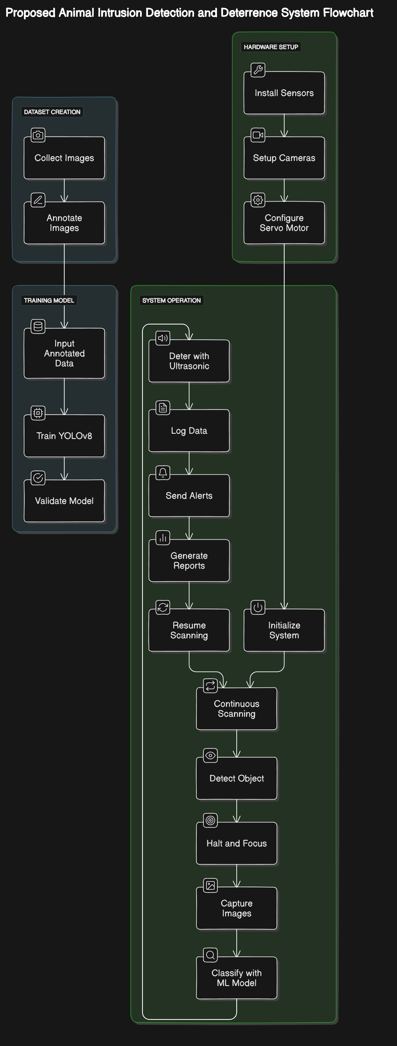

**6. Flow Chart for the proposed system:**

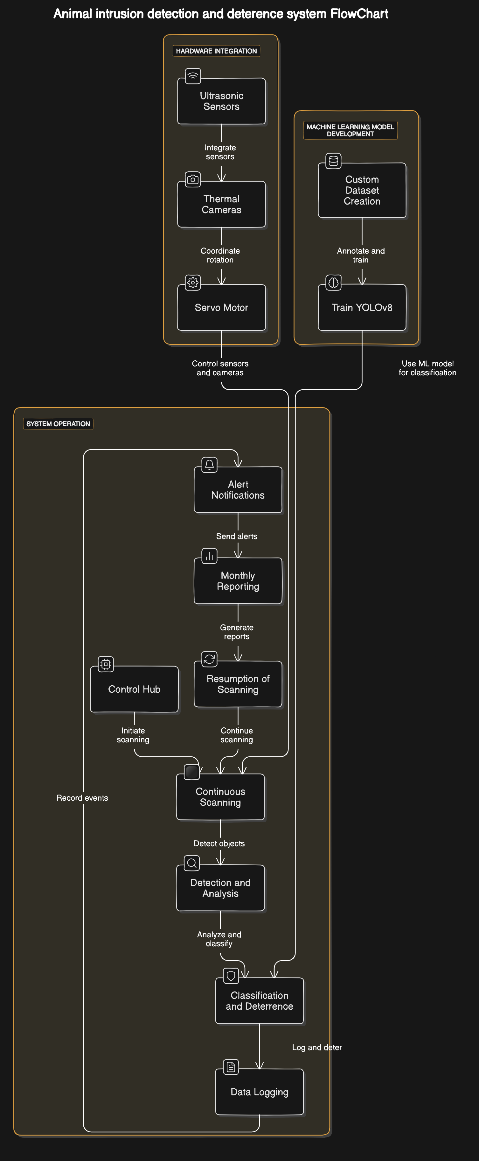

**7. Circuit Diagram:**

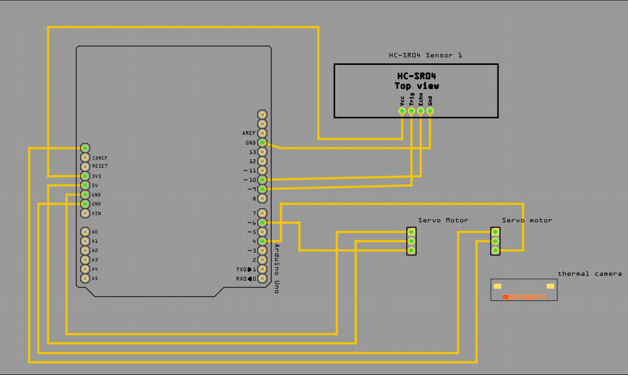

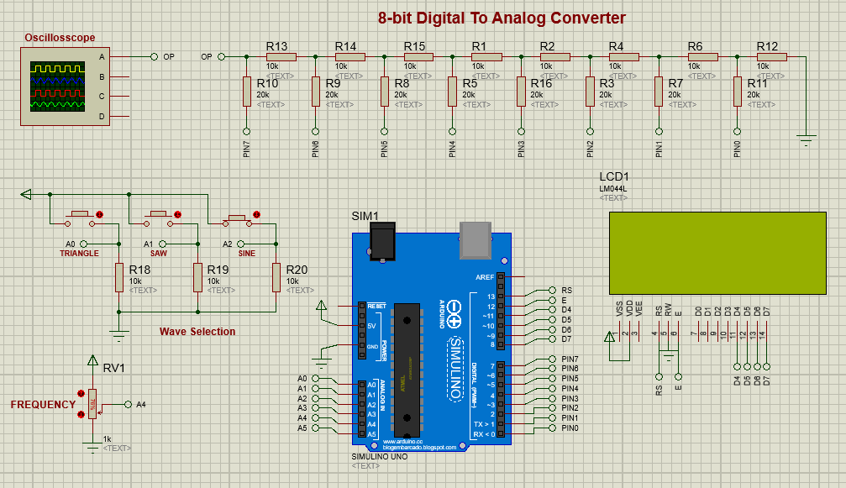

**8. Bottlenecks:**

* **Permission from Animal Husbandry Department:** We need to obtain permission from the animal husbandry department to conduct tests on various animals, as understanding their hearing ranges is essential for optimizing the ultrasonic deterrence.
* **Cost and Availability of Ultrasonic Transducers:** The ultrasonic transducers are rare and expensive, which prompted us to design our own transducer. This presents challenges in ensuring its effectiveness and reliability.
* **Lack of Diverse Animal Datasets:** We currently lack datasets on a diverse range of animals, necessitating collaboration with the animal husbandry department to gather more comprehensive data for training and testing our system.

**9. Future Scope:**

* **Integration with IoT Devices**: Enhancing the system with Internet of Things (IoT) capabilities can enable remote monitoring and control. This allows farmers to receive real-time alerts and manage the system from their smartphones or computers, improving convenience and responsiveness.
* **Solar-Powered Operation**: Implementing solar panels to power the system can make it more sustainable and suitable for remote agricultural areas where access to electricity is limited. This addition can reduce operational costs and the system's environmental impact.
* **Advanced Data Analytics and Visualization**: Improving data analytics capabilities and incorporating sophisticated visualization tools can help farmers better understand intrusion patterns and trends. Advanced dashboards and visual reports can provide actionable insights and aid in decision-making.
* **Integration with Drones**: Utilizing drones equipped with cameras and sensors can expand the surveillance area beyond the fixed positions of the current system. Drones can cover larger fields, provide aerial views, and access hard-to-reach areas, offering a more comprehensive monitoring solution.
* **Multi-Species Deterrence**: Developing and incorporating deterrence methods tailored to a wider variety of animal species can make the system more versatile and effective. This enhancement involves researching and implementing different frequencies and deterrence strategies specific to each animal.

**10. Conclusion:**

The proposed Animal Intrusion Detection and Deterrence System represents a significant advancement in safeguarding agricultural fields from wildlife intrusions. By leveraging a combination of ultrasonic sensors, thermal cameras, and advanced machine learning techniques, the system ensures high precision in detecting and classifying animals. The integration of a custom-designed ultrasonic transducer offers a humane and effective deterrence method, minimizing harm to wildlife while protecting crops. The system's robust data logging capabilities, coupled with real-time alert notifications and comprehensive monthly reports, provide valuable insights into intrusion patterns and trends, enabling farmers to make informed decisions and optimize their wildlife management strategies.

Moreover, the use of the Arduino Uno as the control hub ensures seamless coordination of all components, enhancing the system's reliability and efficiency. The potential for future enhancements, such as IoT integration, solar power, advanced data analytics, drone support, and multi-species deterrence, offers a pathway to greater scalability and effectiveness. Overall, the Animal Intrusion Detection and Deterrence System not only addresses the immediate needs of farmers but also sets the stage for future innovations in wildlife management and agricultural protection, promoting a sustainable and harmonious coexistence between humans and wildlife.