|  |  |
| --- | --- |
| Name | Bruck Assefa |
| Date | 2021-Feb-13 |
| Course | IT FDN 110: Introduction to Programming (Python) |
| Assignment | Assignment 05 |

Assignment 05

# Introduction

This document covers steps involved in creating a script that is tasked to ask a user add data to list, write data to file, display data, to provide cd information or to quit.

The IDE we will be using is Spyder. We will also be working with Python 3.8.5 version as shown on the below console.

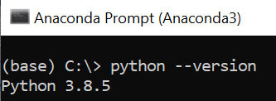

Figure 1 "Python version" script

# Create a Python Script

We will create a python script file that performs the following:

[l] load Inventory from file

[a] Add CD

[i] Display Current Inventory

[d] delete CD from Inventory

[s] Save Inventory to file

[x] exit

First open a note pad document and write down the below scripts.

1. strChoice = '' # User input
2. lstTbl = []  # list of lists to hold data
3. lstRow = []  # list of data row
4. lstRow = {} # replace list of lists with list of dicts
5. strFileName = 'CDInventory.txt'  # data storage file
6. objFile = None  # file object
8. # Get user Input
9. **print**('The Magic CD Inventory\n')
10. **while** True:
11. # 1. Display menu allowing the user to choose:
12. **print**('[l] load Inventory from file\n[a] Add CD\n[i] Display Current Inventory')
13. **print**('[d] delete CD from Inventory\n[s] Save Inventory to file\n[x] exit')
14. strChoice = input('l, a, i, d, s or x: ').lower()  # convert choice to lower case at time of input
15. **print**()
17. **if** strChoice == 'x':
18. # 5. Exit the program if the user chooses so
19. **break**
20. **if** strChoice == 'l':
21. objFile = open(strFileName, 'r')
22. **for** row **in** objFile:
23. lstRow = row.strip().split(',')
24. cdrow = {'ID': lstRow[0], 'CD Title':lstRow[1], 'Artist':lstRow[2]}
25. lstTbl.append(cdrow)
26. **pass**
27. **elif** strChoice == 'a':  # no elif necessary, as this code is only reached if strChoice is not 'exit'
28. # 2. Add data to the table (2d-list) each time the user wants to add data
29. strID = input('Enter an ID: ')
30. strTitle = input('Enter the CD\'s Title: ')
31. strArtist = input('Enter the Artist\'s Name: ')
32. intID = int(strID)
33. lstRow = [intID, strTitle, strArtist]
34. lstTbl.append(lstRow)
35. **elif** strChoice == 'i':
36. # 3. Display the current data to the user each time the user wants to display the data
37. **print**('ID, CD Title, Artist')
38. **for** row **in** lstTbl:
39. **print**(*row, sep = ', ')
40. **elif** strChoice == 'd': #Add functionality of deleting an entry
41. deleteID = input('Select id to delete:')
42. **for** i **in** lstTbl.keys():
43. **if** i == deleteID:
44. **del** lstTbl[key]
45. **pass**
46. **elif** strChoice == 's':
47. # 4. Save the data to a text file CDInventory.txt if the user chooses so
48. objFile = open(strFileName, 'a')
49. **for** row **in** lstTbl:
50. strRow = ''
51. **for** item **in** row:
52. strRow += str(item) + ','
53. strRow = strRow[:-1] + '\n'
54. objFile.write(strRow)
55. objFile.close()
56. **else**:
57. **print**('Please choose either l, a, i, d, s or x!')

Figure 2: Assignment05.py script command lines

# Save your script to a folder

Inside the course folder create another folder called Assignment05 and save the script document as “CDInventory.py”

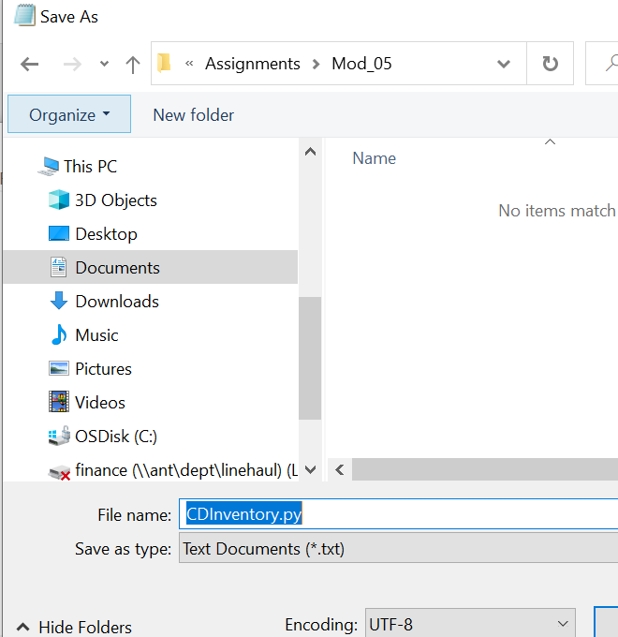

Figure 4 saving a .py extension file

# Run Your Script

Run the script by following the below steps

Open the script using Spyder IDE

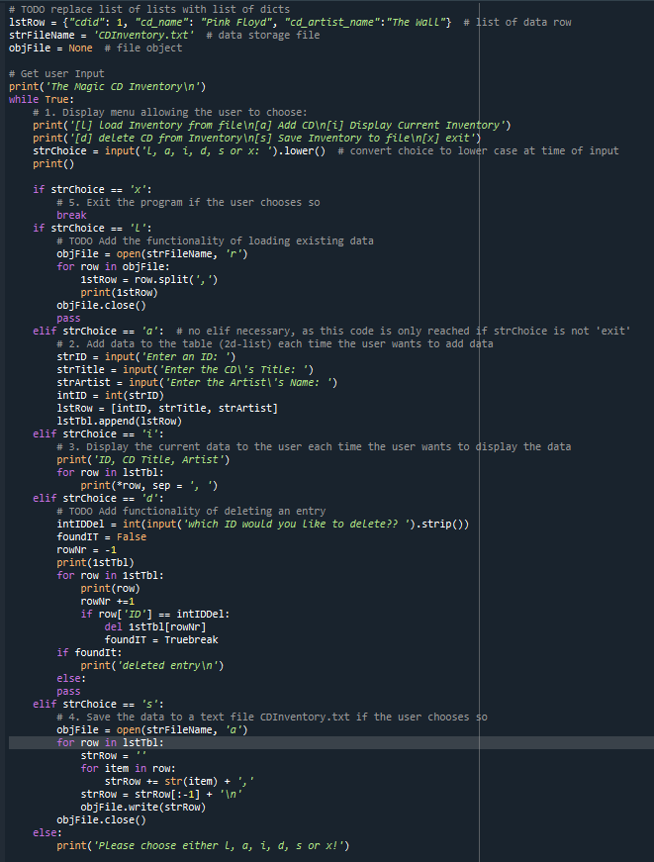

Figure 3 open the CDInventory.py using Spyder IDERun

# Summary

In this assignment, we used python to create a cd inventory text file. We were able to use user provided selection to ask a user add data to list, write data to file, display data, to provide cd information or to quit.

# Reference

* FDN_Py_Module_05 file from IT FDN 110 A Module 04 Overview materials

[https://canvas.uw.edu/courses](https://canvas.uw.edu/courses/1424622/files/69141477/download?wrap=1)