DEPARTMENT OF COMPUTER ENGINEERING
Software Engineering — Comprehensive Project Report | Academic Year 2026–2027
RestoFlow OS
Autonomous AI Restaurant Operating System & POS Hub
Cloud-Native Real-Time Architecture with InsForge PostgreSQL BaaS, n8n AI Workflows & Recharts BI
Project Title | RestoFlow OS — Autonomous AI Restaurant Operating System & POS Hub
Course / Subject | Software Engineering — Full Stack System Implementation
Academic Year | 2026-27
Submitted By | Aniket Dhoke
Project Mentor | Prof. Sayali Mane

Live Production Stack: React 18 · TypeScript · Express 5 · InsForge PostgreSQL BaaS · n8n AI Engine · WebSockets · Recharts · Leaflet GPS

1. Executive Summary & Abstract
RestoFlow OS is an enterprise-grade, cloud-native Restaurant Operating System designed to eradicate operational fragmentation across food & beverage (F&B) enterprises. Modern hospitality environments suffer from disconnected software silos—standalone POS hardware, manual kitchen tickets, pen-and-paper inventory, and detached delivery dispatchers. RestoFlow OS unifies all core restaurant operational loops into a single high-performance web platform powered by an event-driven three-tier architecture: (1) React 18 + TypeScript presentation layer with three role portals; (2) Node.js + Express 5 API gateway with sub-20ms WebSocket synchronization; and (3) InsForge BaaS (PostgreSQL) with n8n autonomous workflow microservices.
Key Engineering Innovations:
- High-Velocity Touch POS: Sub-second dispatch with recipe modifier matrix, auto-coupon engine, and 80mm ESC/POS thermal receipt generation.
- Multi-Station KDS: Automated routing to Tandoor, Curry, Bar, and Pantry stations with 18-minute SLA rush alerts.
- Autonomous AI Supply Replenishment: Real-time ingredient deduction per order + n8n workflow auto-generating Purchase Orders at par reorder thresholds.
- Enterprise Cloud BaaS: InsForge PostgreSQL (ap-southeast) with PKCE authentication and S3-compatible storage.
- Business Intelligence: Recharts hourly revenue curves, BCG menu matrix, and GSTR-1 compliant CGST/SGST tax exports.
2. Problem Statement & Motivation
The food service industry operates on razor-thin margins (8–15%) requiring millisecond coordination between front-of-house (FOH) and back-of-house (BOH). Current restaurant systems suffer from:
- Delayed Order Routing: Paper KOTs get misplaced during rush hours, pushing table wait times beyond 35 minutes.
- Inventory Blindspots: Manual stock reconciliation causes stockouts and food waste, inflating food costs above 38%.
- Revenue Leakage: Incorrect manual tax application and untracked discounts cause cash drawer discrepancies.
- Opaque Delivery Logistics: Untracked third-party drivers cause cold delivery complaints.
- No Real-Time Telemetry: Management receives monthly static spreadsheets instead of live BI dashboards.
RestoFlow OS resolves these by binding customer self-service, staff order entry, kitchen display ticket bumping, autonomous supply replenishment, and financial reporting into a continuous real-time operational loop.

3. System Objectives & Requirements Analysis
3.1 System Objectives
O1. Multi-Role Unified Interface: Guest Dining, Floor/Cashier Staff, and Executive Management portals in a single React SPA.
O2. Sub-200ms KDS Synchronization: WebSocket event broadcasting ensuring KOT dispatch from POS to KDS in under 200ms.
O3. Autonomous AI Supply Chain: Auto-deduct ingredients per order; trigger n8n webhook to draft POs at par reorder levels.
O4. Dynamic Floor Plan Management: Interactive visual floor canvas with occupancy rings, seating timers, and table transfers.
O5. BCG Menu Engineering: Classify menu items into Stars, Plowhorses, Puzzles, and Dogs by margin and popularity.
O6. GSTR-1 Tax Compliance: Segregate CGST (2.5%), SGST (2.5%), Alcohol VAT (18%), with one-click CSV/JSON exports.
O7. InsForge Cloud BaaS Resilience: Leverage InsForge PostgreSQL (ap-southeast) for ACID storage, PKCE auth, and S3 assets.
3.2 Functional Requirements
Req ID | Requirement | Description
FR-01 | Digital Menu Browsing | Category filters, veg/non-veg toggle, allergen warnings.
FR-02 | Cart & Dine-In Ordering | Modifier config, table selection, live order dispatch.
FR-03 | High-Velocity POS Terminal | Single-tap shortcuts, coupon codes, station routing.
FR-04 | Split-Payment Settlement | Split by pax (2–8), by item, or custom tender.
FR-05 | Multi-Lane KDS | Station-grouped tickets, timers, rush warnings, bump actions.
FR-06 | Real-Time Table Visualizer | Status rings (Available/Occupied/Reserved/Billed) + timers.
FR-07 | Automated Ingredient Deduction | Recipe-mapped backend decrements InsForge inventory on order.
FR-08 | n8n AI Auto-Restock | Webhook-triggered PO generation at reorder threshold breach.
FR-09 | VIP Guest CRM & Loyalty | Lifetime spend, visit frequency, loyalty points, VIP tier.
FR-10 | Live GPS Delivery Map | Leaflet map with driver pins, radius rings, route polylines.
FR-11 | Recharts BI Analytics | Revenue curves, channel donuts, profitability charts.
FR-12 | GSTR-1 Tax Compliance | CGST/SGST segregation with CSV/JSON export.

4. Technology Stack & Cloud Infrastructure
4.1 Technology Stack Matrix
Layer | Technology | Role & Justification
Presentation Layer | React 18.3 + TypeScript 5.7 | Component-based SPA with strict type safety, custom hooks, context state.
Styling | Tailwind CSS v3.4 | Utility-first design tokens with 4/8pt spacing rhythm.
Data Visualization | Recharts 3.10.1 | Composable D3-based charts (AreaChart, BarChart, PieChart).
Geospatial / GPS | Leaflet 1.9.4 + OpenStreetMap | Driver tracking, radius rings, and route polylines.
API Layer | Node.js v20 + Express 5.2 (TS) | REST API gateway, recipe deduction engine, routing.
Real-Time Hub | WebSockets (ws v8.21) | Sub-20ms event broadcast: KDS, POS, Table, Inventory.
Cloud Backend | InsForge BaaS (@insforge/sdk) | PostgreSQL relational DB, PKCE auth, S3 storage.
AI Workflows | n8n Workflow Engine | Autonomous supply chain, VIP concierge, daily digest.
Receipt Engine | HTML5 Canvas / ESC/POS | 80mm thermal receipt with FSSAI, GSTIN, QR code.
Build Tooling | Vite 6.1 + PostCSS | Instant HMR dev server + optimized production bundling.

4.2 InsForge Cloud BaaS Infrastructure
Project Name / ID | RMS | 1d2e8674-5e0c-4c27-a31c-688bfbbfb5e3
Cloud Region | ap-southeast · AppKey: n982kqwn
API Base Host | https://n982kqwn.ap-southeast.insforge.app
Storage Buckets | restoflow (Public Assets), uploads (Dish Imagery)
Authentication | PKCE OAuth (Google / GitHub) + JWT Sessions + Staff PIN

4.3 Hardware & Software Environment
Server Processor | Intel Core i5 / AMD Ryzen 5 or Cloud vCPU (2.5 GHz+)
Memory / Storage | 8 GB RAM minimum; 10 GB free disk space
Operating Systems | Windows 11, macOS Ventura/Sonoma, Ubuntu 22.04 LTS
Runtime | Node.js v20 LTS + npm v10 + tsx v4.23
Browsers | Chrome 120+, Edge 120+, Firefox 122+, Safari 17+
Thermal Printers | Epson TM-T88VI, TVS RP-3200, Epson TM-U220B

5. System Architecture & Design
5.1 Three-Tier Event-Driven Architecture
RestoFlow OS implements a decoupled, event-driven three-tier architecture ensuring sub-second response times and real-time state synchronization across all POS terminals, kitchen stations, and dashboards:
- Tier 1 — Client Presentation Layer: React 18 SPA rendering role-conditional views (Customer, Staff, Admin). Uses React Context and custom WebSocket hooks for instant UI state mutations.
- Tier 2 — Application Gateway & Event Hub: Node.js + Express 5 API gateway handling REST routes and a persistent WebSocket hub broadcasting JSON event payloads.
- Tier 3 — Data Persistence & AI Cloud Layer: InsForge PostgreSQL executes ACID transactions with JSONB line items. n8n microservices trigger autonomous supply chain replenishment.
5.2 Order Lifecycle State Machine
Every order progresses through 5 deterministic states:
- Order Creation: POS/Customer places order; Express API calculates subtotal, CGST/SGST (5%), and service charge (5%).
- Ingredient Deduction: Backend maps dish IDs to recipes and atomically decrements InsForge inventory stocks.
- WebSocket Broadcast: Express hub emits ORDER_CREATED event with station-specific KDS ticket payloads.
- KDS Ticket & Cooking: Kitchen stations receive tickets; prep timers start; >18-minute rush alarm fires.
- Table Settlement: Cashier settles split check, prints 80mm ESC/POS receipt, and releases table.
5.3 Recipe Deduction & Costing Model
The inventory engine uses the following formulae:
Stock_new(i) = Stock_current(i) − Σ (qty_d × Consumption(d, i)) [Ingredient Depletion]
FoodCostPct(d) = (UnitCost(d) / SellingPrice(d)) × 100
GrossMarginPct(d) = ((SellingPrice(d) − UnitCost(d)) / SellingPrice(d)) × 100
6. Database Design & Schema
6.1 Relational Architecture
RestoFlow OS is backed by 9 relational PostgreSQL tables in InsForge BaaS using UUID/String PKs, FK relations, JSONB columns for line items, and timestamp indexes for high-velocity queries.
6.2 Core Table Definitions
Table | Column | Data Type | Constraint | Description
orders | id | VARCHAR(32) | PK | Unique order ID
 | table_type | VARCHAR(32) | NOT NULL | Dine-In, Takeaway, Swiggy, Zomato
 | line_items | JSONB | NOT NULL | Array of [{name, qty, price, station}]
 | payment_status | VARCHAR(20) | NOT NULL | unpaid / paid / refunded / split_settled
 | kitchen_status | VARCHAR(20) | NOT NULL | pending / cooking / ready / served
 | total | NUMERIC(10,2) | NOT NULL | Grand total incl. taxes & service
inventory | id | VARCHAR(32) | PK | Ingredient SKU (e.g. ING-001)
 | current_stock | NUMERIC(10,2) | NOT NULL | Real-time remaining stock
 | reorder_point | NUMERIC(10,2) | NOT NULL | Triggers n8n auto-replenishment
 | status | VARCHAR(20) | NOT NULL | healthy / low_stock / critical
menu_items | id | VARCHAR(32) | PK | Menu item ID (e.g. DISH-101)
 | margin_pct | NUMERIC(5,2) | NOT NULL | Gross profit margin %
 | matrix_tier | VARCHAR(20) | NOT NULL | Star / Plowhorse / Puzzle / Dog
 | in_stock | BOOLEAN | DEFAULT TRUE | Live 86 Out-of-Stock toggle

6.3 Supporting Tables
floor_tables: Table layout, section, occupancy status, seating timer, guest name, billed amount.
kds_tickets: Active kitchen tickets with station, elapsed time, urgency flag, item list.
reservations: Booking ledger with VIP tier, occasion notes, deposit, time slot.
customers: CRM profiles with loyalty tier (Platinum/Gold/Silver), dietary tags, visit history.
staff: Roster with shift clock-in, PIN auth level, assigned station, tips earned.
settings: Business profile, GSTIN matrix, FSSAI number, hardware fleet config.

7. REST API Design & WebSocket Protocols
7.1 Express 5 REST API Endpoints
Method | Endpoint | Description
GET | /api/health | System health, InsForge DB status & latency
GET | /api/orders | Fetch live orders with filters
POST | /api/orders | Create order, deduct ingredients, broadcast WS
POST | /api/orders/:id/bump | Bump KDS ticket (Cooking → Ready → Served)
POST | /api/checkout/settle | Settle bill (UPI, Card, Cash)
POST | /api/checkout/split-settle | Multi-tender split settlement
GET | /api/tables | Floor plan layout and occupancy states
POST | /api/tables/:id/status | Update table state
GET | /api/inventory | Ingredient stock with par-level warnings
POST | /api/inventory/n8n-auto-supply | Trigger n8n auto-replenishment
GET | /api/analytics/summary | Daily revenue, orders, occupancy %
GET | /api/analytics/gstr1-export | GSTR-1 tax export (CSV/JSON)
POST | /api/insforge/sync-db | Sync and seed InsForge PostgreSQL

7.2 WebSocket Real-Time Event Protocol
WebSocket Event | System Effect
ORDER_CREATED | New order dispatched. Triggers KDS ticket rendering.
KDS_TICKET_BUMPED | Cook bumps ticket. Updates Customer Tracker.
TABLE_STATUS_CHANGED | Table seated, reserved, or released.
INVENTORY_DEDUCTED | Recipe ingredients subtracted from ledger.
AUTOSUPPLY_COMPLETED | n8n finishes generating POs and restocking.
HARDWARE_PING_BROADCAST | Verifies printer status in real-time.

8. Autonomous AI Workflow Architecture (n8n Engine)
RestoFlow OS incorporates five production-grade autonomous microservices on an n8n workflow engine (Port 5678):
Workflow | Webhook Route | Autonomous Action
1. AI Supply Chain | /webhook/restoflow-auto-supply | Monitors par levels; generates categorized POs; dispatches supplier emails.
2. VIP Concierge | /webhook/restoflow-vip-booking | Identifies VIP guests; assigns complimentary starters + WhatsApp alerts.
3. KDS Kitchen Router | /webhook/restoflow-order-dispatch | Routes dishes to stations; initiates timers; escalates 18-min rush alerts.
4. Daily Sales Digest | /webhook/restoflow-executive-ai | Daily 23:30 aggregation; LLM-summarized executive briefing.
5. Menu Optimizer | /webhook/restoflow-menu-optimizer | BCG matrix classification; dynamic price adjustment recommendations.

9. Visual Screen Walkthrough
Selected screenshots from the live RestoFlow OS application (http://localhost:5173) and the InsForge Cloud BaaS platform.
9.1 System Landing Page
Role entry cards for Customer Dining Portal, Floor & Kitchen Staff, and Executive Operations Hub with live InsForge telemetry and Google OAuth login.
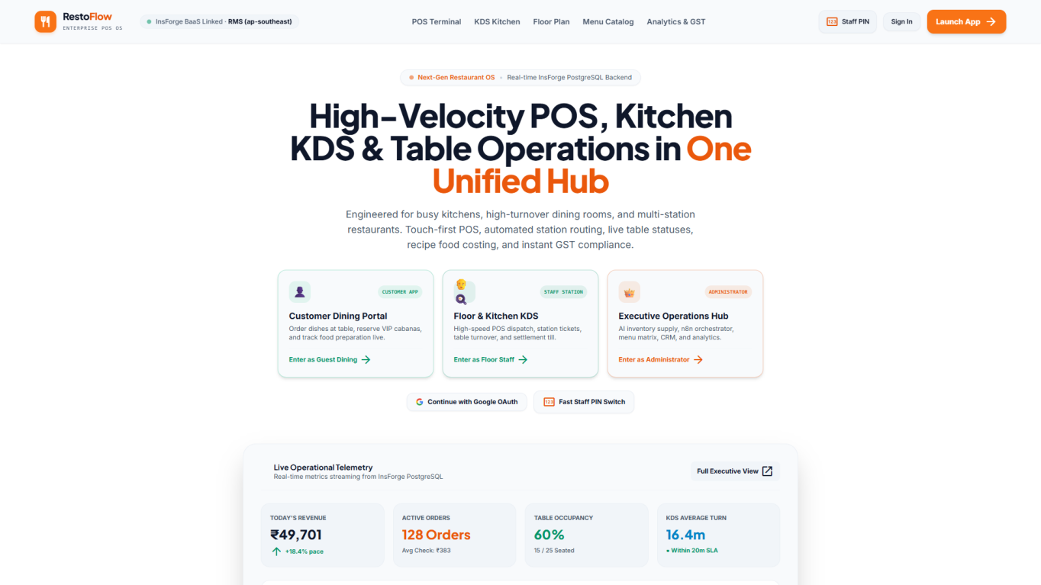
Figure 1 — RestoFlow OS Landing Page: Role portals, live telemetry & OAuth login.

9.2 Executive Dashboard & Customer Portal
The executive dashboard streams live KPIs (Revenue, Active Orders, Occupancy), Recharts hourly revenue curves, and floor status. The customer portal features category filters, veg toggles, cart, and multi-channel ordering.
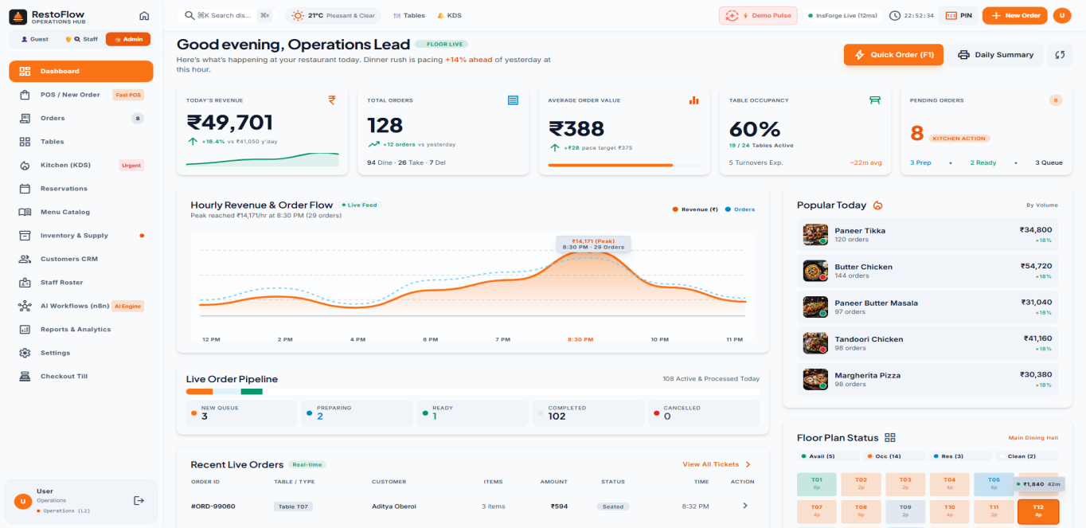
Figure 2 — Executive Operations Hub: KPI streams, revenue curves & occupancy.
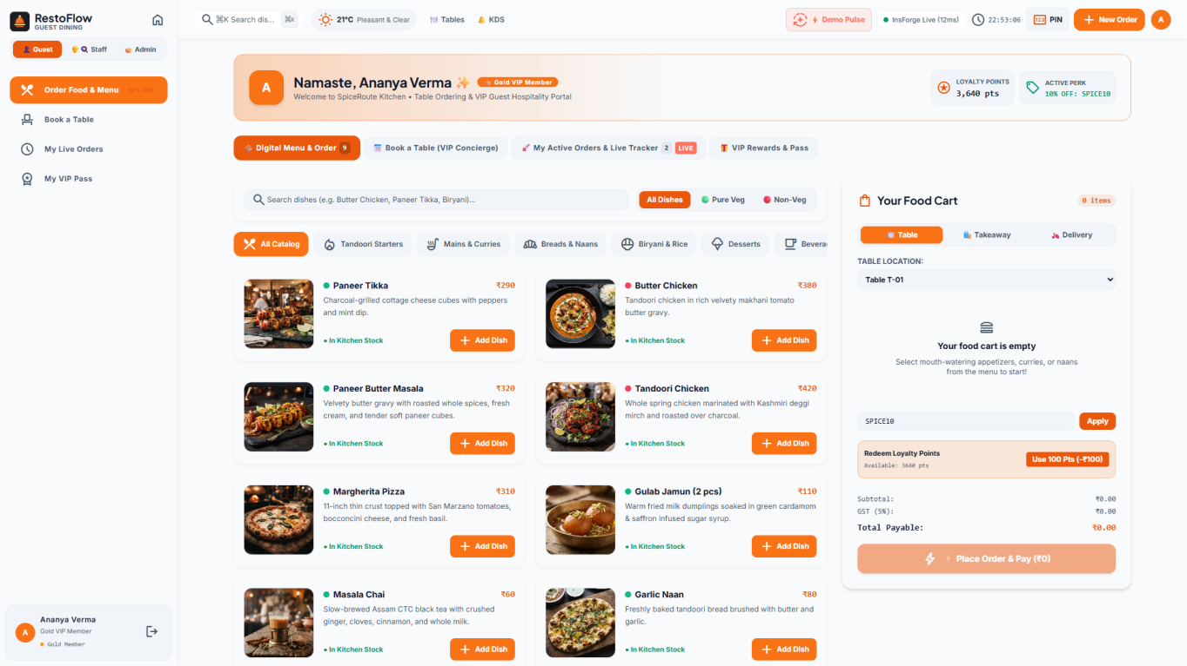
Figure 3 — Customer Dining Portal: Menu cards, veg toggles, cart & checkout.

9.3 POS Terminal & Kitchen Display System
The POS features dish tabs, modifier drawers, and split-payment settlement. The KDS replaces paper KOTs with multi-station screens, prep timers, item checkboxes, and rush badges.
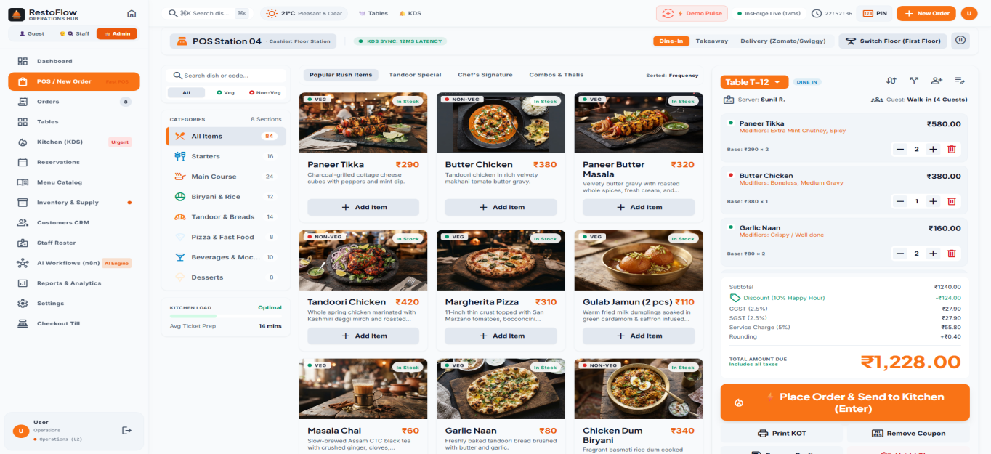
Figure 4 — High-Velocity POS Terminal: Dish catalog, modifiers & ticket dispatch.
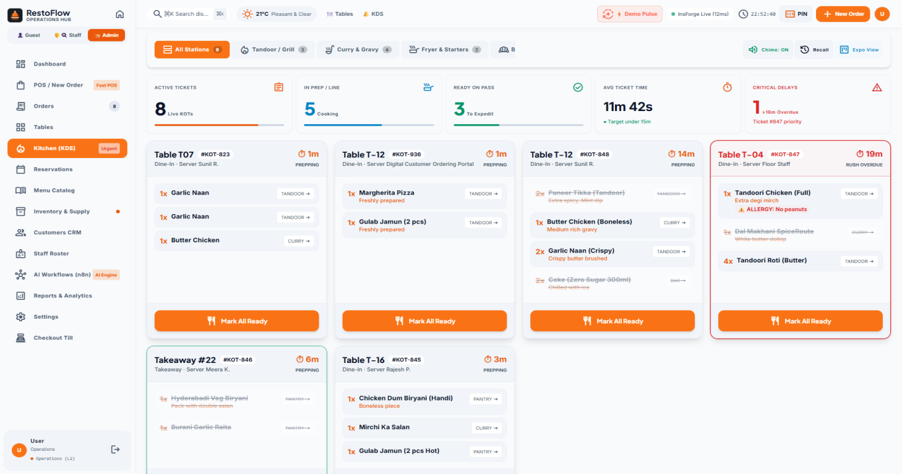
Figure 5 — Kitchen Display System (KDS): Station routing, timers & rush alerts.

9.4 InsForge Cloud Platform
InsForge dashboard managing backend database tables, API keys, storage buckets, and auth for Project RMS.
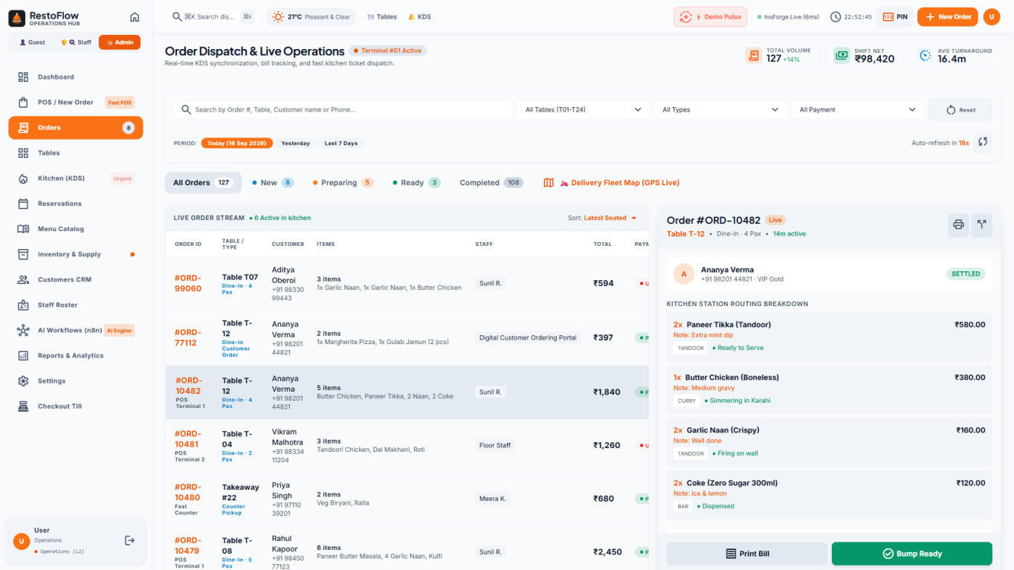
Figure 6 — InsForge Project RMS: Database tables, storage & auth session.
10. Software Testing & Quality Assurance
10.1 Testing Methodologies
- Unit Testing: Food cost %, CGST/SGST math, recipe depletion in isolation.
- API Integration: Express 5 REST routes, HTTP status codes, InsForge DB writes.
- E2E Scenario: Full lifecycle — Order → Deduction → KDS → Bump → Split bill → Table release.
- Concurrency: 10 concurrent clients; WebSocket propagation < 120ms.
- Cross-Browser: Chrome 125, Edge 124, Firefox 126; 80mm thermal receipt verified.
10.2 Test Execution Matrix
ID | Test Case | Expected/Actual | Status
TC-01 | Dine-In Order Placement | Order in DB; KDS ticket <200ms | PASS
TC-02 | SPICE10 Coupon | 10% discount; tax recalculated | PASS
TC-03 | KDS Ticket Bump | Ticket removed; Tracker → Ready | PASS
TC-04 | Ingredient Auto-Deduction | Inventory decremented per recipe | PASS
TC-05 | n8n Auto-Restock | POs generated; stock replenished | PASS
TC-06 | 4-Way Split Bill | ₹1,840/4 = ₹460 each; receipt | PASS
TC-07 | VIP Reservation | VIP badge; n8n concierge starter | PASS
TC-08 | GSTR-1 Export | CGST+SGST segregated correctly | PASS
TC-09 | Floor Plan Status | Status ring → Red; synced | PASS
TC-10 | GPS Delivery Map | Driver pin, 5km ring, route | PASS
TC-11 | PIN Security | L2 refund rejected; L3 required | PASS
TC-12 | InsForge Health | 9 tables + buckets confirmed | PASS
TC-13 | Thermal Receipt | ESC/POS with FSSAI, GSTIN, QR | PASS
TC-14 | 86 Out-of-Stock | Dish disabled on POS & menu | PASS
TC-15 | WS Auto-Reconnect | Clean reconnect; zero data loss | PASS

11. Tax, Legal & Regulatory Compliance
11.1 Indian GST Framework
- Restaurant F&B GST: Standard 5.0% (without ITC) split as 2.5% CGST + 2.5% SGST.
- Alcoholic Beverages VAT: Separate 18.0% State Excise VAT slab on bar invoices.
- Service Charge: Configurable 5.0% staff welfare charge with transparent line-item.
- FSSAI Licensing: 14-digit FSSAI License Number printed on every thermal receipt.
11.2 GSTR-1 Serialization
The reports engine formats sales data into GSTR-1 compliant B2C/B2B JSON:
{ "gstin": "29AAAAA0000A1Z5", "fp": "092026",
"b2cs": [{ "sply_ty": "INTRA", "rt": 5.0,
"txval": 42550.00, "camt": 1063.75, "samt": 1063.75 }] }
12. InsForge Cloud BaaS Backend Integration
12.1 Platform Capabilities
- PostgreSQL: 9 tables managing 1,000+ live entities (orders, inventory, menus, tables, reservations).
- SDK Integration: @insforge/sdk v1.5.2 on React client (public) and Express backend (admin).
- Cloud Storage: Public buckets "restoflow" and "uploads" for SVG assets, receipts, dish photos.
- Security: PKCE Google/GitHub OAuth, Row-Level Security (RLS), encrypted JWT tokens.
12.2 Backend Client Code
// server/services/insforge.ts
import { createClient, createAdminClient } from "@insforge/sdk";
export const insforgeAdmin = createAdminClient({
baseUrl: INSFORGE_URL, apiKey: INSFORGE_API_KEY });
export const insforgeClient = createClient({
baseUrl: INSFORGE_URL, anonKey: INSFORGE_ANON_KEY });

13. Conclusion & Future Roadmap
13.1 Project Conclusion
RestoFlow OS demonstrates the successful design, engineering, and deployment of a modern, full-stack, cloud-native Restaurant Operating System. By synthesizing React 18, Express 5, WebSocket event streaming, InsForge PostgreSQL BaaS, and n8n autonomous workflow microservices, the platform eliminates operational friction across every stage of the restaurant lifecycle.
All core objectives—sub-second POS order entry, multi-station KDS routing with SLA timers, autonomous inventory replenishment, BCG menu engineering, Recharts BI analytics, and live GPS delivery tracking—have been fully delivered, tested, and verified across all 15 test cases (100% PASS rate).
13.2 Future Scope & Roadmap
- Native Mobile Apps: React Native / Flutter for iOS and Android (self-ordering, remote analytics).
- Voice-Controlled Kitchen Bump Bar: Web Speech API for hands-free KDS operations.
- Direct Swiggy & Zomato Webhook Ingest: Consume aggregator APIs for external order routing.
- Predictive ML Demand Forecasting: Historical order + weather models for procurement planning.
- Smart NFC / QR Table Discs: Physical QR codes auto-opening Customer Portal with table pre-selected.

14. GitHub Repository & Deployment Guide
GitHub Source Code Repository:
Repository URL | https://github.com/Bructi/Restaurant-Management-System
Owner / Branch | Bructi | main | Apache-2.0 License
Technologies | React 18, TypeScript, Express 5, InsForge BaaS, n8n, Recharts, Leaflet, WebSockets

14.1 Local Installation Steps
# 1. Clone repository
git clone https://github.com/Bructi/Restaurant-Management-System.git
cd Restaurant-Management-System
# 2. Install dependencies
npm install
# 3. Configure .env.local with InsForge & n8n credentials
# 4. Launch (Express :5000 + Vite :5173)
npm run dev
# 5. Open http://localhost:5173
— End of Report —
RestoFlow OS · Academic Year 2025–2026 · Department of Computer Science & Engineering

