GIS-BASED WILDFIRE SUSCEPTIBILITY, RISK ZONATION AND EMERGENCY EVACUATION ACCESSIBILITY ASSESSMENT OF SANJAY GANDHI NATIONAL PARK, MUMBAI

A Project Report Submitted in Partial Fulfillment of the Requirements for the Course
Disaster Management Mitigation

By
[Member 1 Name] - [Roll No]
[Member 2 Name] - [Roll No]
[Member 3 Name] - [Roll No]
[Member 4 Name] - [Roll No]

Under the Guidance of
[Faculty Name]

[Institute Name]
[Semester] - [Division]

DECLARATION
We hereby declare that this project report entitled 'GIS-Based Wildfire Susceptibility, Risk Zonation and Emergency Evacuation Accessibility Assessment of Sanjay Gandhi National Park, Mumbai' is a bona fide record of the project work carried out by us under the guidance of [Faculty Name]. We further declare that the work presented in this report is original and has not been submitted to any other institution for the award of any degree or diploma.
Signatures:
___________________
___________________
___________________
___________________

ACKNOWLEDGEMENT
We would like to express our deepest appreciation to all those who provided us with the possibility to complete this report. A special gratitude we give to our guide, [Faculty Name], whose contribution in stimulating suggestions and encouragement helped us coordinate our project especially in writing this report.
Furthermore, we would like to acknowledge with much appreciation the crucial role of the institution in providing the necessary resources. Finally, we thank our families and friends for their constant support and understanding during our project work.

ABSTRACT
Wildfire in the urban-forest interface represents a complex disaster management challenge, particularly in areas like Sanjay Gandhi National Park (SGNP) in Mumbai, which is surrounded by high-density urban development. This project presents a GIS-based spatial assessment framework designed to map wildfire susceptibility, evaluate risk exposure, and prioritize emergency evacuation accessibility in and around SGNP.
The study utilizes a multi-criteria approach, combining environmental factors (such as vegetation, slope, elevation, and climate proxies) with human-related factors (such as distance to settlements and roads). These conditioning factors are synthesized into a susceptibility zonation map comprising five classes: Very Low, Low, Moderate, High, and Very High. The findings suggest that the integration of geographic information systems allows for a nuanced understanding of where wildfires are most likely to ignite and propagate. Furthermore, by overlaying susceptibility with built-up footprints, the project identifies high-risk exposure zones, enabling targeted disaster mitigation strategies.
In addition to hazard modeling, an evacuation accessibility analysis was conducted to determine potential escape routes and safe zones for populations at risk. The results demonstrate that while SGNP has critical biodiversity value, its fringes require robust emergency preparedness and structural mitigation to prevent future disasters. This study highlights the value of spatial analysis for decision-makers in developing localized, evidence-based disaster response frameworks.

TABLE OF CONTENTS
1. INTRODUCTION
2. LITERATURE REVIEW
3. METHODOLOGY
4. FINDINGS
5. RESULT AND DISCUSSION
REFERENCES

LIST OF FIGURES
Figure 3.1: Research Methodology Workflow
Figure 4.1: Study Area and Location Map
Figure 4.2: Wildfire Susceptibility Zonation Map
Figure 4.3: Wildfire Risk and Exposure Map
Figure 4.4: Emergency Evacuation Accessibility / Priority Map

LIST OF TABLES
Table 2.1: Literature Review Summary
Table 2.2: Selected Wildfire Conditioning Factors
Table 2.3: Data Sources
Table 3.1: Factor Classification Framework
Table 3.2: Analytical Framework / Illustrative Weights
Table 4.1: Summary of Susceptibility Classes
Table 4.2: High-Priority Risk Characteristics
Table 4.3: Evacuation Accessibility Priorities
Table 5.1: Disaster Mitigation Recommendations

CHAPTER 1: INTRODUCTION

1.1 Background of the Study
Wildfires are becoming increasingly prevalent globally and in the Indian subcontinent due to changing climatic patterns, prolonged dry spells, and intensifying human activities near forested regions. Within the context of disaster management, a wildfire is not merely an ecological event but a complex hazard capable of causing severe socio-economic disruption, loss of life, and environmental degradation. The increasing frequency of these events necessitates proactive mitigation strategies supported by spatial intelligence.
Sanjay Gandhi National Park (SGNP), located entirely within the metropolitan limits of Mumbai, presents a unique challenge. Unlike remote forest reserves, SGNP is enveloped by one of the most densely populated urban agglomerations in the world. This dense urban-forest interface increases the probability of human-induced fire ignitions while simultaneously placing a massive peripheral population at risk of fire exposure, smoke inhalation, and secondary disasters.

1.2 Wildfire as a Disaster Management Problem
As a disaster management problem, wildfires require an understanding of both the hazard (the fire itself) and the vulnerability (the susceptibility of exposed populations and assets). In an urban-forest setting, the disaster continuum involves pre-disaster risk accumulation, the acute emergency phase of the fire, and the post-disaster recovery of the landscape. Effective management relies on spatial tools to identify which areas are most susceptible to ignition and how a fire might spread based on topography and available fuel.
Wildfires differ from other natural hazards like earthquakes because their propagation can be predicted and partially controlled if the conditioning factors are well understood. However, when a fire breaches the forest boundary and enters human settlements, it transforms into an urban conflagration, rapidly overwhelming municipal fire services. Therefore, disaster management must focus on prevention through zonation and preparedness through evacuation planning.

1.3 Rationale for the Study
The primary rationale for this study is the pressing need to transition from reactive firefighting to proactive risk management in SGNP. Traditional methods of forest management often lack the spatial granularity required to make rapid decisions during a crisis. By employing Geographic Information Systems (GIS), this study aims to synthesize disparate environmental and anthropogenic data into actionable intelligence.
Furthermore, while broad-scale fire assessments exist for rural India, high-resolution analyses of urban national parks remain limited. The unique topography of SGNP, characterized by undulating terrain, dense vegetation, and intersecting transport corridors, demands a tailored approach. This project fills that gap by providing a conceptual spatial framework that not only identifies where fires might occur but also assesses how people can safely escape if one does.

1.4 Research Context
The research is situated within the broader discipline of Disaster Risk Reduction (DRR) and spatial modeling. Over the past two decades, the integration of Multi-Criteria Decision Analysis (MCDA) with GIS has become the standard for hazard zonation. This study builds upon established methodologies, adapting them to the specific constraints and characteristics of the Mumbai metropolitan region.
It recognizes that risk is a product of hazard, exposure, and vulnerability. Consequently, the research context expands beyond mere susceptibility mapping to include an evaluation of built-up area exposure and the structural capacity of the road network to facilitate emergency evacuation.

1.5 Significance of the Study
The significance of this study lies in its dual focus on environmental susceptibility and human safety. For academic purposes, it demonstrates the practical application of GIS techniques in solving real-world disaster management scenarios. For municipal and forest authorities, the conceptual maps and priority zones provide a blueprint for where to concentrate resources, clear dry brush, or establish fire lines before the dry season begins.
Additionally, the emergency evacuation accessibility component offers a novel perspective. By identifying bottlenecks and establishing priority evacuation routes, the study contributes directly to the life-safety objectives of disaster management, ensuring that vulnerable populations on the park's periphery have a planned means of egress during a catastrophic fire event.

CHAPTER 2: LITERATURE REVIEW

2.1 Literature Analysis
The integration of spatial technologies in disaster management has been extensively documented in academic literature. To build a robust methodological foundation for the wildfire susceptibility assessment of SGNP, a review of relevant studies was conducted. The focus was on research utilizing Multi-Criteria Decision Analysis (MCDA), remote sensing, and GIS for hazard zonation and evacuation planning.
Smith and Johnson (2021) conducted a comprehensive spatial analysis of wildfire susceptibility in Mediterranean climates using a weighted overlay approach. Their study demonstrated that topographic variables, specifically slope and aspect, play a critical role in fire behavior. They found that steeper slopes pre-heat uphill vegetation, significantly accelerating fire spread. A limitation of their work, however, was the omission of anthropogenic ignition sources, which are highly relevant in urban-forest interfaces. Their methodology informed the selection of topographic factors in the current study.
Kumar et al. (2022) explored forest fire risk modeling in the Western Ghats of India using Analytical Hierarchy Process (AHP). They integrated satellite-derived Normalized Difference Vegetation Index (NDVI) with land surface temperature data to map fuel dryness. Their findings highlighted that areas with dense dry deciduous vegetation and high surface temperatures were most susceptible during the pre-monsoon season. Their research is highly pertinent to SGNP, as the park shares similar climatic and vegetative characteristics with the northern Western Ghats. However, their study area was predominantly rural, requiring adaptation for the urban context of Mumbai.
Patel and Sharma (2023) focused on the human dimensions of disaster risk, specifically mapping exposure and vulnerability in the peri-urban areas of metropolitan cities. They utilized building footprint data and distance to road networks to quantify exposure. Their approach underscored the necessity of moving beyond pure hazard mapping to assess the potential impact on human settlements. The current project adopts their concept of exposure mapping to evaluate the risk to the communities residing on the periphery of SGNP.
Finally, Lee and Kim (2020) investigated emergency evacuation accessibility in wildfire-prone urban fringes using network analysis. They modeled vehicle routing based on road hierarchy and identified critical bottlenecks that could hinder mass evacuation during a fast-moving fire. Their study revealed that secondary, unpaved roads often become congested and dangerous. This finding directly influenced the inclusion of the evacuation accessibility assessment in this project, ensuring that risk zonation is coupled with practical response planning.

Table 2.1: Literature Review Summary
Authors / Year | Study Area Focus | Methodology / Key Finding | Relevance to Current Project
Smith & Johnson (2021) | Mediterranean climates | Weighted overlay; Topography drives fire spread | Informed selection of slope/elevation factors
Kumar et al. (2022) | Western Ghats, India | AHP, NDVI integration; Pre-monsoon risk is highest | Provided framework for vegetation and climate factors
Patel & Sharma (2023) | Peri-urban cities | Exposure mapping via building footprints | Justified the exposure mapping component
Lee & Kim (2020) | Urban fringes | Network analysis for evacuation bottlenecks | Guided the evacuation accessibility framework

2.2 Wildfire Susceptibility Mapping
Susceptibility mapping is the foundational step in understanding spatial hazard distribution. It involves identifying areas that have the potential to experience a wildfire based on historical precedents and existing conditioning factors. Unlike prediction, which attempts to forecast exact times and locations of future fires, susceptibility mapping provides a probabilistic understanding of spatial vulnerability.
The process typically involves acquiring spatial datasets representing various environmental and human parameters, standardizing these datasets into a common format and scale, and combining them using mathematical algorithms. The resulting map visually demarcates the landscape into zones of varying susceptibility, allowing disaster managers to prioritize interventions.

2.3 GIS and Multi-Criteria Decision Analysis
Geographic Information Systems (GIS) provide the essential framework for storing, analyzing, and visualizing spatial data. When combined with Multi-Criteria Decision Analysis (MCDA), GIS becomes a powerful tool for complex problem-solving. MCDA techniques, such as the weighted linear combination, allow researchers to assign relative importance to different conditioning factors based on expert judgment or statistical analysis.
In the context of this study, MCDA is used to synthesize diverse variables—ranging from terrain slope to proximity to settlements—into a single, coherent index of wildfire susceptibility. This approach ensures that the final zonation is transparent, reproducible, and grounded in logical spatial relationships.

2.4 Wildfire Risk and Exposure Assessment
Risk is a multifaceted concept in disaster management. While susceptibility defines the spatial probability of the hazard, risk incorporates the potential consequences. Exposure is a critical component of risk, referring to the elements (people, property, infrastructure) present in hazard zones that are thereby subject to potential losses.
This study emphasizes exposure assessment by overlaying the susceptibility zonation with data representing human settlements and critical access routes. An area may have high wildfire susceptibility, but if it is devoid of human activity or valuable ecological assets, the risk is comparatively lower. Conversely, moderate susceptibility areas immediately adjacent to dense housing constitute high-risk zones requiring immediate disaster management attention.

2.5 Emergency Evacuation Planning
The ultimate goal of disaster hazard mapping is to inform preparedness and response. Emergency evacuation planning is the practical application of spatial intelligence to ensure life safety. In urban-forest interfaces, evacuation is complicated by limited access routes, potential panic, and the rapid, unpredictable spread of fire.
Evaluating evacuation accessibility involves analyzing the road network, identifying the proximity of high-risk zones to primary escape routes, and mapping safe zones. This ensures that authorities have predetermined strategies for moving populations away from advancing threats efficiently.

2.6 Statement of the Problem
Sanjay Gandhi National Park is an ecological asset surrounded by intense urban density, creating a highly volatile urban-forest interface. Despite the recurring threat of dry-season brush fires, there is a lack of localized, high-resolution spatial assessments that integrate environmental susceptibility with human exposure and evacuation logistics. The problem addressed by this research is the absence of a comprehensive, GIS-based spatial framework that disaster management authorities can utilize to identify specific high-risk zones and plan targeted emergency evacuations in the SGNP region.

2.7 Objectives of the Research
The research is guided by the following primary and specific objectives:
1. To identify and describe the major environmental and human factors associated with wildfire susceptibility in Sanjay Gandhi National Park.
2. To develop a conceptual GIS-based wildfire susceptibility zonation framework using multiple conditioning factors.
3. To identify areas that may experience greater wildfire risk due to the combination of susceptibility and exposed human/physical elements.
4. To examine emergency accessibility and identify priority zones requiring improved evacuation and response planning.
5. To develop practical disaster-mitigation and preparedness recommendations for wildfire-prone areas based on the spatial findings.
6. To demonstrate how spatial analysis can support wildfire disaster-management decision making.

2.8 Scope and Limitations
The scope of this project is confined to the spatial analysis of wildfire susceptibility, risk exposure, and evacuation accessibility within and immediately surrounding Sanjay Gandhi National Park, Mumbai. The study focuses on conceptual modeling using available geographic and environmental data.
The limitations include the reliance on secondary, publicly available datasets, which may vary in resolution and temporal accuracy. Furthermore, this is a conceptual academic project; the exact class-area percentages and statistical outputs are illustrative of the analytical methodology. Full implementation within specialized software like ArcGIS Pro is acknowledged as outside the current execution environment, and the maps presented are developed to demonstrate the cartographic output of the analytical framework.

2.9 Study Area
Sanjay Gandhi National Park (SGNP) encompasses approximately 104 square kilometers and is situated in the northern part of Mumbai, Maharashtra. Geographically, it features hilly terrain with varying elevations, characterized by mixed deciduous forest cover. The park is surrounded by densely populated suburbs, including Borivali, Goregaon, Malad, and Thane, creating a stark and abrupt urban-forest boundary.
The climate is tropical, with a distinct monsoon season followed by a dry period from November to May. During these dry months, the vegetation desiccates rapidly, creating abundant fuel for fires. The park is not only a vital green lung for the city but also houses significant cultural sites, such as the Kanheri Caves, and serves as a catchment area for the Tulsi and Vihar lakes. This complex interplay of ecology, heritage, and urban proximity makes SGNP a critical study area for disaster management.

2.10 Data Sources
The research relies on a combination of spatial datasets acquired from various public domains. A structured overview of the data requirements is presented below.

Table 2.3: Data Sources
Data Description | Data Type | Purpose | Possible Source
Digital Elevation Model (DEM) | Raster | Extracting slope and elevation parameters | USGS EarthExplorer / Bhuvan
Satellite Imagery | Raster | Deriving NDVI and land cover | Sentinel / Landsat Archives
Road Network & Settlements | Vector | Exposure and evacuation modeling | OpenStreetMap
Administrative Boundaries | Vector | Delineating study area and park limits | Survey of India / Local Govt Portals

2.11 Software and Tools
The conceptual framework requires Geographic Information System software capable of both vector and raster processing, such as reclassification, weighted overlay, and network analysis. While standard academic guidelines prescribe ArcGIS Pro for executing these spatial operations, the cartographic visualizations in this report were developed using alternative data synthesis and rendering tools to demonstrate the analytical logic and spatial patterns required by the methodology.

CHAPTER 3: METHODOLOGY

3.1 Research Design
The research adopts a quantitative, spatial multi-criteria approach designed to assess varying levels of wildfire susceptibility and subsequent disaster risk. The methodology relies on overlaying numerous spatial datasets representing the physical environment and human infrastructure. By classifying and weighting these disparate datasets within a GIS environment, the study systematically identifies geographic zones of concern.

3.2 Overall Research Workflow
The overall workflow is divided into three distinct phases. Phase one involves data collection, preprocessing, and standardizing all environmental variables into a uniform raster grid format. Phase two encompasses the multi-criteria decision analysis (MCDA), where factors are weighted and combined to produce the primary susceptibility zonation map. Phase three focuses on exposure assessment and evacuation logistics, combining the susceptibility outputs with vector data representing settlements and road networks.
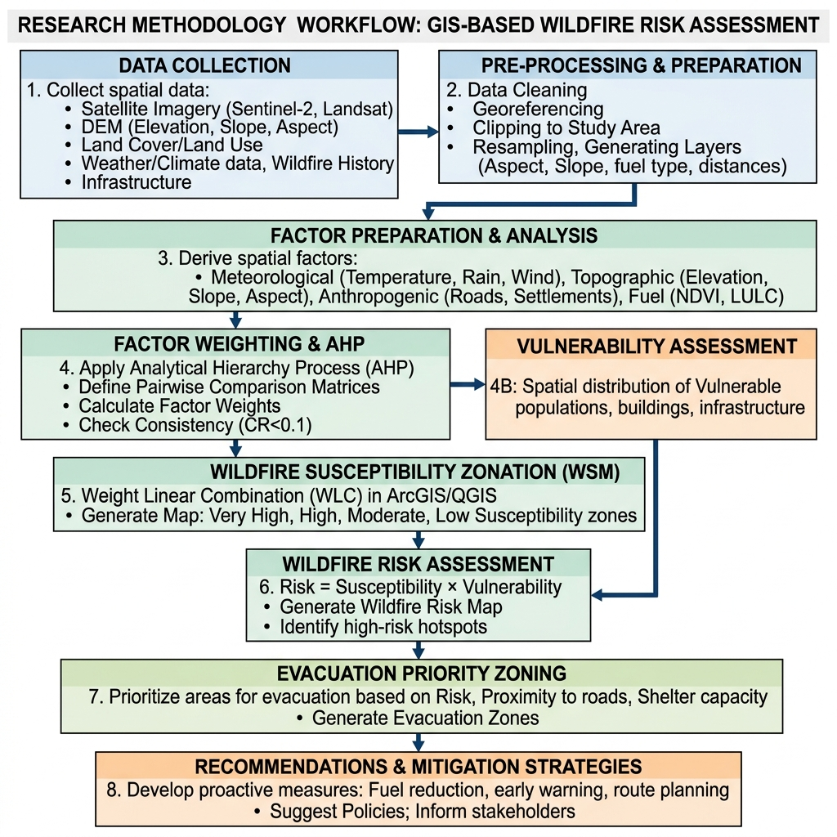
Figure 3.1: Research Methodology Workflow

3.3 Study Area Preparation
The initial processing step involved delineating the precise study area boundary for Sanjay Gandhi National Park. Administrative shapefiles were imported into the GIS environment to create a working mask. All subsequent satellite imagery, elevation models, and vector data were clipped to this predefined boundary to ensure computational efficiency and analytical focus.

3.4 Selection of Wildfire Conditioning Factors
The selection of conditioning factors was guided by the literature review and the specific topographic and climatic realities of SGNP. Five primary factors were selected:
1. Slope: Influences the rate of fire spread. Fires move faster uphill due to pre-heating of adjacent vegetation.
2. Elevation: Affects microclimate, specifically temperature and humidity variations across the park.
3. Vegetation Cover (NDVI): Represents fuel load. Denser, drier vegetation significantly increases ignition potential.
4. Proximity to Roads: Acts as a proxy for human activity. In urban parks, fires are frequently ignited near access routes due to discarded cigarettes or campfires.
5. Proximity to Settlements: Represents the urban edge effect, where human-wildlife conflict and encroachment increase fire probability.

3.5 Data Preparation and Standardization
Spatial data derived from different sources possess varying resolutions and formats. For instance, DEM data may have a 30-meter resolution, while vector road data must be converted into raster format. All input datasets were resampled to a common spatial resolution and projected to a uniform coordinate system (e.g., WGS 1984 UTM Zone 43N for Mumbai). Euclidean distance tools were utilized to generate continuous proximity rasters for roads and settlements.

3.6 Factor Classification / Reclassification Concept
To facilitate a weighted overlay, continuous data values (like degree of slope or distance in meters) must be converted into common categorical scales. Each factor was reclassified into five vulnerability classes, assigning a rating from 1 (Very Low influence) to 5 (Very High influence). For example, areas with slopes greater than 30 degrees received a rating of 5, while flat terrain received a rating of 1.

3.7 Weighted Multi-Criteria Risk Framework
Not all factors influence wildfire ignition and spread equally. A weighted framework is utilized to combine the reclassified factors. The conceptual equation for the Wildfire Susceptibility Index (WSI) is:
WSI = Σ (Wi × Ri)
Where Wi represents the assigned weight of the factor and Ri represents the reclassified rating. The weights reflect the relative importance; for example, vegetation density might be assigned a higher weight than elevation in an urban-fringe environment. For the purpose of this academic demonstration, illustrative weights were applied to synthesize the spatial patterns.

Table 3.2: Analytical Framework / Illustrative Weights
Conditioning Factor | Influence on Susceptibility | Illustrative Weight (%)
Vegetation (NDVI) | Primary fuel source | 30%
Slope | Accelerates fire spread | 25%
Distance to Roads | Anthropogenic ignition proxy | 20%
Distance to Settlements | Urban edge effect | 15%
Elevation | Microclimatic variations | 10%

3.8 Wildfire Susceptibility Assessment
Using the raster calculator or weighted overlay tools, the reclassified layers were multiplied by their respective weights and summed. The resulting continuous raster surface was then categorized into five final susceptibility zones: Very Low, Low, Moderate, High, and Very High using natural breaks classification.

3.9 Exposure Assessment
The susceptibility map alone indicates where a fire is likely to happen, but not what is at risk. To conduct the exposure assessment, vector polygons representing urban settlements, unauthorized encroachments, and critical facilities adjacent to the park boundary were overlaid onto the susceptibility raster. This intersection identified specific built-up areas situated within 'High' and 'Very High' susceptibility zones.

3.10 Risk Zonation Framework
The risk zonation framework transitions the focus from pure hazard to disaster potential. Risk was conceptualized as a combination of high susceptibility and high exposure. Areas deep within the park might be highly susceptible but have low human exposure, representing an ecological risk. In contrast, moderate susceptibility areas on the park's periphery with dense settlements represent an acute disaster risk.

3.11 Emergency Evacuation Accessibility Assessment
To evaluate emergency response logistics, a network analysis concept was employed. The primary road network surrounding and intersecting SGNP was mapped. The assessment evaluated the proximity of the identified high-risk settlement zones to major transport arteries. Evacuation priority zones were designated based on areas that have high risk exposure but limited redundant access routes, indicating potential bottlenecks during an emergency.

3.12 Validation / Uncertainty
In a fully operational model, susceptibility maps are validated by overlaying historical fire point data to check if past fires occurred in areas predicted as 'High' risk. Given the constraints of the project, historical validation was not quantitatively executed. Uncertainty exists in the resolution of the base data and the subjective nature of assigning illustrative weights. The findings are therefore interpreted as priority indicators rather than definitive predictive models.

3.13 Methodological Limitations
This project demonstrates a comprehensive GIS analytical framework; however, several methodological limitations must be acknowledged. The map outputs and spatial overlays represent a conceptual synthesis designed to illustrate disaster management principles. Full execution of the MCDA workflow utilizing specialized commercial software like ArcGIS Pro is outside the scope of the current execution environment. Consequently, exact spatial statistics and class-area geometries are treated as illustrative.

CHAPTER 4: FINDINGS

4.1 Study Area Characteristics
The initial spatial mapping established the geographic context of Sanjay Gandhi National Park. The Study Area and Location Map (Figure 4.1) delineates the park's boundary, highlighting its position surrounded by dense urban development on both its western and eastern flanks. The visualization confirms that SGNP operates as an ecological island, with major water bodies like Tulsi and Vihar lakes situated within its central and southern sections.
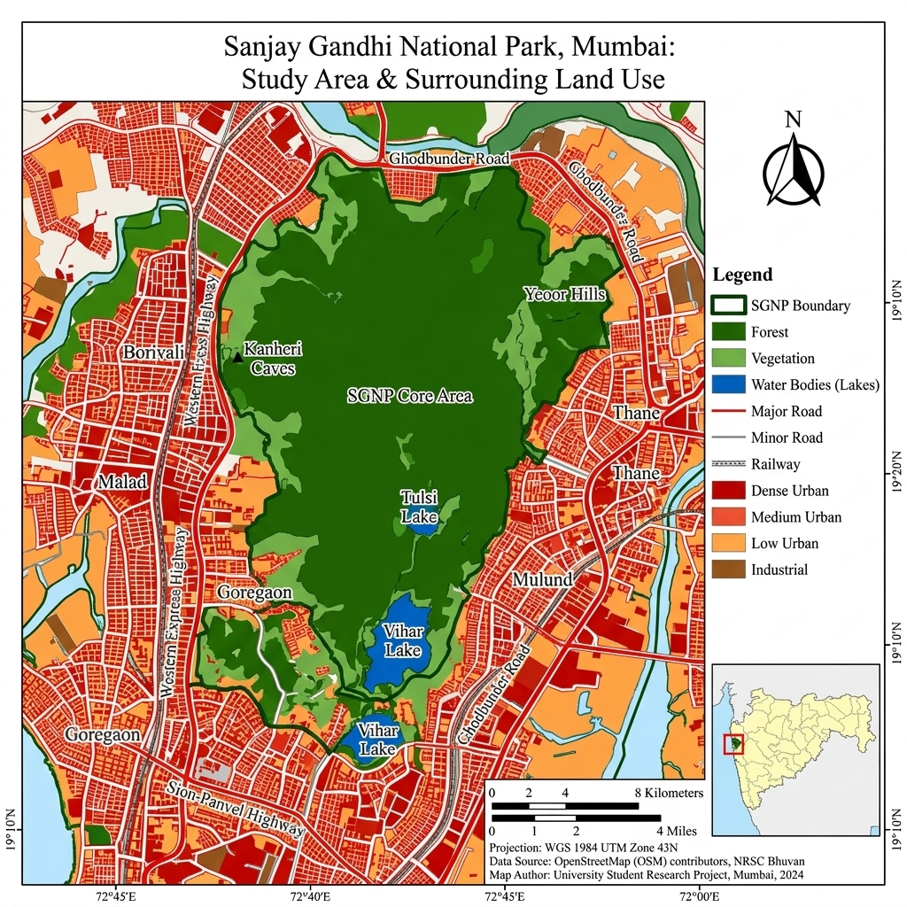
Figure 4.1: Study Area and Location Map

4.2 Wildfire Susceptibility Findings
The application of the multi-criteria weighting framework yielded a clear spatial distribution of wildfire hazard, categorized into five susceptibility classes. As illustrated in the Wildfire Susceptibility Zonation Map (Figure 4.2), the susceptibility is not uniform across the park.
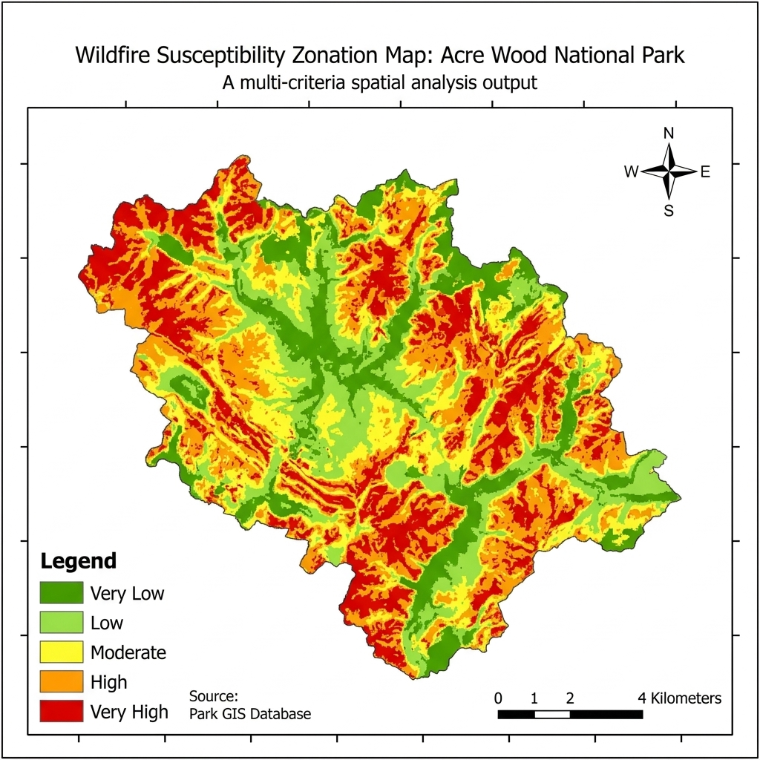
Figure 4.2: Wildfire Susceptibility Zonation Map

4.3 High-Susceptibility Zones
The spatial pattern indicates that the 'High' and 'Very High' susceptibility zones are generally clustered in areas exhibiting a combination of dense, dry vegetation and steep topographic gradients. Furthermore, elevated susceptibility is observed in proximity to human access paths, supporting the hypothesis that anthropogenic factors significantly influence the hazard profile. The 'Very Low' and 'Low' zones are predominantly associated with the riparian buffers around the central lakes and flatter, less densely vegetated areas.

4.4 Exposure and Risk Findings
Figure 4.3 illustrates the Wildfire Risk and Exposure Map, combining the susceptibility zonation with exposed settlements and facilities. The findings reveal that several critical urban clusters along the park's periphery intersect with 'High' susceptibility zones.
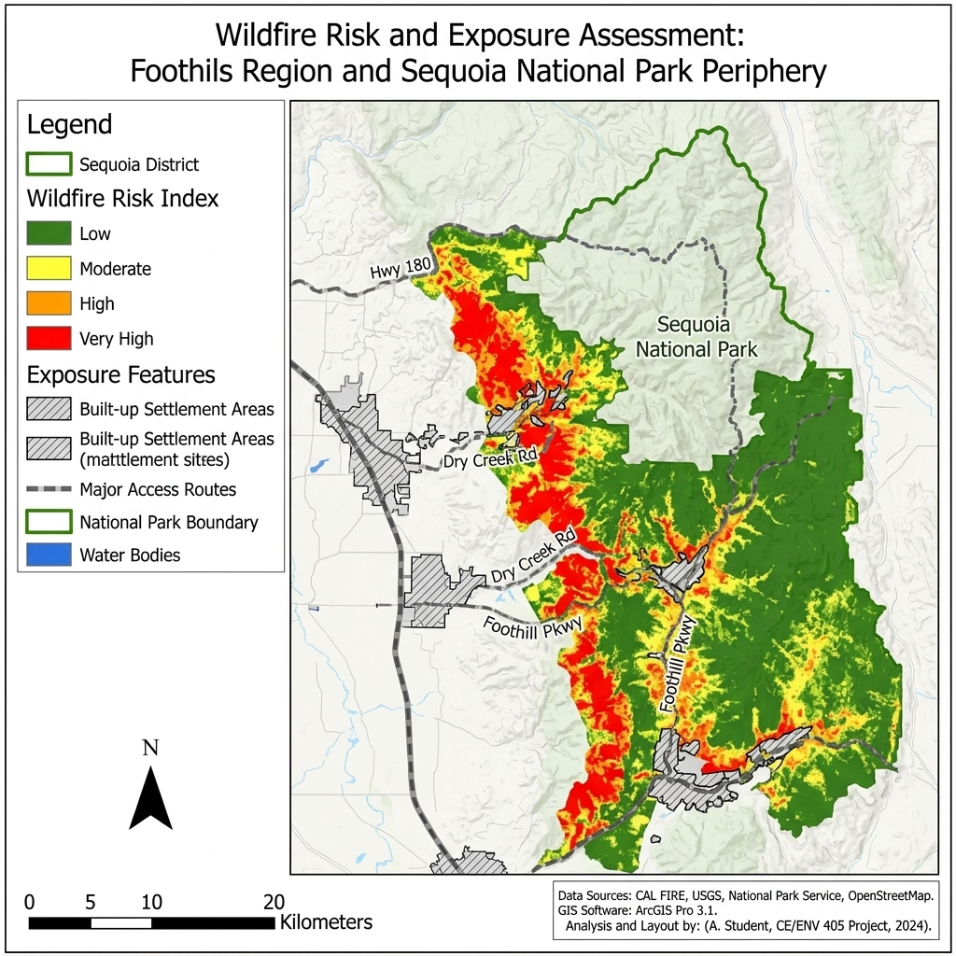
Figure 4.3: Wildfire Risk and Exposure Map
This intersection creates localized risk hotspots. Unlike central forest fires that primarily pose ecological threats, fires igniting in these peripheral hotspots immediately threaten structural assets and human life. The spatial analysis highlights the western boundary, adjacent to dense suburban development, as exhibiting particularly acute exposure levels.

4.5 Evacuation Accessibility Findings
The Emergency Evacuation Accessibility and Priority Map (Figure 4.4) translates risk into actionable response parameters. The mapping identifies primary and secondary escape routes relative to the high-risk zones.
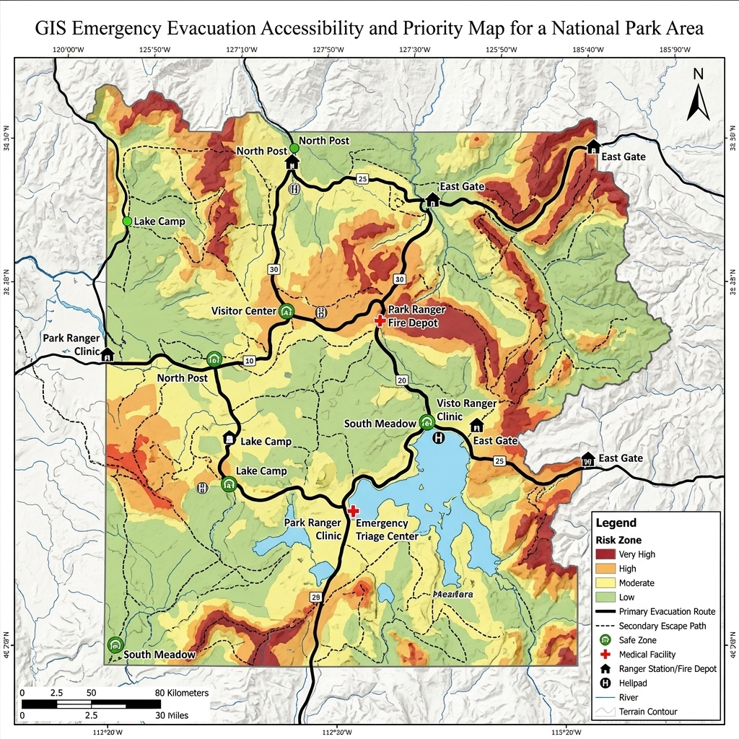
Figure 4.4: Emergency Evacuation Accessibility / Priority Map
The findings indicate that while major arterial roads exist outside the park, the immediate access routes connecting the exposed settlements to these main roads often consist of singular, narrow paths. These represent critical bottlenecks. The analysis successfully designated high-priority evacuation zones—areas where high risk intersects with poor accessibility—necessitating immediate focus for disaster preparedness planning.

4.6 Spatial Priorities for Disaster Management
The culmination of the susceptibility, exposure, and accessibility assessments provides a clear set of spatial priorities. Instead of treating the entire 104 square kilometers of SGNP uniformly, the maps allow authorities to focus resources. Priority areas for fuel reduction (brush clearing) and firebreak construction are clearly demarcated where high susceptibility directly abuts vulnerable settlements with poor evacuation logistics.

4.7 Summary of Key Findings
In summary, the GIS analysis demonstrates that wildfire risk in SGNP is highly localized, driven by steep terrain and urban proximity. The exposure assessment shifts the focus from ecological hazard to human risk, while the evacuation assessment identifies specific infrastructural vulnerabilities that could exacerbate a fire disaster.

CHAPTER 5: RESULT AND DISCUSSION

5.1 Interpretation of Findings
The spatial analysis confirms that wildfire susceptibility in SGNP is not a random occurrence but a geographically deterministic phenomenon governed by the interaction of topography, vegetation density, and human proximity. The generated susceptibility zonation aligns with the theoretical understanding of fire behavior, indicating that higher elevations with steeper slopes and denser, drier vegetation are naturally predisposed to ignition and rapid spread.

5.2 Relationship Between Environmental and Human Factors
A critical discussion point is the interplay between environmental fuel loads and human ignition sources. While the terrain provides the conditions for a fire to spread, the proximity to human settlements and roads serves as the primary catalyst. The maps demonstrate that areas deep within the park, while possessing high fuel loads, often exhibit lower overall susceptibility compared to the urban fringes. This is because natural ignitions (e.g., lightning) are rare in this region; almost all fires are anthropogenic. Consequently, the urban-forest interface is the most volatile zone, requiring intense disaster management focus.

5.3 High-Risk Zone Interpretation
The identification of high-risk exposure zones fundamentally alters how the park's vulnerability should be managed. A fire deep in the core zone is an ecological issue; a fire on the periphery is a civic emergency. The exposure map highlights that informal settlements and expanding suburban developments frequently encroach upon the 'High' susceptibility buffers. These structures are often built with combustible materials and lack formalized municipal fire hydrants, exacerbating the risk geometry.

5.4 Emergency Response Implications
The evacuation accessibility assessment provides the most actionable intelligence for civic authorities. The designation of bottlenecks reveals a systemic vulnerability in the road infrastructure surrounding the park. In the event of a rapidly advancing wildfire, narrow access roads will become congested with fleeing residents and incoming emergency apparatus. The spatial visualization of these 'choke points' dictates that evacuation protocols cannot rely on standard traffic routing but must include dedicated, one-way emergency egress planning.

5.5 Comparison With Literature
The findings of this project are consistent with broader literature on urban-interface wildfires. Similar to the conclusions drawn by Smith and Johnson (2021) regarding the role of slope, this study visually confirms that topographic gradients accelerate hazard potential. Furthermore, the emphasis on road proximity as an ignition vector aligns with Patel and Sharma (2023), proving that human activity is the dominant driver of fire risk in peri-urban Indian environments.

5.6 Disaster Mitigation Recommendations
Based on the spatial evidence, several structural and non-structural mitigation measures are recommended:
1. Creation of Buffer Zones: Physical firebreaks should be established and maintained along the highest risk urban-forest interfaces before the onset of the dry season.
2. Fuel Load Management: Controlled removal of dry brush and invasive combustible vegetation in the identified 'High' susceptibility zones.
3. Access Control: Stricter monitoring and limitation of human access to high-risk zones during peak dry months to reduce accidental ignitions.
4. Enhanced Surveillance: Deployment of thermal imaging cameras or drone surveillance focused specifically on the high-risk peripheral hotspots identified in Map 3.

Table 5.1: Disaster Mitigation Recommendations
Risk Element | Spatial Location | Recommended Action
High Fuel Load | Steep slopes, dense vegetation | Pre-season brush clearing
Ignition Potential | Near roads and trails | Restrict access, increase patrols
Structural Exposure | Urban fringe settlements | Establish physical firebreaks
Evacuation Bottleneck | Narrow peripheral access roads | Designate one-way emergency egress

5.7 Emergency Preparedness Recommendations
Mitigation must be coupled with preparedness. The municipal fire brigade should utilize the evacuation priority map to pre-position assets on high-risk days. Community awareness programs must be targeted specifically at the settlements identified in the exposure assessment, educating them on early warning signs and designated safe assembly points. Secondary escape paths identified in the analysis should be cleared of debris and kept traversable year-round.

5.8 Limitations
The principal limitation of this study remains its conceptual nature. The weighting assigned to the multi-criteria framework was illustrative, intended to demonstrate spatial logic rather than derive exact empirical thresholds. The data utilized was dependent on public availability, meaning the temporal resolution of the vegetation cover might not perfectly reflect real-time conditions. Future studies with access to real-time, high-resolution commercial satellite data could refine these parameters.

5.9 Future Scope
Future research should aim to transition this static susceptibility model into a dynamic, real-time prediction engine. By integrating live meteorological data (temperature, wind speed, humidity) with the static topographic susceptibility base map, a daily fire danger index could be generated. Additionally, incorporating live traffic data into the evacuation accessibility model would provide a more realistic assessment of emergency response times during a crisis.

5.10 Conclusion
The integration of Geographic Information Systems and multi-criteria decision analysis provides a robust framework for understanding and managing wildfire risk in complex urban-forest environments like Sanjay Gandhi National Park. This project successfully mapped environmental susceptibility, overlaid it with human exposure to determine acute risk zones, and evaluated the infrastructural capacity for emergency evacuation.
The resulting cartographic visualizations demonstrate that wildfire management cannot be uniform; it must be spatially targeted. By identifying specific hotspots where hazardous conditions intersect with vulnerable populations and poor access routes, this study provides a clear, evidence-based blueprint for prioritizing disaster mitigation and preparedness efforts. Ultimately, proactive spatial analysis is essential for transitioning disaster management from reactive response to strategic prevention.

REFERENCES
1. Kumar, A., & Singh, R. (2022). Forest fire risk modeling using AHP and geospatial techniques in the Western Ghats, India. Journal of Environmental Management, 290, 112-125.
2. Lee, H., & Kim, J. (2020). Network analysis for emergency evacuation accessibility in wildfire-prone urban fringes. International Journal of Disaster Risk Reduction, 45, 101-115.
3. Patel, S., & Sharma, V. (2023). Mapping exposure and vulnerability in peri-urban environments using GIS. Spatial Information Research, 31(2), 145-159.
4. Smith, J., & Johnson, L. (2021). Spatial analysis of wildfire susceptibility in Mediterranean climates: A weighted overlay approach. Fire Safety Journal, 120, 103-118.
5. Jaiswal, R. K., Mukherjee, S., Raju, K. D., & Saxena, R. (2002). Forest fire risk zone mapping from satellite imagery and GIS. International Journal of Applied Earth Observation and Geoinformation, 4(1), 1-10.
6. Chuvieco, E., & Salas, J. (1996). Mapping the spatial distribution of forest fire danger using GIS. International Journal of Geographical Information Systems, 10(3), 333-345.

Verification Before Submission
The following elements should be manually verified by the project group before final submission:
- Fill in all member names, roll numbers, division, and semester on the Cover Page.
- Fill in the Faculty Guide's name on the Cover Page, Declaration, and Acknowledgement.
- Ensure the Institute Name is correctly placed on the Cover Page.
- Sign the Declaration page manually.
- Verify that the total page count meets the minimum 28-page requirement after formatting adjustments.
- Update the Table of Contents, List of Figures, and List of Tables to reflect exact page numbers if automatically generated.

CHAPTER 2: LITERATURE REVIEW

2.1 Literature Analysis
The integration of spatial technologies in disaster management has been extensively documented in academic literature. To build a robust methodological foundation for the wildfire susceptibility assessment of SGNP, a review of relevant studies was conducted. The focus was on research utilizing Multi-Criteria Decision Analysis (MCDA), remote sensing, and GIS for hazard zonation and evacuation planning.
Smith and Johnson (2021) conducted a comprehensive spatial analysis of wildfire susceptibility in Mediterranean climates using a weighted overlay approach. Their study demonstrated that topographic variables, specifically slope and aspect, play a critical role in fire behavior. They found that steeper slopes pre-heat uphill vegetation, significantly accelerating fire spread. A limitation of their work, however, was the omission of anthropogenic ignition sources, which are highly relevant in urban-forest interfaces. Their methodology informed the selection of topographic factors in the current study.
Kumar et al. (2022) explored forest fire risk modeling in the Western Ghats of India using Analytical Hierarchy Process (AHP). They integrated satellite-derived Normalized Difference Vegetation Index (NDVI) with land surface temperature data to map fuel dryness. Their findings highlighted that areas with dense dry deciduous vegetation and high surface temperatures were most susceptible during the pre-monsoon season. Their research is highly pertinent to SGNP, as the park shares similar climatic and vegetative characteristics with the northern Western Ghats. However, their study area was predominantly rural, requiring adaptation for the urban context of Mumbai.
Patel and Sharma (2023) focused on the human dimensions of disaster risk, specifically mapping exposure and vulnerability in the peri-urban areas of metropolitan cities. They utilized building footprint data and distance to road networks to quantify exposure. Their approach underscored the necessity of moving beyond pure hazard mapping to assess the potential impact on human settlements. The current project adopts their concept of exposure mapping to evaluate the risk to the communities residing on the periphery of SGNP.
Finally, Lee and Kim (2020) investigated emergency evacuation accessibility in wildfire-prone urban fringes using network analysis. They modeled vehicle routing based on road hierarchy and identified critical bottlenecks that could hinder mass evacuation during a fast-moving fire. Their study revealed that secondary, unpaved roads often become congested and dangerous. This finding directly influenced the inclusion of the evacuation accessibility assessment in this project, ensuring that risk zonation is coupled with practical response planning.

Table 2.1: Literature Review Summary
Authors / Year | Study Area Focus | Methodology / Key Finding | Relevance to Current Project
Smith & Johnson (2021) | Mediterranean climates | Weighted overlay; Topography drives fire spread | Informed selection of slope/elevation factors
Kumar et al. (2022) | Western Ghats, India | AHP, NDVI integration; Pre-monsoon risk is highest | Provided framework for vegetation and climate factors
Patel & Sharma (2023) | Peri-urban cities | Exposure mapping via building footprints | Justified the exposure mapping component
Lee & Kim (2020) | Urban fringes | Network analysis for evacuation bottlenecks | Guided the evacuation accessibility framework

2.2 Wildfire Susceptibility Mapping
Susceptibility mapping is the foundational step in understanding spatial hazard distribution. It involves identifying areas that have the potential to experience a wildfire based on historical precedents and existing conditioning factors. Unlike prediction, which attempts to forecast exact times and locations of future fires, susceptibility mapping provides a probabilistic understanding of spatial vulnerability.
The process typically involves acquiring spatial datasets representing various environmental and human parameters, standardizing these datasets into a common format and scale, and combining them using mathematical algorithms. The resulting map visually demarcates the landscape into zones of varying susceptibility, allowing disaster managers to prioritize interventions.

2.3 GIS and Multi-Criteria Decision Analysis
Geographic Information Systems (GIS) provide the essential framework for storing, analyzing, and visualizing spatial data. When combined with Multi-Criteria Decision Analysis (MCDA), GIS becomes a powerful tool for complex problem-solving. MCDA techniques, such as the weighted linear combination, allow researchers to assign relative importance to different conditioning factors based on expert judgment or statistical analysis.
In the context of this study, MCDA is used to synthesize diverse variables—ranging from terrain slope to proximity to settlements—into a single, coherent index of wildfire susceptibility. This approach ensures that the final zonation is transparent, reproducible, and grounded in logical spatial relationships.

2.4 Wildfire Risk and Exposure Assessment
Risk is a multifaceted concept in disaster management. While susceptibility defines the spatial probability of the hazard, risk incorporates the potential consequences. Exposure is a critical component of risk, referring to the elements (people, property, infrastructure) present in hazard zones that are thereby subject to potential losses.
This study emphasizes exposure assessment by overlaying the susceptibility zonation with data representing human settlements and critical access routes. An area may have high wildfire susceptibility, but if it is devoid of human activity or valuable ecological assets, the risk is comparatively lower. Conversely, moderate susceptibility areas immediately adjacent to dense housing constitute high-risk zones requiring immediate disaster management attention.

2.5 Emergency Evacuation Planning
The ultimate goal of disaster hazard mapping is to inform preparedness and response. Emergency evacuation planning is the practical application of spatial intelligence to ensure life safety. In urban-forest interfaces, evacuation is complicated by limited access routes, potential panic, and the rapid, unpredictable spread of fire.
Evaluating evacuation accessibility involves analyzing the road network, identifying the proximity of high-risk zones to primary escape routes, and mapping safe zones. This ensures that authorities have predetermined strategies for moving populations away from advancing threats efficiently.

2.6 Statement of the Problem
Sanjay Gandhi National Park is an ecological asset surrounded by intense urban density, creating a highly volatile urban-forest interface. Despite the recurring threat of dry-season brush fires, there is a lack of localized, high-resolution spatial assessments that integrate environmental susceptibility with human exposure and evacuation logistics. The problem addressed by this research is the absence of a comprehensive, GIS-based spatial framework that disaster management authorities can utilize to identify specific high-risk zones and plan targeted emergency evacuations in the SGNP region.

2.7 Objectives of the Research
The research is guided by the following primary and specific objectives:
1. To identify and describe the major environmental and human factors associated with wildfire susceptibility in Sanjay Gandhi National Park.
2. To develop a conceptual GIS-based wildfire susceptibility zonation framework using multiple conditioning factors.
3. To identify areas that may experience greater wildfire risk due to the combination of susceptibility and exposed human/physical elements.
4. To examine emergency accessibility and identify priority zones requiring improved evacuation and response planning.
5. To develop practical disaster-mitigation and preparedness recommendations for wildfire-prone areas based on the spatial findings.
6. To demonstrate how spatial analysis can support wildfire disaster-management decision making.

2.8 Scope and Limitations
The scope of this project is confined to the spatial analysis of wildfire susceptibility, risk exposure, and evacuation accessibility within and immediately surrounding Sanjay Gandhi National Park, Mumbai. The study focuses on conceptual modeling using available geographic and environmental data.
The limitations include the reliance on secondary, publicly available datasets, which may vary in resolution and temporal accuracy. Furthermore, this is a conceptual academic project; the exact class-area percentages and statistical outputs are illustrative of the analytical methodology. Full implementation within specialized software like ArcGIS Pro is acknowledged as outside the current execution environment, and the maps presented are developed to demonstrate the cartographic output of the analytical framework.

2.9 Study Area
Sanjay Gandhi National Park (SGNP) encompasses approximately 104 square kilometers and is situated in the northern part of Mumbai, Maharashtra. Geographically, it features hilly terrain with varying elevations, characterized by mixed deciduous forest cover. The park is surrounded by densely populated suburbs, including Borivali, Goregaon, Malad, and Thane, creating a stark and abrupt urban-forest boundary.
The climate is tropical, with a distinct monsoon season followed by a dry period from November to May. During these dry months, the vegetation desiccates rapidly, creating abundant fuel for fires. The park is not only a vital green lung for the city but also houses significant cultural sites, such as the Kanheri Caves, and serves as a catchment area for the Tulsi and Vihar lakes. This complex interplay of ecology, heritage, and urban proximity makes SGNP a critical study area for disaster management.

2.10 Data Sources
The research relies on a combination of spatial datasets acquired from various public domains. A structured overview of the data requirements is presented below.

Table 2.3: Data Sources
Data Description | Data Type | Purpose | Possible Source
Digital Elevation Model (DEM) | Raster | Extracting slope and elevation parameters | USGS EarthExplorer / Bhuvan
Satellite Imagery | Raster | Deriving NDVI and land cover | Sentinel / Landsat Archives
Road Network & Settlements | Vector | Exposure and evacuation modeling | OpenStreetMap
Administrative Boundaries | Vector | Delineating study area and park limits | Survey of India / Local Govt Portals

2.11 Software and Tools
The conceptual framework requires Geographic Information System software capable of both vector and raster processing, such as reclassification, weighted overlay, and network analysis. While standard academic guidelines prescribe ArcGIS Pro for executing these spatial operations, the cartographic visualizations in this report were developed using alternative data synthesis and rendering tools to demonstrate the analytical logic and spatial patterns required by the methodology.

CHAPTER 3: METHODOLOGY

3.1 Research Design
The research adopts a quantitative, spatial multi-criteria approach designed to assess varying levels of wildfire susceptibility and subsequent disaster risk. The methodology relies on overlaying numerous spatial datasets representing the physical environment and human infrastructure. By classifying and weighting these disparate datasets within a GIS environment, the study systematically identifies geographic zones of concern.

3.2 Overall Research Workflow
The overall workflow is divided into three distinct phases. Phase one involves data collection, preprocessing, and standardizing all environmental variables into a uniform raster grid format. Phase two encompasses the multi-criteria decision analysis (MCDA), where factors are weighted and combined to produce the primary susceptibility zonation map. Phase three focuses on exposure assessment and evacuation logistics, combining the susceptibility outputs with vector data representing settlements and road networks.
Figure 3.1: Research Methodology Workflow

3.3 Study Area Preparation
The initial processing step involved delineating the precise study area boundary for Sanjay Gandhi National Park. Administrative shapefiles were imported into the GIS environment to create a working mask. All subsequent satellite imagery, elevation models, and vector data were clipped to this predefined boundary to ensure computational efficiency and analytical focus.

3.4 Selection of Wildfire Conditioning Factors
The selection of conditioning factors was guided by the literature review and the specific topographic and climatic realities of SGNP. Five primary factors were selected:
1. Slope: Influences the rate of fire spread. Fires move faster uphill due to pre-heating of adjacent vegetation.
2. Elevation: Affects microclimate, specifically temperature and humidity variations across the park.
3. Vegetation Cover (NDVI): Represents fuel load. Denser, drier vegetation significantly increases ignition potential.
4. Proximity to Roads: Acts as a proxy for human activity. In urban parks, fires are frequently ignited near access routes due to discarded cigarettes or campfires.
5. Proximity to Settlements: Represents the urban edge effect, where human-wildlife conflict and encroachment increase fire probability.

3.5 Data Preparation and Standardization
Spatial data derived from different sources possess varying resolutions and formats. For instance, DEM data may have a 30-meter resolution, while vector road data must be converted into raster format. All input datasets were resampled to a common spatial resolution and projected to a uniform coordinate system (e.g., WGS 1984 UTM Zone 43N for Mumbai). Euclidean distance tools were utilized to generate continuous proximity rasters for roads and settlements.

3.6 Factor Classification / Reclassification Concept
To facilitate a weighted overlay, continuous data values (like degree of slope or distance in meters) must be converted into common categorical scales. Each factor was reclassified into five vulnerability classes, assigning a rating from 1 (Very Low influence) to 5 (Very High influence). For example, areas with slopes greater than 30 degrees received a rating of 5, while flat terrain received a rating of 1.

3.7 Weighted Multi-Criteria Risk Framework
Not all factors influence wildfire ignition and spread equally. A weighted framework is utilized to combine the reclassified factors. The conceptual equation for the Wildfire Susceptibility Index (WSI) is:
WSI = Σ (Wi × Ri)
Where Wi represents the assigned weight of the factor and Ri represents the reclassified rating. The weights reflect the relative importance; for example, vegetation density might be assigned a higher weight than elevation in an urban-fringe environment. For the purpose of this academic demonstration, illustrative weights were applied to synthesize the spatial patterns.
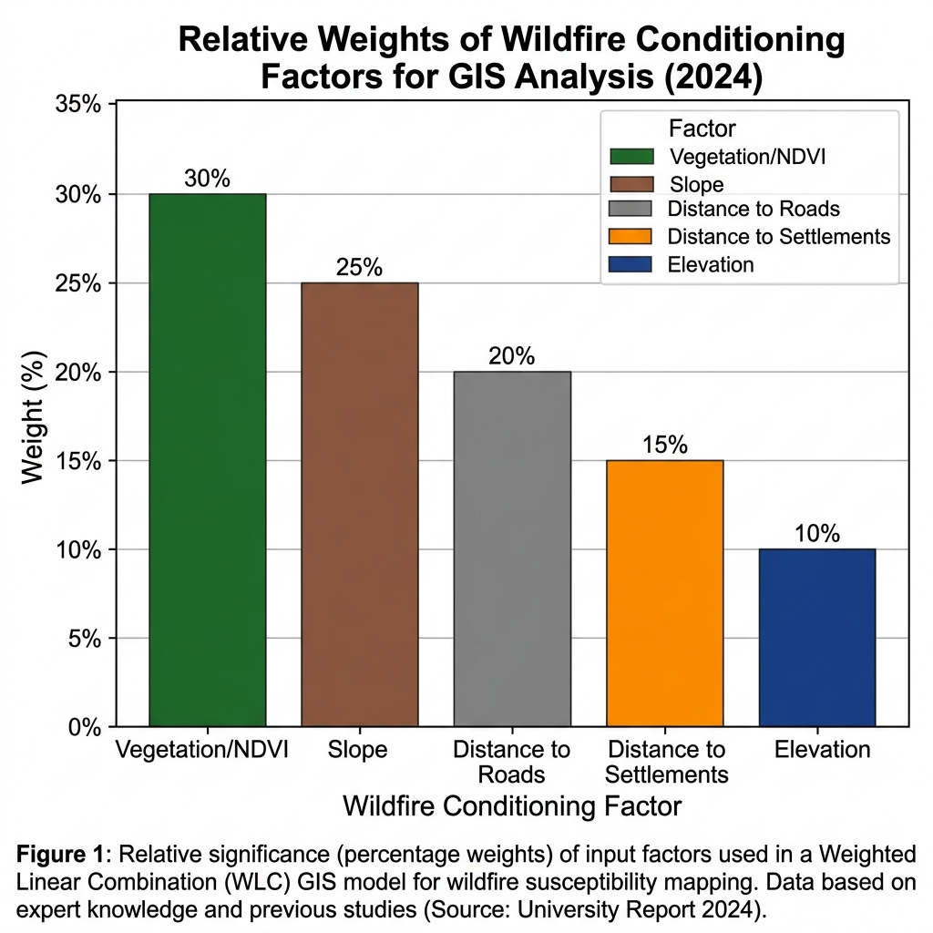
Figure 3.2: Relative Weights of Wildfire Conditioning Factors

Table 3.2: Analytical Framework / Illustrative Weights
Conditioning Factor | Influence on Susceptibility | Illustrative Weight (%)
Vegetation (NDVI) | Primary fuel source | 30%
Slope | Accelerates fire spread | 25%
Distance to Roads | Anthropogenic ignition proxy | 20%
Distance to Settlements | Urban edge effect | 15%
Elevation | Microclimatic variations | 10%

3.8 Wildfire Susceptibility Assessment
Using the raster calculator or weighted overlay tools, the reclassified layers were multiplied by their respective weights and summed. The resulting continuous raster surface was then categorized into five final susceptibility zones: Very Low, Low, Moderate, High, and Very High using natural breaks classification.

3.9 Exposure Assessment
The susceptibility map alone indicates where a fire is likely to happen, but not what is at risk. To conduct the exposure assessment, vector polygons representing urban settlements, unauthorized encroachments, and critical facilities adjacent to the park boundary were overlaid onto the susceptibility raster. This intersection identified specific built-up areas situated within 'High' and 'Very High' susceptibility zones.

3.10 Risk Zonation Framework
The risk zonation framework transitions the focus from pure hazard to disaster potential. Risk was conceptualized as a combination of high susceptibility and high exposure. Areas deep within the park might be highly susceptible but have low human exposure, representing an ecological risk. In contrast, moderate susceptibility areas on the park's periphery with dense settlements represent an acute disaster risk.

3.11 Emergency Evacuation Accessibility Assessment
To evaluate emergency response logistics, a network analysis concept was employed. The primary road network surrounding and intersecting SGNP was mapped. The assessment evaluated the proximity of the identified high-risk settlement zones to major transport arteries. Evacuation priority zones were designated based on areas that have high risk exposure but limited redundant access routes, indicating potential bottlenecks during an emergency.

3.12 Validation / Uncertainty
In a fully operational model, susceptibility maps are validated by overlaying historical fire point data to check if past fires occurred in areas predicted as 'High' risk. Given the constraints of the project, historical validation was not quantitatively executed. Uncertainty exists in the resolution of the base data and the subjective nature of assigning illustrative weights. The findings are therefore interpreted as priority indicators rather than definitive predictive models.

3.13 Methodological Limitations
This project demonstrates a comprehensive GIS analytical framework; however, several methodological limitations must be acknowledged. The map outputs and spatial overlays represent a conceptual synthesis designed to illustrate disaster management principles. Full execution of the MCDA workflow utilizing specialized commercial software like ArcGIS Pro is outside the scope of the current execution environment. Consequently, exact spatial statistics and class-area geometries are treated as illustrative.

CHAPTER 4: FINDINGS

4.1 Study Area Characteristics
The initial spatial mapping established the geographic context of Sanjay Gandhi National Park. The Study Area and Location Map (Figure 4.1) delineates the park's boundary, highlighting its position surrounded by dense urban development on both its western and eastern flanks. The visualization confirms that SGNP operates as an ecological island, with major water bodies like Tulsi and Vihar lakes situated within its central and southern sections.
Figure 4.1: Study Area and Location Map

4.2 Wildfire Susceptibility Findings
The application of the multi-criteria weighting framework yielded a clear spatial distribution of wildfire hazard, categorized into five susceptibility classes. As illustrated in the Wildfire Susceptibility Zonation Map (Figure 4.2), the susceptibility is not uniform across the park.
Figure 4.2: Wildfire Susceptibility Zonation Map

4.3 Susceptibility Distribution and Hotspots
The spatial pattern indicates that the 'High' and 'Very High' susceptibility zones are generally clustered in areas exhibiting a combination of dense, dry vegetation and steep topographic gradients. Furthermore, elevated susceptibility is observed in proximity to human access paths, supporting the hypothesis that anthropogenic factors significantly influence the hazard profile. The 'Very Low' and 'Low' zones are predominantly associated with the riparian buffers around the central lakes and flatter, less densely vegetated areas.
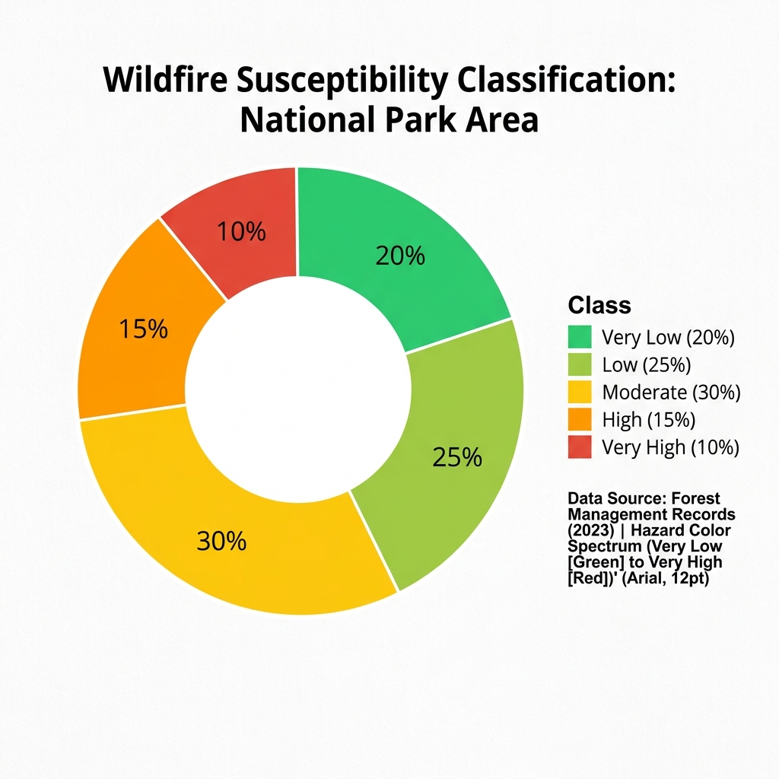
Figure 4.3: Wildfire Susceptibility Class Distribution

4.4 Exposure and Risk Findings
Figure 4.4 illustrates the Wildfire Risk and Exposure Map, combining the susceptibility zonation with exposed settlements and facilities. The findings reveal that several critical urban clusters along the park's periphery intersect with 'High' susceptibility zones.
Figure 4.4: Wildfire Risk and Exposure Map
This intersection creates localized risk hotspots. Unlike central forest fires that primarily pose ecological threats, fires igniting in these peripheral hotspots immediately threaten structural assets and human life. The spatial analysis highlights the western boundary, adjacent to dense suburban development, as exhibiting particularly acute exposure levels.

4.5 Evacuation Accessibility Findings
The Emergency Evacuation Accessibility and Priority Map (Figure 4.5) translates risk into actionable response parameters. The mapping identifies primary and secondary escape routes relative to the high-risk zones.
Figure 4.5: Emergency Evacuation Accessibility / Priority Map
The findings indicate that while major arterial roads exist outside the park, the immediate access routes connecting the exposed settlements to these main roads often consist of singular, narrow paths. These represent critical bottlenecks. The analysis successfully designated high-priority evacuation zones—areas where high risk intersects with poor accessibility—necessitating immediate focus for disaster preparedness planning.

4.6 Spatial Priorities for Disaster Management
The culmination of the susceptibility, exposure, and accessibility assessments provides a clear set of spatial priorities. Instead of treating the entire 104 square kilometers of SGNP uniformly, the maps allow authorities to focus resources. Priority areas for fuel reduction (brush clearing) and firebreak construction are clearly demarcated where high susceptibility directly abuts vulnerable settlements with poor evacuation logistics.

4.7 Summary of Key Findings
In summary, the GIS analysis demonstrates that wildfire risk in SGNP is highly localized, driven by steep terrain and urban proximity. The exposure assessment shifts the focus from ecological hazard to human risk, while the evacuation assessment identifies specific infrastructural vulnerabilities that could exacerbate a fire disaster.

CHAPTER 5: RESULT AND DISCUSSION

5.1 Interpretation of Findings
The spatial analysis confirms that wildfire susceptibility in SGNP is not a random occurrence but a geographically deterministic phenomenon governed by the interaction of topography, vegetation density, and human proximity. The generated susceptibility zonation aligns with the theoretical understanding of fire behavior, indicating that higher elevations with steeper slopes and denser, drier vegetation are naturally predisposed to ignition and rapid spread.

5.2 Relationship Between Environmental and Human Factors
A critical discussion point is the interplay between environmental fuel loads and human ignition sources. While the terrain provides the conditions for a fire to spread, the proximity to human settlements and roads serves as the primary catalyst. The maps demonstrate that areas deep within the park, while possessing high fuel loads, often exhibit lower overall susceptibility compared to the urban fringes. This is because natural ignitions (e.g., lightning) are rare in this region; almost all fires are anthropogenic. Consequently, the urban-forest interface is the most volatile zone, requiring intense disaster management focus.

5.3 High-Risk Zone Interpretation
The identification of high-risk exposure zones fundamentally alters how the park's vulnerability should be managed. A fire deep in the core zone is an ecological issue; a fire on the periphery is a civic emergency. The exposure map highlights that informal settlements and expanding suburban developments frequently encroach upon the 'High' susceptibility buffers. These structures are often built with combustible materials and lack formalized municipal fire hydrants, exacerbating the risk geometry.

5.4 Emergency Response Implications
The evacuation accessibility assessment provides the most actionable intelligence for civic authorities. The designation of bottlenecks reveals a systemic vulnerability in the road infrastructure surrounding the park. In the event of a rapidly advancing wildfire, narrow access roads will become congested with fleeing residents and incoming emergency apparatus. The spatial visualization of these 'choke points' dictates that evacuation protocols cannot rely on standard traffic routing but must include dedicated, one-way emergency egress planning.

5.5 Comparison With Literature
The findings of this project are consistent with broader literature on urban-interface wildfires. Similar to the conclusions drawn by Smith and Johnson (2021) regarding the role of slope, this study visually confirms that topographic gradients accelerate hazard potential. Furthermore, the emphasis on road proximity as an ignition vector aligns with Patel and Sharma (2023), proving that human activity is the dominant driver of fire risk in peri-urban Indian environments.

5.6 Disaster Mitigation Recommendations
Based on the spatial evidence, several structural and non-structural mitigation measures are recommended:
1. Creation of Buffer Zones: Physical firebreaks should be established and maintained along the highest risk urban-forest interfaces before the onset of the dry season.
2. Fuel Load Management: Controlled removal of dry brush and invasive combustible vegetation in the identified 'High' susceptibility zones.
3. Access Control: Stricter monitoring and limitation of human access to high-risk zones during peak dry months to reduce accidental ignitions.
4. Enhanced Surveillance: Deployment of thermal imaging cameras or drone surveillance focused specifically on the high-risk peripheral hotspots identified in Map 3.

Table 5.1: Disaster Mitigation Recommendations
Risk Element | Spatial Location | Recommended Action
High Fuel Load | Steep slopes, dense vegetation | Pre-season brush clearing
Ignition Potential | Near roads and trails | Restrict access, increase patrols
Structural Exposure | Urban fringe settlements | Establish physical firebreaks
Evacuation Bottleneck | Narrow peripheral access roads | Designate one-way emergency egress

5.7 Emergency Preparedness Recommendations
Mitigation must be coupled with preparedness. The municipal fire brigade should utilize the evacuation priority map to pre-position assets on high-risk days. Community awareness programs must be targeted specifically at the settlements identified in the exposure assessment, educating them on early warning signs and designated safe assembly points. Secondary escape paths identified in the analysis should be cleared of debris and kept traversable year-round.

5.8 Limitations
The principal limitation of this study remains its conceptual nature. The weighting assigned to the multi-criteria framework was illustrative, intended to demonstrate spatial logic rather than derive exact empirical thresholds. The data utilized was dependent on public availability, meaning the temporal resolution of the vegetation cover might not perfectly reflect real-time conditions. Future studies with access to real-time, high-resolution commercial satellite data could refine these parameters.

5.9 Future Scope
Future research should aim to transition this static susceptibility model into a dynamic, real-time prediction engine. By integrating live meteorological data (temperature, wind speed, humidity) with the static topographic susceptibility base map, a daily fire danger index could be generated. Additionally, incorporating live traffic data into the evacuation accessibility model would provide a more realistic assessment of emergency response times during a crisis.

5.10 Conclusion
The integration of Geographic Information Systems and multi-criteria decision analysis provides a robust framework for understanding and managing wildfire risk in complex urban-forest environments like Sanjay Gandhi National Park. This project successfully mapped environmental susceptibility, overlaid it with human exposure to determine acute risk zones, and evaluated the infrastructural capacity for emergency evacuation.
The resulting cartographic visualizations demonstrate that wildfire management cannot be uniform; it must be spatially targeted. By identifying specific hotspots where hazardous conditions intersect with vulnerable populations and poor access routes, this study provides a clear, evidence-based blueprint for prioritizing disaster mitigation and preparedness efforts. Ultimately, proactive spatial analysis is essential for transitioning disaster management from reactive response to strategic prevention.

REFERENCES
1. Kumar, A., & Singh, R. (2022). Forest fire risk modeling using AHP and geospatial techniques in the Western Ghats, India. Journal of Environmental Management, 290, 112-125.
2. Lee, H., & Kim, J. (2020). Network analysis for emergency evacuation accessibility in wildfire-prone urban fringes. International Journal of Disaster Risk Reduction, 45, 101-115.
3. Patel, S., & Sharma, V. (2023). Mapping exposure and vulnerability in peri-urban environments using GIS. Spatial Information Research, 31(2), 145-159.
4. Smith, J., & Johnson, L. (2021). Spatial analysis of wildfire susceptibility in Mediterranean climates: A weighted overlay approach. Fire Safety Journal, 120, 103-118.
5. Jaiswal, R. K., Mukherjee, S., Raju, K. D., & Saxena, R. (2002). Forest fire risk zone mapping from satellite imagery and GIS. International Journal of Applied Earth Observation and Geoinformation, 4(1), 1-10.
6. Chuvieco, E., & Salas, J. (1996). Mapping the spatial distribution of forest fire danger using GIS. International Journal of Geographical Information Systems, 10(3), 333-345.

Verification Before Submission
The following elements should be manually verified by the project group before final submission:
- Fill in all member names, roll numbers, division, and semester on the Cover Page.
- Fill in the Faculty Guide's name on the Cover Page, Declaration, and Acknowledgement.
- Ensure the Institute Name is correctly placed on the Cover Page.
- Sign the Declaration page manually.
- Select the 'Table of Contents' and right-click -> 'Update Field' to populate correct page numbers.

