Mike Bruenger

May 18, 2021

Introduction to Python

Assignment06

<https://github.com/Bruengerjr/IntroToProg-Python-Mod06.git>

To Do List

# Introduction

The purpose of this document is to describe the steps taken to complete Assignment06, which consists of using a starter script, intended to represent taking over someone else’s code, to create a to do list that can be manipulated within the context of a menu. It will consist of 3 steps, opening the Assignment06 Starter script, adding additional capabilities to the script, and preparing them for submission.

# Opening the Assignment06 Starter Script

As directed, I began by opening the starter script and examining the existing code. I observed that the code was very similar to Assignment05; however, I needed to add code chunks for the new functions that would run for each of 5 areas of a menu system

# Adding Additional Capabilities to the Script

Once I was able to get the individual functions working, adding the references was easy and didn’t require much troubleshooting. I ran through some test scenarios to ensure, for example, that if I add a task and reload without saving, that it really does reload the data and erase any unsaved tasks. I’ve tested each option from the menu and everything behaves as expected.

# Preparing for Submission

In preparation for submission I created the desired folder hierarchy, named the files appropriately, and took the required screenshots of the code in action (Figure 1) as well as the created txt file (Figure 2).

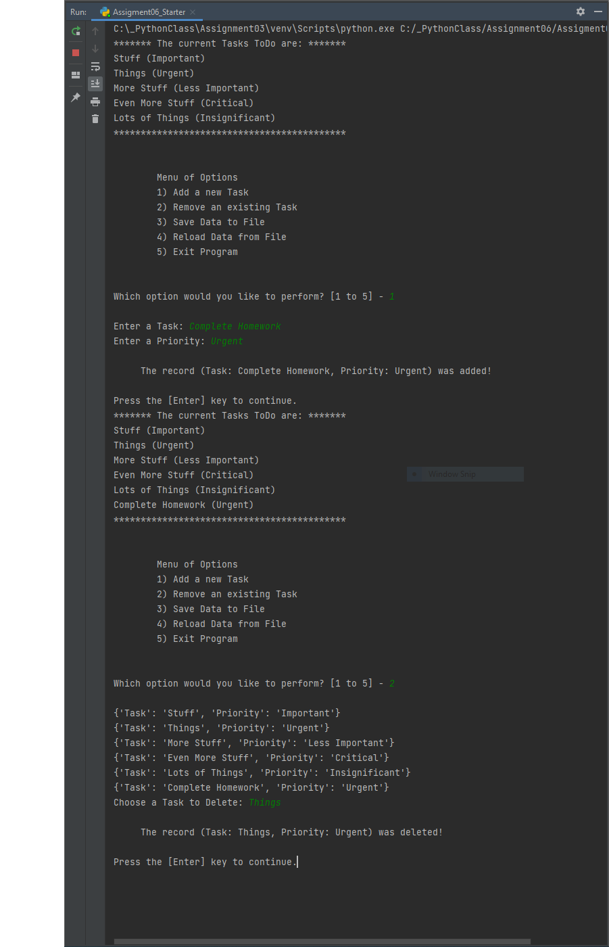

Figure 1: My script executing.

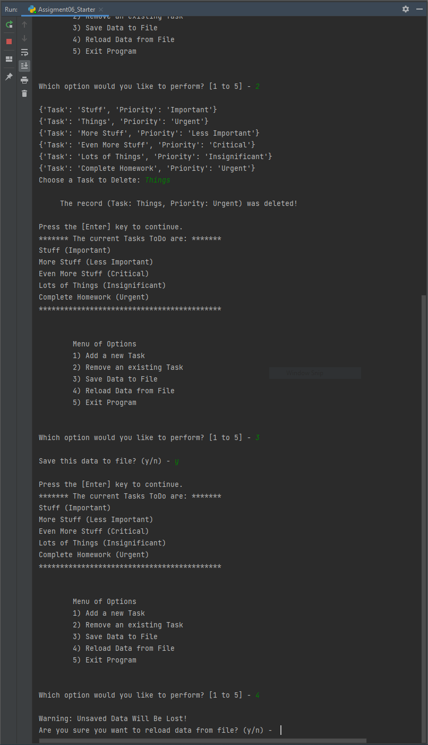

Figure 2: My Script Running cont.

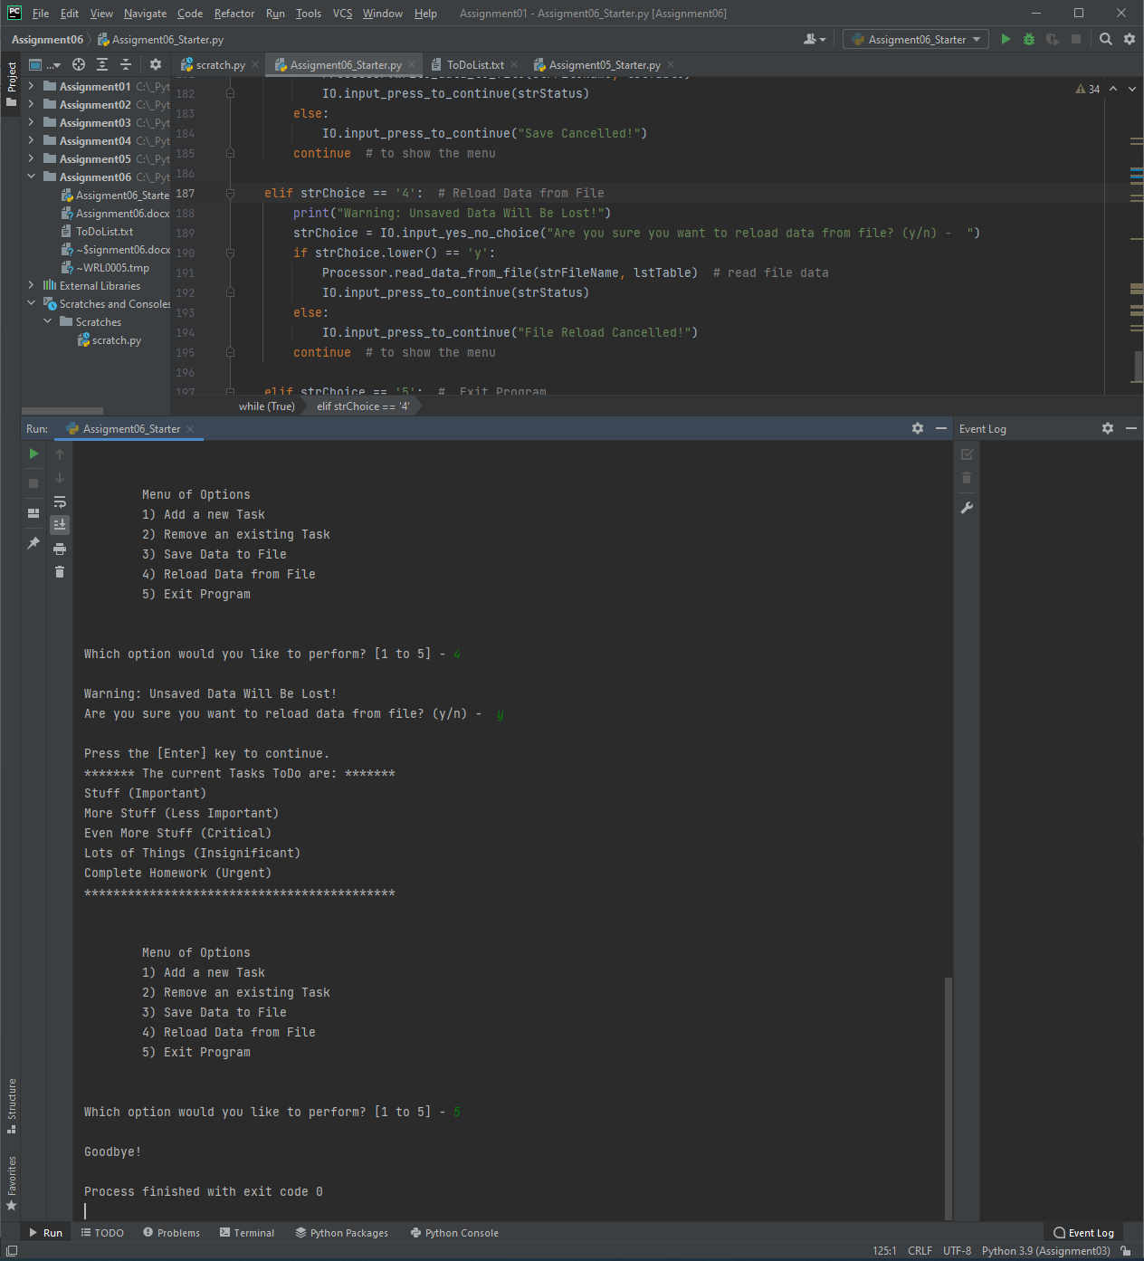

Figure 3: My Script Running Final

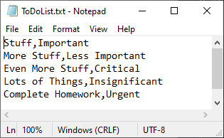

Figure 4: The ToDoList.txt File

# Summary

I have described the process of completing Assignment0 and the steps I opening the Assignment06 Starter script, adding additional capabilities to the script, and preparing them for submission.