Mike Bruenger

June 2, 2021

Introduction to Python

Assignment08

https://github.com/Bruengerjr/IntroToProg-Python-Mod08.git

Classes

# Introduction

The purpose of this document is to describe the steps taken to complete Assignment08, which consists of researching Classes and applying the learned knowledge. It will consist of 3 steps, creating the Assignment08 script, adding additional capabilities to the script, and preparing them for submission.

# Creating the Assignment08 Script

I started off referencing some of the code from my prior assignments, reusing code to generate the menu, grab user input and save and load files. I used Assignment06 and went through and changed the Task/Priority references to be Name/Product and made other changes to align with the new purpose of the code.

# Adding Additional Capabilities to the Script

I created the product class with the two necessary field’s strName and fltPrice. Cleaned up code in the IO class and made what enhancements I could.

# Preparing for Submission

In preparation for submission I created the desired folder hierarchy, named the files appropriately, and took the required screenshots of the code in action (Figure 1), the created txt file (Figure 2).

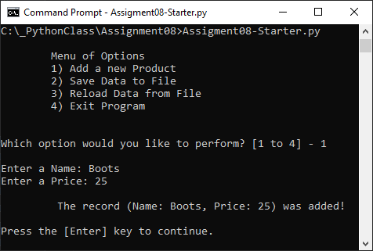

Figure 1: My script executing.

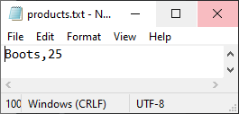

Figure 2: The products.txt File

# Summary

I have described the process of completing Assignment08 and the steps I took, creating the Assignment08 script, adding additional capabilities to the script, and preparing them for submission.